USB-IF TD 4.3.1 & 4.3.4 Failures

It appears that when the CVS is pulling down the CC1 with Rd with CC2 open the TI TUSB320LAI side is reported by the CVS as having a lot of activity on the CC lines.

Below is a scope capture of a connect of a TUSB320RWBR on an EVM to the TUSB320LAI that is on our device.

The setup is the TUSB320 EVM board REV B configured by dip switches as a DFP connected to the DUT with a TUSB320LAI configured as a UFP with GPIO by pulling the port pin to ground as shown in the schematic segment below. The TUSB320 EVM has a I2C to USB converter attached that is driven by a PC. The test below shows a test where the TUSB320 EVM is commanded via I2C from UFP mode to DFP mode and attaches to the DUT and then changes Rp to set the three current set points.

As can be seen the CC1 trace has pulses on it caused by the TUSB320LAI on the DUT. These pulses are causing the 4.3.4 USB-IF test to fail for Rp not being constant (See captured protocol suite screen capture below). It is interesting to note that the TUSB320RWBR chip does not do this when substituted as DUT.

Left to Right: First two graticules have CC1 pulsing with a Default USB Current Rp originating from the DUT’s TUSB320LAI. Graticule 3 is the transition from UFP to DFP of the TUSB320 EVM. 8 through 10 are the tests for TD 4.10.1. Yellow – CC1, Magenta - CC2, Cyan – VBUS, Green VBUS current.

A screen shot of a computer

Description generated with very high confidence

Below is a scope capture of a connect of the TUSB320LAI EVMCC lines. The board is straight out of the box and the only change was to close DIP switches 1 & 8. Which should have put it into UFP only mode. As can be seen the CC lines are driven rather than pulled down with Rd continuously as stated in the parts datasheet.

**It would appear that there is either a design issue with the TUSB320LAI or that it is performing a function that I am unaware of for UFP only operation and my VIF is incorrect.**

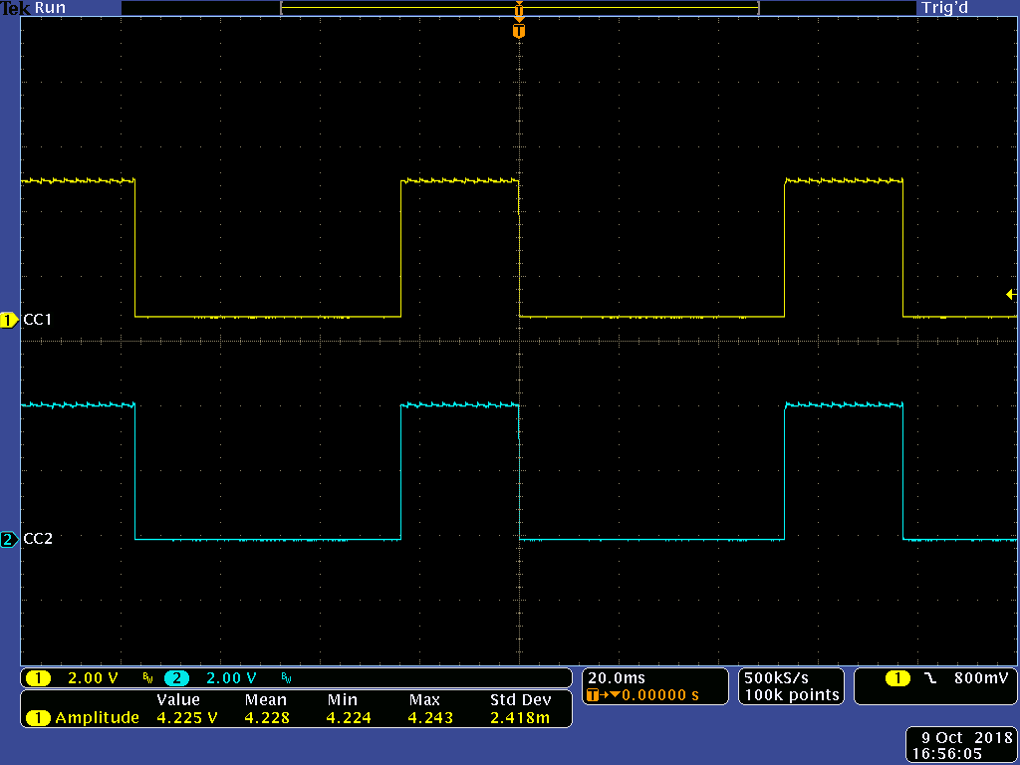

TUSB320LAI

<http://www.ti.com/product/tusb320lai?qgpn=tusb320lai>

***7.2.1.2 Upstream Facing Port (UFP) - Sink***

The TUSB320 device can be configured as a UFP only by pulling the PORT pin low to GND. In UFP mode, the

TUSB320 device constantly presents pulldown resistors (Rd) on both CC pins. The TUSB320 device monitors

the CC pins for the voltage level corresponding to the Type-C mode current advertisement by the connected

DFP. The TUSB320 device debounces the CC pins and wait for VBUS detection before successfully attaching. As

a UFP, the TUSB320 device detects and communicates the advertised current level of the DFP to the system

through the OUT1 and OUT2 GPIOs (if in GPIO mode) or through the I2C CURRENT_MODE_DETECT register one time in the Attached.SNK state.

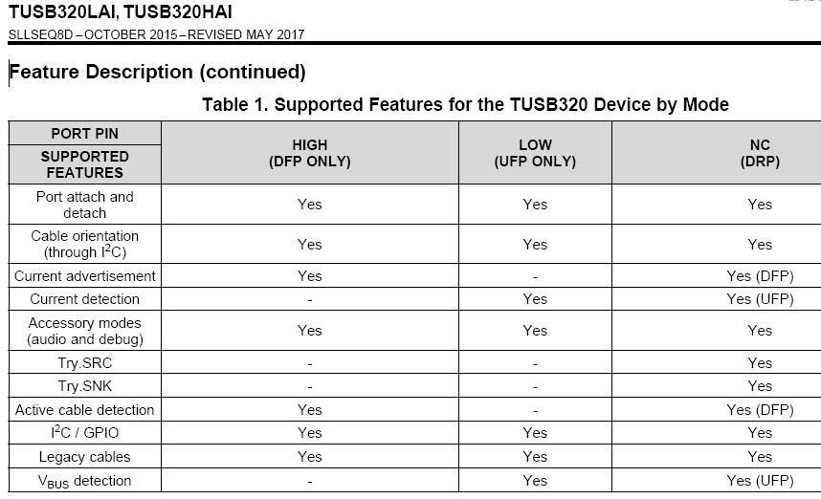

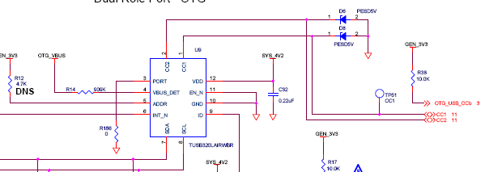

|  |  |  |
| --- | --- | --- |
| **TD.4.3.1 Sink Connect Source - Testing Upstream Port** | | |
| **PASSED** | Applying Source Terms | PUT must advertise Rd termination for 100 ms |
| **PASSED** | Applying VBUS | PUT must sink no more than 100 mA (actual was 0 A) |
| **PASSED** | Applying VBUS | PUT_R must not source Vconn (0 V measured) |
| **FAILED** | Removing VBUS | PUT must not toggle between Rd/Rp |



* TD 4.3.4 Sink Connect Try.SNK DRP Test FAIL
  + Teledyne LeCroy USB Compliance Suite Version: 3.53 Build 734
  + Starting VIF Extraction...
  + Extracting from file "Crossmatch__900469-7680__A__10007755__J1.txt" ...
  + VIF_Product_Type = 0
  + Connector_Type = 2
  + USB_PD_Support = NO
  + Type_C_State_Machine = 1
  + Type_C_Is_Debug_Target_SNK = NO
  + Type_C_Can_Act_As_Host = NO
  + Type_C_Can_Act_As_Device = YES
  + Type_C_Supports_Audio_Accessory = NO
  + Captive_Cable = NO
  + Device_Speed = 0
  + Successfully finished VIF Extraction.
  + The test conditions are met and test is applicable to run.
  + Cable is matched.
  + Successfully detected device role (0x2) according to the provided VIF.
  + InitPDLink.updg: Starting PD Generation
  + Waiting... [maximum 15000 ms]
  + Generation Complete... 204 ms
  + InitPDLink.updg: Stopping PD Generation
  + TD.4.3.4_USB2_Host.rec: Starting Recording
  + Analyzer Trainer is Ready... 1516 ms
  + TD.4.3.4.UPDg: Starting PD Generation
  + Waiting... [maximum 20000 ms]
  + Pausing the generation... 812 ms
  + TD.4.3.4_Host.UTG: Starting USB2 Generation
  + Resuming generation... 2580 ms
  + Pausing the generation... 3812 ms
  + TD.4.3.4_Host.UTG: Stopping USB2 Generation
  + Resuming generation... 3984 ms
  + Generation Complete... 5188 ms
  + TD.4.3.4.UPDg: Stopping PD Generation
  + Analyzer Trigged... 5764 ms
  + TD.4.3.4_USB2_Host.rec: Stopping Recording at 5876 ms
  + Trace is ready... 7392 ms
  + making a copy from Intermediate folder...
  + TD.4.3.4.vse: Running Verification Script
  + Error(0x00000004): The PUT does not transition to Attached.SNK.
  + Verification Result: FAILED
  + 01_TD.4.3.4____FAIL__.usb: Saving trace file
  + Trace saved... 8516 ms
  + TD.4.3.4 : Finished
  + Test Elapsed Time: 0 minute(s) and 24 seconds

TD 4.3.4 Sink Connect Try.SNK DRP Test

A. Purpose

1. Verify a Sink transitions to Attached.SNK according to spec

B. Applicability:

1. This test applies when VIF field Type_C_State_Machine is SNK and Type_C_Supports_Audio_Accessory is NO and Type_C_Supports_VCONN_Accessory is NO.

C. Asserts:

1. TBD

D. Procedure:

1. CVS transitions to Unattached.SRC for 5ms

2. CVS transitions to Unattached.SNK for 30ms

3. CVS transitions to Unattached.SRC

4. CVS verifies PUT continues to provide Rd on the CC pin for the duration of this test

a. For a PUT_R, verify Rd is provided on both CC pins until Attached, and then on at least one CC for the duration of this test.

5. CVS transitions to AttachWait.SRC for tCCDebounce

6. CVS transitions to Try.SNK for tDRPTry

7. CVS transitions to TryWait.SRC for tCCDebounce

8. CVS transitions to Attached.SRC

9. CVS verifies that PUT transitions to Attached.SNK:

a. PUT sinks current according to CVS advertisement

b. If PUT supports USB 3.1:

i. PUT starts data communications on its SuperSpeed pairs.

c. Else if PUT supports USB 2.0:

i. PUT starts data communications on its D+/D- pair

d. For a PUT_R, VCONN is not applied

10. CVS transitions to Disabled

11. CVS verifies that PUT transitions to Unattached.SNK before tVBUSOFF expires a. PUT data communication has ceased

b. PUT is not sourcing Vbus (Vbus is at vSafe0V)

c. PUT is not sourcing Vconn

