1.) K-level
The chirp signal K-level is only 700mV, but it should be 800mV.
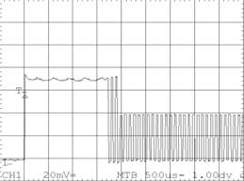
Is it a intended behavior? Is it so ok?

2.) USB Test Modes
I can not switch the TUSB4020 into test mode with the Test mode selectors
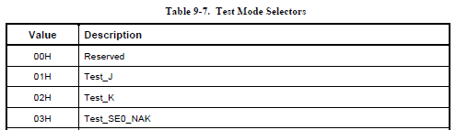
Are the test modes supported by TUSB4020?
Is a special hardware configuration necessary to access the test modes?

3.) Stress test
A short of D+/D- to 5V results in fatal damage of the TUSB4020.
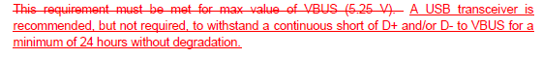
see “5V Short Circuit Withstand ECN.pdf”
In datasheet the absolute maximum rating for all other pins is 3.8V
What is the maximum allowed voltage for D+ and D- pins?

4.) Battery Charging Mode
The configuration pins are:
Pin21= 4k7 to GND -> active high
Pin36 = 4k7 to GND -> power switching supported
Pin35 = 4k7 to GND -> individual power control supported
Pin6 = (PWRCTL2) 10k to 3.3V -> battery charging supported

Have we to set the 0A register by software?
Is it this register with offset Ah?
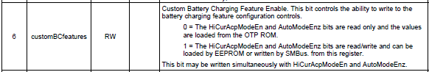
Can we measure if the TUSB4020 is in battery charging mode by D+/D- lines ? how?
,because for BC-detection we have only a device which should support it .

Is in divider mode the fixed voltage adjustable?
How can I adjust the fixed voltage in divider mode?

