**Test1**- VDD33&VDD11 **Td1=250us**

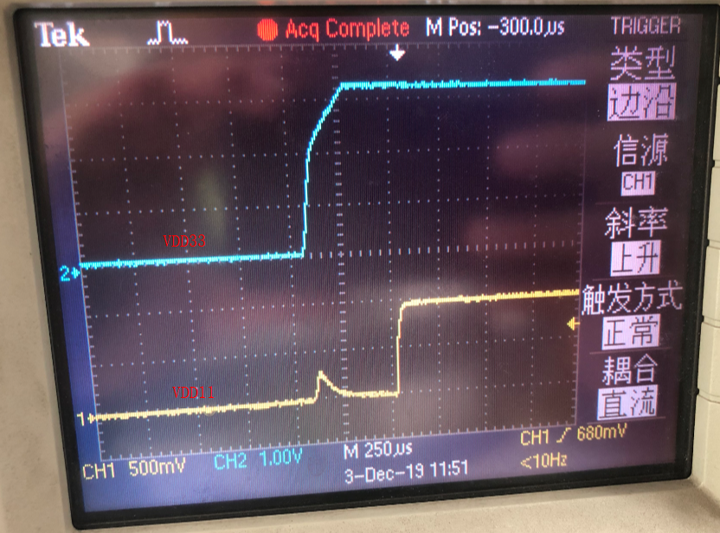

Picture.1

**Test2-** VDD11&GRSTz ,**Td2=5ms**

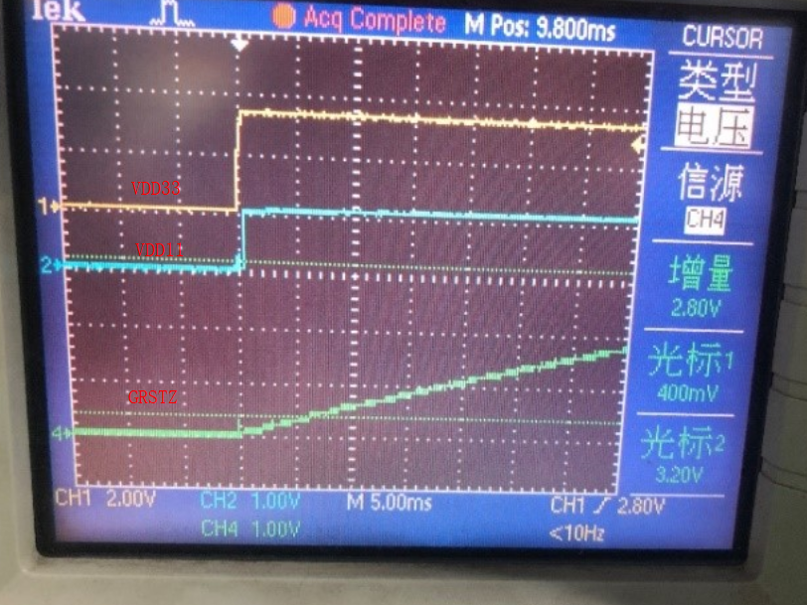

Picture.2

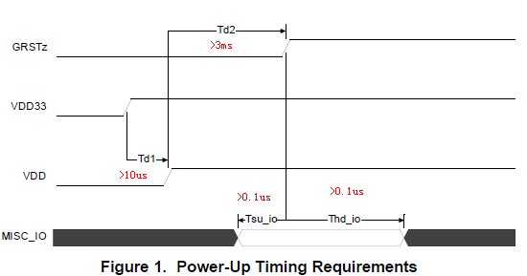

**Picture.3**

**Summarize the test1&test2 via Picture 3. Ignore the the red character in picture 3 .**

**The correct td1>250us and td2>5ms.**

**Test-3** USB_VBUS &VDD33 (There is no sequence about USB_VBUS&VDD33 mentioned in specification )

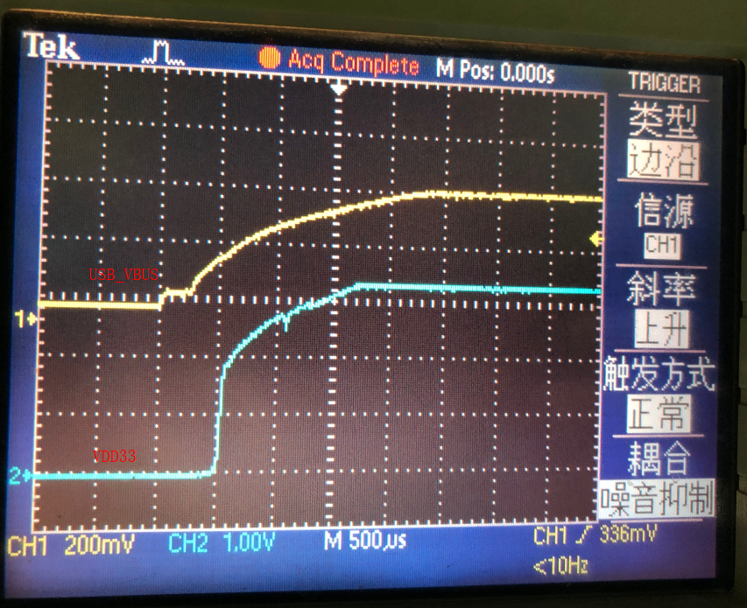

Picture.4