1. Problem Description

The USB Hub chip model we are using is TUSB4041IPAP. We attempted to start using the default configuration of internal resistors and EEPROM I2C configuration. However, when inserting USB into the WIN11 system device, we encountered the problem of 'requesting USB device descriptor failed', as shown in the following figure.

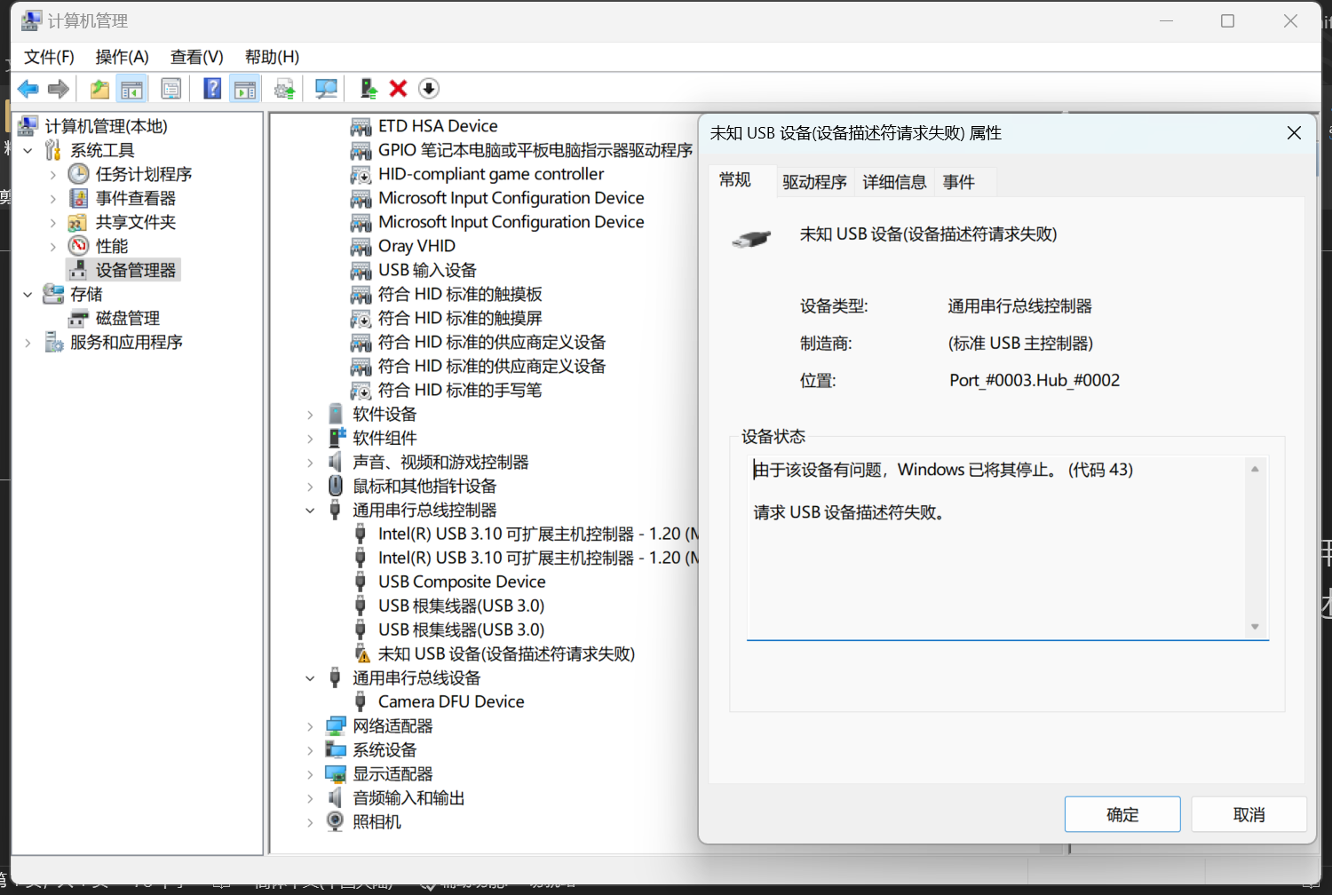

1. Hardware Design Status

Below are the details of our hardware design schematic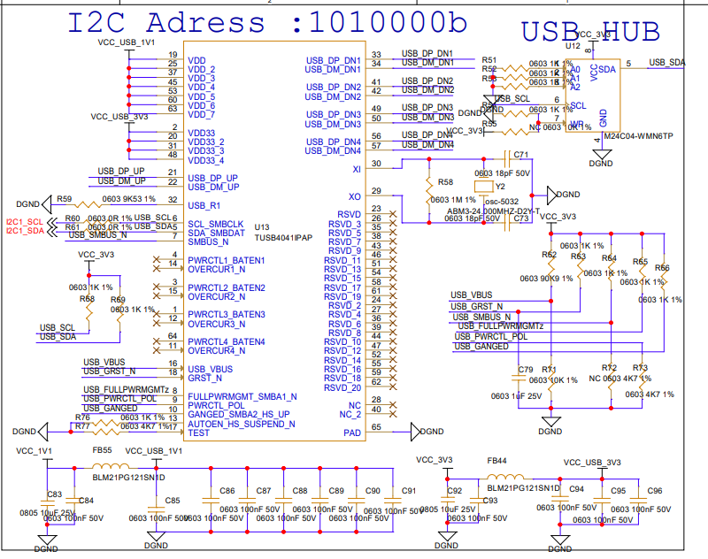

Chip Configuration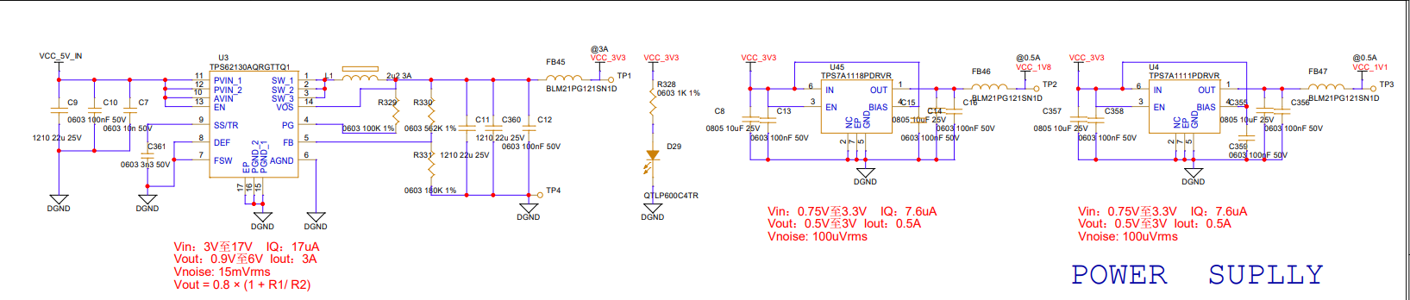

power supply

Chip reset pin GRST_ N is an external trigger.

1. Design Requirements

Currently, assistance is needed to confirm the cause of the "device descriptor recognition issue"; Can you also provide a WINDOWS based EEPROM utility and an EEPROM burning bin example file.

The following is the content of the bin file we are currently burning in EEPROM.

00 55 ROM Signature

01 51 TI VID 0451 LSB

02 04 TI VID 0451 MSB

03 42 TI PID 8142 LSB for eval board read from device

04 81 TI PID 8142 MSB for eval board

05 9C Custom Strings enabled, power ganged, port power switching status reporting disabled

06 00 No battery charging

07 80 Downstream ports not removable

08 0F 4 ports enabled

09 00 Reserved, program to 00

0A 22 PWRCTL is Active HIGH, Auto Chg Mode disabled

0B 9E Enable downstream polarity, swap downstream polarity

10 00 Container ID[0x0] - EEPROM utility read 5CD1C002-CD40-BCE7-6715-881D272D0300

11 03

12 2D

13 27

14 1D

15 88

16 15

17 67

18 E7

19 BC

1A 40

1B CD

1C 02

1D C0

1E D1

1F 5C Container ID[0xF]

20 09 Lang ID LSB 0409 = US English

21 04 Lang ID MSB

22 00 Serial Number length - should not be read as customSernum is 0 in reg 5

23 12 Mfg Name Length

24 0D Prod Name Length

50 50 P Mfg Name[0]

51 68 h

52 6F o

53 74 t

54 6F o

55 20

56 52 R

57 65 e

58 73 s

59 65 e

5A 61 a

5B 72 r

5C 63 c

5D 68 h

5E 20

5F 49 I

60 6E n

61 63 c

90 50 P Prod Name[0]

91 52 R

92 49 I

93 20

94 54 T

95 72 r

96 75 u

97 2D -

98 38 8

99 20

9A 55 U

9B 53 S

9C 42 B

F0 00 additional features - power on time