TUSB564 Debugging Progress
- Hardware connection
Our hardware connection is as follows: PC (DP output or USB 3.0 HOST) ->P25 (Type-C) ->TUSB564 (recognizing forward and reverse insertion + USB/DP MUX splitting) ->[USB 3.0 through 3588 USB PHY] or [DP through LT8711UX to HDMI → 3588 HDMI-RX0], 3588 configured TUSB564 and LT8711UX respectively through I2C.
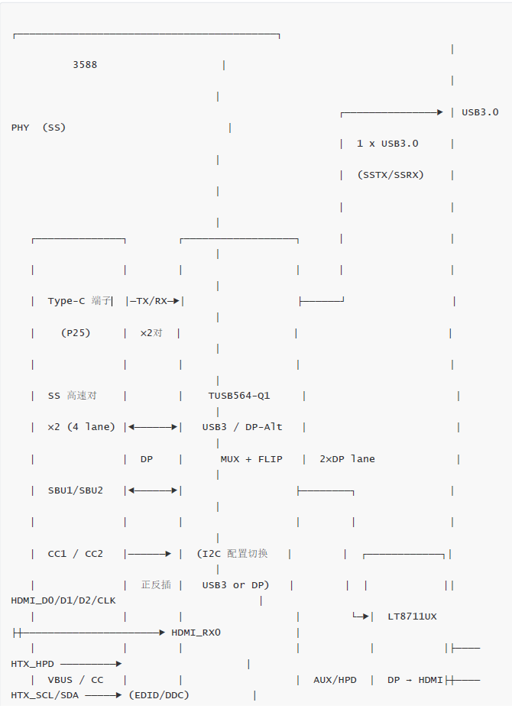
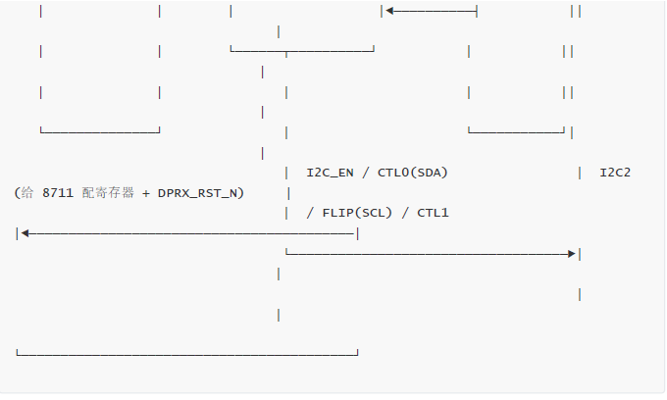
Test method: Use a fully functional TYPEC cable to connect the PC and P25 terminals. The phenomenon is that there is no DP signal output from the DP_SX0-P, DP_SX0-N, DP_SX1-P, and DP_SX1-N terminals of TUSB564.
- Register configuration with forward and reverse insertion（#正插：forward; #反插：Reverse）
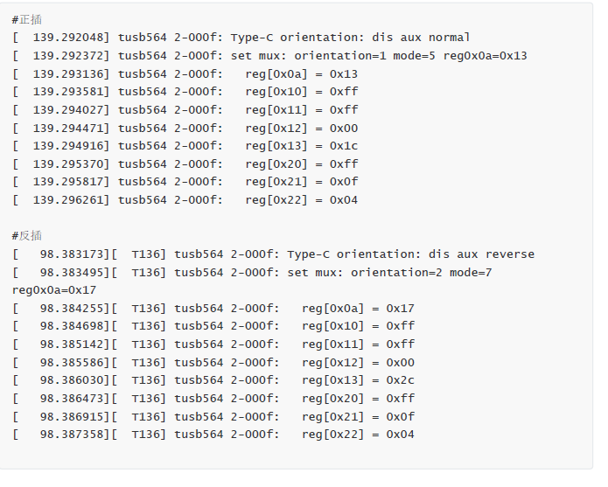

- Oscilloscope measurement of AUX related waveforms
3.1、SUB1（16pin）
Output waveform after inserting PC
3.2、AUXp
It can be seen here that AUX actually responded, but the DP out of TUSB564 did not output. There are several possibilities here, such as TUSB564 Incorrect register configuration leads to mapping issues, or the incorrect state of LT8711 results in no response.
I would like to confirm with the manufacturer how many times there are AUX training sessions for the PC, TUSB564, and LT8711 links?
Does TUSB564 participate in AUX training? If TUSB564 does not participate in the training, then I can confirm that it is the AUX training between PC and LT8711
There is a problem, otherwise there is a problem with the training between TUSB564 and LT8711.
I hope you can provide some debugging ideas to help us locate the software and hardware issues.

