Packets Transmit and Receiving on EVM & Custom-Board

Table of Contents

1 Introduction on EVM 4
2. Observation on Custom Board 7

1 Introduction on EVM

MAC-PHY TX/RX Path Validation Document
The purpose of this validation is to ensure that the transmit (TX) and receive (RX) paths between the MAC (AM2634) and PHY are functioning correctly. The validation also includes end-to-end verification using a PC as the communication endpoint.
Block Diagram / Flow
Transmit path:
AM2634 (MAC) --> PHY --> Cable --> PC (Wireshark)
Receiver path:
PC --> Cable --> PHY --> AM2634 (MAC)
Transmit Path Validation Procedure
• Implemented the transmit function in the project file.
• Configured MAC to send Ethernet packets to the PHY.
• PHY receives packets from MAC and drives them through the RJ45 interface to the PC.
• PC captures the transmitted packets using Wireshark.
• Validation Check: Compare transmitted packet data and format in Wireshark to ensure integrity.
• Result: Packets transmitted successfully and verified on Wireshark.
I added the logs both tera term and Wireshark

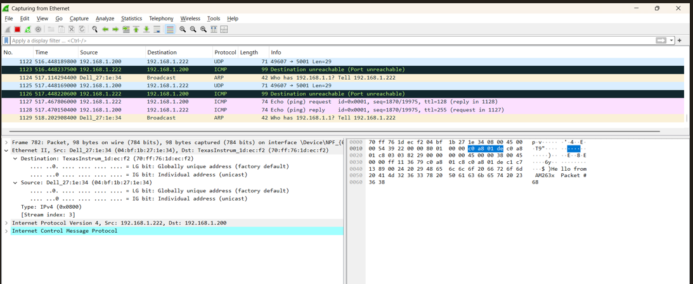

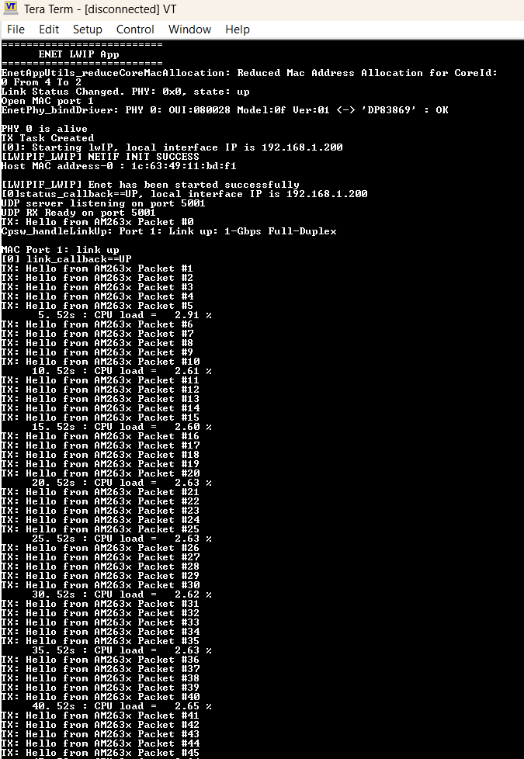
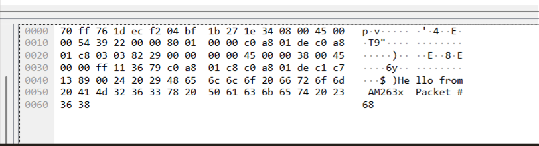
Receive Path Validation Procedure
- Send test packets from the PC through Wireshark.
- Packets traverse the cable and PHY to the MAC.
- MAC receives the packets.
- Validation Check: Verify packet count and data at MAC against transmitted PC packets.
- Result: Packets received successfully.
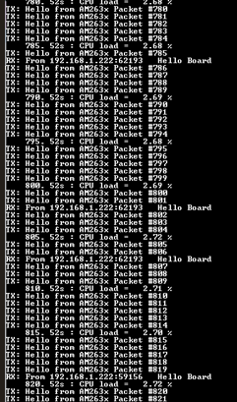
RX: From 192.168.1.222 [PC] Hello Board.

Observation on Custom Board
We have tested same project file on custom board and observed following below.
Transmit path:
AM2634 (MAC) --> PHY --> Cable --> PC (Wireshark)
Receiver path:
PC --> Cable --> PHY --> AM2634 (MAC)
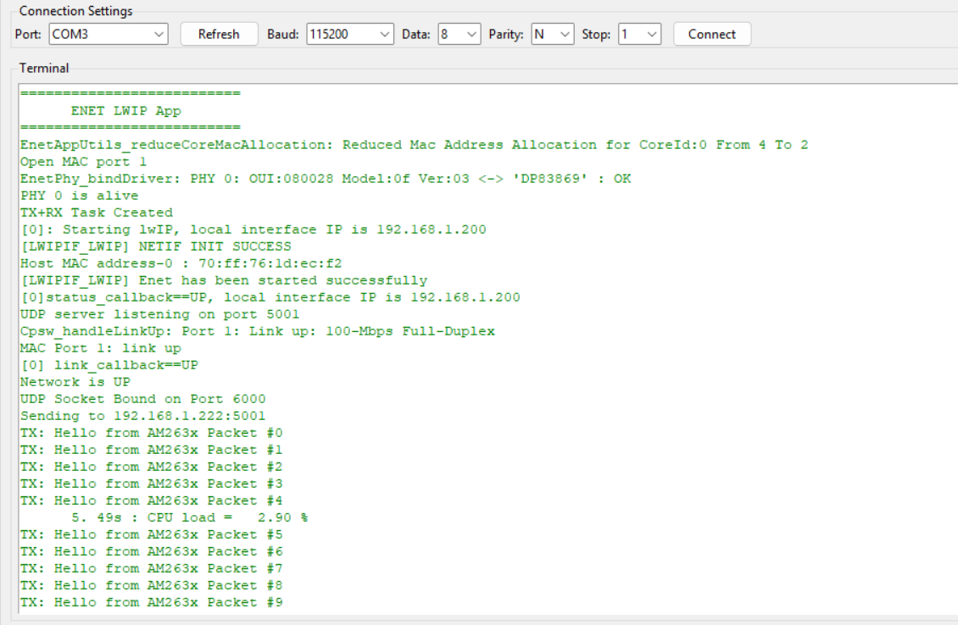
MAC transmitted the packets to the PHY, but PHY didn’t receive the packets. We didn’t see any transmitted packet in the Wireshark.
