一、Computer is set 100M，the equipment with DP83867 is set 1000M
The iperf3 test is shown below.
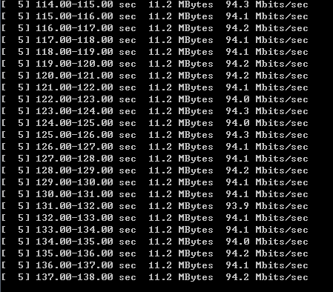
二、Computer is set auto-negotiation，equipment is set 100M
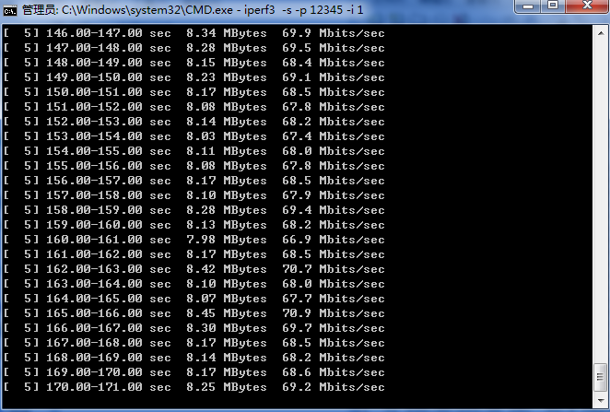
三、The computer is set auto-negotiation，equipment is set 1000M
