Testing 2lane DP alt mode with 86 template on 2.15 FW:

1. Using the app config tool, load the tool with ‘TPS65986_HD3SS460_DRP_Source_Full_2_15.tpl’ you will also need to manually load the low region (to prevent flashing errors): ‘TPS65986_HD3SS460_DRP_Source_Full_2_15_lowregion’
   1. this can be found in C drive<Program Files< Texas Instruments<TPS6598x Application Customization 2_15rc2<tps6598x-app-customizer<gui<binaries
2. Next, go to ‘GPIO event map’ register 0x5c in the config tool.
   1. Change GPIO 0,3,14 to match the screenshots below

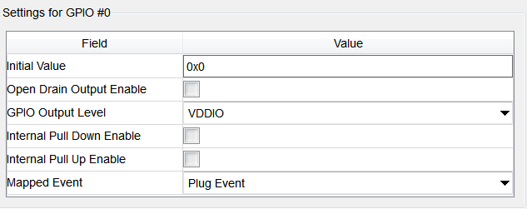

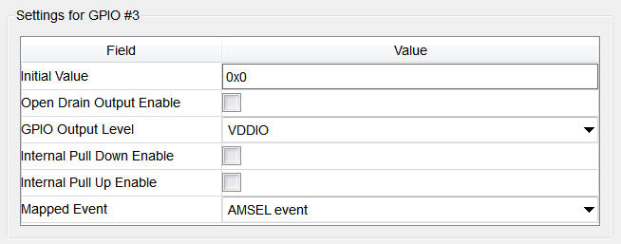

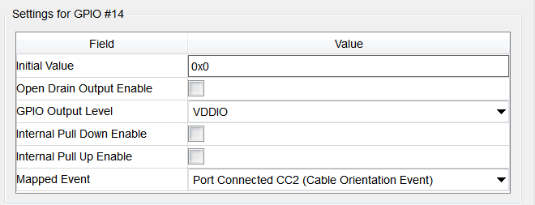

1. Flash the device and power cycle (or reset the EVM)
2. Connection: can be done before or after flashing -> Using one 82 EVM acting as the dock and a Macbook acting as the Host, connect the Macbook to the dock with a type C to type C cable. Using a mini DP to DP cable, connect the expansion board to a DP monitor. (no barrel jack is needed).
3. The last thing I typically do is Plug in the type C cable to dock Or Macbook and verify monitor pops up (as opposed to power cycling with all connections already made)
4. Next verify that USB3.0 is also enabled in data status register 0x5f as seen below. Verifying USB3.0 is connected means that 2 lanes of DP and 2 lanes of USB3.0 is enabled.

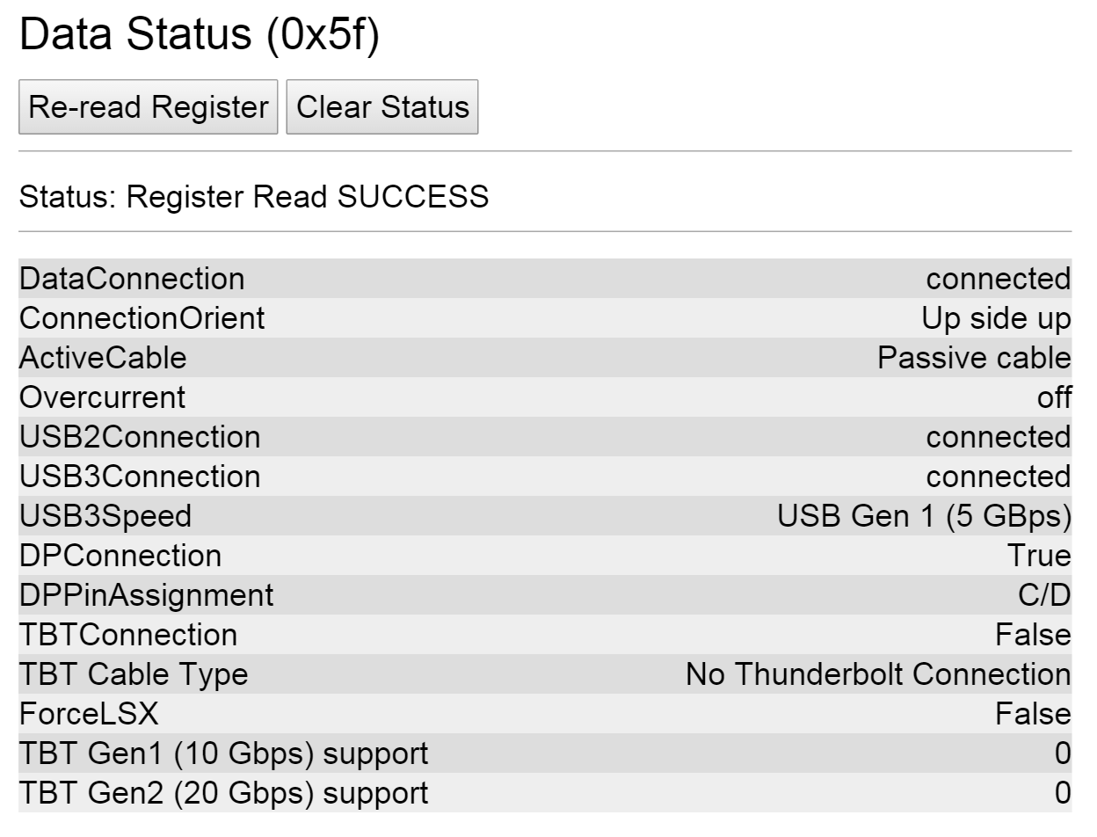

Note: There should be 1 LED ON (MUX_ctrl1) during run time as well as the HPD LED on the expansion board.