Testing DP alt mode with base FW image:

1. Using the app config tool, Reflash 86 base image FW on both EVMs by selecting ‘EVM recovery file: tps65982_evm_flash_image.bin’ and verify the ‘VERSION’ (0xf) register says 0x0179 confirming the base FW was correctly loaded.
   1. At this time you can set the dip switches: Verify the source has B0 to the right B1 and B2 to the left and sink has all dip switches to the left -> just like the picture below.
   2. Make sure you use the reset button after you reflash in order to load the base FW onto the 82.
2. Connect the EVMs the same as the following picture
   1. Note that the barrel jack is supposed to go on the source/DFP. Not the sink/UFP. i.e. The location of the barrel jack in the picture is wrong.
   2. After making the final connection the source display should flicker and a different colored LED should appear on the sink DP monitor. There is a few seconds delay time between when you make the final connection and when the monitor actively displays something.

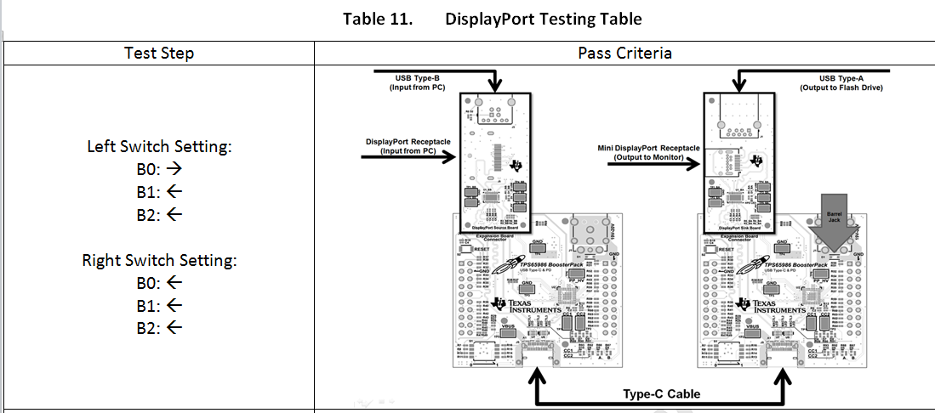

Note: Source is on the left, Sink is on the right