USB Signal (TX /RX) Path topology on Board:

CONNECTOR
MUX / DEMUM
HD3SS3212IRKSR
ESD DIODE
ESD7016MUTAG
USB HUB IC
TUSB8041IPAPRQ1
FERRITE BEAD
0603USB-251MLC
FERRITE BEAD
0603USB-251MLC
MUX / DEMUM
HD3SS3212IRKSR
ESD DIODE
ESD7016MUTAG
CONNECTOR
USB UPSTEAM PATH
DOWN UPSTEAM PATH

My design requirement is such that, upstream side of connector will be connected to Host PC with 3-meter USB3.0 compliant Cable and Downstream port side of USB3.0 connector will be connected to USB3.0 compliant Camera board with 1-meter USB3.0 cable.
In this regards, above signal path is available on my board and it will be connected either side of the board as I mentioned.

- Signal Topology from Upstream connector (TX’r) to USB Hub device (Rx’r) :
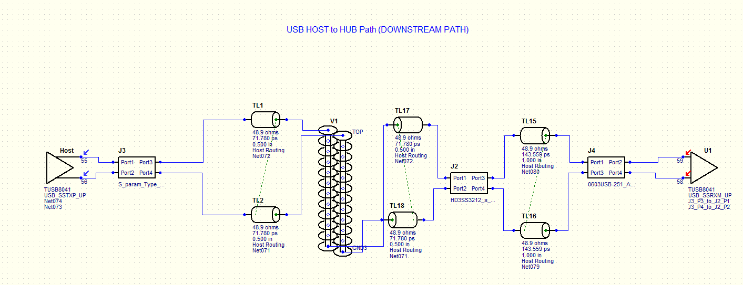
And here I mapped TUSB8041.ibis file for Transmit device as well receiver model for receiving device. As you know that, TUSB8041 device doesn’t have IBIS-AMI model, in this case, I run Fasteye analysis and observed below results.
And below eye mask set in tool as per USB3.0 specification (Please correct me if I’m wrong)
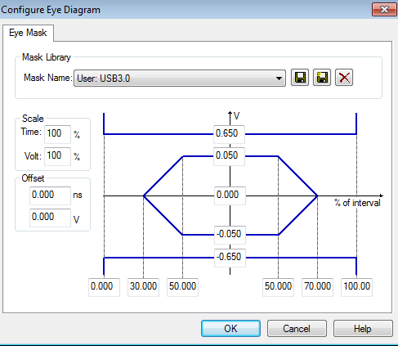

Simulation output in Standard operation mode:
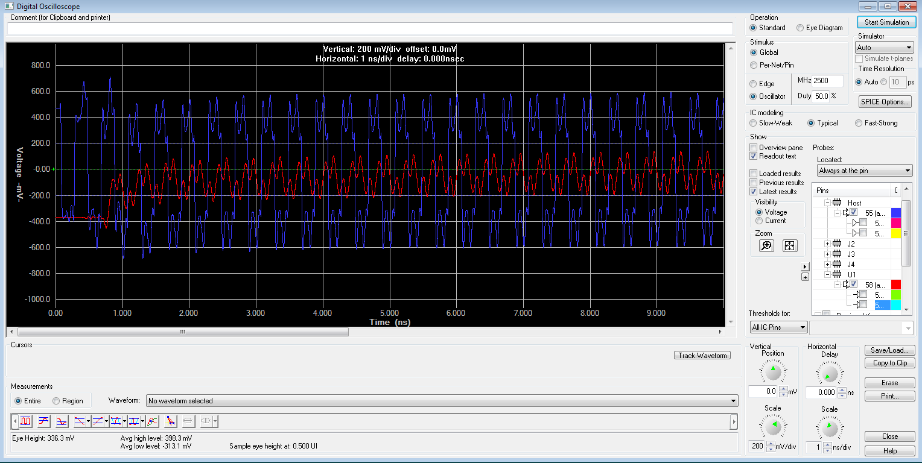
Simulation output in Eye diagram mode:
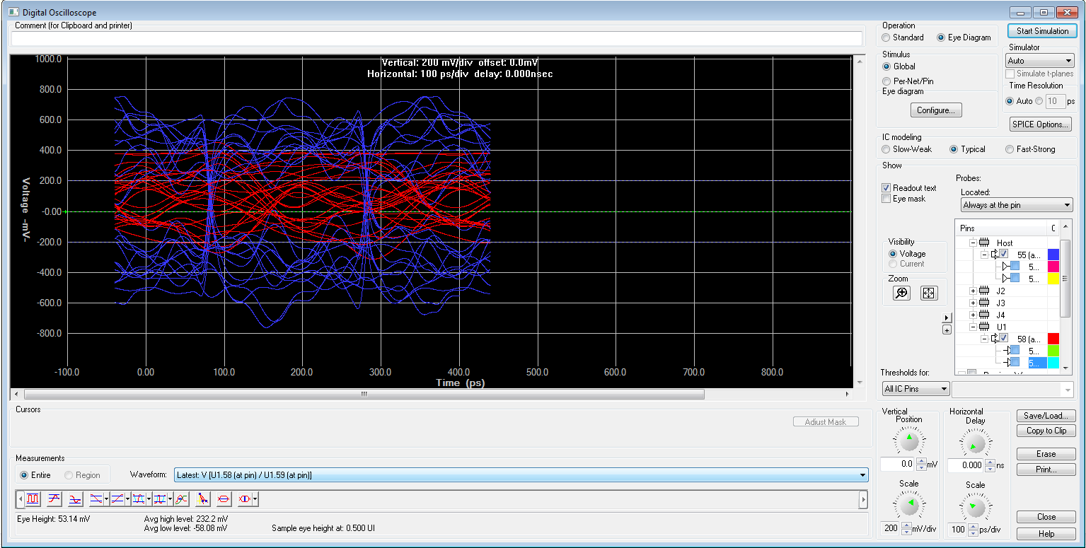

Fasteye analysis results:
Hyperlynx SI eye density viewer:
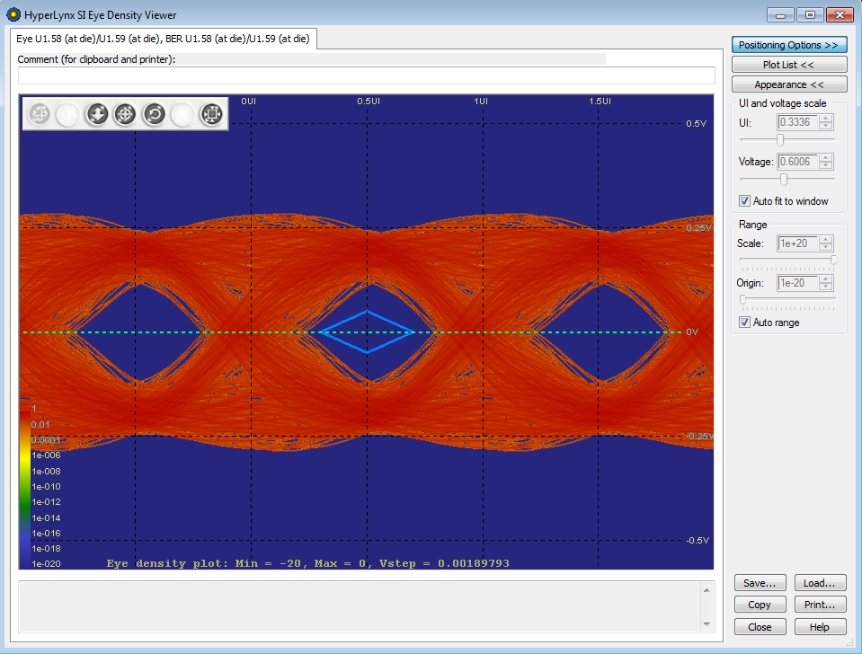
Hyperlynx bath tub chart at receiver device :
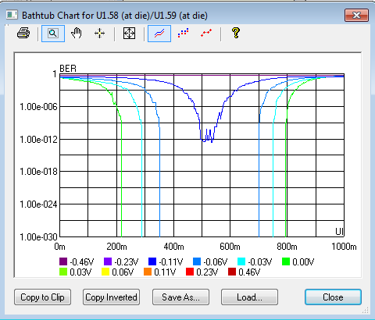

In this regards, I have below few queries, please correct me if I’m wrong.
- Is these results are Valid? And also I would to know, how can check available margin in term of time and voltage levels
- Do let me know, whether you would like to share any other suggestions to have better results.

