Issue 1: Error code with 1 channel camera and 4 channel cameras
According to TI response, we try Image Sensor ISX019 4 camera module and 1 camera module to read 0x55 & 0x56 & 0x4D & 0x4E twice shown as bellowed.
In 1 Channel camera, the image can display continuously.
But 4 channel cameras, it cannot show image.
the register 0x4E showed 0x1C.
It means the buffer error.
Which part we need to set for buffer?

1. For 4 channel cameras
0x55 : 0x00 =>0x00
0x56 : 0x00 =>0x00
0x4D : 0x33=>0x03
0x4E : 0xFD=>0x1C

2. For 1 Channel camera
0x55 : 0x00 =>0x00
0x56 : 0x00 =>0x00
0x4D : 0x33=>0x03
0x4E : 0xED=>0x0C

Issue 2 : frame sync with 4 channel cameras
We have setting register 0x20=>0x00 and Register 0x21=>0x3C.
Compared with OV9716(933) and Sony IMX019(913), All registers show different shown as bellowed.
The different setting is using red mark.
How to set the correct frame sync?
- Ov9716<933>Registers Setting(4 camera work well)，I2C table：
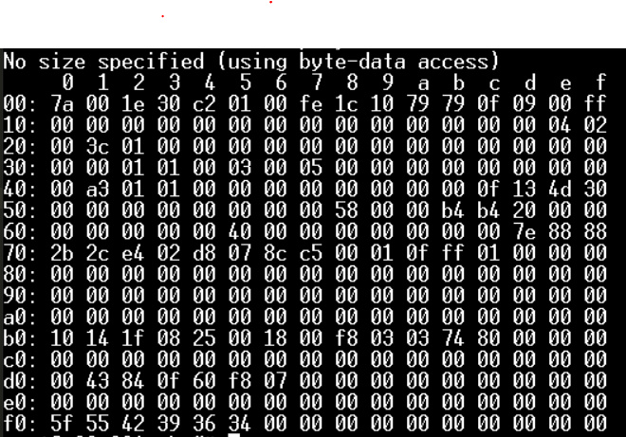

- Sony<913> Registers Setting(4 camera cannot display)，I2C table：
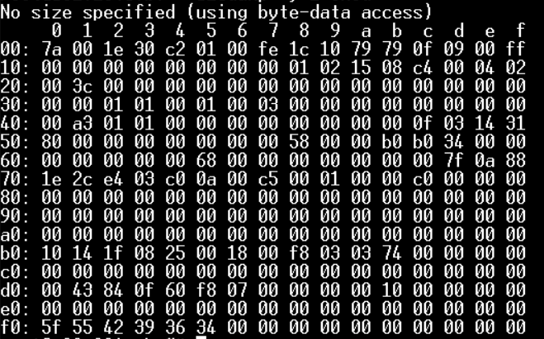

In OV9716 with 933, we checked Register 0x22=> 0x01, it can work correctly.
In ISX019 with 913, We checked Register 0x22 => 0x00，it means Video is not synchronized
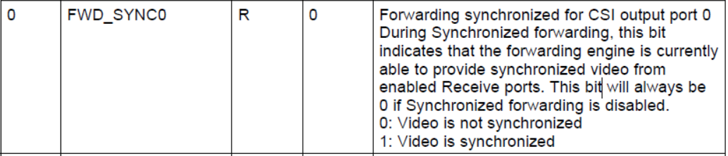

In OV9716 with 933, We checked Register 0x35 => 0x03, it can work correctly.
In ISX019 with 913, We checked Register 0x35 => 0x00，it means Input streams are not synchronized
