Hi,Support,
I’ve recently encountered issues with two different parts and would appreciate your assistance! （SN65C3232EPWR+TPS5420DR ）
First Issue, SN65C3232EPWR:
We purchased SN65C3232EPWR 2505+. During aging tests, the motor would intermittently stop and then resume operation, and this phenomenon occurred repeatedly. When we replaced them with the 2145+ we had previously used, the system operated normally. We checked PCN and seems no function change; the datasheet has not been updated and is still the 2021 version. Could you please tell us where the problem lies? And we also question the differences in the marking versions, and we have not found any documentation explaining this.Can you help provide an official explanation? Thank you!
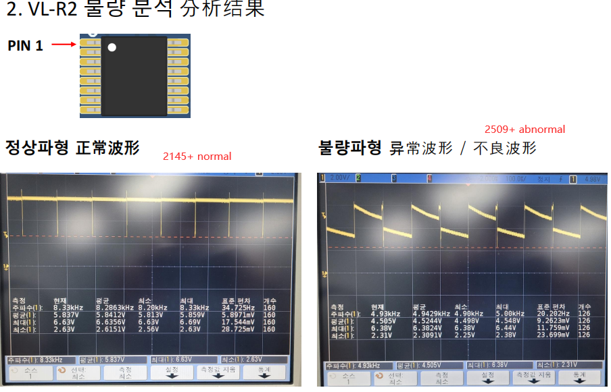

Abnormal Waveform for pn3 pn4 pn5 (2509+)
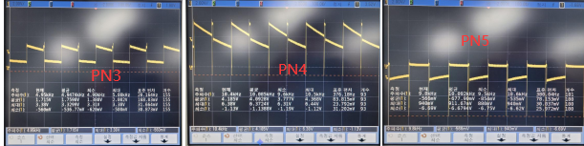
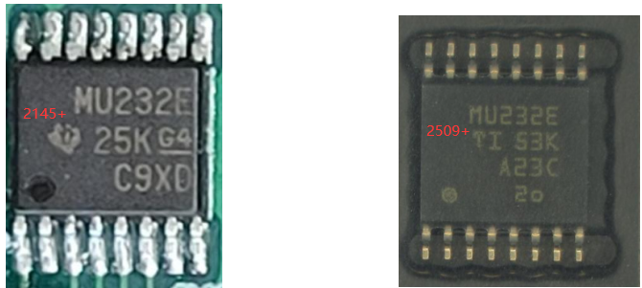

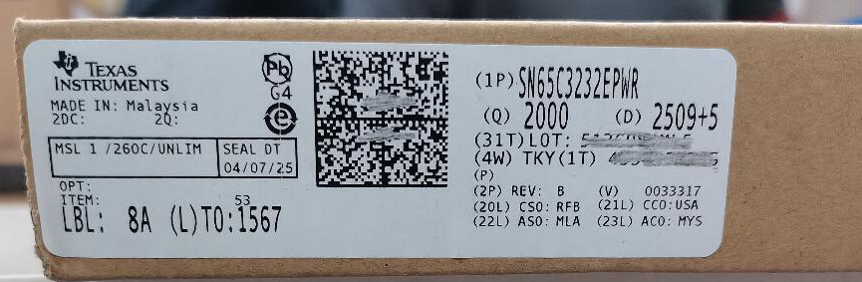

Second Issue: TPS5420DR
We purchased two versions of this part, MSL1 and MSL2.The datasheet is MSL 2, but we have not found documents explaining why is MSL1 . We sent the them to GETS for testing, where some issues were discovered,I really need u help!
1.the Xray and die marking are different, the changes are normal?
- 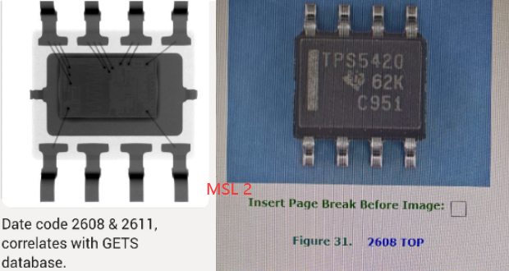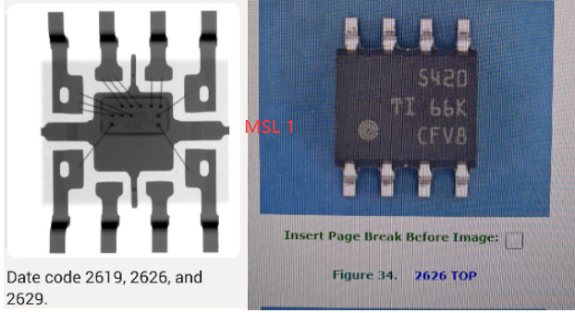

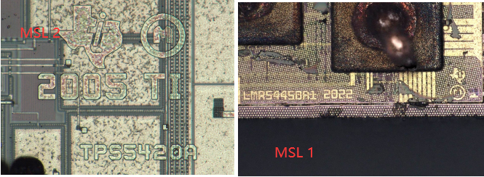

- During electrical testing, the MSL2 all performed normally, but those MSL 1 showed a short circuit. We sent the lab datasheet April 2026, but they still shorted at 12V. Could this be due to an incorrect setup, or is there a problem with the parts itself? Thx so much !
