When the CPU started，it can’t connect the USB HUB( TUSB8041) occasionally.

Restart the TUSB8041, sometimes it will work well, and sometimes the USB 2.0 will disconnect.

When the USB 2.0 disconnected, the CPU UART0 will print like this:

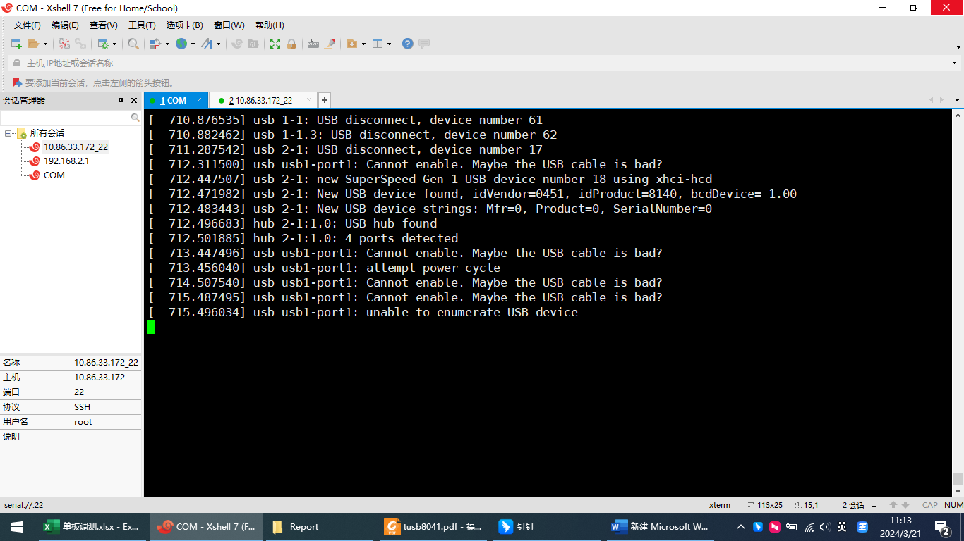

Compare above, when the USB 2.0 connected, the CPU UART0 will print like this:

