1. **HS200 mode and frequency = 50MHz:**

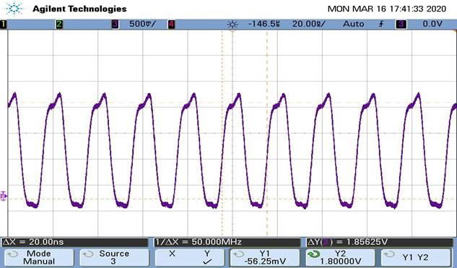

1. **HS200 mode and frequency = 100MHz:**

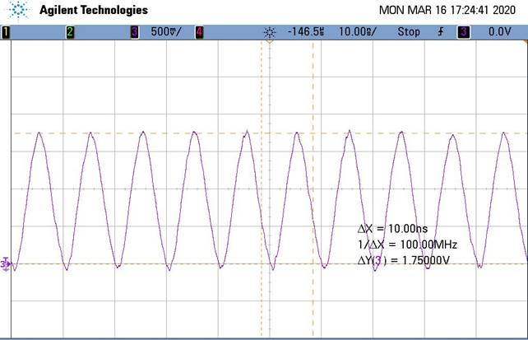

1. **HS200 mode and frequency = 200MHz:**

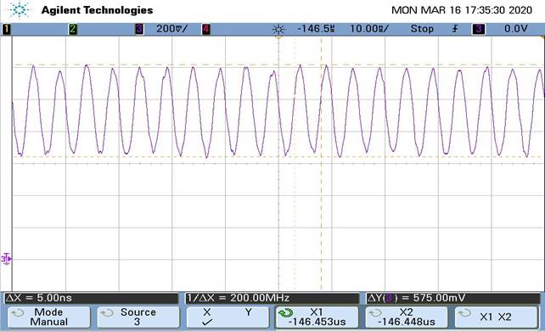

**We are observing a +ve offset voltage on clock signal when frequency is increased to 200MHz.**