1. Enter demo mode (select demo mode, press apply)

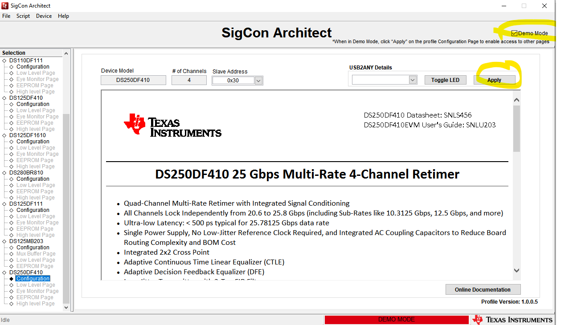

1. Select adapt mode 2 from high level page, apply to all channels.

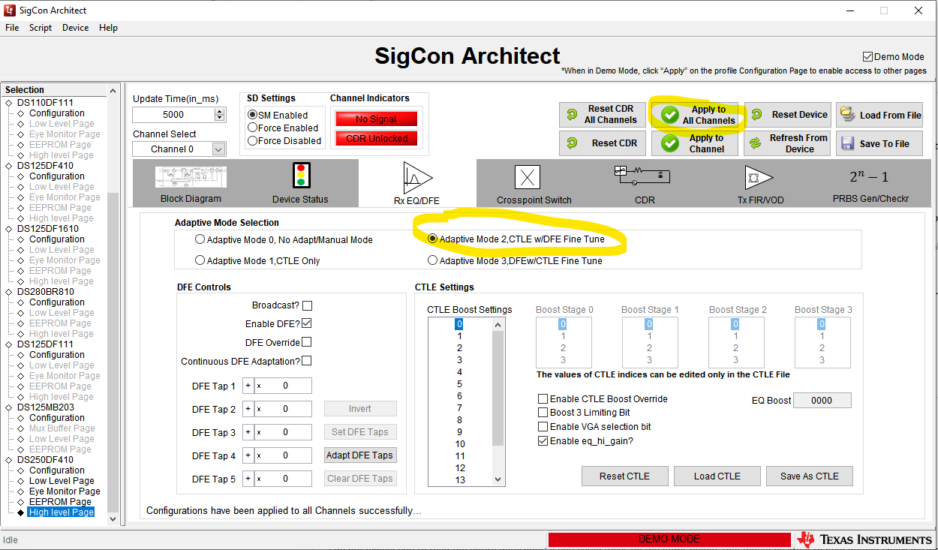

1. From EEPROM Page: Select EEPROM size, “Update slot from device”, then save EEPROM file (Write to EEPROM Hex)

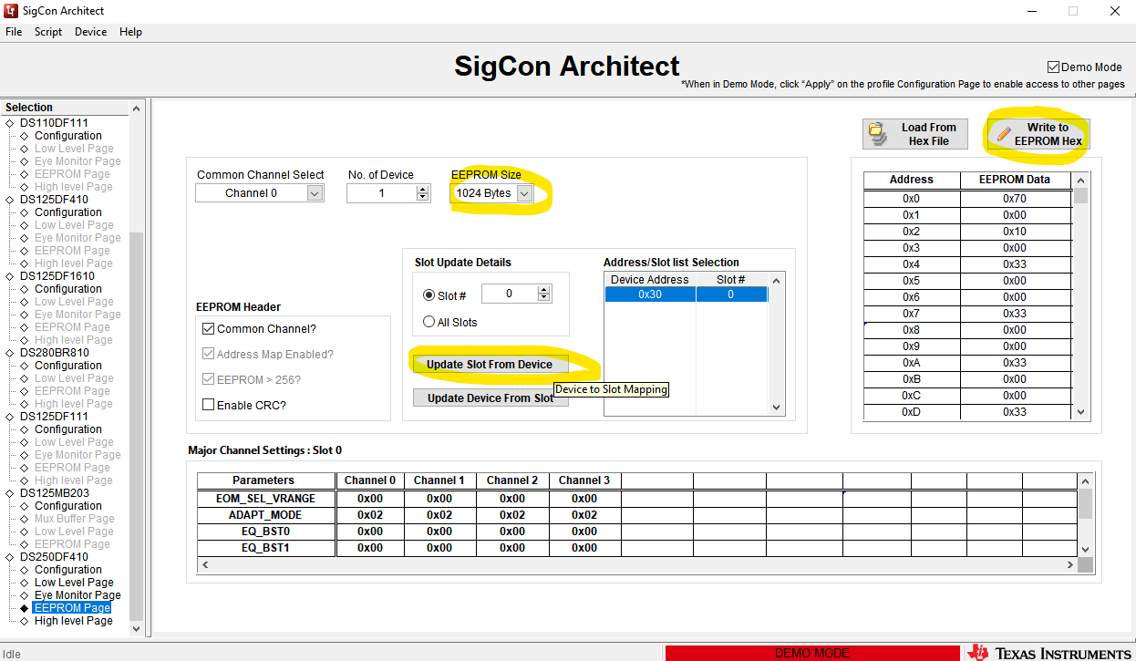

1. Modify hex file, add address header in location 0x44 (EEPROM offset 33d (0x21) ). EEPROM documentation found in <https://www.ti.com/lit/an/snla244/snla244.pdf>

Address header pointer location can be copied from default value at offset for 0x30.

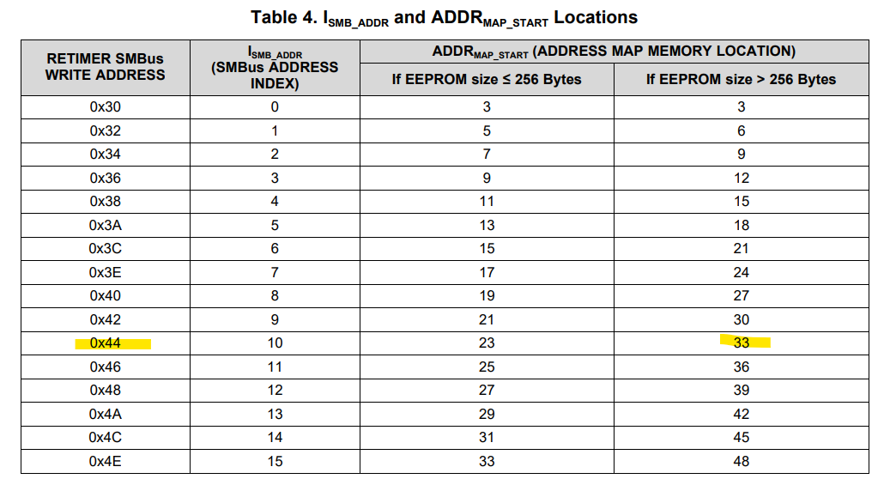

Before:

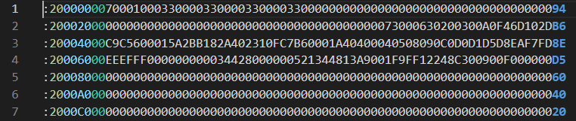

After:

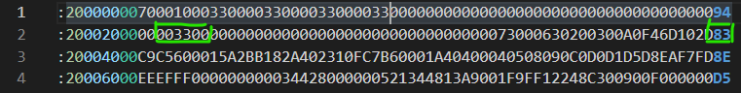

Note: CRC also must be updated after modifying address map header