1.mkdir ql-ol-kernel/include/dt-bindings/net

2 cp ti-dp83867.h ql-ol-kernel/include/dt-bindings/net/

3 cp dp83867.c  ql-ol-kernel/drivers/net/phy/

4 modify ql-ol-kernel/drivers/net/phy/Makefile   add: obj-m += dp83867.o

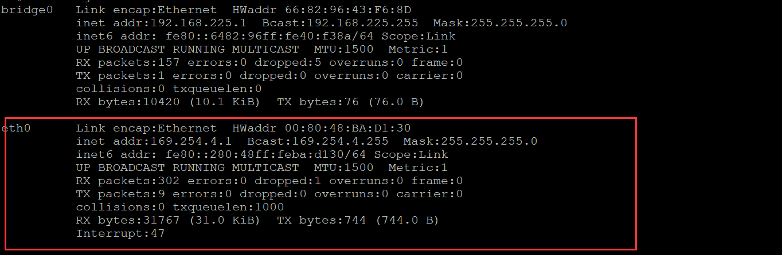

**Modify /etc/init.d/start_emac_le    add line:**

**insmod $MODULE_BASE/net/phy/dp83867.ko**

**Execute   command    /etc/init.d/start_emac_le  start**

**Note that before executing this script, it is necessary to check the demo board with the network cable. I am not sure whether the hardware wiring problem or the software configuration problem occurs?**

**Ifconfig**

brctl delif bridge0 eth0

ifconfig eth0 10.88.107.199 netmask 255.255.255.0

route add default gw 10.88.107.1

ping 180.101.49.12

