1. I want to daisy chain the [TPS65982](http://www.ti.com/product/TPS65982), but the datasheet is not clear about it: How many can you daisy chain?

The datasheet as well as the FW users guide states => “Currently the TPS65982 firmware only supports 2 device (1 primary + 1 secondary) systems”. This info can be found right next to **UART Download Process flow diagram** found in both 82 datasheet as well as FW users guide SLVUAH7B.

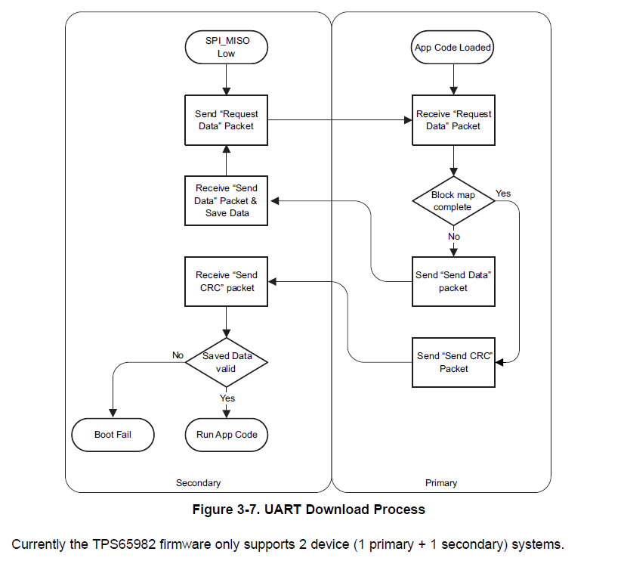

2. And how? I am guessing TX of the 'master' on the RX on the slave and so on.

This should be correct. TX connects to RX. I cannot find in the datasheet where it talks about it being RX during POR.

3. In daisy chain, should ever device boot at the same time to load the firmware?

From the 82 datasheet screenshot below the secondary will load the app FW right after the flash loads and or the primary boots up (this cannot be delayed).

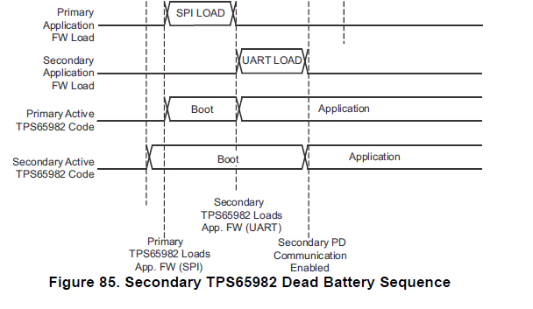

5&6. Configuration Data Sets:   
I can select 6 configuration sets, This are sets I can choose by a GPIO to load when the system boots? Is this the same as the configurations seen in slvuaf8c (page 13) ? But that are 16 different configurations... How is this been done? Or is this something else

Page 13 is unrelated. This field is for implementing different config’s during run time for a specific alt mode entry or register R/W.

You are correct -> slvuaf8a document does not cover ‘Configuration Data Sets’ as seen in version 2.15 of the tool. I will clear this up and update the user guide.

7. Where can I find the project file for the EVM module instead of the binary?

You can go to ‘Project<Save Project’ at the top menu of the tool. Or you can ‘load project’ and select a template of your choice.