Receiver Return Loss
Application Version : 3.2.8.28
3ns to 5ns
<1.4ns
<500ps
<5%
<500ps(±250ps)
<1.4ns
<5%
<500ps
3ns to 5ns
3ns to 5ns
3ns to 5ns
0.98 to 1.02
-950mV to -1050mV
950mV to1050mV
Fit the template
Transmitter Return Loss
Distortion (Duty Cycle)
Transmit Jitter(-ve)
Transmit Jitter(+ve)
Overshoot(-ve)
Overshoot(+ve)
Rise/Fall Symmetry(-ve)
Rise/Fall Symmetry(+ve)
Fall Time(-ve)
Fall Time(+ve)
Rise Time(-ve)
Rise Time(+ve)
Amplitude Symmetry
Output Voltage (-Vout)
Output Voltage (+Vout)
AOI Template
Result
Measured Value
Spec. Range
Test
Time:
16:38:20
Test Report for 100Base-TX
Device ID :
Device Description :
Port ID :
Pass
Pass
996.6mV
-996.3mV
1.000
Pass
3.95ns
3.79ns
3.83ns
3.65ns
Pass
Pass
Pass
Pass
160ps
180ps
Pass
Pass
0.00%
0.01%
Pass
Pass
590ps
590ps
660ps
Not Available
Not Available
Pass
Fail
Pass
Pass
ANSI X3.263-1995: Annex J AOI Template
AOI Template Result :
Pass
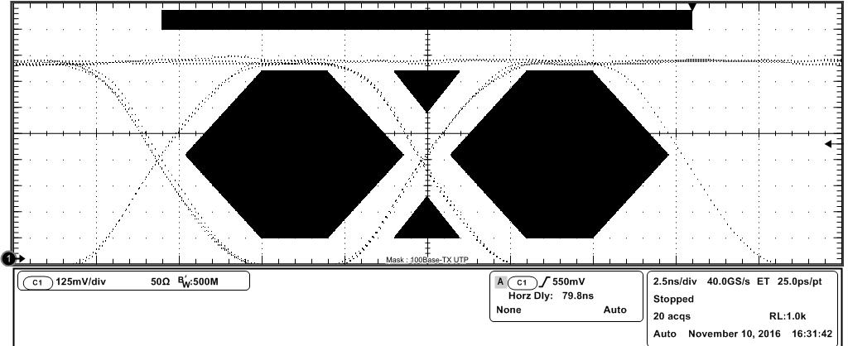
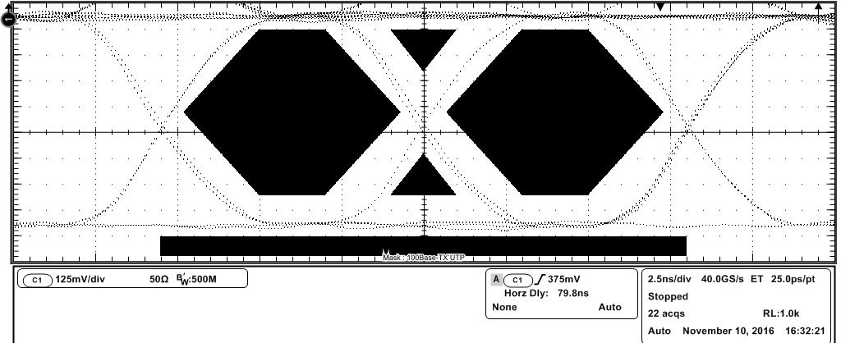
NOTE: Amplitude values are corrected for Baseline voltage
Spec Range : 950mV to 1050mV
Spec Range : -950mV to -1050mV
ANSI X.3.263-1995 : 9.1.2.2 Differential Output Voltage
Positive Amplitude(+Vout) : 996.6mV
Negative Amplitude(-Vout) : -996.3mV
Output Voltage(+Vout) Result : Pass
Output Voltage(-Vout) Result : Pass
Differential Output Voltage Result : Pass
Baseline(+ve) : -58.9mV
Baseline(-ve) : -69.8mV
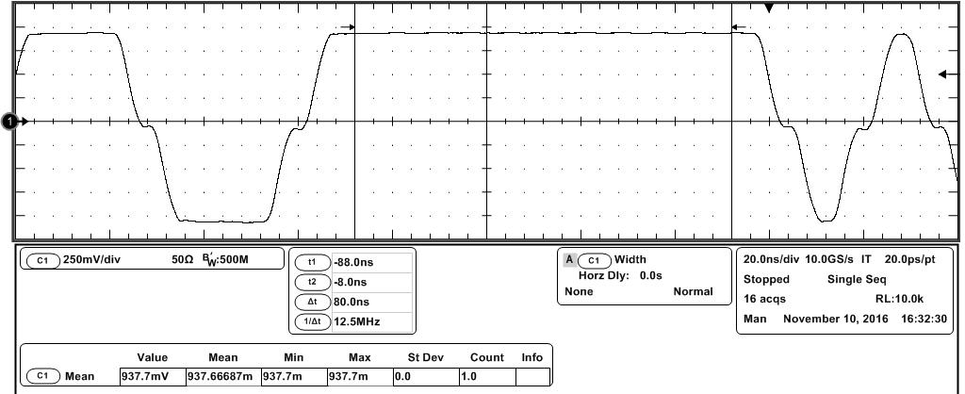
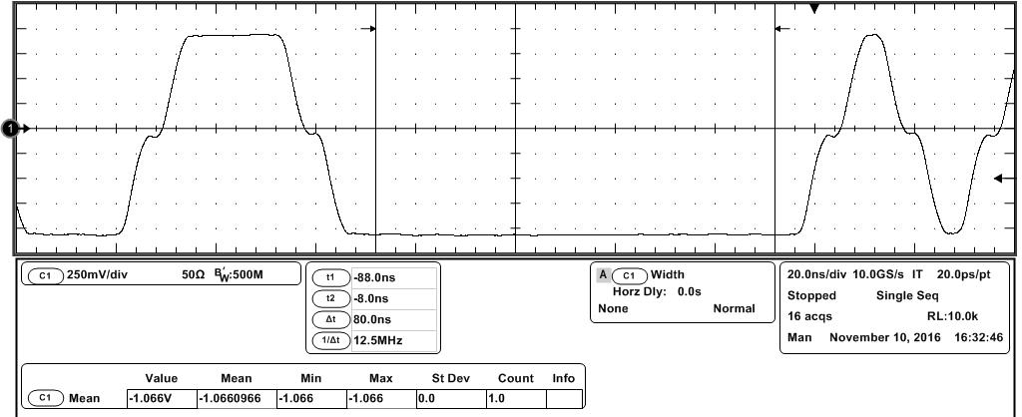
Spec Range: 0.98 to 1.02
ANSI X3.263-1995: 9.1.4 Signal Amplitude Symmetry
Amplitude Symmetry : 1.000
Amplitude Symmetry Result : Pass
Spec Range: 3ns to 5ns
ANSI X3.263-1995: 9.1.6 Rise Time
Rise Time(+ve) : 3.95ns
Rise Time Test Result : Pass
Rise Time(+ve) Result : Pass
Spec Range: 3ns to 5ns
Rise Time(-ve) : 3.83ns
Rise Time(-ve) Result : Pass
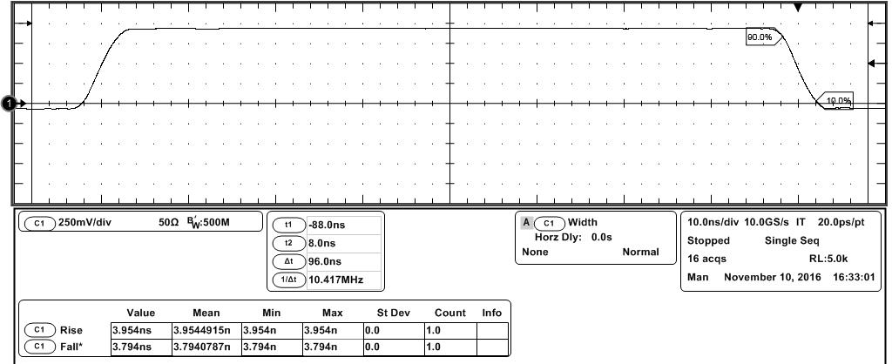
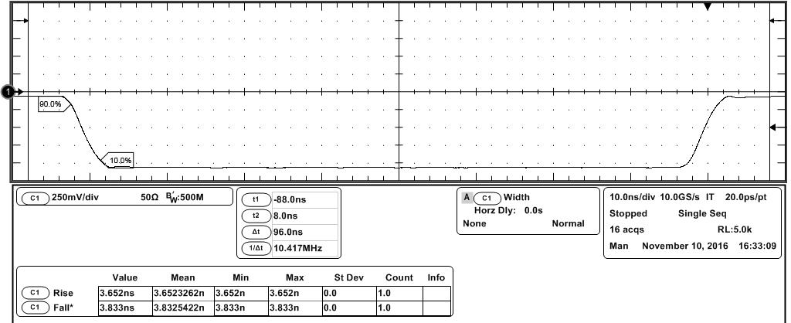
Spec Range: 3ns to 5ns
Spec Range: 3ns to 5ns
ANSI X3.263-1995: 9.1.6 Fall Time
Fall Time(+ve) : 3.79ns
Fall Time(-ve) : 3.65ns
Fall Time Test Result : Pass
Fall Time(+ve) Result : Pass
Fall Time(-ve) Result : Pass
Spec Range: <500ps
Spec Range: <500ps
ANSI X3.263-1995: 9.1.6 Rise Fall Symmetry
Rise/Fall Symmetry Result : Pass
Rise/Fall Symmetry(+ve) : 160ps
Rise/Fall Symmetry(-ve) : 180ps
Rise/Fall Symmetry(+ve) Result : Pass
Rise/Fall Symmetry(-ve) Result : Pass
Rise/Fall Symmetry(Max-Min) : 302ps
Spec Range: <5%
Spec Range: <5%
ANSI X3.263-1995: 9.1.3 Waveform Overshoot
Overshoot(+ve) : 0.00%
Overshoot(-ve) : 0.01%
Waveform Overshoot Test Results : Pass
Overshoot(+ve) Result : Pass
Overshoot(-ve) Result : Pass
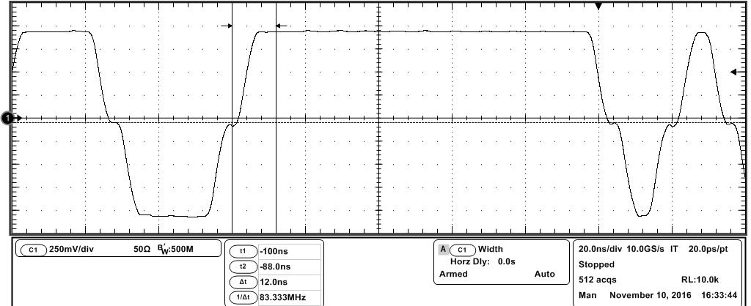
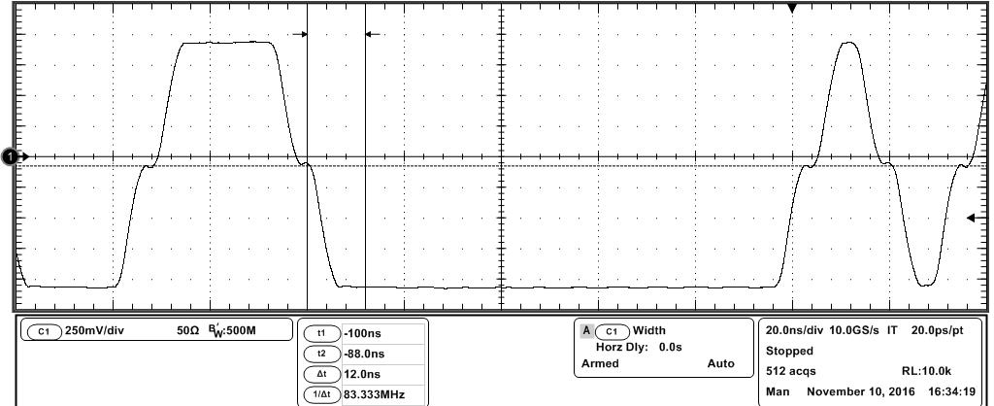
Spec Range: <1.4ns
Spec Range: <1.4ns
ANSI X3.263-1995: 9.1.9 Transmit Jitter
Transmit Jitter(-ve) : 590ps
Transmit Jitter(+ve) : 590ps
Transmit Jitter(-ve) Result : Pass
Transmit Jitter(+ve) Result : Pass
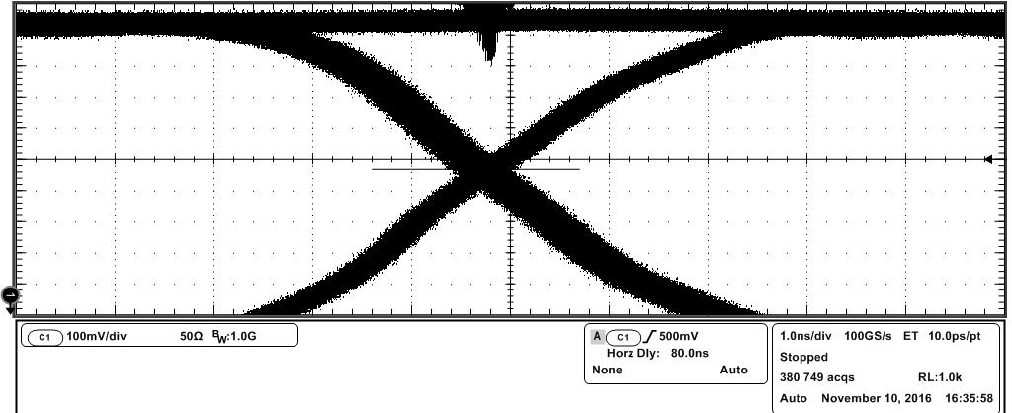
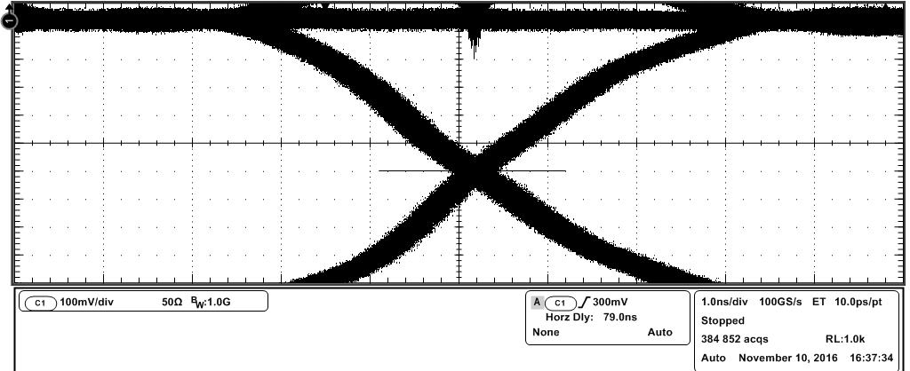
Spec Range: <500ps(+/-250ps)
ANSI X3.263-1995: 9.1.8 Distortion(Duty Cycle)
Distortion(Duty Cycle) : 660ps
Distortion(Duty Cycle) Result :
Fail
T1 = 20.0ps T2 = 460ps
T3 = 660ps T4 = 480ps
T5 = 200ps T6 = 180ps
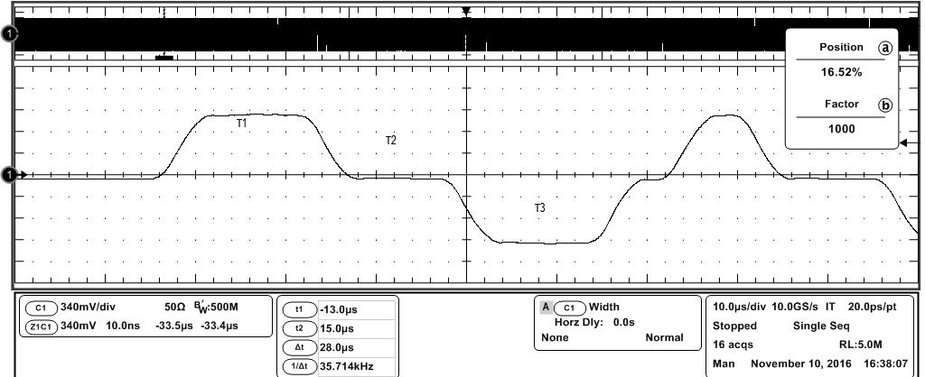
-10.00dB
-10.00dB
-9.97dB
-11.56dB
-13.50dB
-16.00dB
-16.00dB
-16.00dB
-16.00dB
60 MHz
70 MHz
80 MHz
50 MHz
40 MHz
30 MHz
20 MHz
10 MHz
1 MHz
Measured Value
Spec. Value
Frequency
ANSI X3.263-1995: 9.1.5 Transmitter Return Loss
Not Available
Not Available
Not Available
Not Available
Not Available
Not Available
Not Available
Not Available
Not Available
Not Available
Result
Transmitter Return Loss Result : Not Available
Not Available
-16.00dB
-16.00dB
-16.00dB
-16.00dB
-13.50dB
-11.56dB
-9.97dB
-10.00dB
-10.00dB
Not Available
Not Available
Not Available
Not Available
Not Available
Not Available
Not Available
Not Available
Not Available
60 MHz
70 MHz
80 MHz
50 MHz
40 MHz
30 MHz
20 MHz
10 MHz
1 MHz
Result
Measured Value
Spec. Value
Frequency
ANSI X3.263-1995: 9.1.5 Receiver Return Loss
Not Available
Receiver Return Loss Result : Not Available
Not Available

