Receiver Return Loss
Application Version : 3.2.8.28
3ns to 5ns
<1.4ns
<500ps
<5%
<500ps(±250ps)
<1.4ns
<5%
<500ps
3ns to 5ns
3ns to 5ns
3ns to 5ns
0.98 to 1.02
-950mV to -1050mV
950mV to1050mV
Fit the template
Transmitter Return Loss
Distortion (Duty Cycle)
Transmit Jitter(-ve)
Transmit Jitter(+ve)
Overshoot(-ve)
Overshoot(+ve)
Rise/Fall Symmetry(-ve)
Rise/Fall Symmetry(+ve)
Fall Time(-ve)
Fall Time(+ve)
Rise Time(-ve)
Rise Time(+ve)
Amplitude Symmetry
Output Voltage (-Vout)
Output Voltage (+Vout)
AOI Template
Result
Measured Value
Spec. Range
Test
Time:
16:49:43
Test Report for 100Base-TX
Device ID :
Device Description :
Port ID :
Pass
Pass
1002.4mV
-1004.5mV
0.998
Pass
3.87ns
3.78ns
3.76ns
3.67ns
Pass
Pass
Pass
Pass
88.8ps
88.8ps
Pass
Pass
0.00%
0.00%
Pass
Pass
600ps
480ps
600ps
Not Available
Not Available
Pass
Fail
Pass
Pass
ANSI X3.263-1995: Annex J AOI Template
AOI Template Result :
Pass
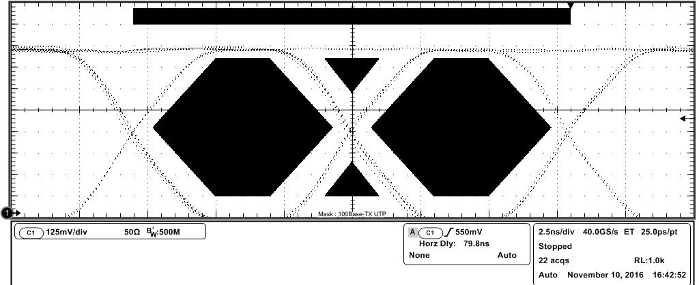
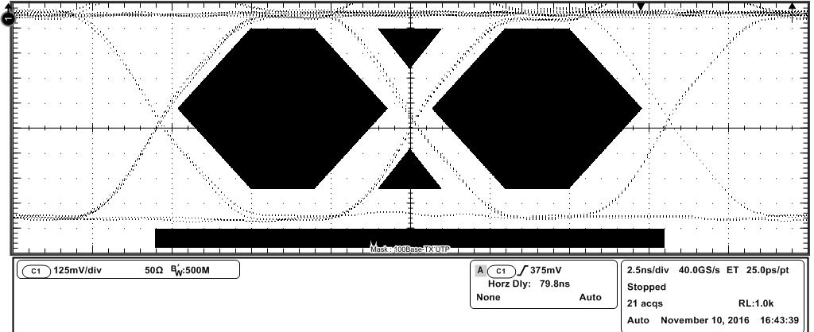
NOTE: Amplitude values are corrected for Baseline voltage
Spec Range : 950mV to 1050mV
Spec Range : -950mV to -1050mV
ANSI X.3.263-1995 : 9.1.2.2 Differential Output Voltage
Positive Amplitude(+Vout) : 1002.4mV
Negative Amplitude(-Vout) : -1004.5mV
Output Voltage(+Vout) Result : Pass
Output Voltage(-Vout) Result : Pass
Differential Output Voltage Result : Pass
Baseline(+ve) : -53.1mV
Baseline(-ve) : -63.1mV
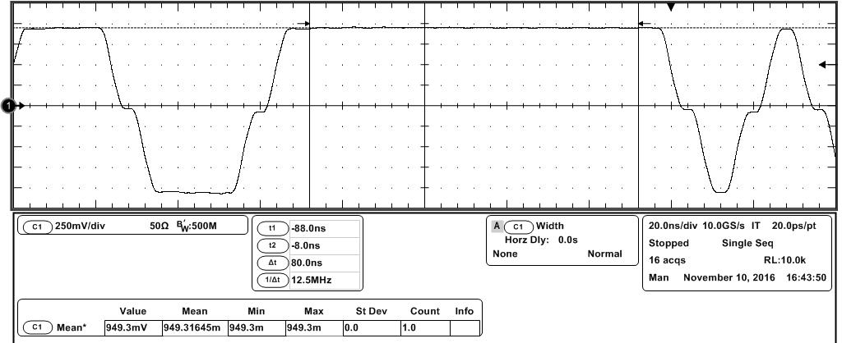
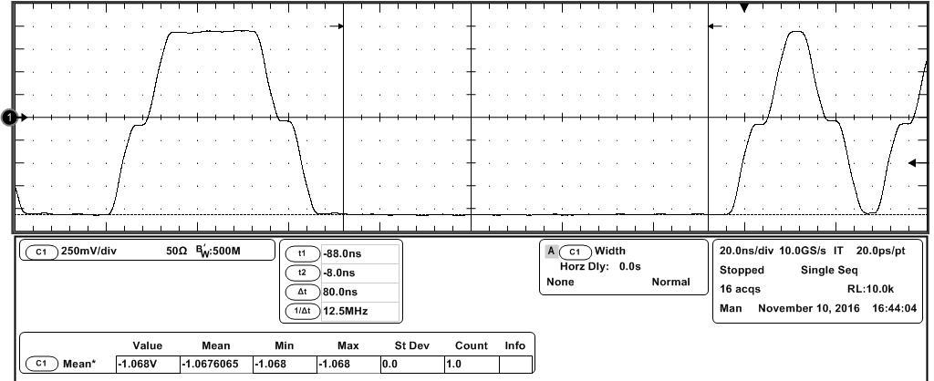
Spec Range: 0.98 to 1.02
ANSI X3.263-1995: 9.1.4 Signal Amplitude Symmetry
Amplitude Symmetry : 0.998
Amplitude Symmetry Result : Pass
Spec Range: 3ns to 5ns
ANSI X3.263-1995: 9.1.6 Rise Time
Rise Time(+ve) : 3.87ns
Rise Time Test Result : Pass
Rise Time(+ve) Result : Pass
Spec Range: 3ns to 5ns
Rise Time(-ve) : 3.76ns
Rise Time(-ve) Result : Pass
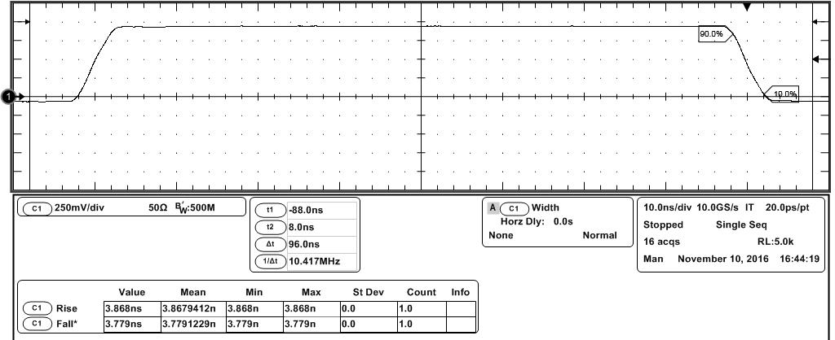
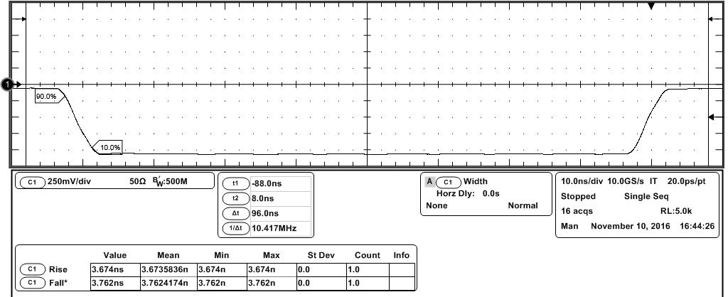
Spec Range: 3ns to 5ns
Spec Range: 3ns to 5ns
ANSI X3.263-1995: 9.1.6 Fall Time
Fall Time(+ve) : 3.78ns
Fall Time(-ve) : 3.67ns
Fall Time Test Result : Pass
Fall Time(+ve) Result : Pass
Fall Time(-ve) Result : Pass
Spec Range: <500ps
Spec Range: <500ps
ANSI X3.263-1995: 9.1.6 Rise Fall Symmetry
Rise/Fall Symmetry Result : Pass
Rise/Fall Symmetry(+ve) : 88.8ps
Rise/Fall Symmetry(-ve) : 88.8ps
Rise/Fall Symmetry(+ve) Result : Pass
Rise/Fall Symmetry(-ve) Result : Pass
Rise/Fall Symmetry(Max-Min) : 194ps
Spec Range: <5%
Spec Range: <5%
ANSI X3.263-1995: 9.1.3 Waveform Overshoot
Overshoot(+ve) : 0.00%
Overshoot(-ve) : 0.00%
Waveform Overshoot Test Results : Pass
Overshoot(+ve) Result : Pass
Overshoot(-ve) Result : Pass
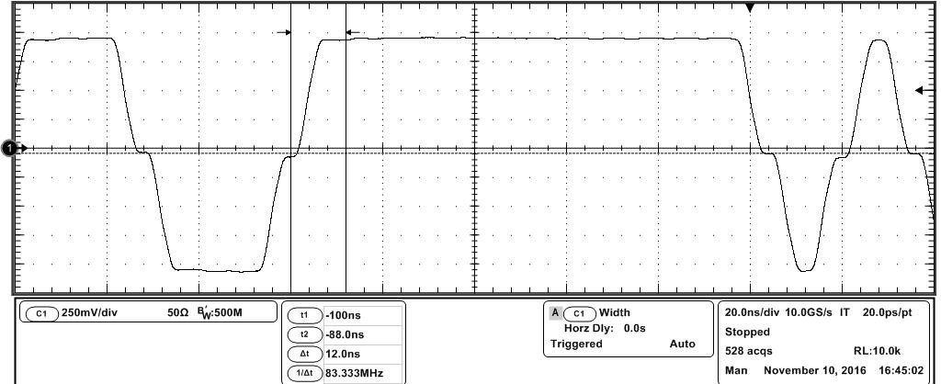
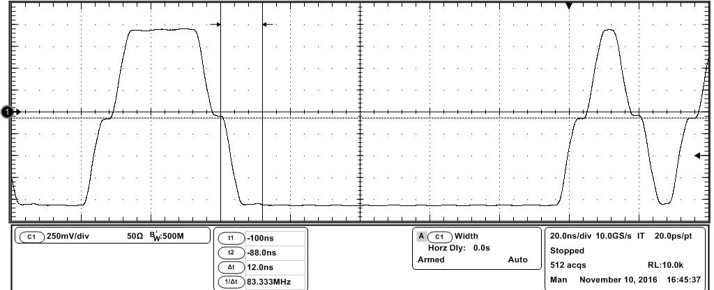
Spec Range: <1.4ns
Spec Range: <1.4ns
ANSI X3.263-1995: 9.1.9 Transmit Jitter
Transmit Jitter(-ve) : 480ps
Transmit Jitter(+ve) : 600ps
Transmit Jitter(-ve) Result : Pass
Transmit Jitter(+ve) Result : Pass
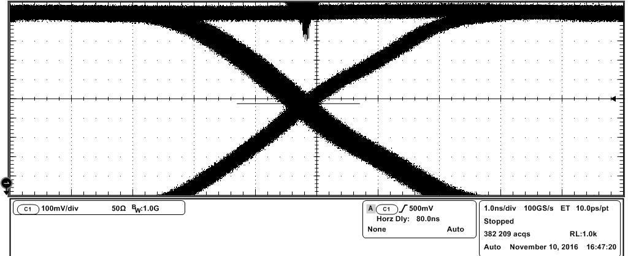
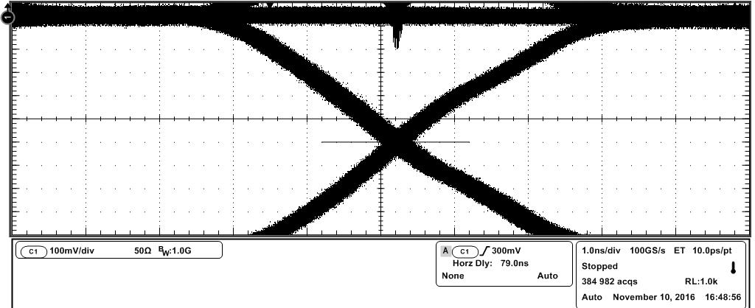
Spec Range: <500ps(+/-250ps)
ANSI X3.263-1995: 9.1.8 Distortion(Duty Cycle)
Distortion(Duty Cycle) : 600ps
Distortion(Duty Cycle) Result :
Fail
T1 = 40.0ps T2 = 340ps
T3 = 600ps T4 = 300ps
T5 = 260ps T6 = 300ps
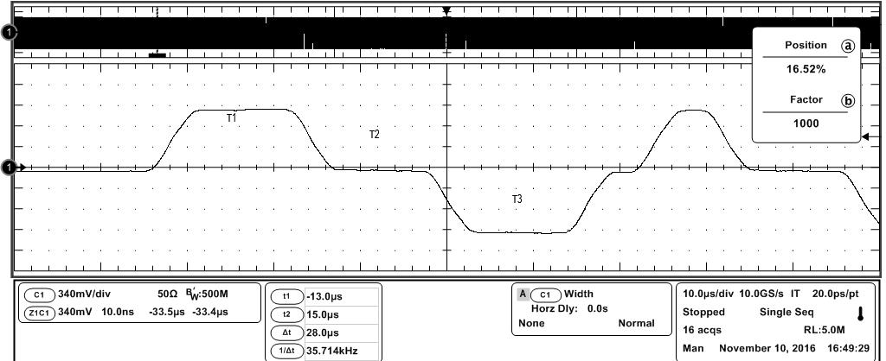
-10.00dB
-10.00dB
-9.97dB
-11.56dB
-13.50dB
-16.00dB
-16.00dB
-16.00dB
-16.00dB
60 MHz
70 MHz
80 MHz
50 MHz
40 MHz
30 MHz
20 MHz
10 MHz
1 MHz
Measured Value
Spec. Value
Frequency
ANSI X3.263-1995: 9.1.5 Transmitter Return Loss
Not Available
Not Available
Not Available
Not Available
Not Available
Not Available
Not Available
Not Available
Not Available
Not Available
Result
Transmitter Return Loss Result : Not Available
Not Available
-16.00dB
-16.00dB
-16.00dB
-16.00dB
-13.50dB
-11.56dB
-9.97dB
-10.00dB
-10.00dB
Not Available
Not Available
Not Available
Not Available
Not Available
Not Available
Not Available
Not Available
Not Available
60 MHz
70 MHz
80 MHz
50 MHz
40 MHz
30 MHz
20 MHz
10 MHz
1 MHz
Result
Measured Value
Spec. Value
Frequency
ANSI X3.263-1995: 9.1.5 Receiver Return Loss
Not Available
Receiver Return Loss Result : Not Available
Not Available

