Michael Steffes,
Sept 17, 2019

OPA209 BW investigation using 2011 TINA model in the V11 library. The TI product folder did not seem to have a TINA model? The Aol curve shows a projected 1 pole GBP of 23.7Mhz. This one is a little odd with what looks like a higher frequency zero/pole pair. You can see that from the phase going back up a bit.
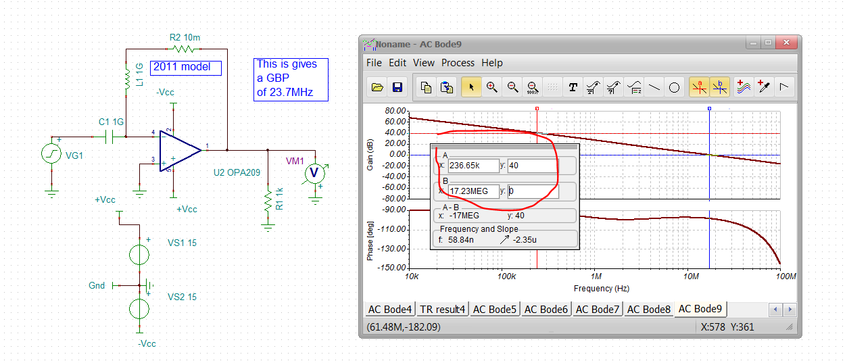

Running a closed loop gain of 1 gives 22.8Mhz (quite a bit more than the simple 18Mhz from the PDS GBW product)
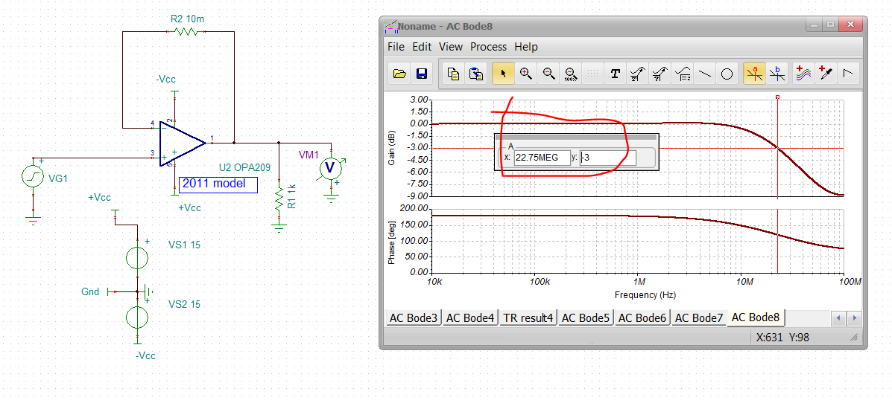
The actual Aol = 0dB frequency is about 17.23MHz, but due to the phase shift there, the closed loop SSBW extends out beyond the expected frequency to 22.8Mhz.
Let me do the gain of 1 LG a little more carefully, including the 6pF input capacitance. This will only have an effect if the model has an open loop output impedance, Yes, 17.3MHz with 80deg phase margin – V_LG is rotated to show phase margin directly.
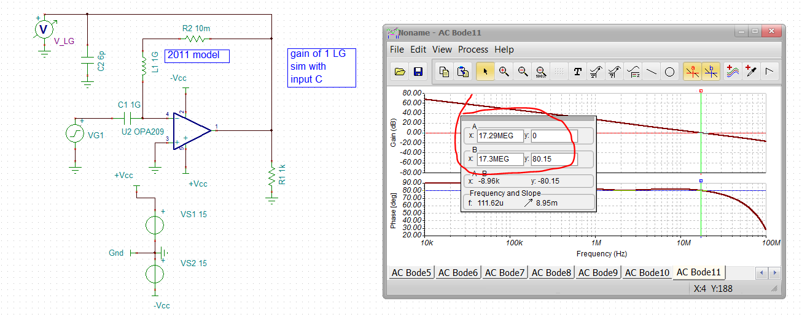

Now a big simplification used often is the closed loop SSBW is simply the LG=0dB frequency (or GBP divided by noise gain). That actually never was true if the phase margin is <90deg. There is a phase margin dependent LG=0dB to F-3dB BW multiplier for SSBW. For 80deg, that is a 1.2X in this 2nd order analysis. That gets us to 20.8MHz F-3dB, still less than the simulated 22.8Mhz, but closer – likely the output impedance is not simple R, but more complex. Here is the full plot for a 2nd order LG situation.
