オペアンプ問い合わせ資料

1. **Result of LV7321**

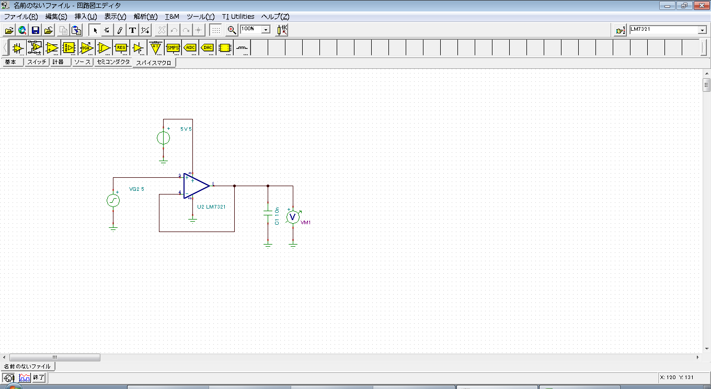

Fig１．schematic

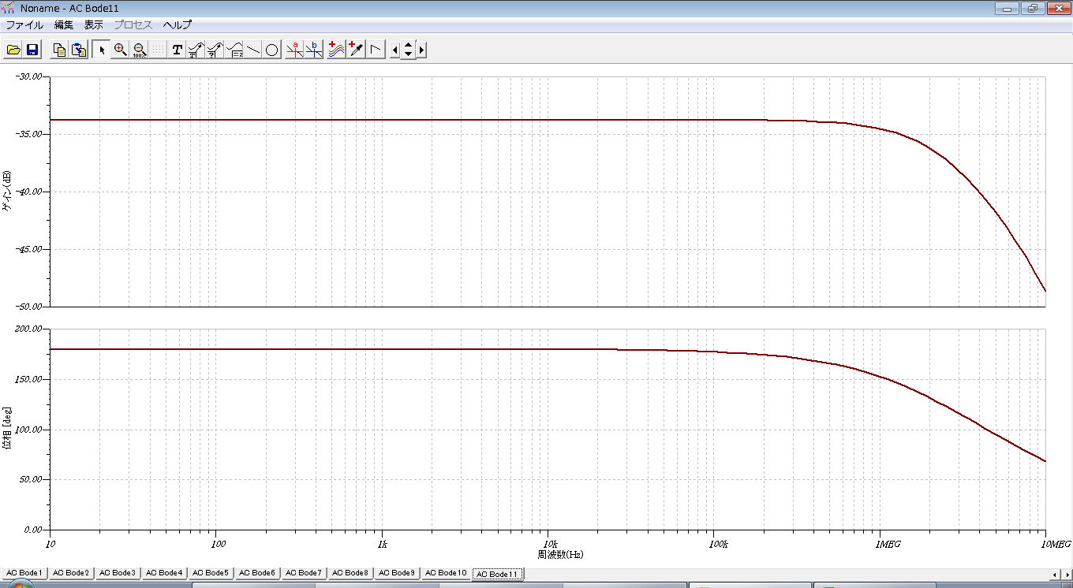

Fig２．Simulation result

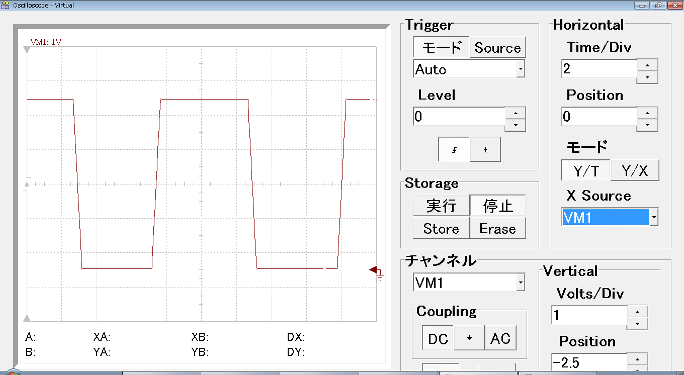

Fig３．Output waveform

1. **Result of LMV321**

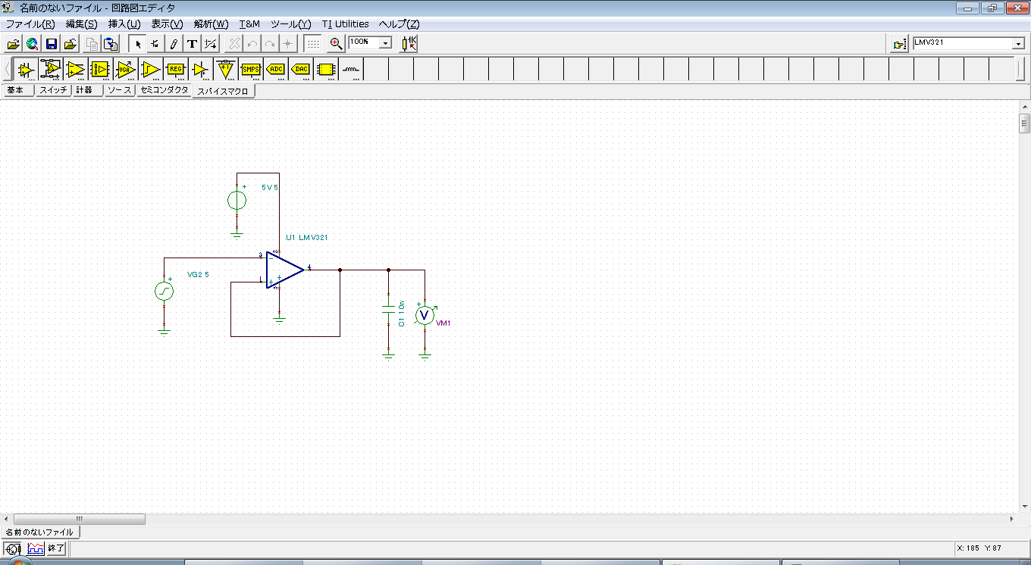

Fig４．schematic

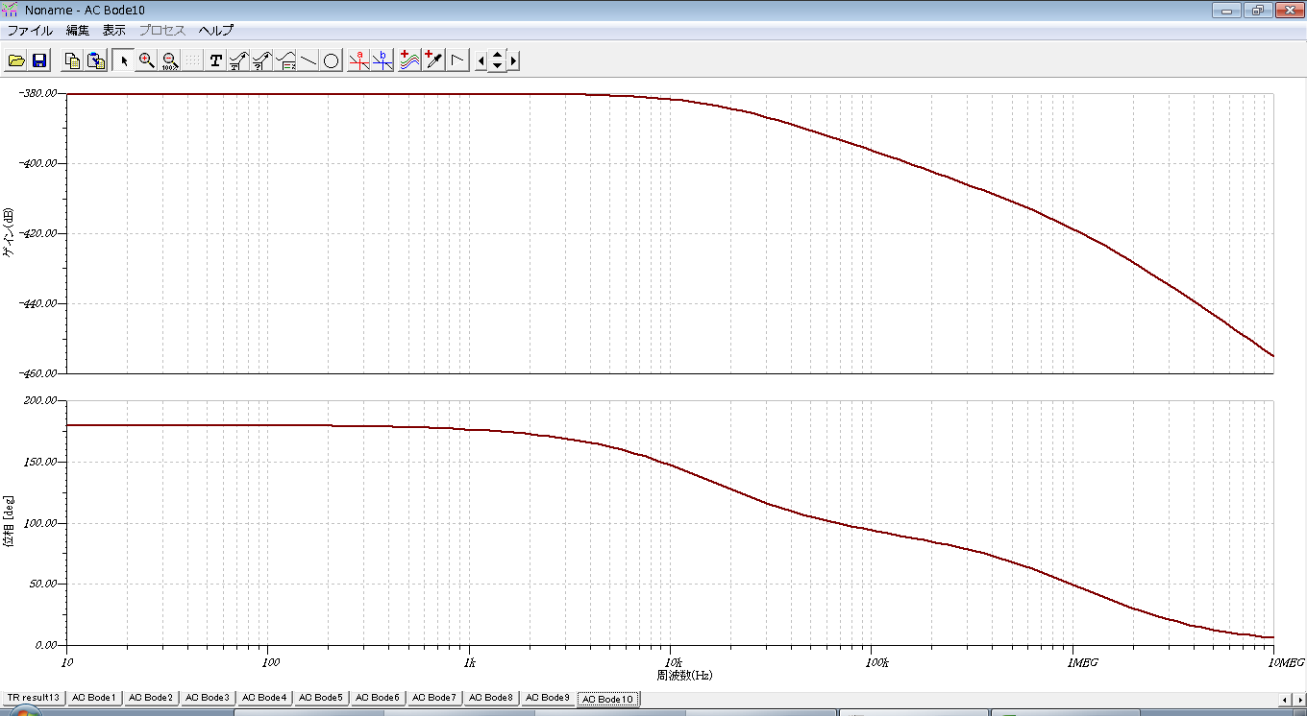

Fig５．Simulation result

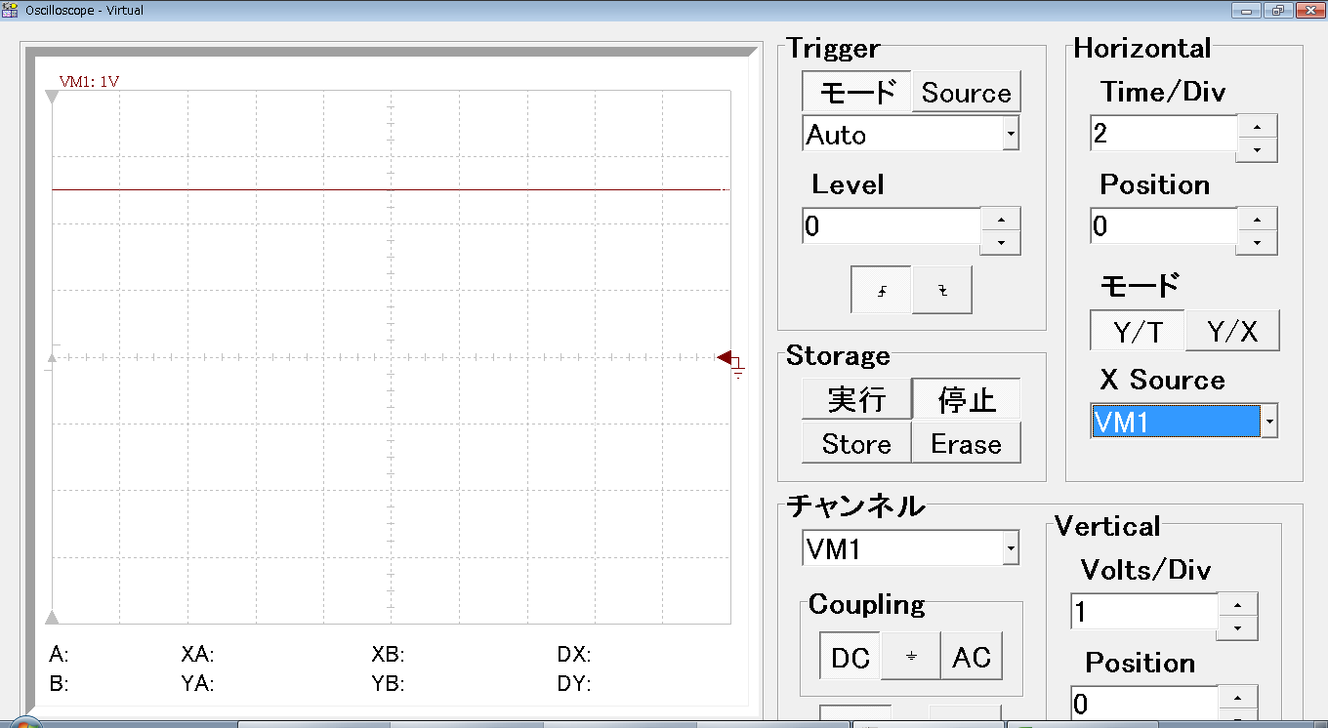

Fig６．Output waveform

1. **Result of OPA830**

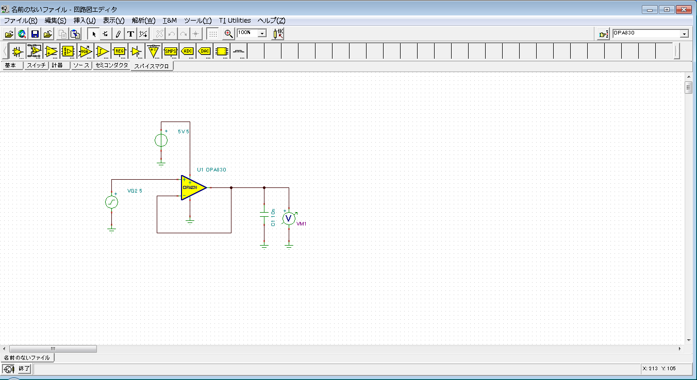

Fig７．schematic

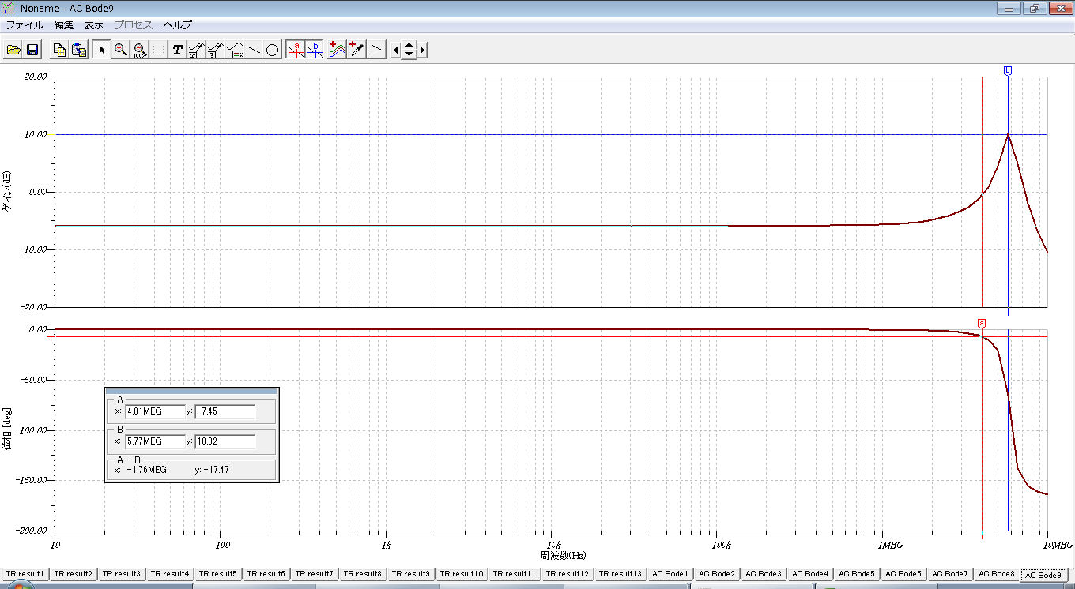

Fig８．Simulation result

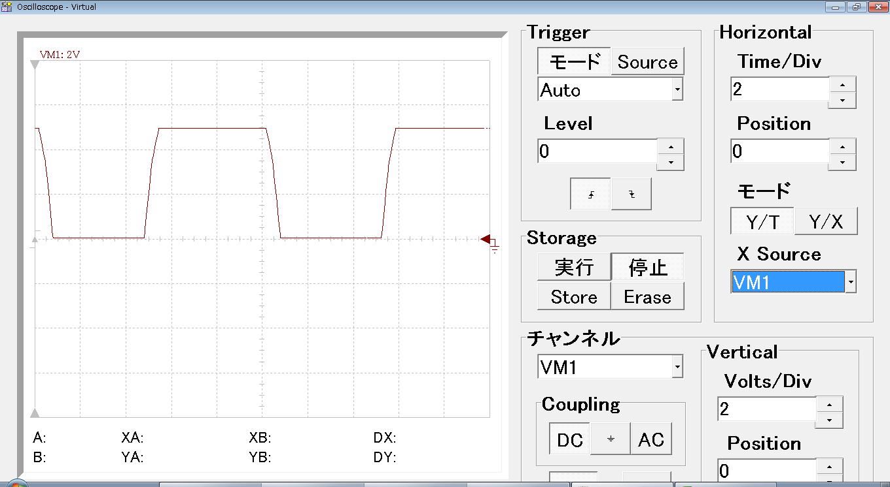

Fig９．Output waveform