25kHz 4th order BP suggestions
Updated with more AM options at the bottom
Michael Steffes, 4/17/2019
2.6kHz BW, Bessel use the TLC2272
From an alternate design tool, this looks pretty good – used 0.5% R’s and 1% C’s in a 400case monte Carlo
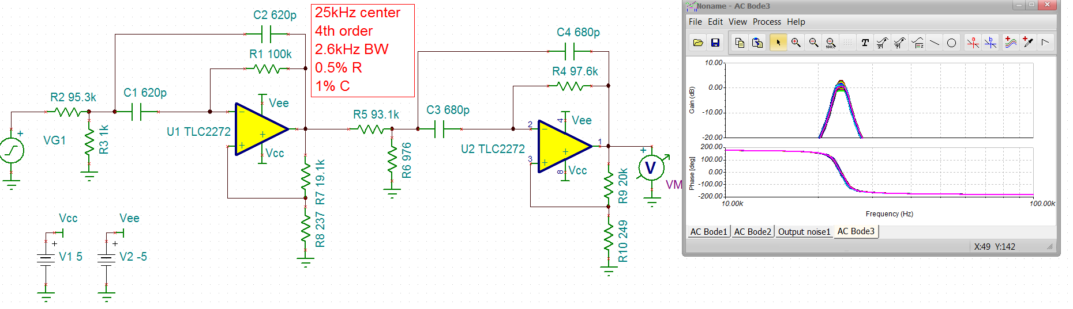

These always seem to be really noisy,
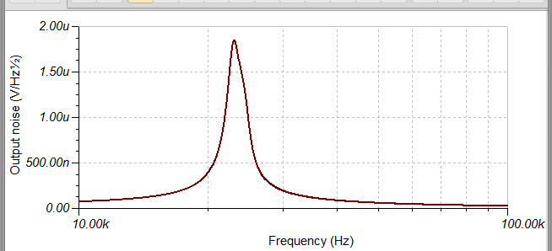

So Filterpro started working again, here is what it says, need about 20MHz according to this tool – the tools I used was saying recommended 4MHz.

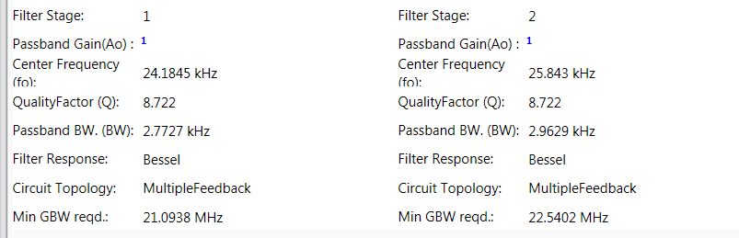
Will go on from here and try the Ackerberg-Mossberg approach, After a few iterations on each stage, I get to this solution using lower resistor, higher C to get lower noise. This is a very heuristic design flow where I also discovered some R’s that do not interact with the filter – the lower one from the input is DC bias not part of filter and the one across the last stage inputs is just increasing noise gain there, no filter impact – get rid of it.
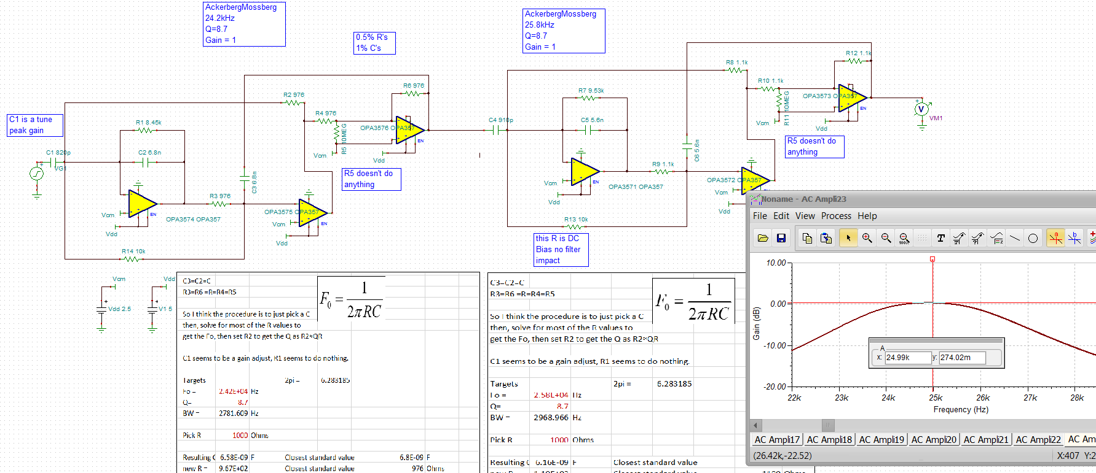
I had built this with 0.5% uniform dist. On the R’s and 1% uniform on the C’s. run a Monte Carlo 200cases now. I built this from that earlier OPA357 design, still need to drop in the right dual op amp on +/-5V supplies. Don’t need too much of a dual op amp – maybe >3MHz, +/-5V supplies Vos<10mV SR>0.5V/usec – Selguide does not give me much, but the RC4558 does come back – and that dual is only $0.10/each. Yes, using the OPA357 this does look really good spread wise –

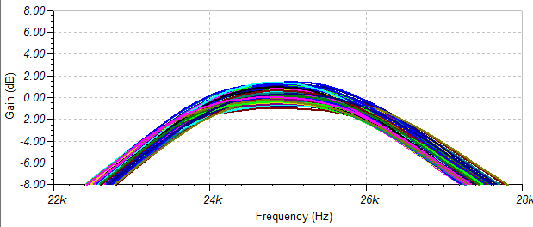
Here it is with the 3MHz RC4558 – about the same spread but shifted down 1dB on peak gain, not bad for a $0.10 dual op amp
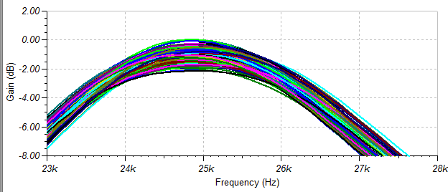

The RC4558 might be too slow, the OPA1678 looks perfect for this and only $0.25 – spread and centering very good using that in the sim
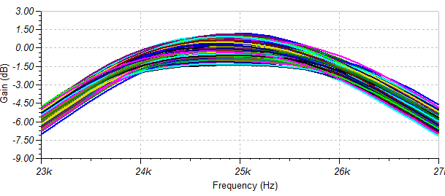
Now run an output spot noise using the OPA1678 solution. This is quite a bit lower than that earlier MFB two stage design
