Testing the old against the new LMP7721 TINA models,
Michael Steffes, 3/15/2019
The TINA library had a 2008 NSM model, ckt based it looked like, PA recently updated this to their current GWL template - from the LG phase margin, lets see what changed – this would be the Aol, Zol, and input capacitance.
First test the open loop Zol, for the NSM model, starts out at about 10kohm then goes flat (resistive) at 123ohm – I think that was the RRout model for quite some time, newer models add a resonance at higher F peaking this up
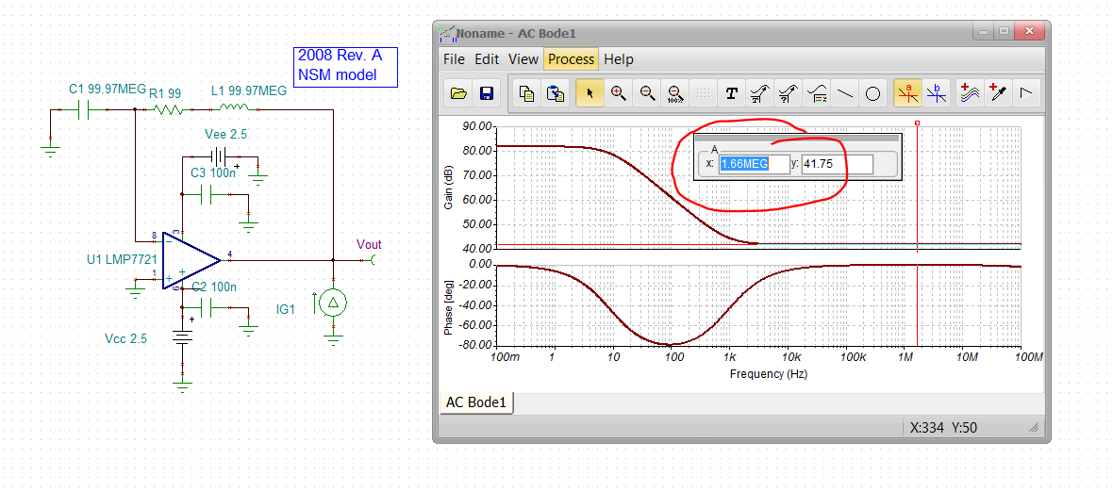

Now the new TI model, pretty similar but different low and high levels, This starts out at 1kohm and goes to 20ohm.
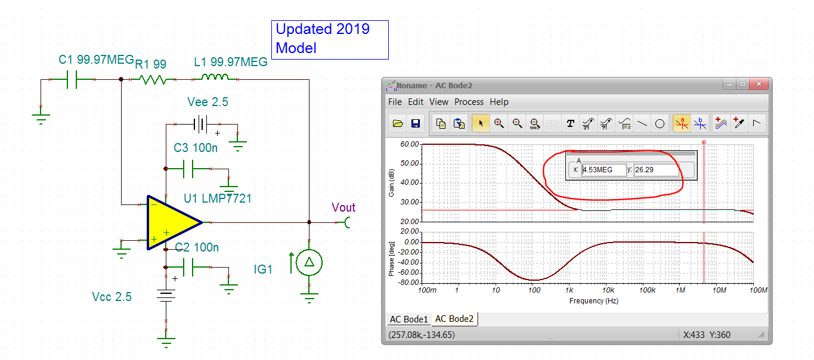
Now try a no load Aol, the Vout will read phase margin directly, This is a 22Mhz GBP with a Aol=0dB of 18Mhz. The data sheet says it’s a 17MHz GBP in the spec lines, which is probably the Aol = 0dB point, slight error. Oh, and they are doing the plot with cap loads so that will pull I back some.
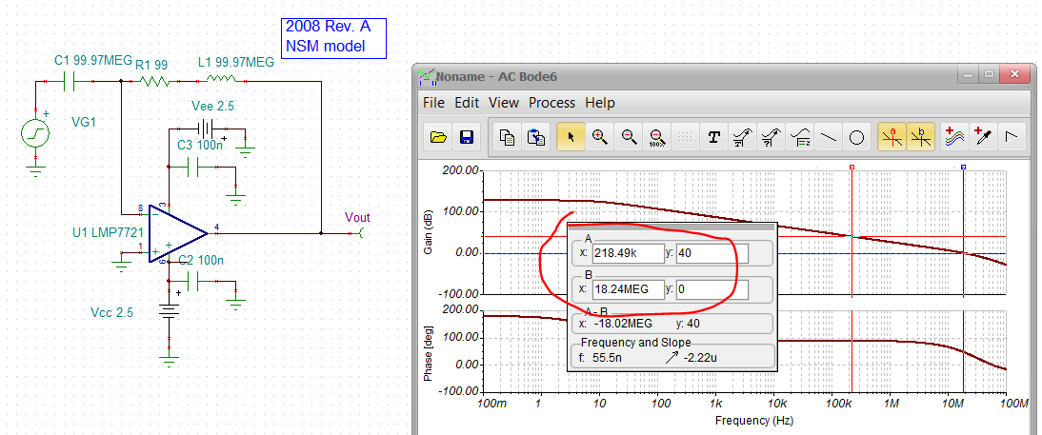
The no load unity gain phase margin would be 55deg.
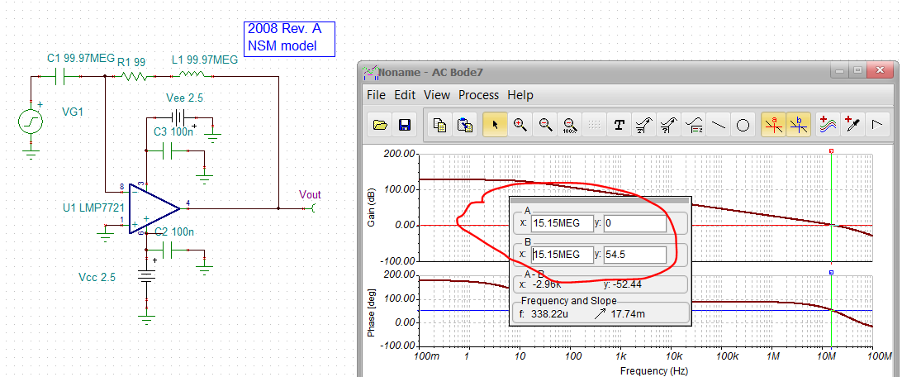

Now try the new model,
So this is a 19Mhz GBP with a Aol = 0dB at 16.8MHz. That looks a little closer to the reported 17Mhz GBP in the PDS.
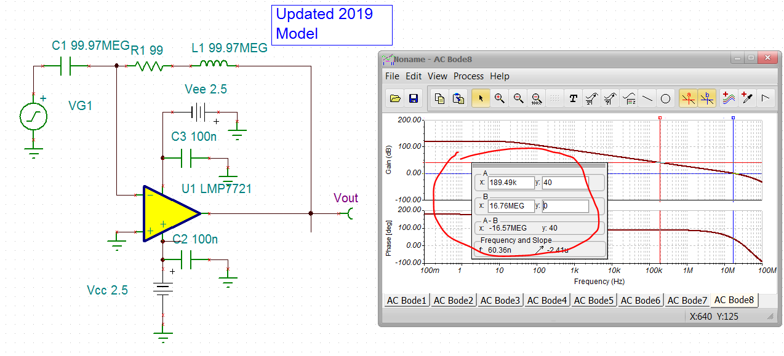
At unity gain, the phase margin would be 41deg. That is probably to help get that unity gain overshooting in Fig. 25 matching better, but that still has a 10pF load as well.
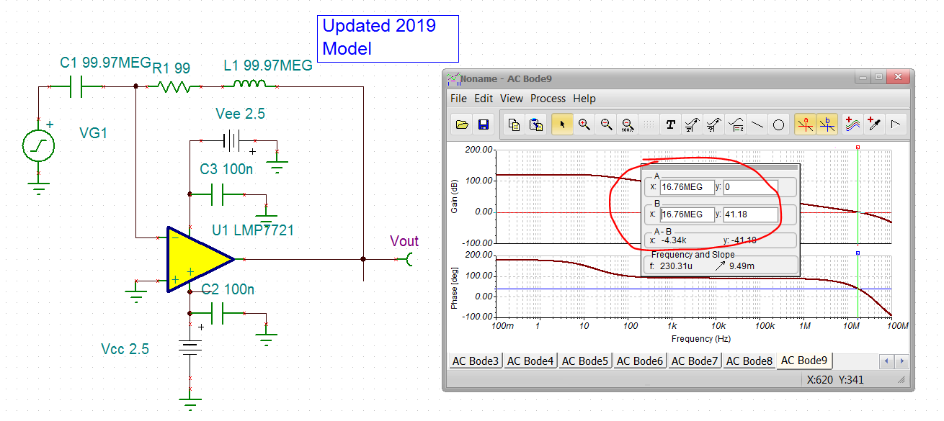

Now the input capacitance, first the old model, this first test gets the Ccm+ Cdiff.
Oops, the old model had no input C – that is a huge miss, calculating .05pF. The data sheet says it has 11pF, page 18.
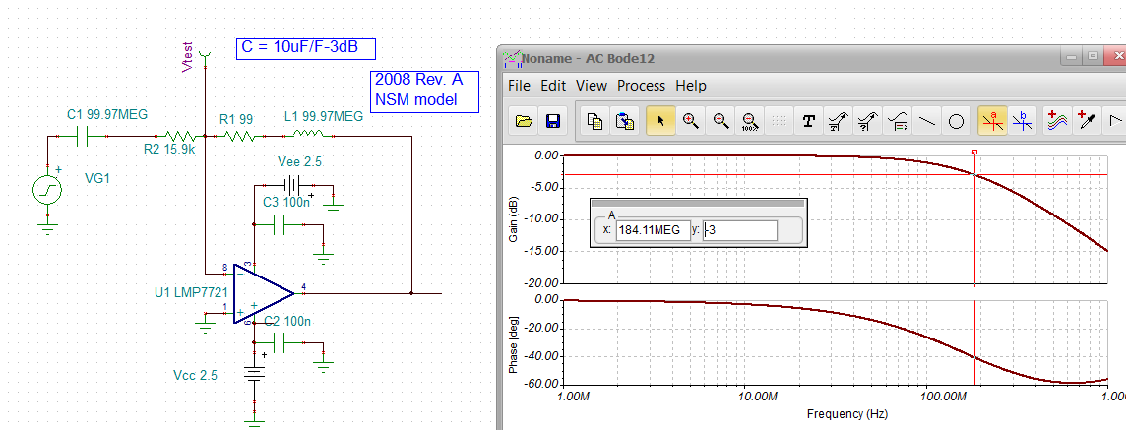

Stop there, go to new model, So the new 2019 model seems to have 20pF, that is too high and will drastically effect the LG phase margin sims.
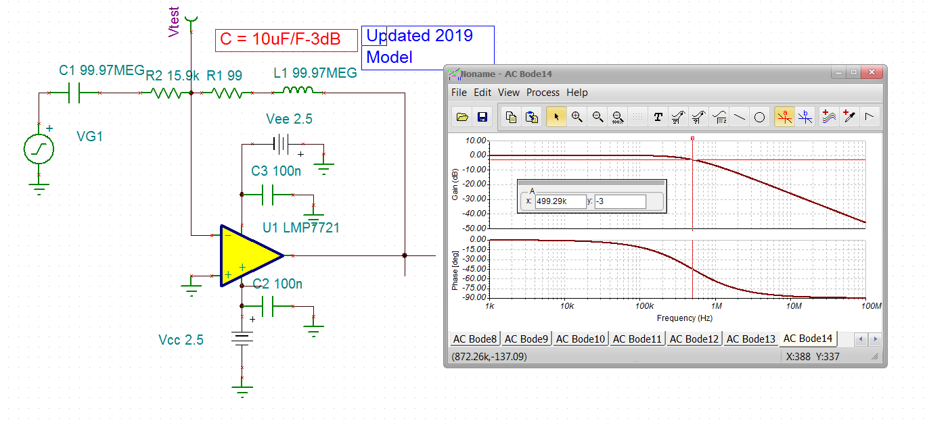
Go on to isolate on the Ccm using a non-inverting closed loop test, Ok the Ccm looks like most of the input C, that 2nd bump is where the LG =0dB and you start to see the Cdm. So the Ccm is 15.1pF
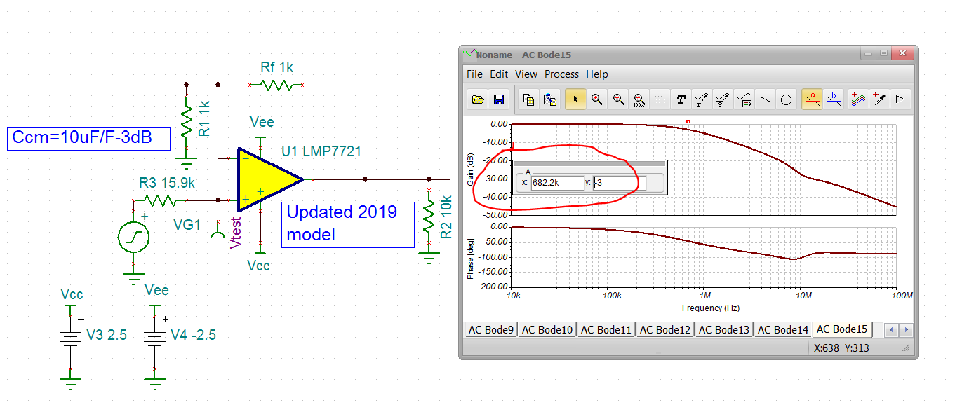
Try something now with non=-inverting feedback C equalizations. Yes, so even with just 1kohm R’s gain of 2, we are getting 4.8dB peaking – now try to equalize – is it 15pF or 20pF?
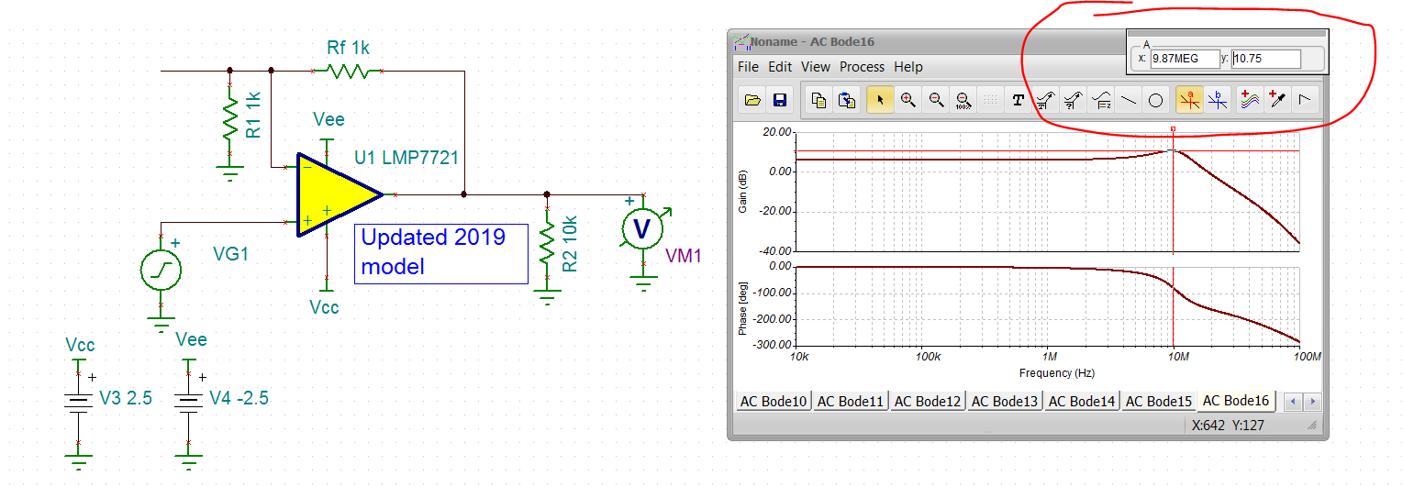

15pF looks pretty good, but definitely not 90deg phase margin, probably about 58deg
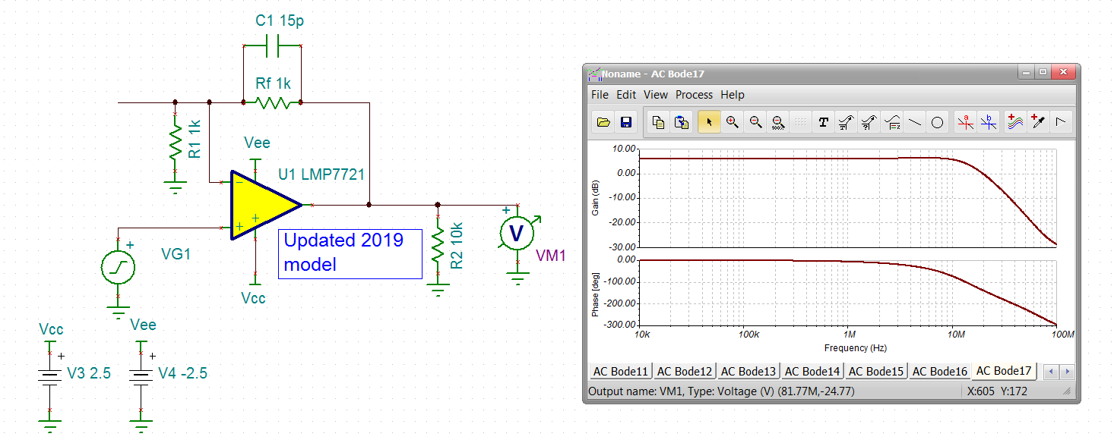
I think for beta equalization, it looks like it is Ccm+Cdiff or 20pF in this model,
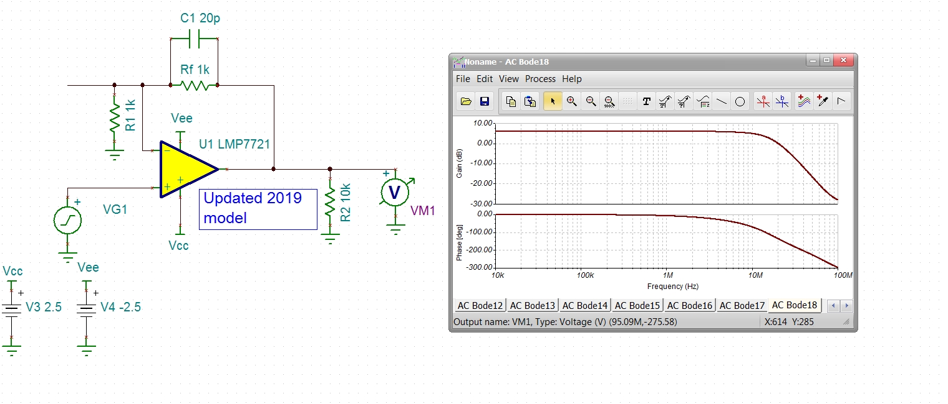
So, to go one more step, it turns out TINA will accept negative C’s. So if we wanted to modify the LMP7721 as a subckt so to speak, we can add external negative C’s to move the new macro towards what the PDS says.
My experience has been the Cdiff is usually tiny compared to Ccm in these large input device VFA parts. We spent some time re-modeling that with designer help over in high speed. So I will target a 1pF Cdiff and 10pF Ccm on each side to match what the PDS says in total . That will look like this, still looking at gain of +2V/V beta equalization with the feedback C now at 11pF – looks pretty good. This kind of stuff is critically important for transimpedance design work.
