4th order BP using the DABP topology
This is a pretty simple design flow with a lot of equal components and only 2 amplifiers. I would say this is a pretty useful approach – does have a limited range on peak gain, but very easy to design otherwise and appears to operate very well. Total design flow in one page here -
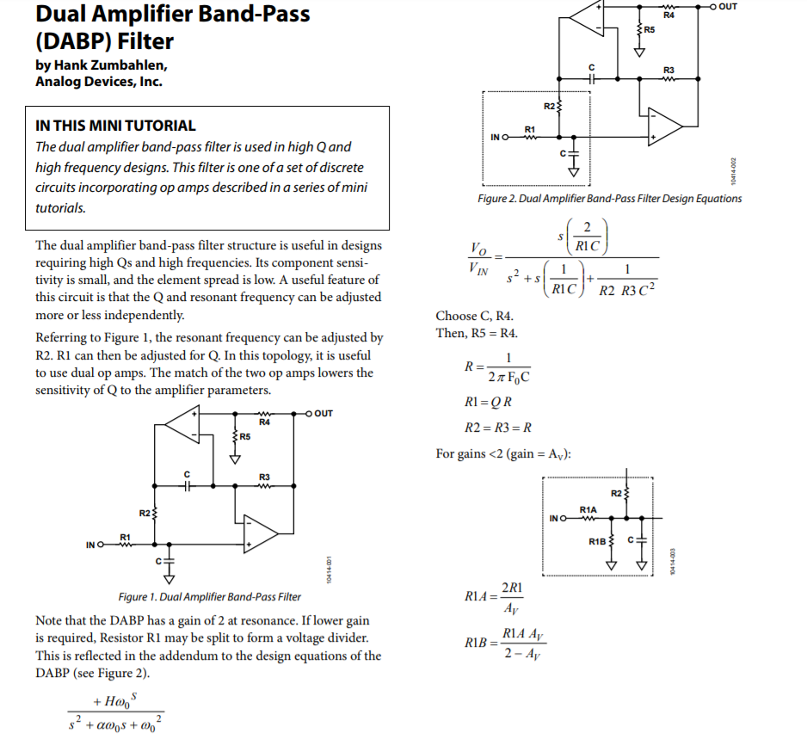
In the flow that I did, I snapped to E96 values where I found the solved R2=R3 setting the Fo was a little low in the first stage – probably due to selecting standard E24 Caps. Manually decreased it in e96 steps to hit 25kHz Fo in the 1st only.
The monte-carlo shows very little peak gain change but some Fo range due to the 0.5% R’s and 1% C’s.
This is the 1st stage,
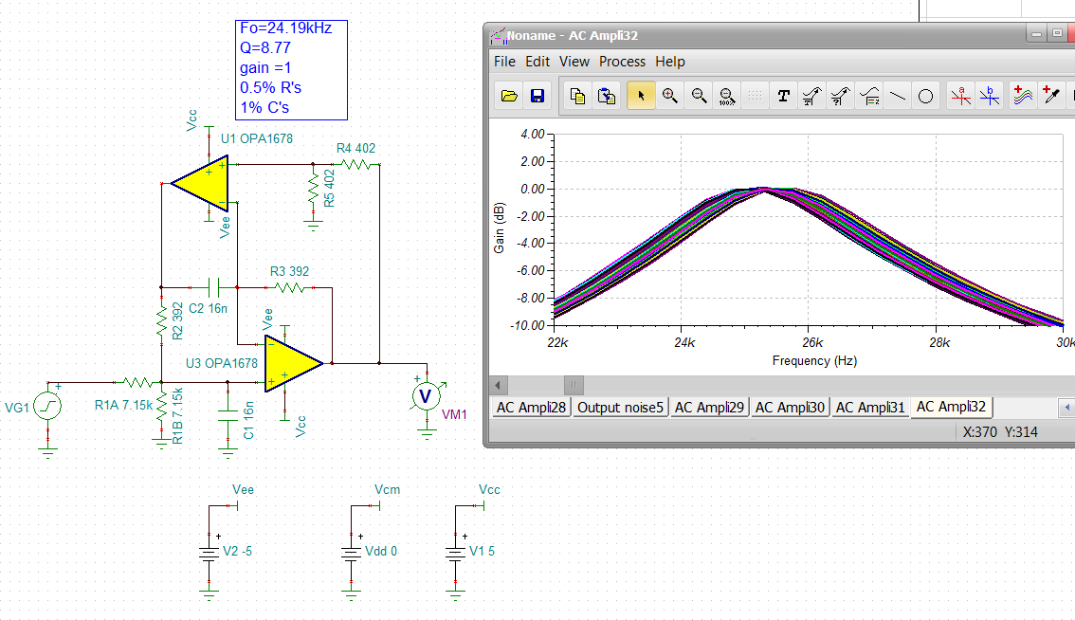
The output noise is better than I expected. The Q is set by the Q*R2 so higher Q gets into higher input R’s. The topology produces a gain of 2 where dividing down the input by ½ gets you back to 1V/V peak gain. This is just the first stage, can easily copy and paste to start modifying RC for the 2nd stage
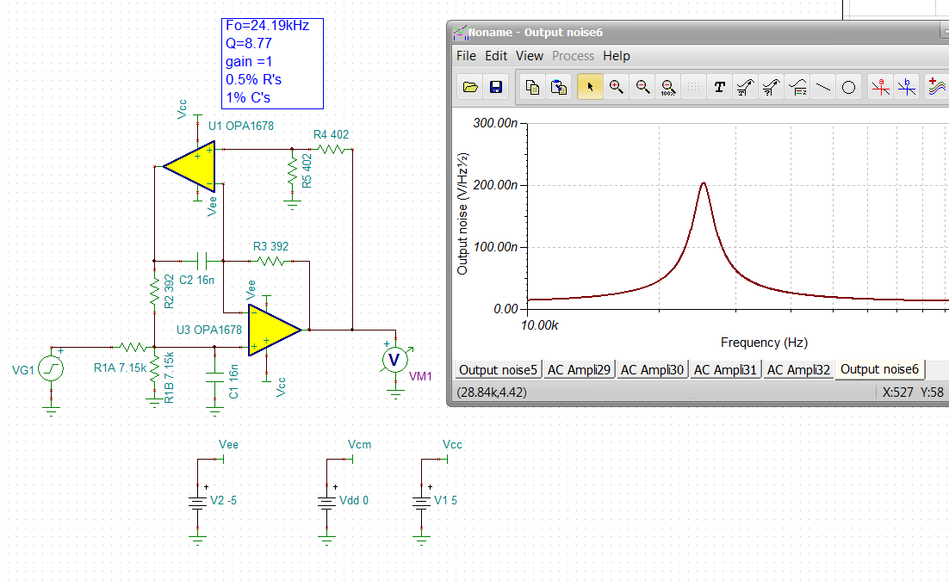
So adding the 2nd stage, the C’s went to E24 15nF and I had to step up the R2=R3 in E96 steps to tune the total filter into 25kHz,
So right now the Fo is a little low and we have a little bit of insertion loss – can adjust the gain with the R1A R1B divider in the 2nd stage.
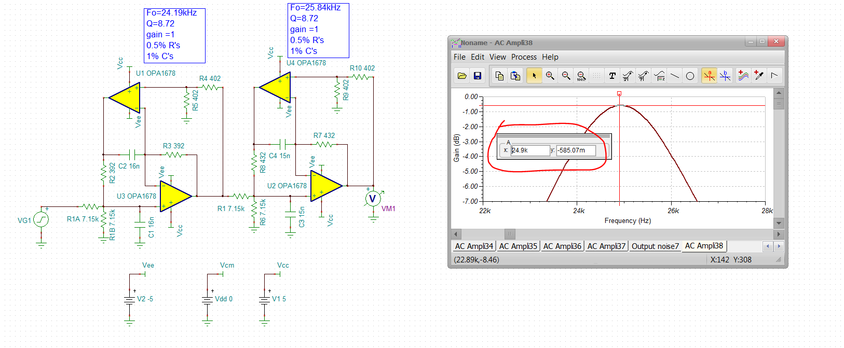
Looks to be low by .934 (not sure why), can increase it by targeting 0.5/.934 = .535 in the 2nd stage. This actually meant targeting 1/0.934 for the 2nd stage gain – yea, that worked very well.
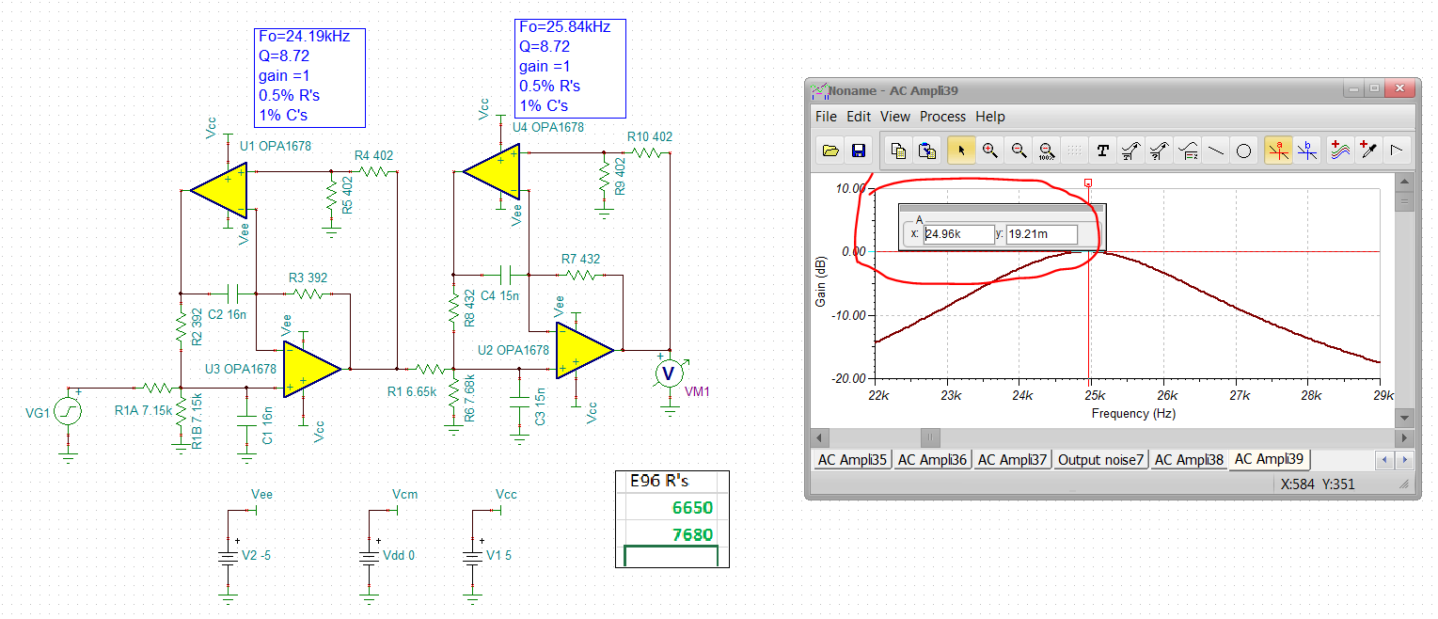
The output noise is still very good (relative to the 4th order MFB).
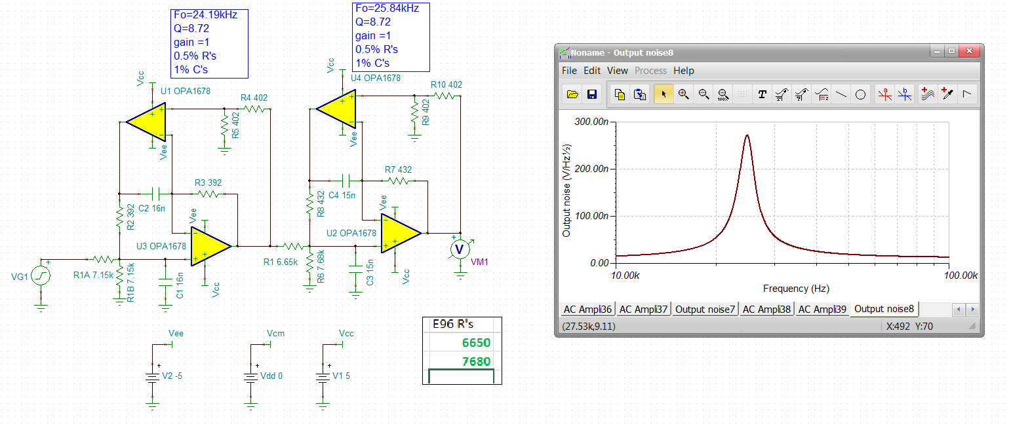
Now run a 200case Monte-Carlo – looks like maybe just a bit more peak gain spread than the AckerbergMossberg but actually pretty good. Why would you not just use this all the time? Got to be some cost,
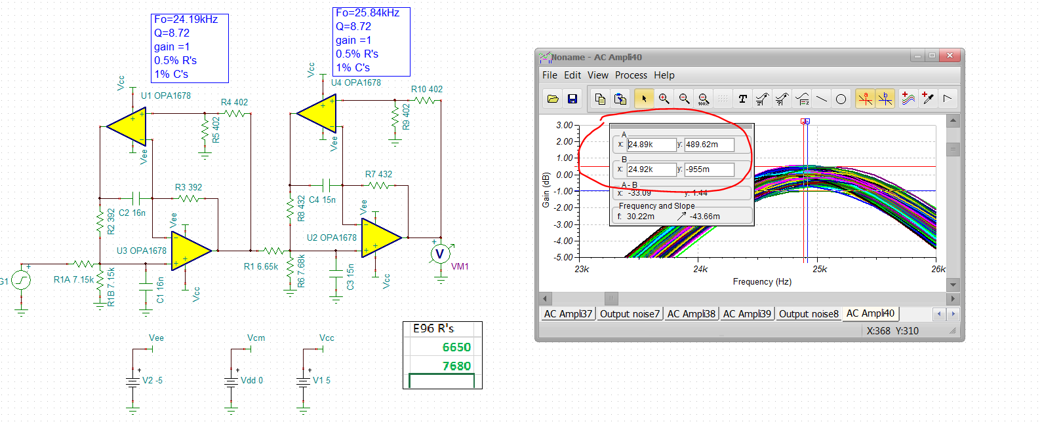
Hiding inside all these are Loop Gains, lets look at the output impedance and see if we can see a min LG point.
Yea it pops up to 3.71dBohms or 1.5ohms at Fo. Figure 29 in the PDS shows about 50ohms open loop so the LG at Fo is around 32V/V or 30dB – pretty good actually – using a faster device will improve this.
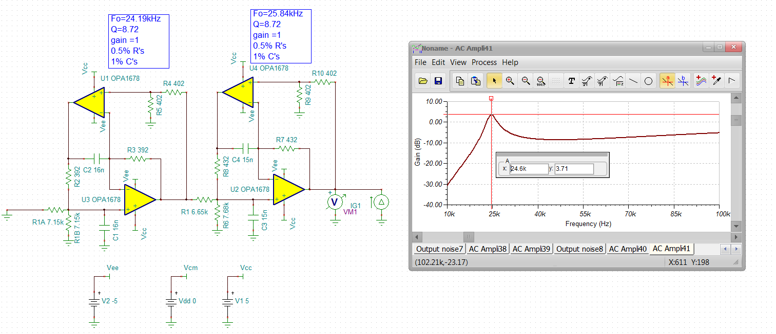
So lets run a 30kHz sine wave through this, kind of interesting to see the magnitude envelope to buildup then decay to a attenuated level.
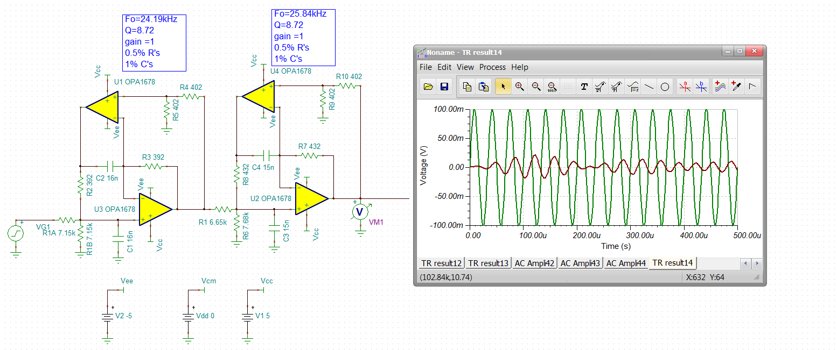
If I put in a 25kHz signal it grows to a gain of 1
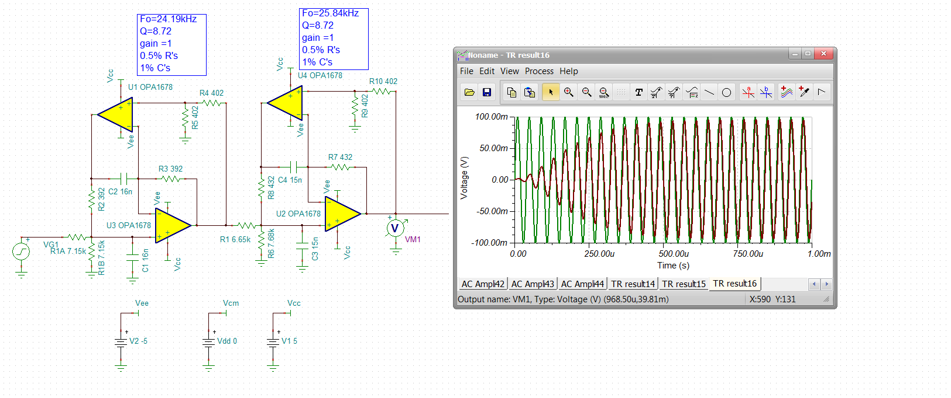
Lets do an integrated noise, pretty good.
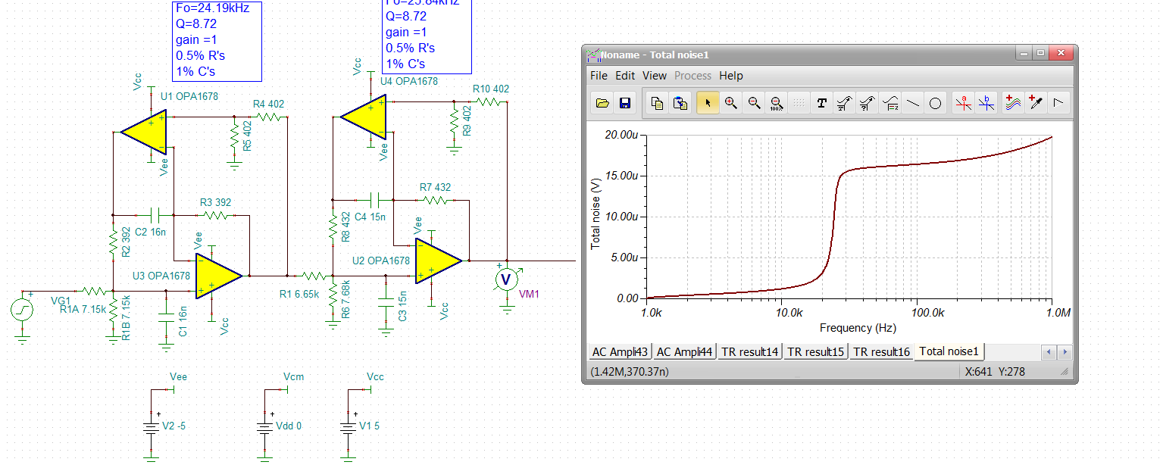
A broadband response shows no feedthrough problems
