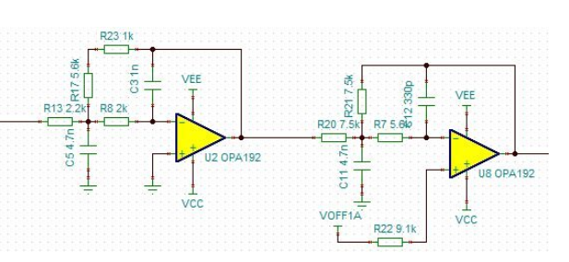
First stage is implementing this,
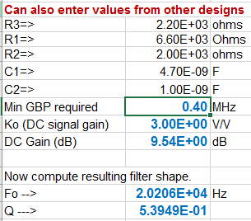
The 2nd stage is implementing this, higher Q stage should actually go first to reduce integrated noise.
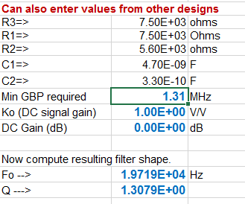
Here is the original response shape,
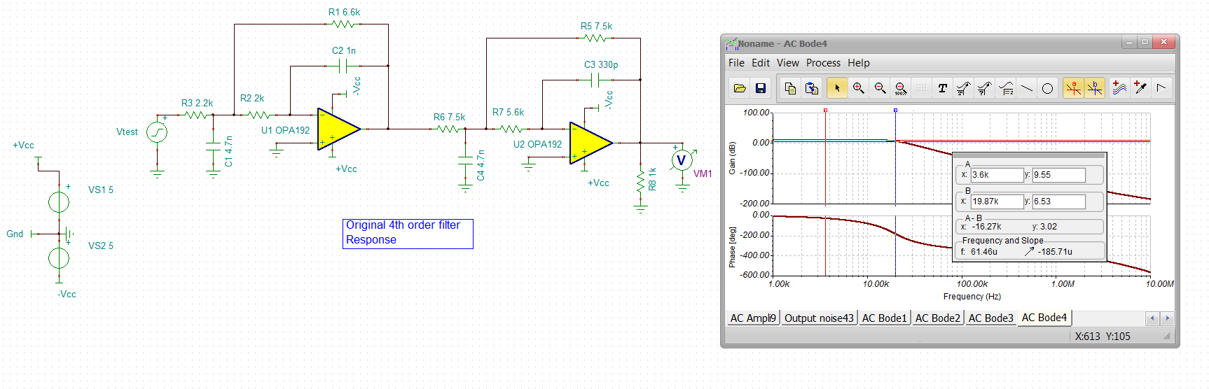
The output spot noise looks pretty normal, that peaking is the NG peaking in that last stage mainly,
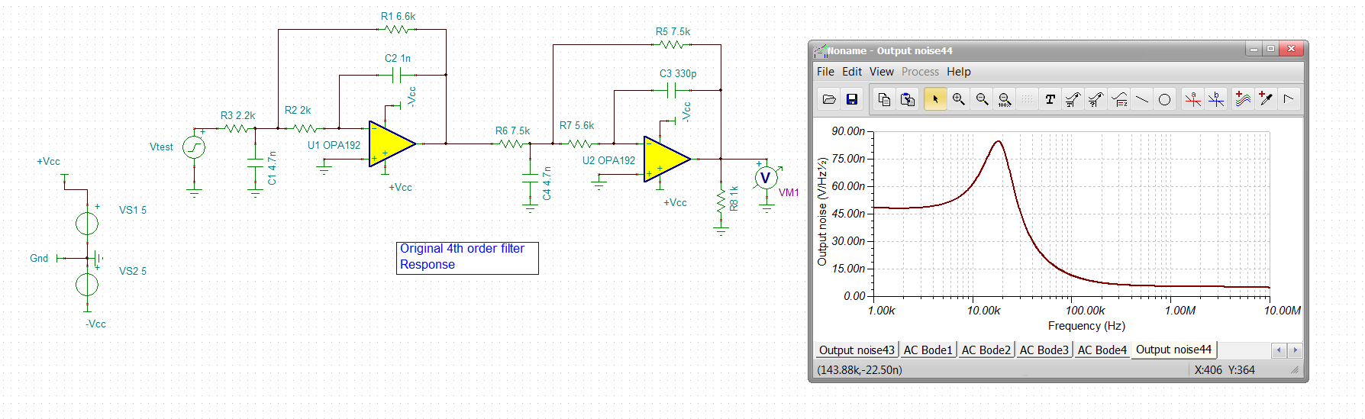
Run an integrated noise to get this as a baseline to compare to an improved design, yea it keeps going up, a final RC filter would fix this, but say at 100kHz we have about 13uVrms or about 6*13uV = 78uVpp – not much, might not need any improvement on this,
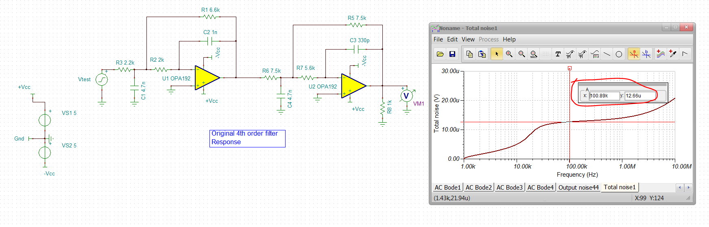
But anyway, lets see if we can incrementally improve this with the same response shape,
Move the higher Q stage first with a gain of 1.73 (split gains equally in the two stage for a total of 3), Also set a min input R of 2kohm in each, Here is the first stage solution,
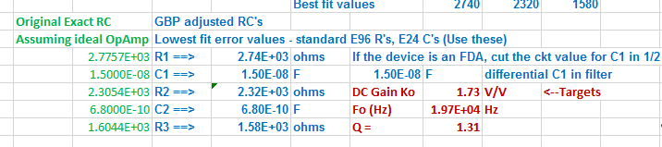
And then the 2nd stage is the same gain but the lower Q stage
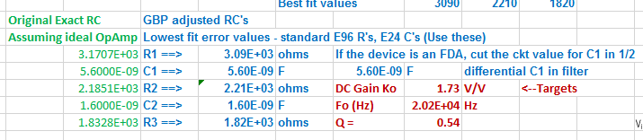
Putting those together gives the same response shape, low frequency gain is a bit lower, but that is the 2nd stage choosing RC to minimize Fo & Q errors,
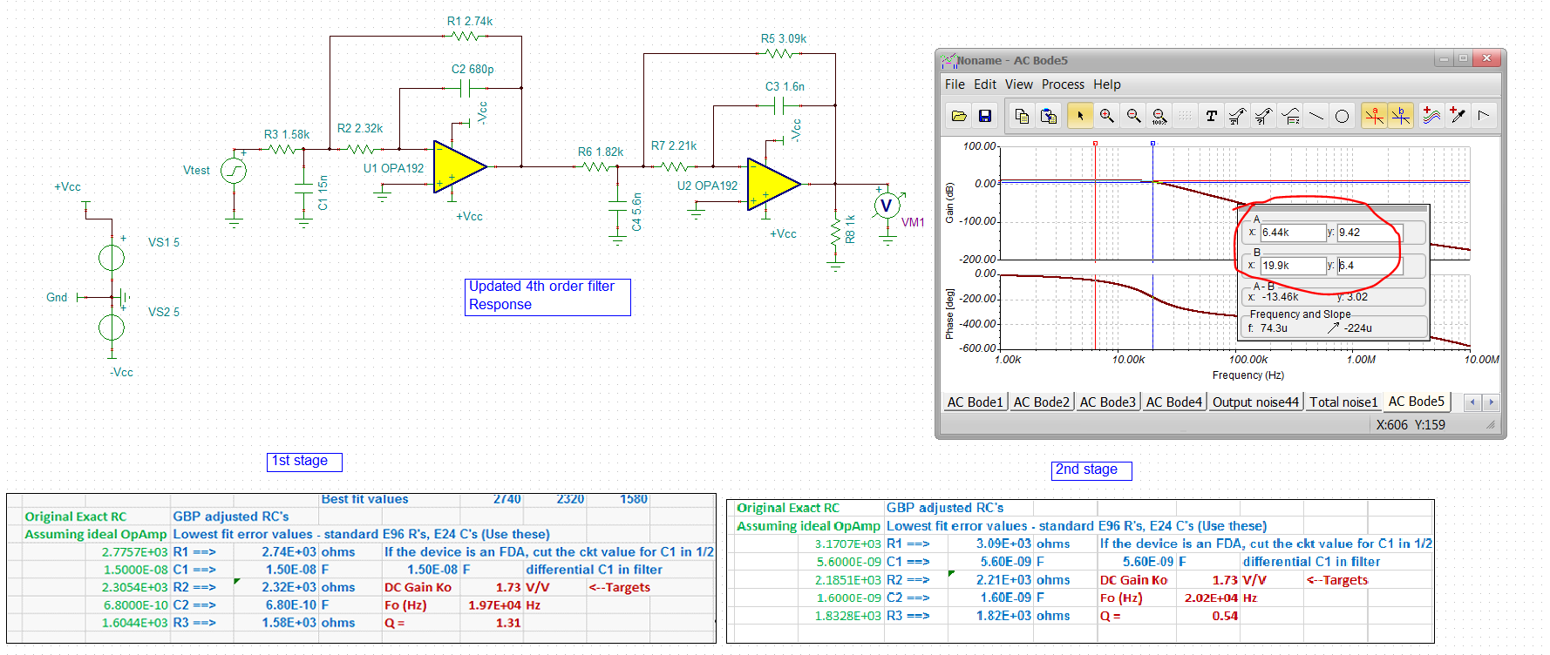

The spot noise is lower, as we would expect with the changed sequencing, lower R’s, and lower NG peaking,
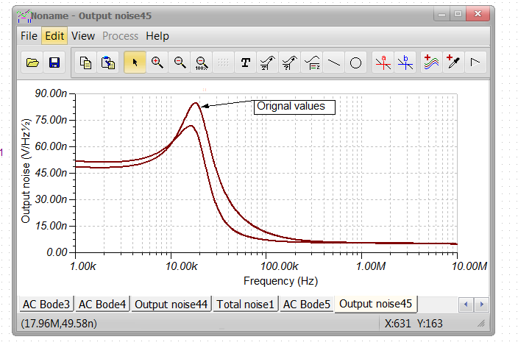
The integrated noise to 100kHz actually goes down nicely, about 10uV
