500Hz 4th order Butterworth active filter with the THP210
Michael Steffes, 12/20/2020
I don’t do filters this low in F very often, it turned out I needed to update a few things in my MFB design tool – useful to do that occasionally,
- I update with the highest <$0.1 in 1k 2% C0G MLCC cap values – yes, they have moved up a bit from the last time I looked, Murata standard E24 values up through 47nF look available now.
- The FDA design flow is complicated in that you use 2X the physical value across the inputs for the equations. In this 500Hz target, that means using 2*47nF =94nF for the equations where the final physical C will be 47nF and everything flows from there – this gives a little lower R values for this max C design – reducing noise.
1st need the pole locations – for an overall gain of 1 filter, yes the higher Q should be last. On filters with gain, it should be a descending Q sequence, these Filterpro RC solutions are primitive, can slightly improve on the overall integrated noise with better RC values. But I just really wanted the Fo and Q targets out of Filterpro – of course with Butterworth the poles are on a circle of equal Fo in the negative s-plane, only the Q’s change
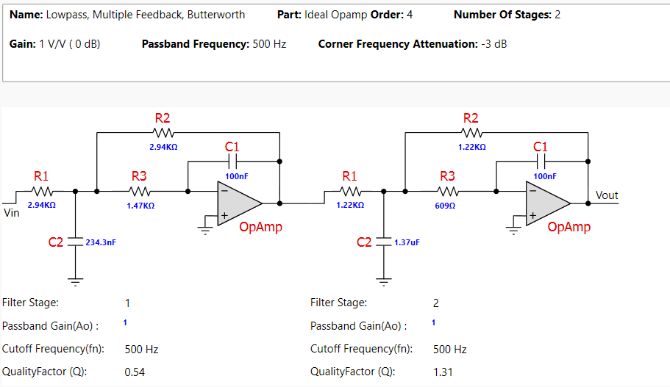
I just needed the target Fo and Q for a design flow that will give best fit standard values with reduced noise gain peaking,
1st stage solution is here, this is the Q=0.54 stage, . Note the C1 row is 94nF for calculation purposes but 47nF for implementation. The green column is ideal op amp R values, the final R’s adjust for GBP and E96 best fit standard values, not much change here given the THP210 vastly exceeds the required GBP for a good fit.

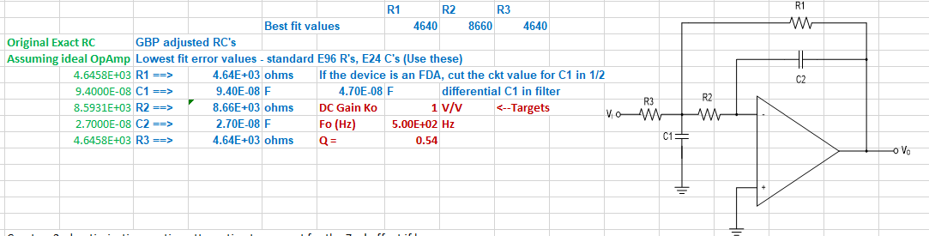

And then the 2nd stage, this is the Q=1.31 stage

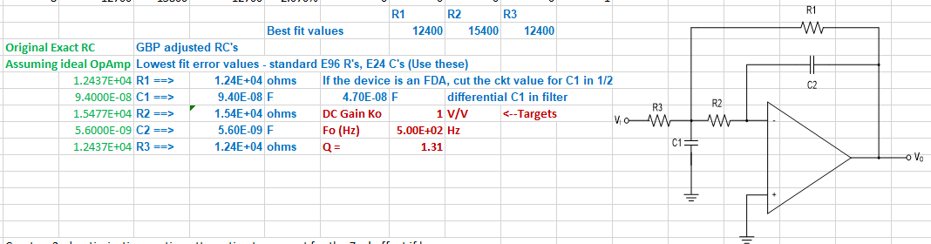
Doing the 1st stage in TINA, I do worry about phase margin with that big 27nF feedback C, quick way to look is spot noise at the outputs – there is little peak, probably ok, but connecting that feedback C outside those inside the loop R’s (0ohm for now) gives a tune to improve that. The 27nF gives you a 0dB noise gain, that is hitting the Aol curve around the 8MHz GBP showing <50deg phase margin is seems from that little noise peak out there,
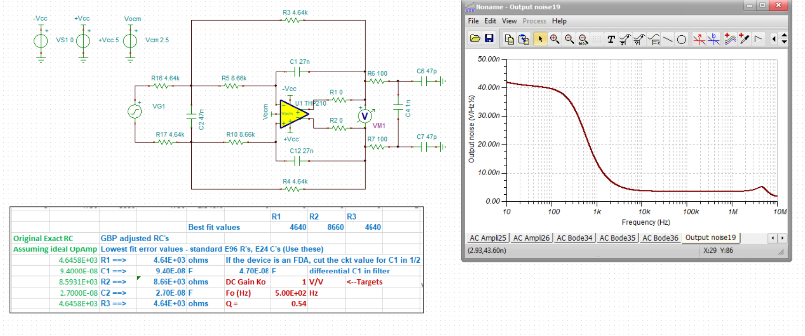
And then here are the two stages together,
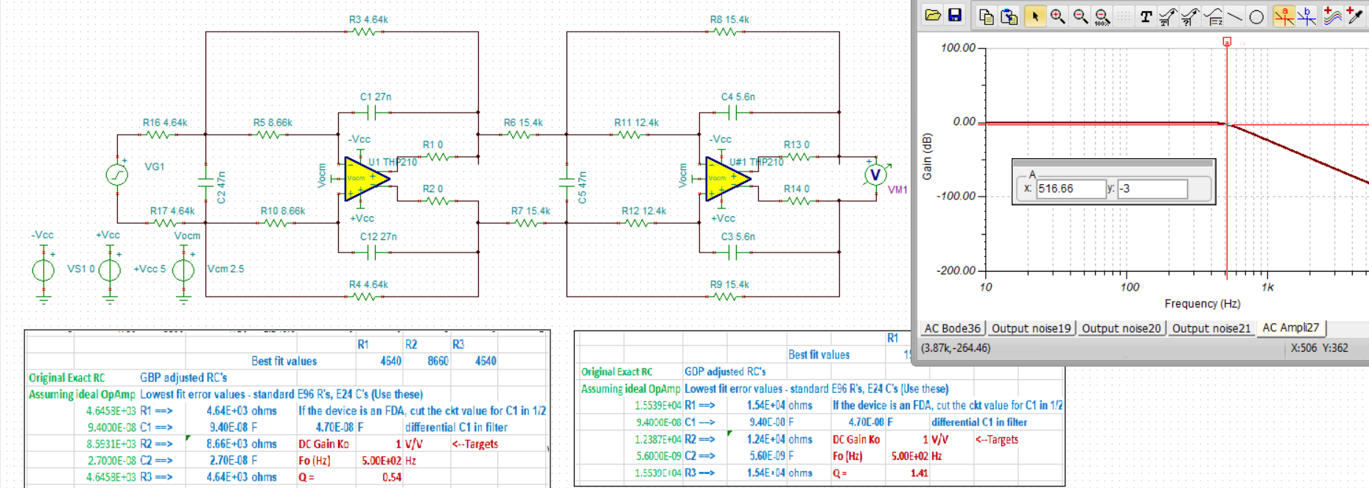
Putting the higher Q stage 1st will reduce integrated noise but risk step response overshoot clipping, here is the integrated noise for this ascending Q design, little under 4uVrms or about .24mVpp
