50Hz notch with the Fliege topology and LMP7702 and OPA1678
Michael Steffes, April 27, 2019
The thing to keep in mind is these notch filters are very sensitive to RC tolerances

I put 0.5% R tolerance and 1% C tolerance and ran 200 monte carlo – yes it moves around a lot, which will show up as different 50Hz ripple levels at the output,
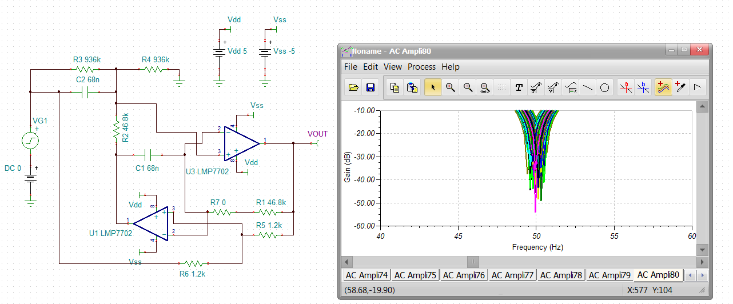
I also ran a nominal 200kHz square wave through this, yes there is that 2MHz peaking in this result, needs some work, or maybe a faster part with more phase margin, like an audio dual,
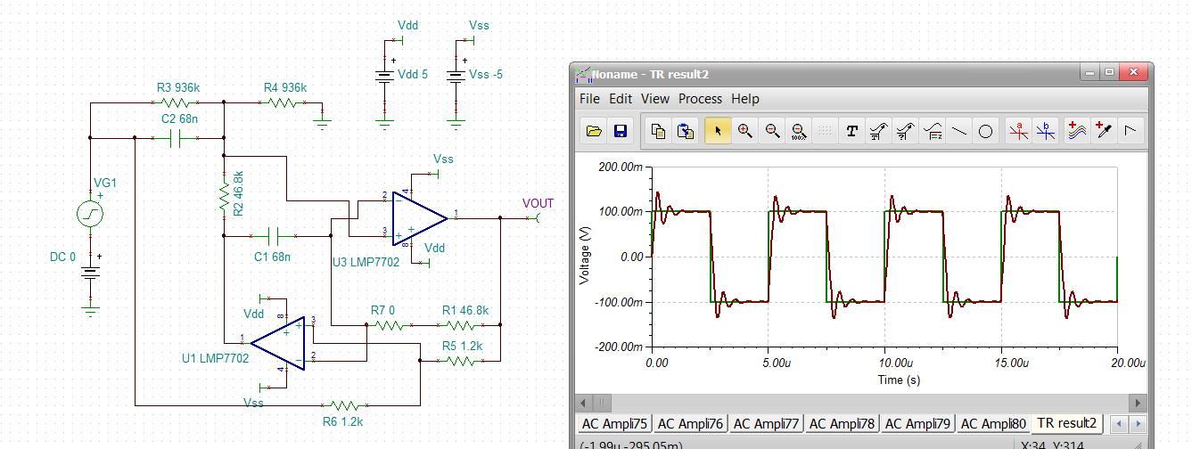

Yes, dropping in an OPA1678 moves the peaking out – definitely a unity gain crossover issue where this 7.5dB peaking is 25deg phase margin – better, maybe just a post RC will be enough here?

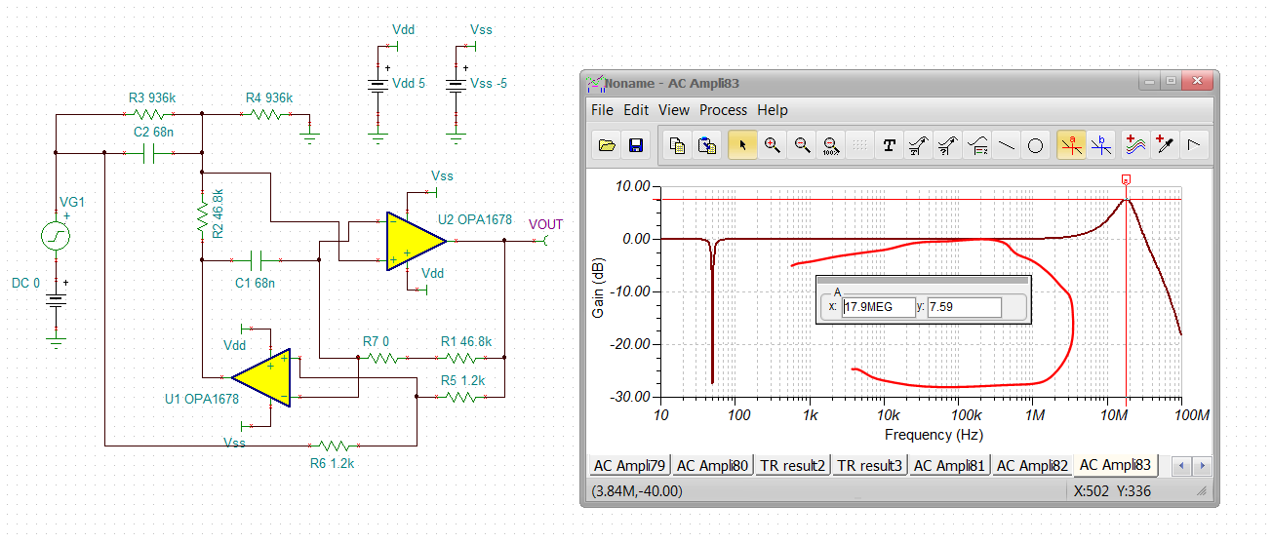
If I add a 2MHz post RC filter, the step response looks like this, pretty nice actually, without that is has a sharp overshoot with quicker settling.
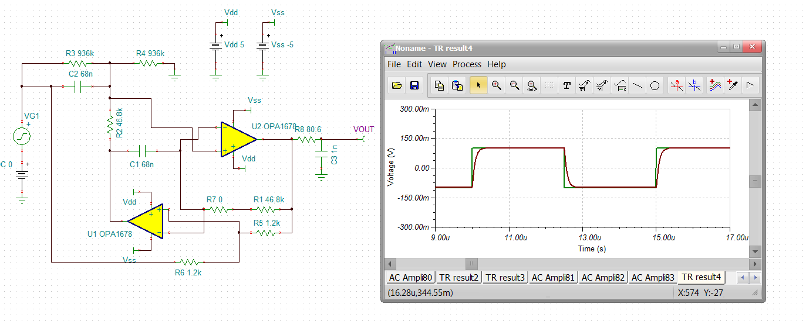
Re-running the AC with tolerances and the faster OPA1678, this looks a little better in terms of attenuation at 50Hz across tolerancing – again 0.5% R’s and 1% C’s. If you just pulled normal tolerance RC out of the drawer – not much chance of success,
I see one curve in here that is only –16.7dB at 49.99Hz – there you go, RC tolerances – might need to spend more on better C and R.
