OPA858 model testing,

Michael Steffes, Dec. 17 2019

Had this set up for some testing already, extract input impedance models as well,

5.4GHz GBP

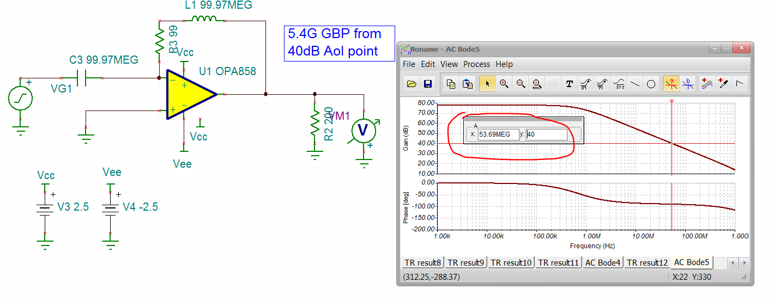

Setting up 1st closed loop gain of 11 and inserting a series R to the V+input gives the reported 0.6pF in the model, good job.

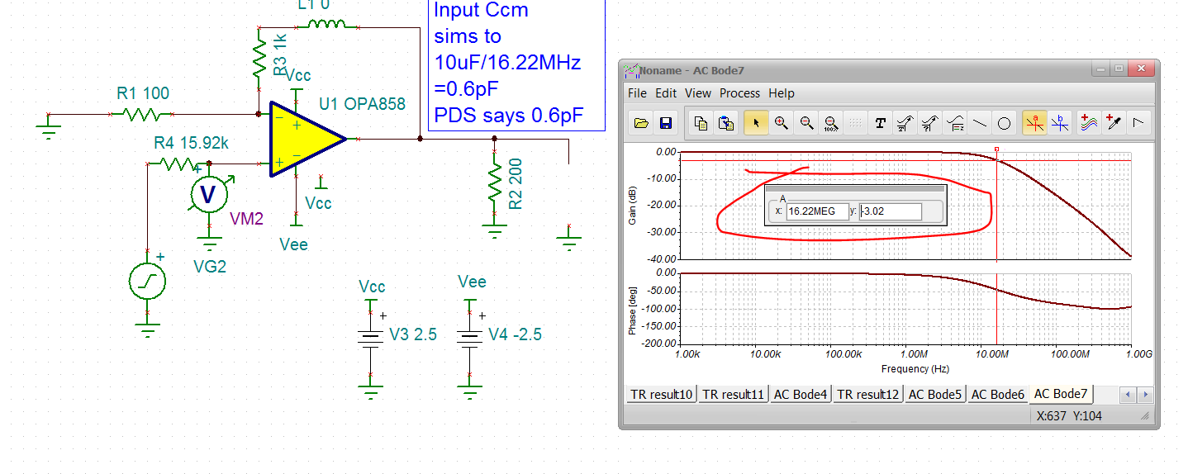

And then running a Ccm + Cdiff sim using a break the loop approach, yields a Cdiff = 0.22pF, very good job here.

