Output taken in normal resolution:
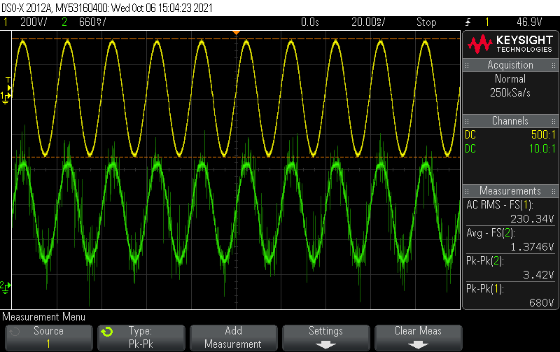
Here we can see switching frequency ripples along with fundamental 50Hz.

Output taken in High resolution:
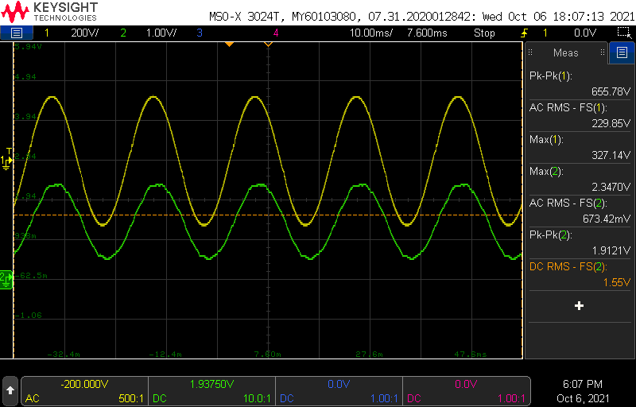

Output(Green) looks little bit flattened.is this because of low pass filter in input side of AMC1100?
Snapshots from TIDA-00555:
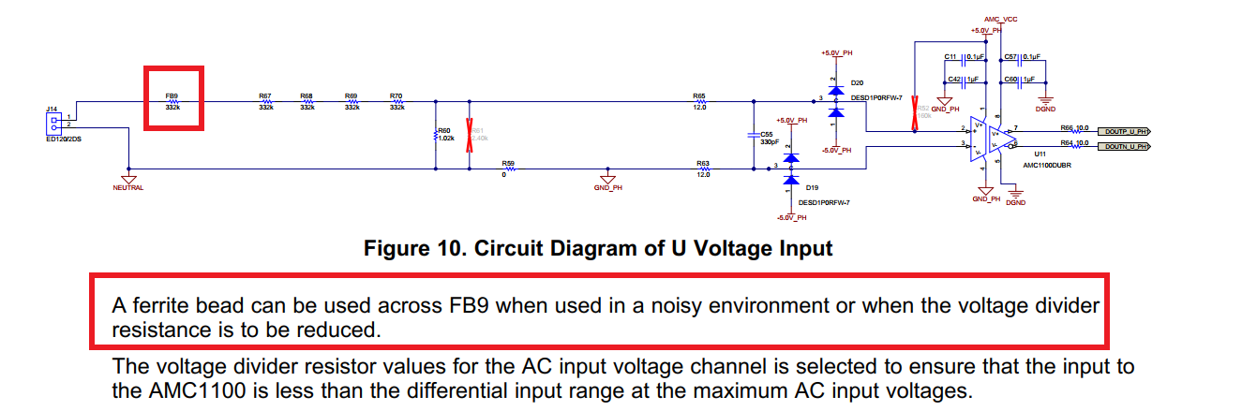

We are measuring AC voltage of 50KHz switching frequency and fundamental frequency of 50Hz at input side of AMC1100,which is very noisy.(Kindly find the attached images of waveform.doc)
We are not getting proper AC voltage shape and its flattening, so we assume is it because of gain error?
We wish to reduce 50KHz switching frequency ripples by placing ferrite bead across a resistor as per below image,

In that case if we place ferrite bead across 332k resistor then net Series resistance also changes.So we need to make changes in Voltage divider circuit to keep input voltage range
with in +/-250mV range.Right?
If we place ferrite bead across the resistor,is below calculation still applies?

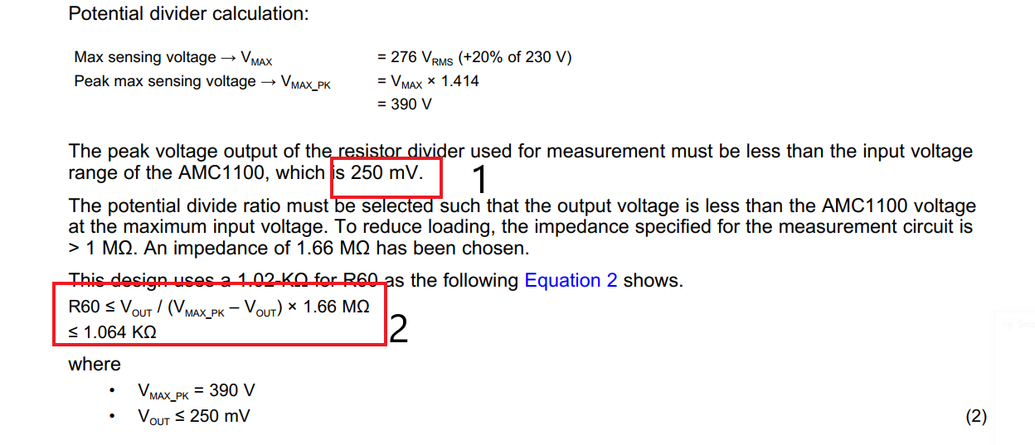
First point(1) in above image is about to maintain input voltage range with in 250mV.
I couldn't understand value 1.064Kohm?How is it calculated?
By placing ferrite bead and adjusting input voltage range to with in +/-250mV,can we reduce switching frequency ripples?
Can we remove RC low pass filter at input side of AMC1100? is it lowering gain or making sine wave flatter?
Kindly suggest us solutions.

