**Very Low Distortion, >400mA Output, Composite Amplifier Headphone Driver**

Michael Steffes, March 2021

Several very high output current, dual, current feedback amplifier (CFA) options have been available from the early ADSL line driver days. One of those (the THS6012, reference 1) has been re-branded as the audio TPA6120A2 (reference 2) driver with a much smaller package option (the 14pin VQFN, RGY) made available at lower cost. While using this as a standalone amplifier already provides very low audio band distortion, combining this with a recent very low noise audio preamplifier (OPA1612, reference 3) can lower this even further in a composite amplifier structure.

The need for very high current output differential twisted pair line drivers emerged in the late 1990’s as the xDSL (Digital Subscriber Line) standards emerged. The earliest CO (Central Office) devices were higher voltage, independent dual channel, CFA designs like the THS6012. This core >100MHz CFA device can also find wide application as a high-power audio headphone driver – subsequently re-introduced in 2004 as the TPA6120A2. This later device is relatively sparce in specifications, but those can be mapped over from the more thorough (and accurate) THS6012 device datasheet. Similarly, as there was no separate simulation model for the audio version, we can use the 2011 updated transistor level THS6012 model.

**Inverting composite amplifier design with an imbedded TPA6120A2 gain stage.**

As is always the case when imbedding a power stage inside the loop, we would like that stage to be much faster than the targeted overall loop bandwidth for stability reasons. To reduce the swing requirements (slew rate and output current) from the core amplifier, target a gain of +5V/V in the power stage. Since this is a CFA type amplifier, the bandwidth can always be extended at higher gains by reducing the feedback resistor value. Figure 1 shows the small signal bandwidth (SSBW) for the intended gain of +5V/V power stage using the THS6012 model. The +/-16V supplies shown here are the maximum for this device where a +/-12V swing is then available even into a 32Ω load (+/-375mA peak, here using the +/-400mA minimum specification from the THS6012 vs. the +/-700mA typical only specification from the TPA6120A2).

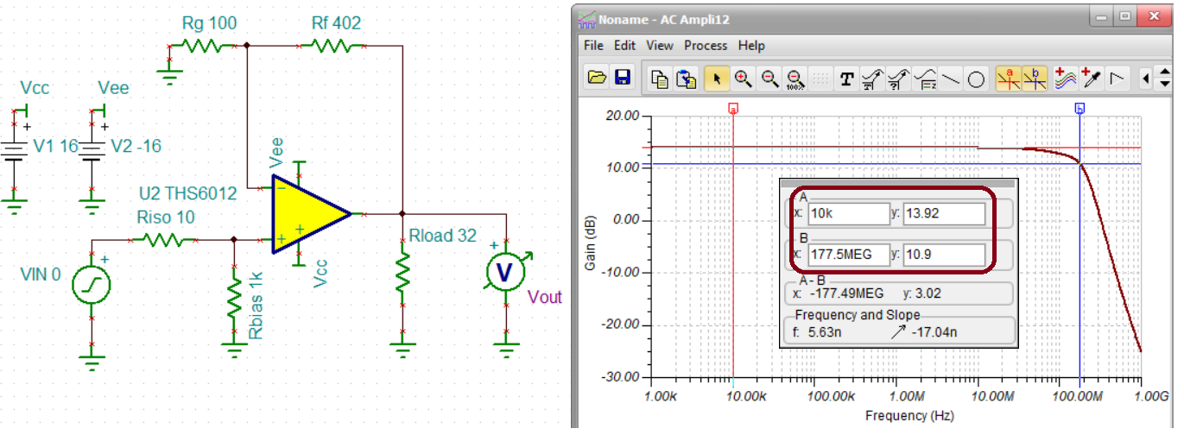

Figure 1. THS6012 gain of +5V/V with extended 178MHz SSBW using a reduced RF = 402Ω.

This very capable power stage can then be imbedded inside the loop of many different core op amps. To get the lowest noise and distortion here, use the dual OPA1612 “SoundPlusTM” device (reference 3). Targeting an overall inverting gain of -10V/V, and including an estimated 0.6nsec package propagation delay for the power amplifier, gives the closed loop response of Figure 2.

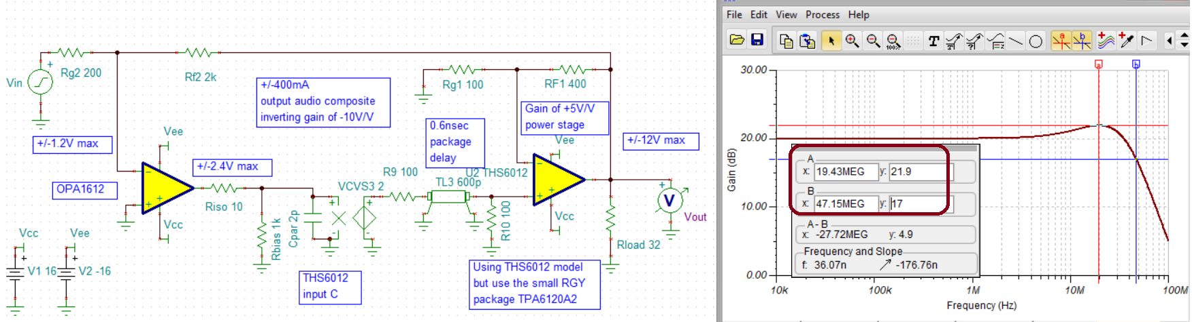

Figure 2. Inverting gain of -10V/V composite power amplifier.

Imbedding this gain of +5V/V stage inside the loop for this simulated 92MHz gain bandwidth product (GBP) OPA1612 has effectively created a 5X92MHz = 460MHz decompensated voltage feedback amplifier (VFA). This combination would not be stable at unity gain, but the inverting gain of -10V/V (noise gain =11V/V) shows excellent stability with only 1.9dB peaking and 47MHz SSBW. No added compensation is apparently required where a loop gain simulation shows a LG=0dB crossover (xover) at 24MHz with 48deg phase margin. Theoretically, this 48deg phase margin should produce 1.9dB peaking (figure 2, reference 4) exactly matching Figure 2.

This remarkable 47MHz SSBW at a gain of -10V/V suggests wider application at frequencies far exceeding the audio range. At some point, either the OPA1612 or TPA6120A2 will slew limit constraining the frequency range for a full scale +/-12V output swing. Solving for that limit using the 1300V/μsec TPA6120A2 slew rate specification, and a 12VPEAK maximum output, gives a maximum operating frequency of 17MHz. This will never be reached in fact as the much lower 27V/μsec OPA1612 slew rate will limit the maximum swing range to 1.8MHz using its lower maximum required output of 2.4VPEAK. Lower swings of course can operate to higher frequencies or an alternate, higher slew rate, input op amp can be selected. The OPA1612 is not only extremely low noise and distortion itself, but has a unique open loop response that includes a phase lead at higher frequencies. This feature (Figure 5, reference 3) is very useful for overall stability in this composite structure. Recall, the transmission line delay in the simulation circuit of Figure 2 is not added externally – you will get that along with the package as an approximate delay. A 0.6nsec delay at the 24MHz LG xover adds 5 degrees phase shift in the loop. If the layout adds significantly more delay, the phase margin will decrease rapidly.

**Compensation options for this inverting composite amplifier.**

A common next step for applying the composite circuit of figure 2 would be to add a feedback bandlimiting capacitor. This will immediately create two sources of instability. The most obvious is that this capacitor will be shaping the noise gain to 1V/V at higher frequencies putting the overall loop (for this essentially decompensated op amp) into oscillations. Fixing this 1st issue with a capacitor to ground on the inverting node, a 2nd instability appears from those two series capacitors acting as a load to the output CFA stage. Both issues can be handled easily as shown in the 100kHz bandlimited modification of figure 3.

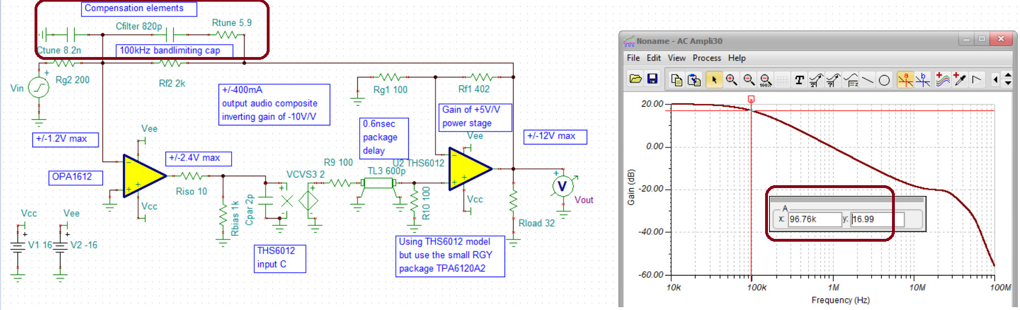

Figure 3. Bandlimited design to a 100kHz F-3dB with compensation elements.

The capacitor to ground on the inverting node essentially shapes the noise gain to be constant over frequency using capacitor ratios equal to the resistor ratios. This approach is a common inverting VFA design technique to apply decompensated op amps over a wide range of gains (reference 5). The small series resistor in series with the feedback capacitor acts to isolate the closed loop TPA6120A2 power stage from what now looks like a capacitive load in the feedback path. This resistor was only effective in a fairly narrow range of values. Going lower than 5.9Ω brings in the output stage instability while going higher decreases the effectiveness of the overall noise gain shaping with the capacitor to ground on the inverting node. The design of Figure 3 gives an overall loop phase margin of 32 degrees using the values shown with a closed loop 97kHz F-3dB . Again, the original composite circuit of figure 2 appears stable with no compensation – trying to bandlimit it with a typical feedback capacitor creates this potential for instability.

**Expected harmonic distortion improvement using the composite structure.**

The TPA6120A2’s already remarkably low distortion driving a high swing into a heavy load should be improved by the overall loop gain in this composite structure. However, it is very difficult to extract a useful large signal harmonic distortion number from the two datasheets that might apply for the output power stage design shown here. For instance, using the lower 402Ω feedback resistor for this CFA power amplifier will increase its loop gain and hence lower the output stage distortion - but no data is shown for that condition. These exact operating conditions do not appear in either datasheet with the closest perhaps showing a worst case 2nd harmonic of -70dBc at 1MHz for a 20Vpp swing into a 25Ω load (figure 30, reference 2). Estimating a 20dB loop gain improvement going from this 1MHz specification down to 100kHz would suggest the output CFA by itself can deliver <-90dBc distortion terms for this 20Vpp swing into a 25Ω load at 100kHz. From this already exceptional intrinsic output stage linearity, the composite loop gain should further reduce the actual harmonic distortion at the load. At 100kHz, the loop gain for Figure 2 or 3 is 52dB suggesting this circuit might provide <-140dBc at 100kHz 20Vpp into a 32Ω load – even lower at audio frequencies since the composite LG continues up to 72dB at 10kHz.

Where the source can drive the relatively low input impedance for this inverting design, extremely low harmonic distortion driving high powers into low audio loads can be delivered combined the best of recent audio amplifiers with the high current output legacy ADSL current feedback line drivers. The inverting design lends itself to simple compensation techniques simply using a feedback capacitor and a capacitor to ground to shape the noise gain.

References Part #16, March 2021

1. “500mA Dual Differential Line Driver”, Texas Instruments THS6012 Datasheet revised June 2012, <https://www.ti.com/lit/ds/symlink/ths6012.pdf>
2. “High Fidelity Headphone Amplifier”, Texas Instruments TPA6120A2 Datasheet revised Feb. 2015, <https://www.ti.com/lit/ds/symlink/tpa6120a2.pdf>
3. “High Performance, Bipolar Input Audio Operational Amplifiers”, Texas Instruments OPA1612 Datasheet revised Aug. 2014, <https://www.ti.com/lit/ds/symlink/opa1612.pdf>
4. Planet Analog article, “Stability Issues for High Speed Amplifiers: Introductory Background and Improved Analysis”, Michael Steffes, Feb. 3, 2019, <https://www.planetanalog.com/stability-issues-for-high-speed-amplifiers-introductory-background-and-improved-analysis-insight-5/>
5. EDN article, “Unique compensation technique tames high bandwidth voltage feedback op amps”, Michael Steffes, Feb. 27, 2019, <https://www.edn.com/unique-compensation-technique-tames-high-bandwidth-voltage-feedback-op-amps-2/>