Current Schematic
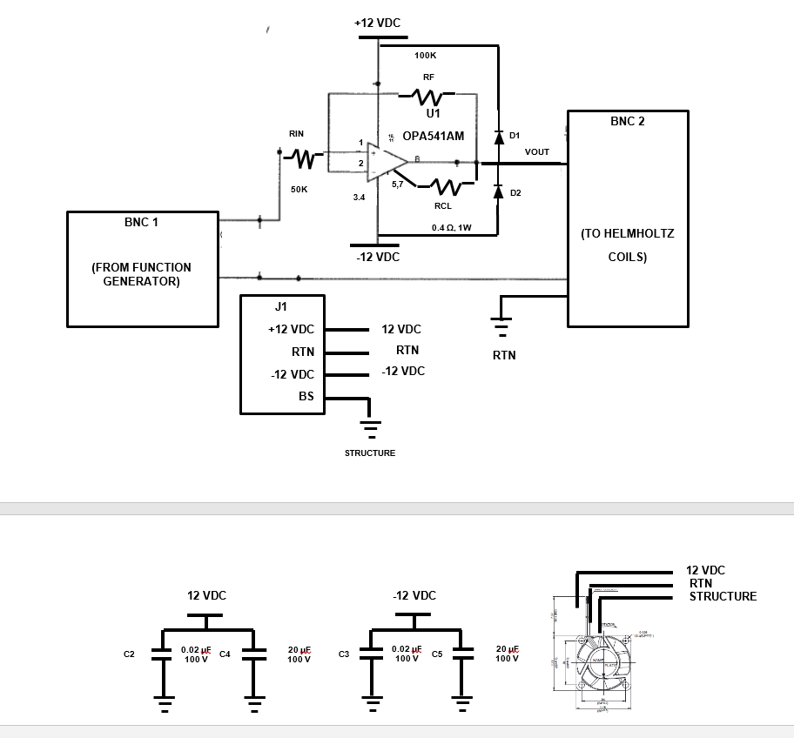

BOM

C11 | D1,  D2 | 2 | 1N4003  1N4003 | QPL  ON SEMI | DIODE, 200V, 1A
C10 | RF | 1 | RLR05C10003GMB14  ERL05 | QPL  VISHAY | RES, 100KOHM, ¼ W, Metal Film, MIL-PRF-39017, 2%
C9 | RIN | 1 | RLR05C5003GMB14  ERL05 | QPL  VISHAY | RES, 50KOHM, ¼ W, Wire Wound
C8 | NA | AR | 120-8 | Wakefield-Vette | Thermal Compound, Silicon, .7 W/m °K
C7 | H1 | 1 | 500403B 3 0000G | AAVID | Heat Sink, TO-3, Square Basket, Option A Silicon Pad
C6 | C4,C5 | 2 | L1RN301206KS24 | Kemet | Capacitor, 20 uF, Ceramic, 100 V, 20%
C5 | C2,C3 | 2 | C2225A203K1GAC7189 | Kemet | Capacitor, 0.02 uF, Ceramic, 100 V, 10%
C4 | C1 | 1 | CKR05BX103KR | Kemet | Capacitor, 0.01 uF, Ceramic 100 V, 10%
C3 | R1 | 1 | AC01000 0 0 4007 J AC 00 | Vishay | Resistor, 0.400-ohm, 1 Watt, 5%, Cemented Leaded Wire wound
C2
C1 | U1 | 1 | OPA541AP | TI  Burr Brown | OP AMP, 5 A Continuous, +/- 40 V, T0-220 PKG
ITEM | REF | QTY | PART NUMBER | MFR. | DESCRIPTION
COMMERCIAL PARTS LIST

Previous 555 Timer Circuit

