Updating power FET driver
This is very high current Infineon power FET, very high input C, > 8nF – but the voltages are not very high, could probably do this with a +/-6V supply.
Also the current sim transient current with ideal op amp is about 2usec, so not really that fast. Say we wanted to move the Vgs about 2V in 100nsec, that 20V/usec slew rate into 8nF requires 160mA, not 1A.
The stability here is a concern with a CFA. Also, going to 0V input shutting the FET off, where is the feedback path?
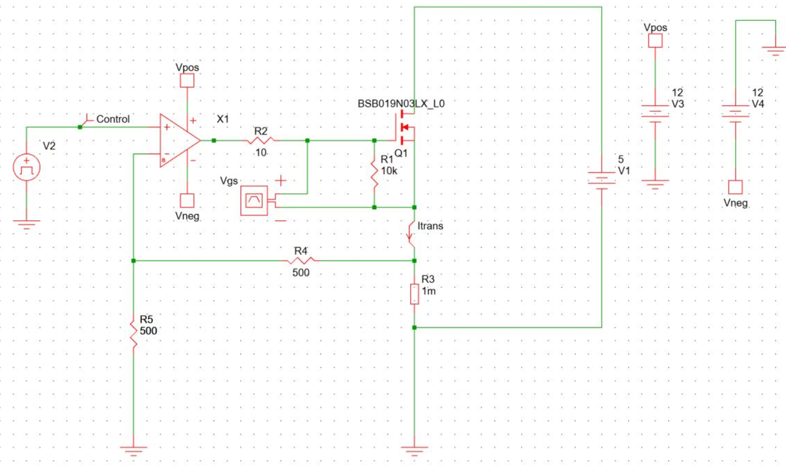
This does look like a Simplis sim – used to use that but been awhile,
TINA model library does have this power fet in it so can do some things. Let’s try to slow the input edge down with an RC and use a high output VFA on +/-5V.
Target 100nsec rise time or say about a 5MHz input RC pole,
Use the OPA2613 high output VFA, slow down the input and add a 10mV input DC bias to turn the fet on, the AC peaking is the prop delay inside the loop, not very stable likely,
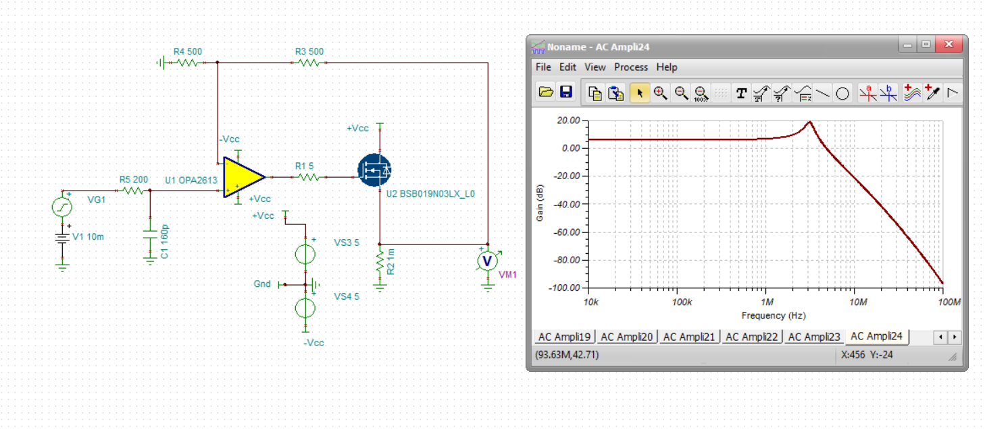
Try adding another feedback path within the fet path – yea, this seems to work,
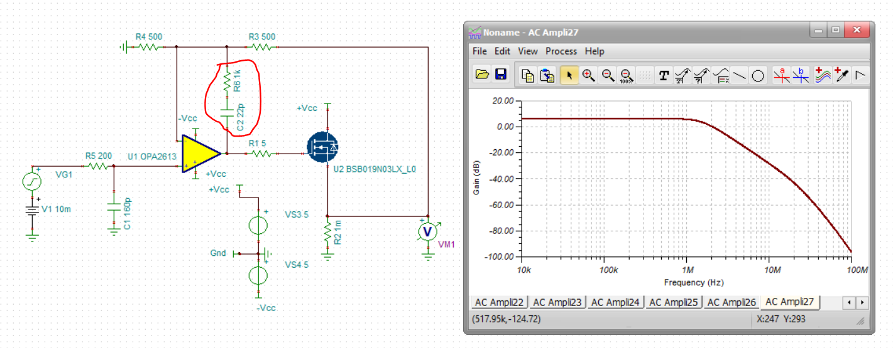
Now lets add a 100mV step onto the input 10mA bias – still concerned about shutting the FET off on the feedback loop effect, pretty ringy, not sure you would want that as this 0.28V peak is a 280A peak.
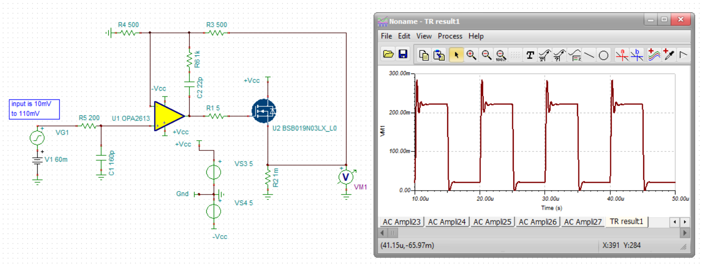
Lets check the output pin voltage 1st, might be clipping, try a +10/-2V supply next,
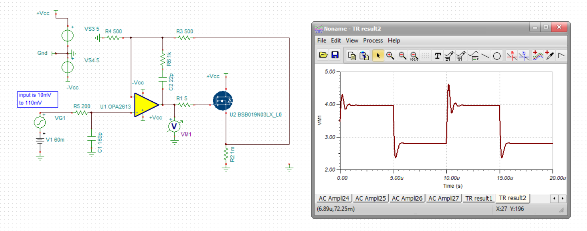
No its ok, but leave that +10V supply there to add headroom for increasing that series R into the gate,
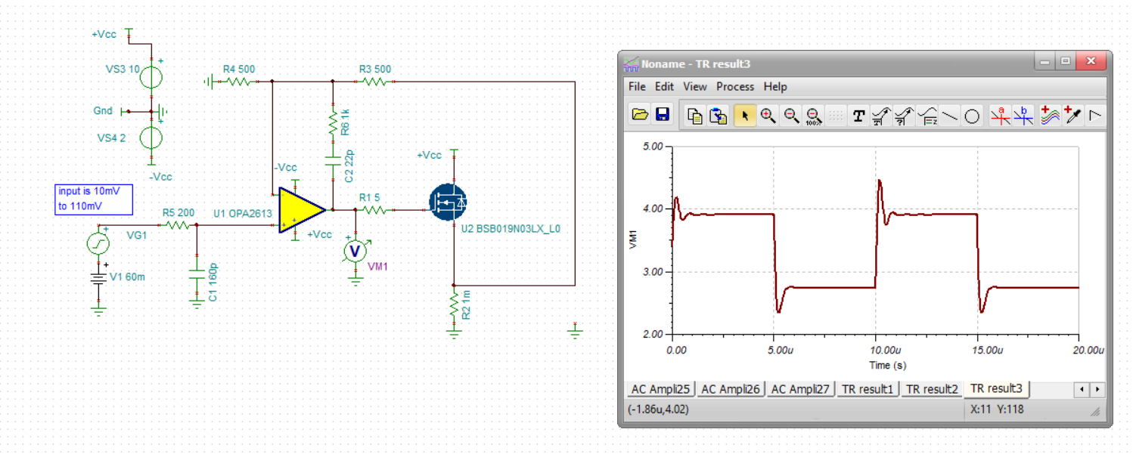
Does not need much gate R, took this to 2ohms but can tune the overshoot with the feedback series C, this looks pretty good at the op amp output pin,
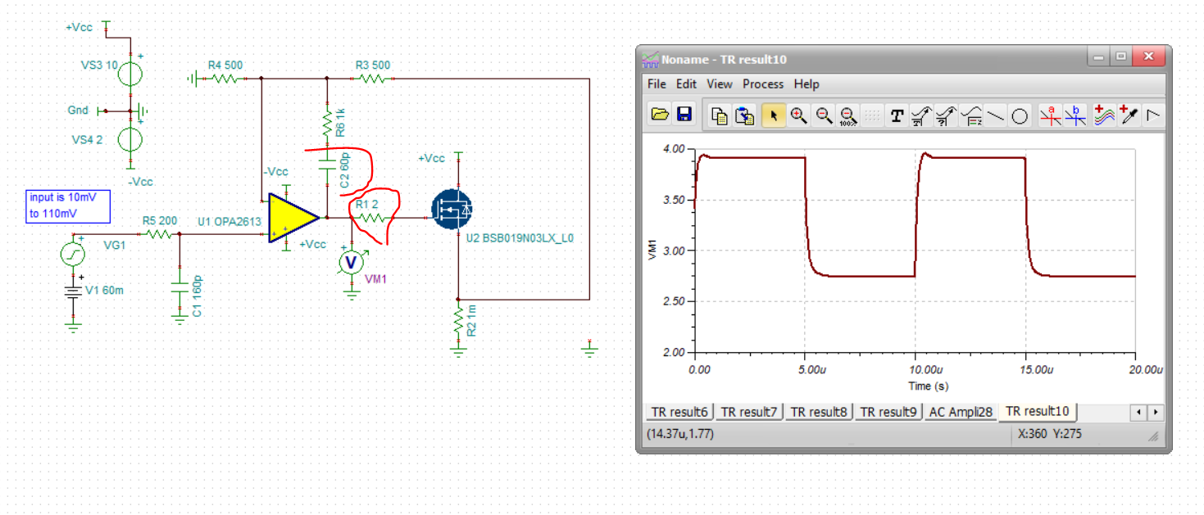
Now look at the load current, looks pretty good I think, can tune this more – series feedback C, increases this will round this off more, lower will overshoot more – next, how to go to zero current and keep the feedback loop closed?
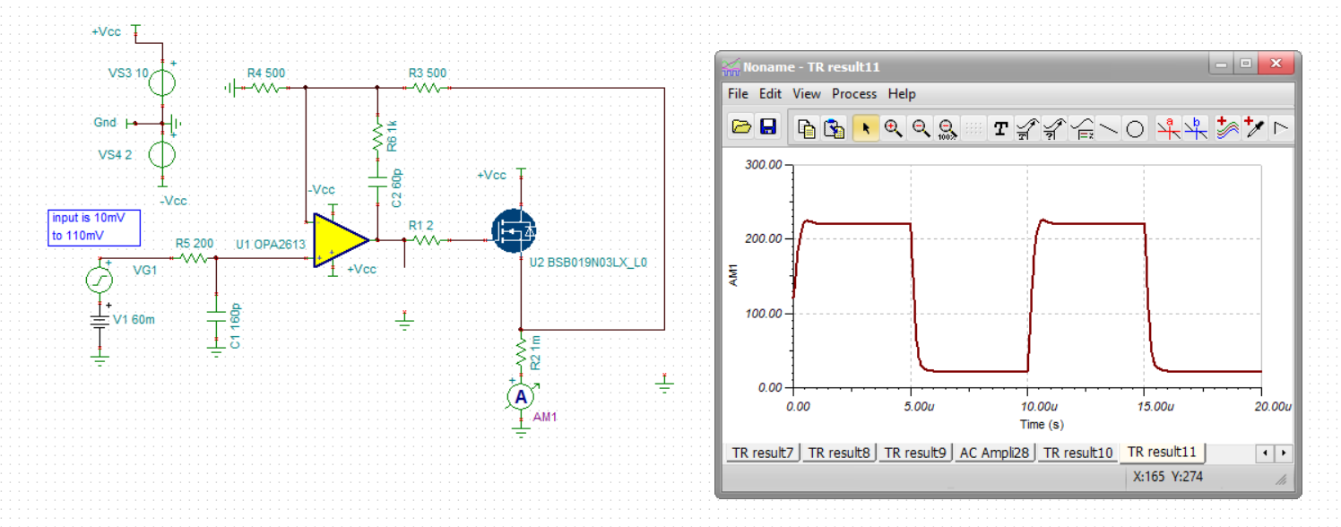
Now we have a +/-50mV input where the fet shuts off to zero current and the feedback is closed through the feedback diode network, yes – goes to zero current but this switching feedback will now have some sharp edges on the output pin voltage, Have gone to +/-6V supply now on the op amp with 6V on the FET
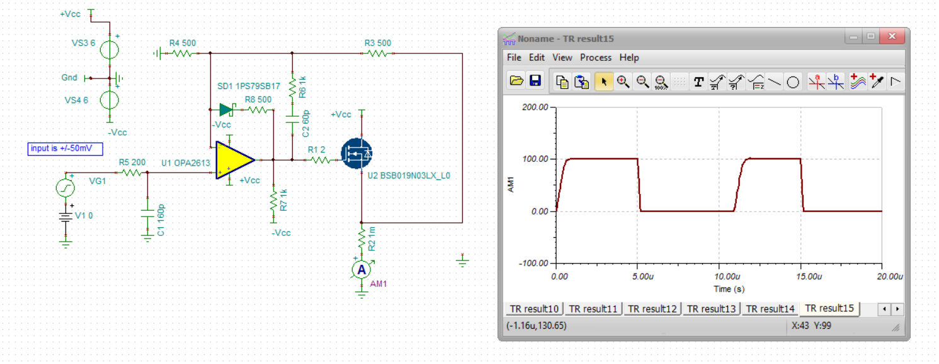
Now lets look at the op amp output pin voltage, not bad looking really,
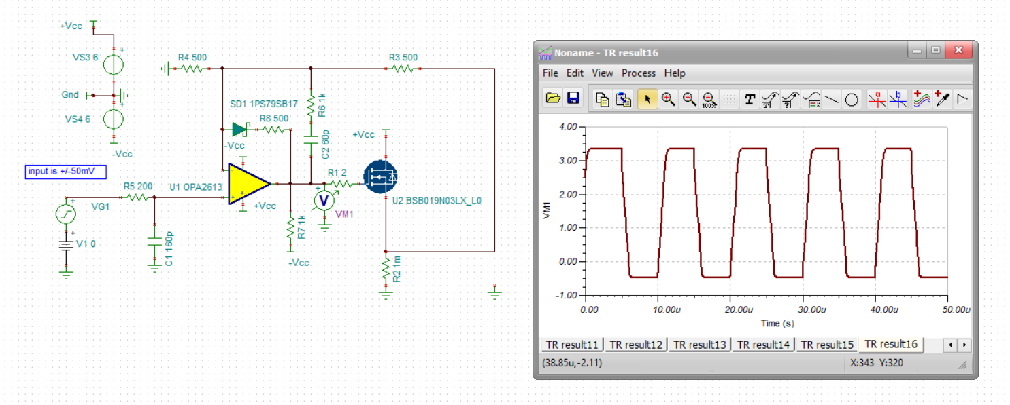
Now lets look at the op amp output pin current, nothing out of range here,
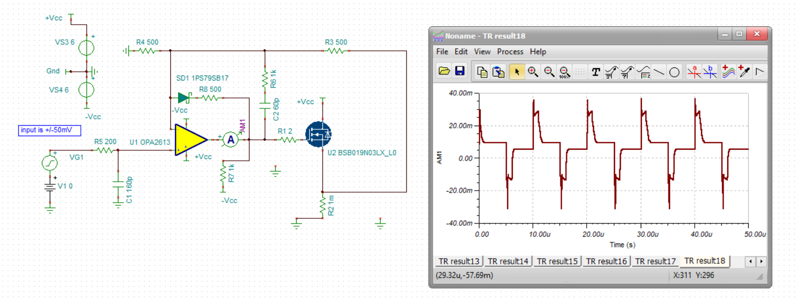
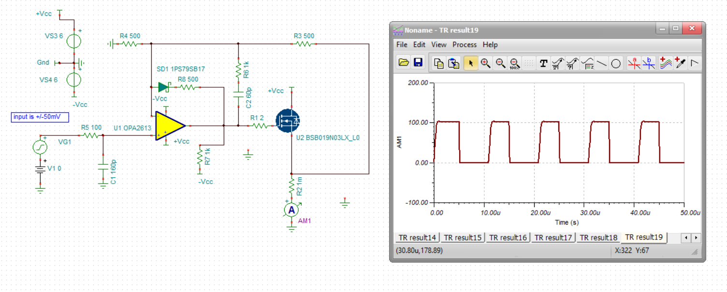
Back to a 0 to 100A output, looks like the pulse has been shortened due to the switching transition – but nice edges. Let’s try just going 0V to 50mV on the input, little more square but that is because the output current is not going to zero and the FET is staying on – due to offset voltage in the op amp. Might want to flip this all around to take a bigger input swing to overwhelm the offset and run inverting attenuation.
