8th order bandpass options in filterpro

Well it allows you force an order, here I am doing 1kHz center with 100Hz span, at the bottom it gives you shape options – these are the polynomial coefficient tables essentially,

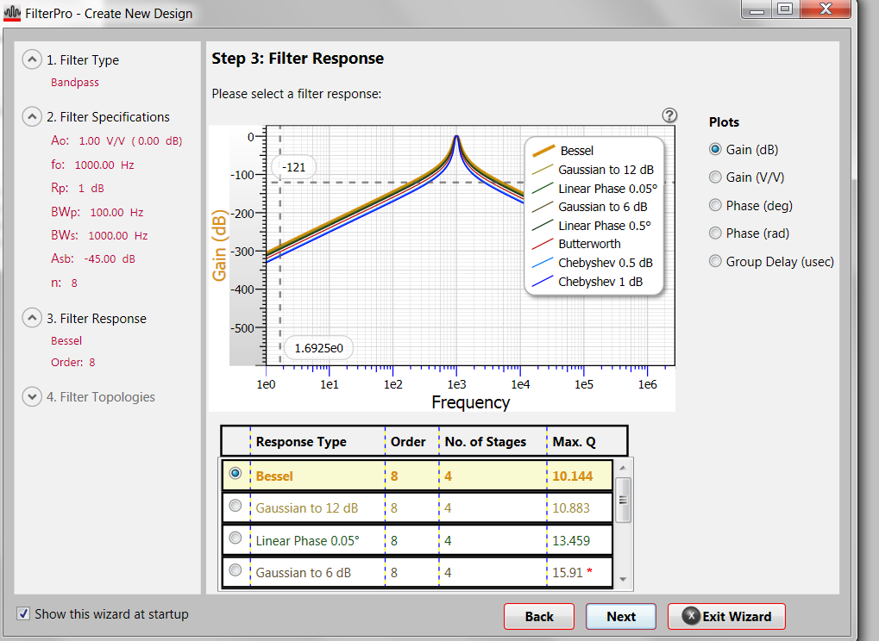
The Bessel will be linear phase through the passband,
Hitting next will give you this, these are pretty high Q’s for implementation – running monte carlo you will find a lot of spread on the shape,
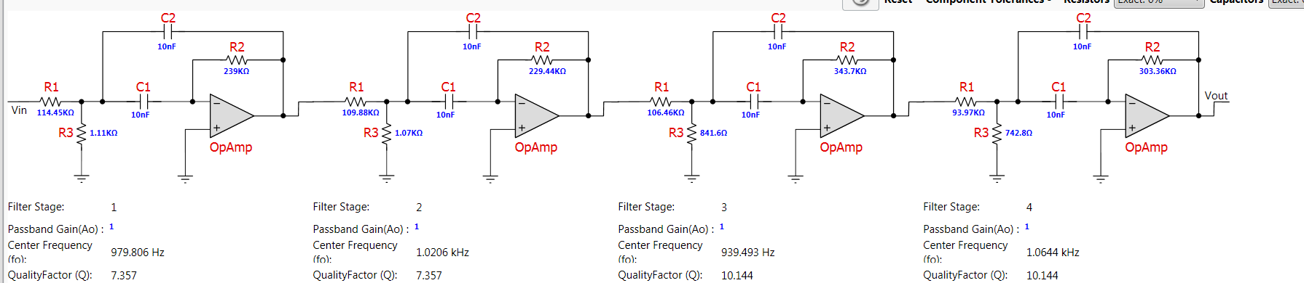
If I go back and change this so a Butterworth, even higher – can’t implement that,
