AFE030 Register settings
06/21/2021
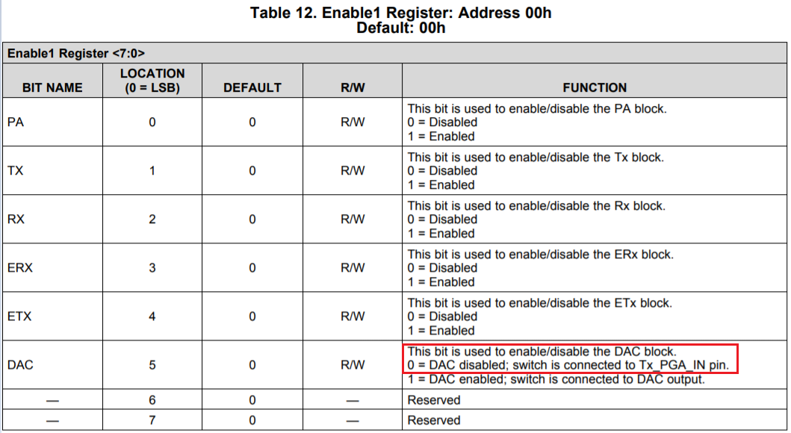
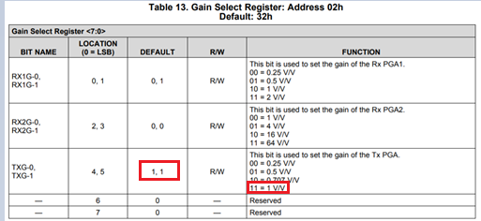
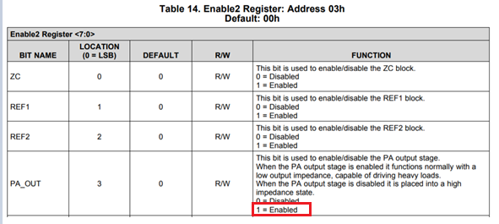
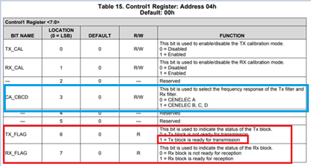

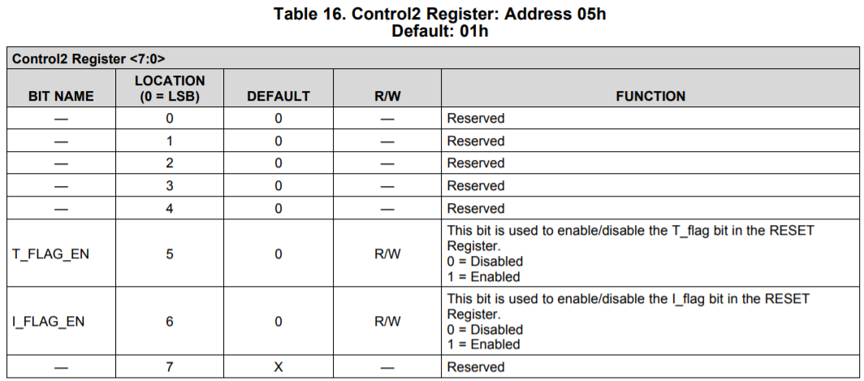

Two PWM Singals and additional RC filters – Figure 29 is two wire PWM mode. Figure 28 is one wire mode.
Modulated PWM signals are directly fed from MCU’s GPIOs. SPI is only needed to configure the AFE030’s registers. Use impedance matching resistors per recommendations shown in Figure 29, see the block diagram.
Since you are not suing SPI for transmitting DAC data, you do not need fast SCLK frequency to communicate with AFE030.
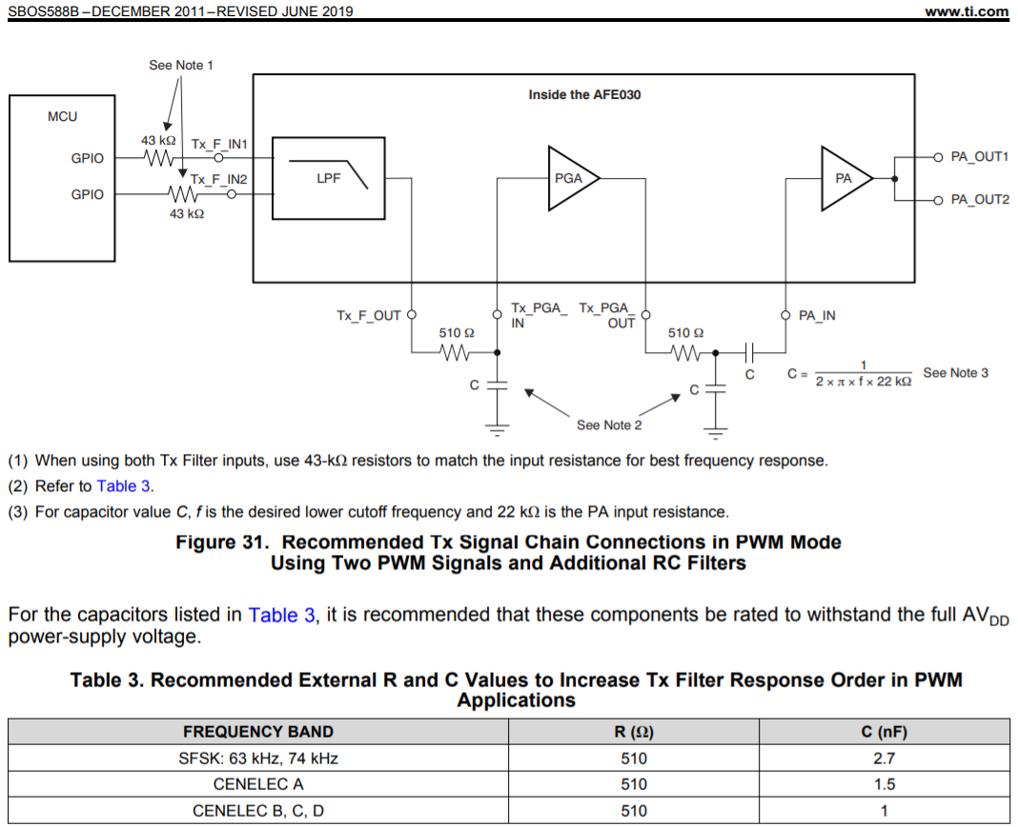

FOR SPI serial communication, you need to select one of two avaiable modes to operate. Please pay attention of to rising and falling edge requirements in each SPI Mode.
