**TECHNICAL ARTICLE** [**https://www.allaboutcircuits.com/technical-articles/understanding-photovoltaic-and-photoconductive-modes-of-photodiode-operation/**](https://www.allaboutcircuits.com/technical-articles/understanding-photovoltaic-and-photoconductive-modes-of-photodiode-operation/)

**Understanding Photovoltaic and Photoconductive Modes of Photodiode Operation**

December 20, 2020 by [**Robert Keim**](https://www.allaboutcircuits.com/author/robert-keim)

**In this article, we’ll look at advantages of two types of photodiode implementation.**

When should you use photovoltaic and photoconductive modes when implementing photodiodes? In this article, we'll discuss the details of these modes and design choices associated with them.

This is part three of our Introduction to Photodiodes series, which explores the technical details of these devices that respond to high-frequency EM radiation in various forms:

1. [The Nature of Light and pn Junctions](https://www.allaboutcircuits.com/technical-articles/introduction-to-photodiodes-the-nature-of-light-and-pn-junctions/)
2. [Physical Operation of Light-Sensitive pn Junctions](https://www.allaboutcircuits.com/technical-articles/physical-operation-of-light-sensitive-pn-junctions/)
3. **Understanding Photovoltaic and Photoconductive Modes of Photodiode Operation**
4. [Characteristics of Different Photodiode Technologies](https://www.allaboutcircuits.com/technical-articles/characteristics-of-different-photodiode-technologies/)
5. [Understanding the Photodiode Equivalent Circuit](https://www.allaboutcircuits.com/technical-articles/understanding-the-photodiode-equivalent-circuit/)

**Photocurrent**

The basic output of a photodiode is current that flows through the device from cathode to anode and is approximately linearly proportional to illuminance. (Keep in mind, though, that the magnitude of the photocurrent is also influenced by the wavelength of the incident light—more on this in the next article.) Photocurrent is converted into a voltage for further signal processing by a series resistor or a current-to-voltage amplifier.

The details of a photodiode’s light-to-current relationship will vary according to the diode’s biasing conditions. This is the essence of the distinction between photovoltaic mode and photoconductive mode: In a photovoltaic implementation, the circuitry surrounding the photodiode keeps the anode and cathode at the same potential; in other words, the diode is zero-biased. In a photoconductive implementation, the circuitry surrounding the photodiode imposes a reverse bias, meaning that the cathode is at a higher potential than the anode.

**Dark Current**

A major non-ideality that affects photodiode systems is called dark current, because it is current that flows through the photodiode even when no illumination is present. The total current flowing through the diode is a summation of dark current and photocurrent. Dark current will limit the system’s ability to accurately measure low light intensities if these intensities produce photocurrents with magnitudes similar to the magnitude of the dark current.

The deleterious effect of dark current can be mitigated by techniques that subtract the expected dark current from the diode current. However, dark current comes with dark noise, i.e., a form of shot noise observed as random variations in the magnitude of the dark current. A system cannot measure light intensities whose associated photocurrent is so small as to be lost in the dark noise.

**Photovoltaic Mode in Photodiode Circuits**

The following diagram is an example of a photovoltaic implementation.

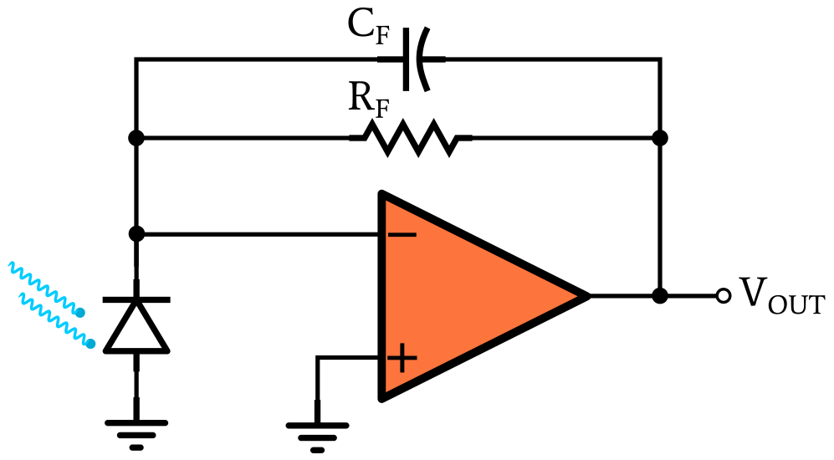

This op-amp circuit is called a transimpedance amplifier (TIA). It is designed specifically to convert a current signal into a voltage signal, with the current-to-voltage ratio determined by the value of the feedback resistor RF. The op-amp’s non-inverting input terminal is grounded, and if we apply the virtual short assumption, we know that the inverting input terminal will always be at approximately 0 V. Thus, the photodiode’s cathode and anode are both held at 0 V.

I’m not convinced that “photovoltaic” is a completely accurate name for this op-amp-based implementation. I don’t think that the photodiode is functioning like a solar cell that generates voltage by means of the photovoltaic effect. But “photovoltaic” is accepted terminology, whether I like it or not. “Zero-bias mode” is better, I think, because we can use the same TIA with the photodiode in photovoltaic or photoconductive mode, and thus the absence of a reverse-bias voltage is the most conspicuous distinguishing factor.

**When to Use Photovoltaic Mode**

The advantage of photovoltaic mode is the reduction of dark current. In a normal diode, applying a reverse-bias voltage increases reverse current, because the reverse bias reduces diffusion current but does not reduce drift current, and also because of leakage.

The same thing happens in a photodiode, but the reverse current is called dark current. Higher reverse-bias voltage leads to more dark current, so by using the op-amp to hold the photodiode at approximately zero bias, we virtually eliminate dark current. Thus, photovoltaic mode is good for applications that need to maximize low-illuminance performance.

**Photoconductive Mode in Photodiode Circuits**

To switch the above detector circuit over to photoconductive mode, we connect the photodiode’s anode to a negative voltage supply instead of ground. The cathode is still at 0 V, but the anode is at some voltage below 0 V; thus, the photodiode is reverse-biased.

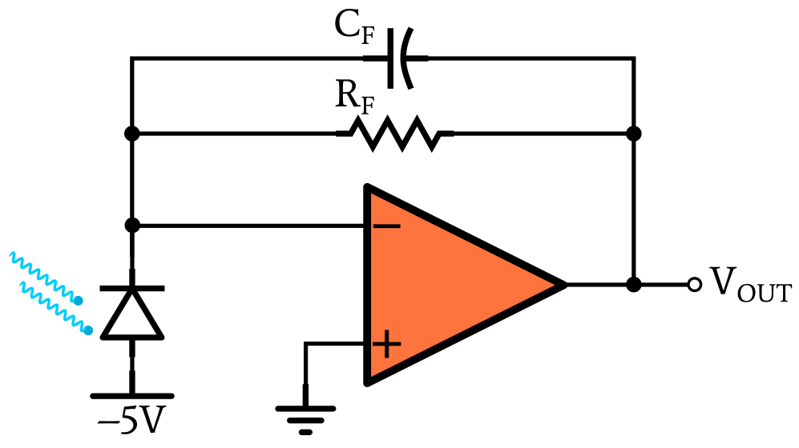

**When to Use Photoconductive Mode**

Applying a reverse-bias voltage to a pn junction causes the depletion region to become wider. This has two beneficial effects in the context of photodiode applications. First, a wider depletion region makes the photodiode more sensitive, as explained in the preceding article. Thus, photoconductive mode is a good choice when you want to produce more output signal relative to illuminance.

Second, a wider depletion region reduces the photodiode’s junction capacitance. In the circuit shown above, the presence of the feedback resistance and the junction capacitance (along with other sources of capacitance) limits the closed-loop bandwidth of the system. As with a basic RC low-pass filter, reducing capacitance increases the cut-off frequency. Thus, photoconductive mode allows for wider bandwidth and is preferable when you need to maximize the detector’s ability to respond to rapid variations in illuminance.

Finally, reverse bias also extends a photodiode’s range of linear operation. If you’re concerned about maintaining accurate measurements with high illuminance, you can use photoconductive mode and then choose the reverse-bias voltage according to your system requirements. But remember that more reverse bias also increases dark current.

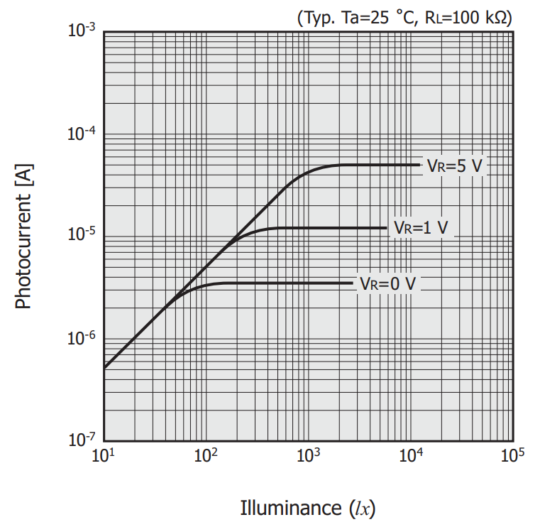

***Hamamatsu is a leading manufacturer of photodetectors. This plot, taken from their***[***Silicon Photodiodes Handbook***](https://www.hamamatsu.com/resources/pdf/ssd/e02_handbook_si_photodiode.pdf)***, gives you an idea of how much you can extend a photodiode’s region of linear response by increasing the reverse-bias voltage.***

**Recap**

The performance of a photodiode-based detector system is influenced by the photodiode’s biasing conditions. Photoconductive mode employs reverse biasing and provides higher sensitivity, wider bandwidth, and improved linearity. Photovoltaic mode employs zero bias and minimizes dark current.

The next article in the Introduction to Photodiodes series covers several different [photodiode semiconductor technologies](https://www.allaboutcircuits.com/technical-articles/characteristics-of-different-photodiode-technologies/).