Applying the OPA862 as an MFB filter
Michael Steffes March 13, 2021
This device was intended to get a high input impedance single to differential conversion stage. Since it has an op amp in it, perhaps that can be used to implement an MFB filter.
First need to add that op amps parameters to my MFB design tools starting with true GBP.
Run an open loop sim to extract this – since it has a differential load across the two outputs, where that internal inverting stage will be swinging wildly for an Aol test, cancel that externally with a -8.4kohm element. Presumeably, if I can get all the nodes DC biased at 0V, that 700ohm into the inverting stage will also look like a load, but it is really always there, so need to leave it for an Aol sim.
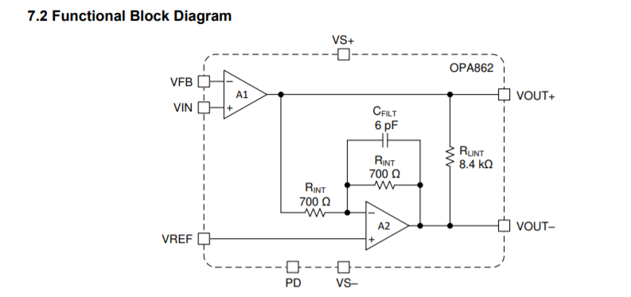
Most of the tests seem to be with a 1kohm load, so use that for Aol, Here is a DC run, yep output a ground – just trying to isolate on the op amp internal to the model,
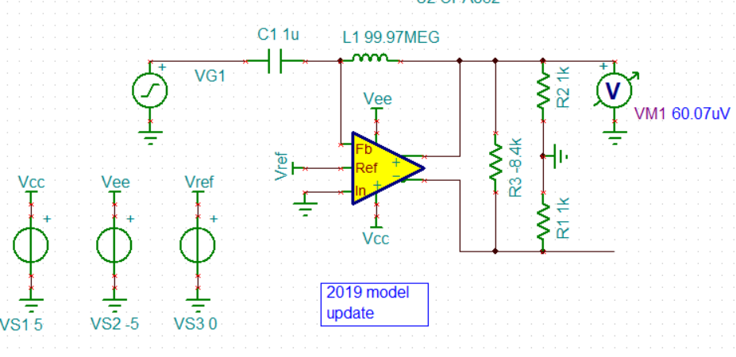
Ok, here is the Aol gain and phase (changing that input cap to 99.97M), So it is a 191MHz GBP
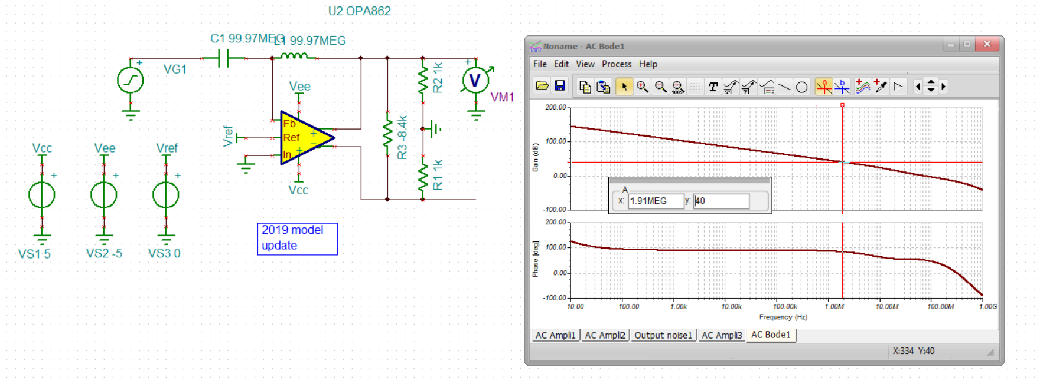
With about 50deg phase margin at unity gain xover at 72MHz, I would expect the closed loop gain of 1 to be about 1.6*72Mhz = 115MHz? Lot lower than what the data sheet says?
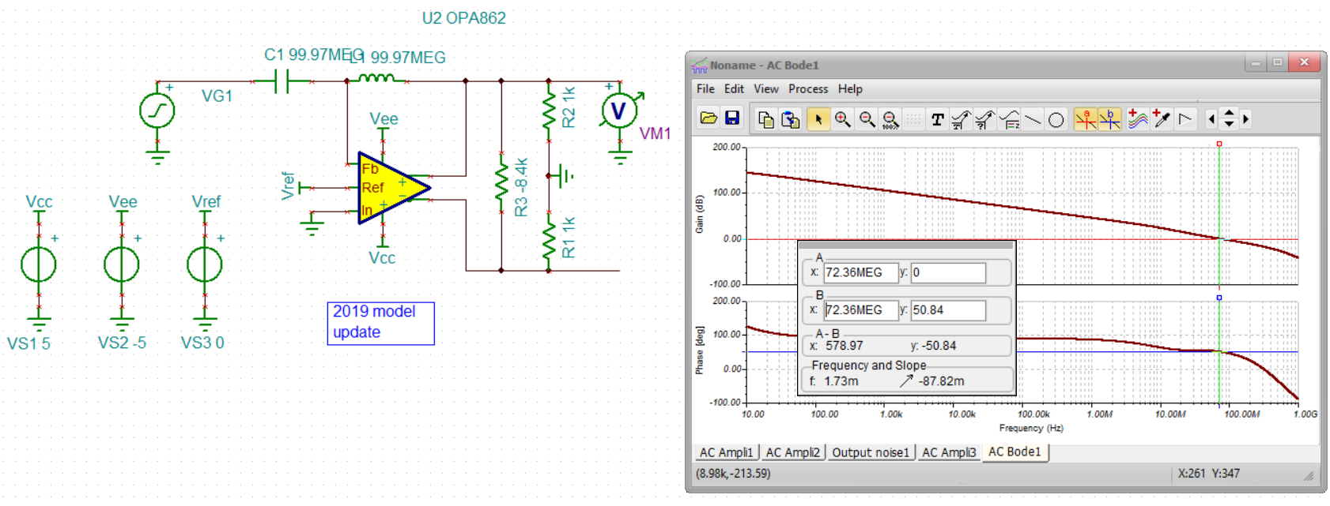
So let’s try that single ended test of the upper op amp. Yep, so it simulates out as about 120MHz gain of 1 – great fit to Aol analysis.
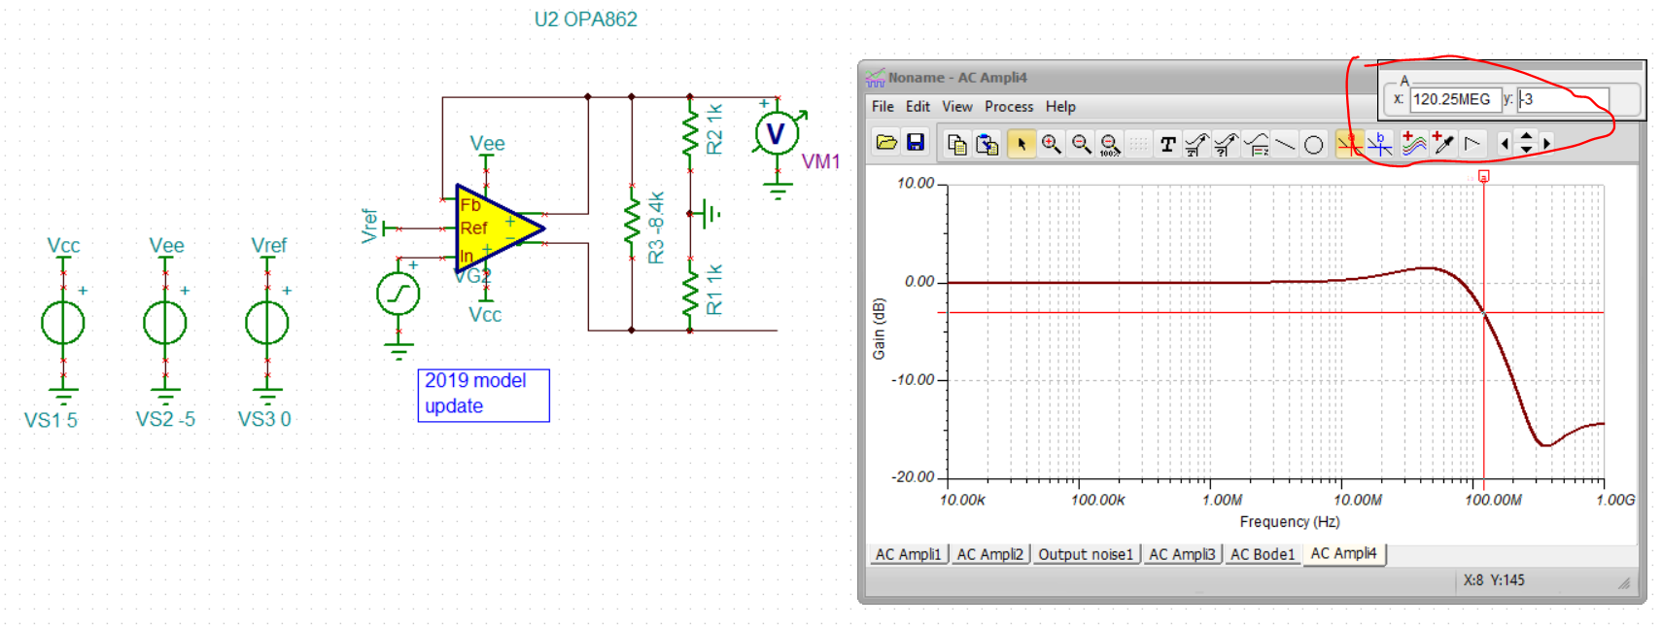
Yea, not sure were these differential out numbers are coming from. This gain of 2 is top op amp gain of 1 then inverted to get a gain of 2 differential. That 6pF across the 700ohm feedback in the inverting stage is 38Mhz, so maybe that is where it is coming from, but the raw unity gain output from the op amp stage is 120MHz. Oh well,

0.25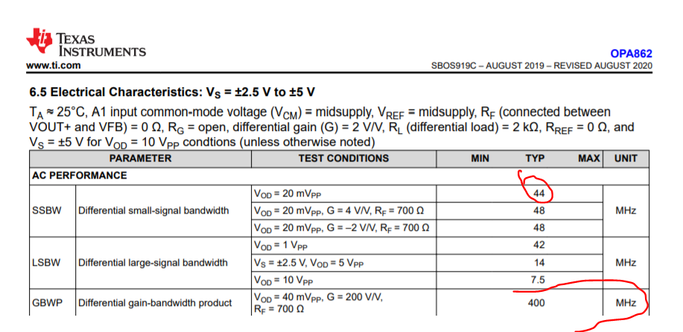
Ok, continue to build parameters for the MFB tool.
The stated 140V/usec slew rate will be differential, so 70V/usec for just the op amp stage.
Output voltage headroom 0.25V
Input headroom 0.5V on the negative side, 1.1V to the positive supply.
Operating supply range 3 to 12.6V (using +/-5V spec values)
Typ input offset 50uV
Type input bias current 1uA
Typ input offset current A1 4nA
Min Linear output current 40mA
Ccm + Cdm = 2.5pF,
Input voltage noise 2.3nV, 30Hz corner
Input current noise .7pA, 1kHz corner
DC Aol, from sim, 150dB (31.6E6) very high, not likely but use.
Here is what that eventually looks like for design, use the TINA model GBP for design
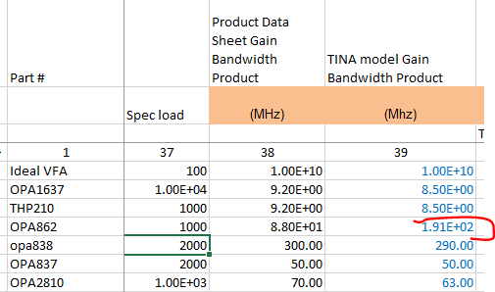
Ok, that GBP is pretty high – looks like an added pole zero way out there to pull xover back under 100MHz with good phase margin. Yea, you can see the 2nd pole mainly in the phase, but then that tilts up again around xover,
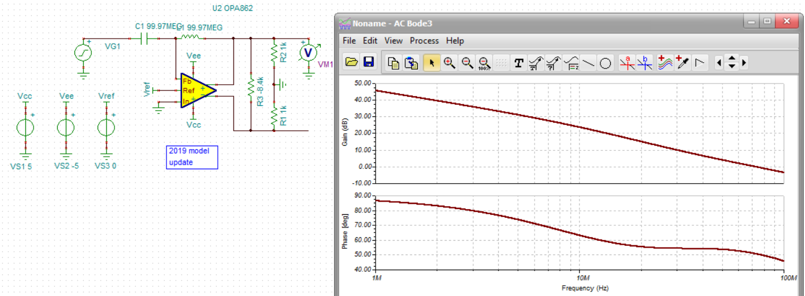
Ok, so we have an op amp inside the part now available for MFB design,
Going back to the original request that was this (and this part is way too fast for this design), And since will have an inverted output to double the gain, target a MFB gain of 15

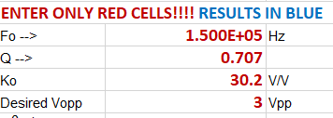
Targeting a min Rg inverting input R of approx.. 300ohm gives this set of R’s

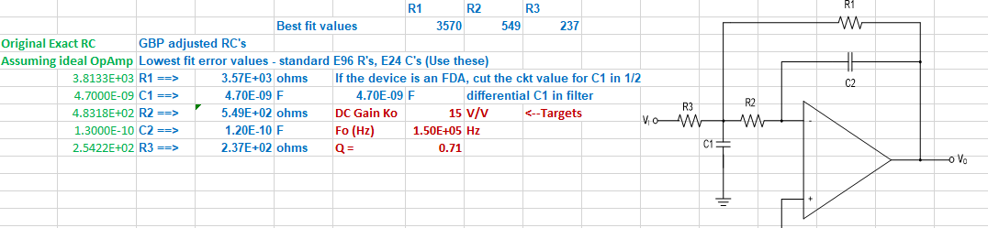

And here is the filter, checking DC points 1st. If we leave the non-inverting inputs at ground, the output CM should be about ground and it is. If we need a higher output CM, would have to feed that into the Vref then divide that down by the MFB gain to feed into the Vin point if the filter is DC coupled, IF AC coupled at the input can just feed Vref into both that and VIN. The probe is on the lower output, looks pretty good,
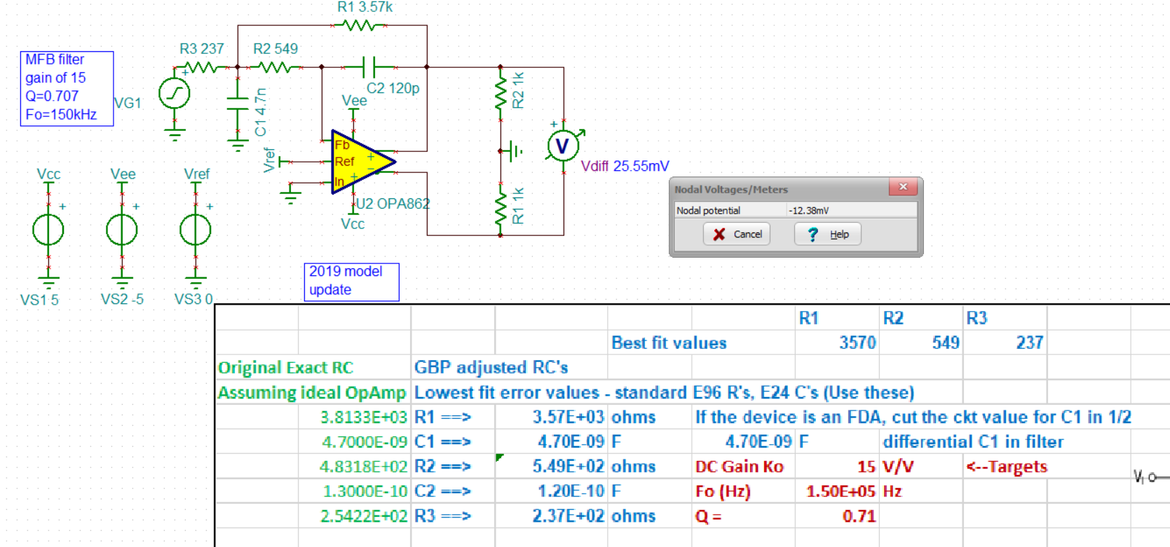
Here is the differential filter response, This looks remarkably good
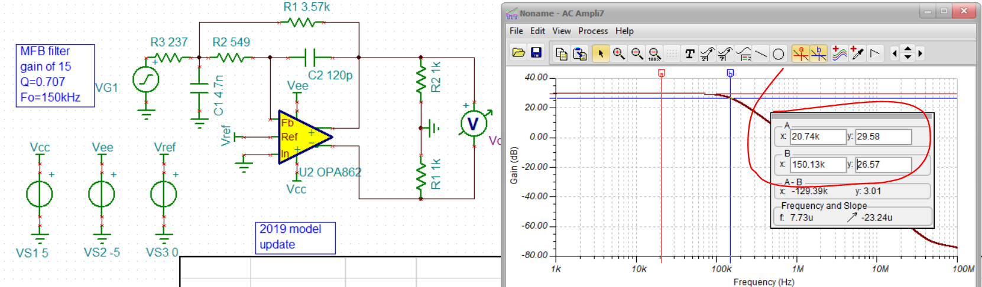
And then the differential output noise, and this looks really good,
