Can Audio Experts Lean on Information Coming out of High-Speed Amplifier Developments?
Michael Steffes, Sr. Applications Manager, July 2019
In the course of my 32years of high speed amplifier developments, we were often designing for the next generation test equipment. The irony is that there was usually nothing we could buy to perform some of the necessary parametric measurements. Hence, a great deal of advanced characterization and application tricks came out of the high-speed groups that may not have filtered out into the audio world. For instance –
How do the spurious levels coming into an ADC combine with the ADC generated terms for a combined FFT output spurious level?
This kind of fundamental question leads into the necessary spurious input levels to hit a target degradation through the ADC. To combine distortion terms, you can work in absolute voltage swing levels for the harmonics, more commonly the -dBc specifications, or the negative of that – the SFDR for the highest spurious. Working in -dBc specifications will yield an expression that applies more globally.
Some of the legacy literature simply repeats the THD equation shown as Eq. 1 – This is converting the -dBc specification for a harmonic distortion terms (2nd and 3rd usually dominant) at the ADC input pins and the ADC -dBc specification into a power, adding those and taking the square root, then converting back to a -dBc specification.
Eq. 1

So, for instance, if both the signal coming and the ADC have -90dBc HD2, this equation predicts -87dBc combined. But really??
The ADC is accepting the input harmonic distortion as a signal, then generating its own harmonic at the same frequency to combine with the input harmonic. Eq. 1 is essentially assuming those two terms add in quadrature (if you think of little sine waves at the harmonic frequencies with some phase relation -90deg out of phase is the assumption of Eq. 1). There is no reason for that assumption to be accurate – and, in fact, the two harmonic sine waves add in phase as a V_{pp} addition – they stack up on top of each other increasing the voltage swing at the harmonic frequency. Correcting equation 1 to add voltages instead of powers, gives Equation 2 –

Eq. 2

Putting two -90dBc terms into Equation 2 will give a -84dBc combined result coming out of the ADC in the FFT – a 6dB degradation. But even more generally, if we ramp the input harmonic distortion down how does the net result behave. Figure 1 shows this where both ADC and input signal start out at -90dBc and the HD at the input pins is ramped down going to the right. The combined result slowly approaches the ADC only number as the input spurious goes down. In fact, to degrade the ADC by no more than +1dBc, equation 2 can be solved to show a 19dBc better input harmonic distortion is required. This plot in dBc looks the same for any starting point on the ADC – from any ADC only spurious specification tone by tone, the input signal would need to have a harmonic distortion term that is a least 19dB below that ADC term to yield <1dB degradation. Or, equation 2 can be used with the actual levels to get the combination. A common target in the literature has been 10dB better than the ADC coming into the input pins. That is fine, but note that will degrade the ADC only specification by 2.4dBc.
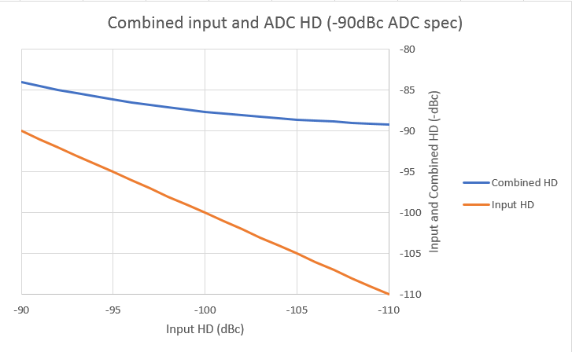
Figure 1. Combining input signal and ADC only harmonic distortion -dBc for a combined result.
This much more extreme requirement explains the much lower HD targets in the most recent Fully Differential Amplifier product introductions like that shown in Figure 2 (Figure 13, Reference 1). Similarly <-145dBc harmonic distortions show up the newest April 2019 FDA introduction (Reference 2).
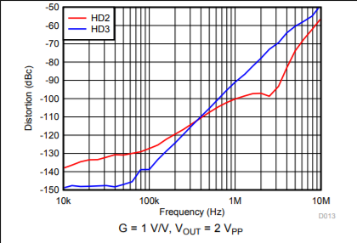
Figure 2. Example very low HD performance for the recent THS4551 FDA device.
The next two technical briefs will show bench data reconfirming this V_{pp} additive distortion effect for a recent two stage amplifier product then go on to describe how you might actually take the data of Figure 2 (hint, it is definitely not an Audio Precision solution).
References:
- TI THS4551, “Low Noise, Precision, 150MHz, Fully Differential Amplifier” http://www.ti.com/lit/ds/symlink/ths4551.pdf
- ADI ADA4945-1, “High Speed, +/-0.1μV/°C Offset Drift, Fully Differential ADC Driver”, https://www.analog.com/media/en/technical-documentation/data-sheets/ADA4945-1.pdf

