Original question

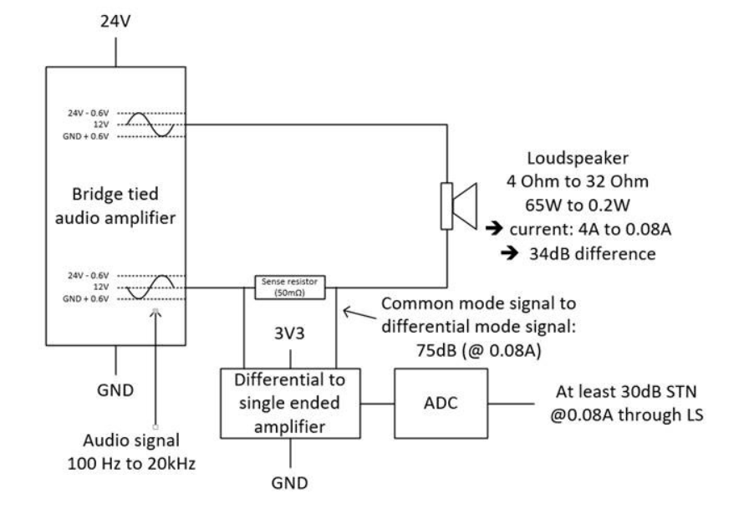

An alternate approach might be to use a dual high CMRR and supply range VFA as buffers into a diff I/O FDA stage.

One cool capability it adds is the ability to add diff gain while still level shifting the output CM to the required level for the ADC. That will happen regardless of anything else due to the FDA CM loop creating a Icm level shift current in the resistors.

The ADC can accept diff inputs, and it would give better results if you take advantage of that.

For instance, if your max diff signal across that 50mOhm is +/-3A\*50mOhm = 150mV (is that RMS, or peakpeak – may need adjusting for Vpp) To get up to say 4Vpp at the ADC, need a gain in the FDA of 13V/V – fortunately, there are plenty of choices like the THS4131 which will give a BW of 7MHz at a diff gain of 13. Plenty to noise bandlimit with a 2nd order Butterworth at 22kHz.

The FDA needs to level shift the 12Vcm coming in down to say 1.65Vcm at the ADC inputs. With gain, the summing nodes don’t move much down from the 12Vcm input so the higher voltage THS4131 is suitable.

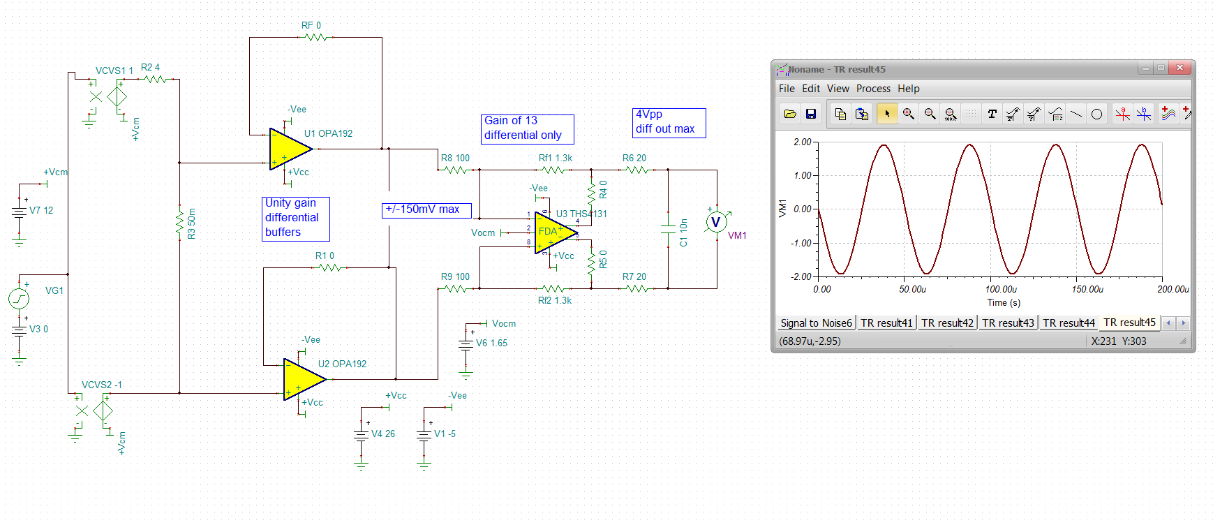

Will look at SNR with 4Vpp output (1.4Vrms) – add a 22kHz butterworth MFB into the FDA stage,

Actually, I am going to use input blocking caps so no CM level shift is required – use the THS4551.

Here that is, those 6uF set about an 80Hz HP

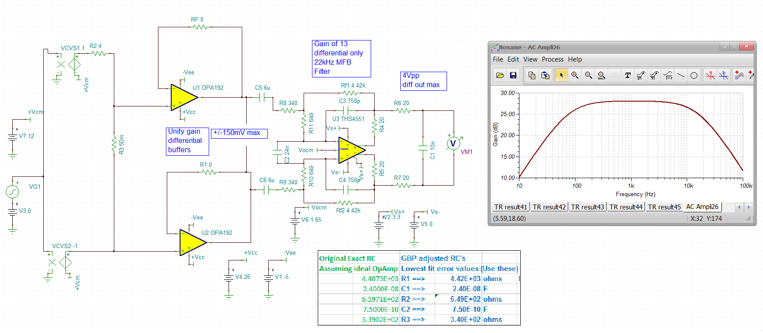The response looks good, the SNR is surprisingly good, but this is max input swing,

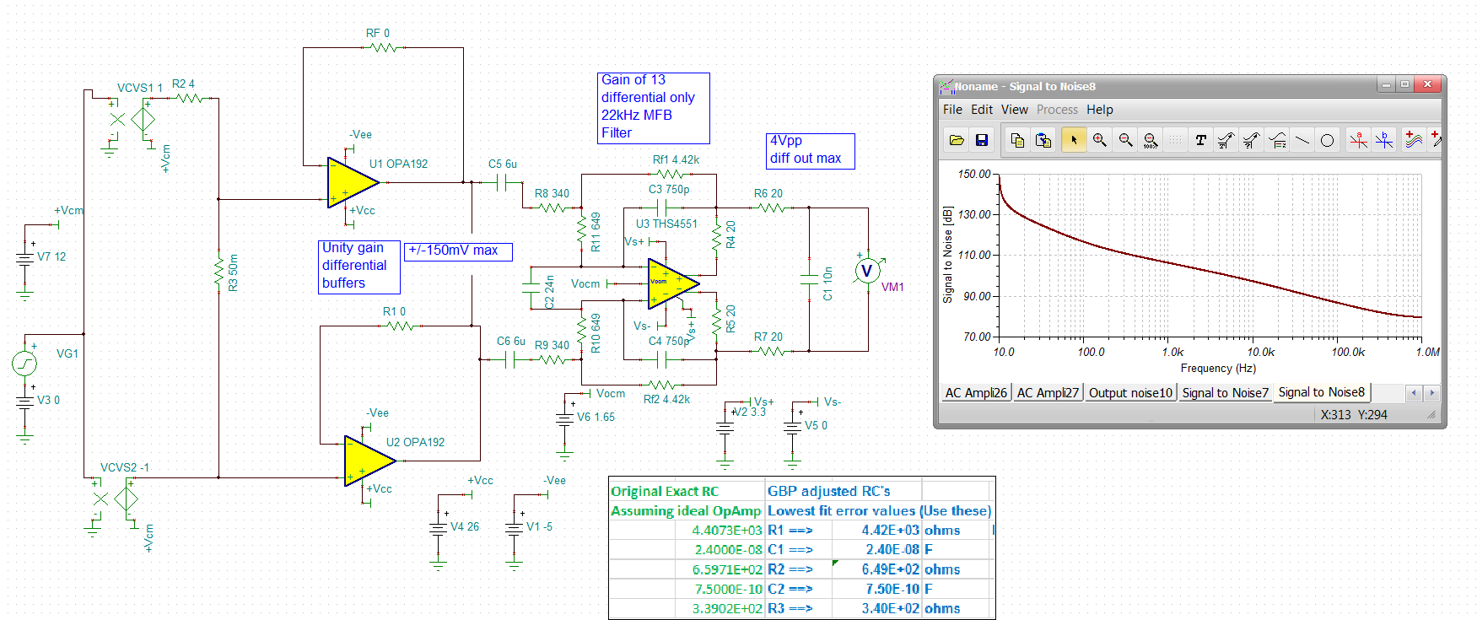

Going down to min input would drop this by 34dB, still pretty good.

The input OPA192’s have plenty of I/O headroom and great CMRR. The FDA CMRR will be set by how well the two Rf and Rg resistors are matched – would need to be 0.1% at least or get a matched array.