Lets continue the SR mapping from LSBW on the OPA2810 PDS and model.
Michael Steffes, Dec 4,2020.
Going to that article where I tried to account for SSBW effects in the transition region, that equation is here –
Full article here again, this article was mainly trying to find the peak dV/dT on a 2nd order step to allow an easy comparison to available slew rate – this actually came out of a screening effort to apply adequate op amps to filter designs. Once I had the expected peak dV/dT on the output of each filter stage (and the gain sequencing gets into that directly of course), I would screen to op amps offering at least 2X that signal requirement.
https://www.edn.com/what-is-op-amp-slew-rate-in-a-slew-enhanced-world-part-2/

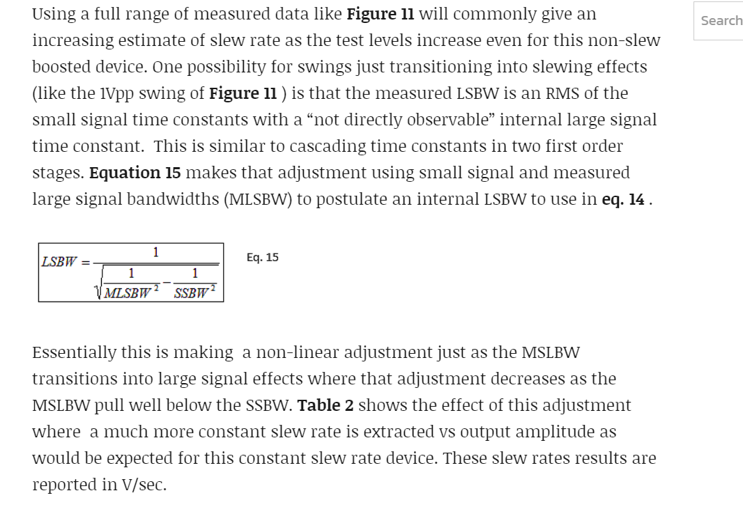
So again looking at the 10V specs,
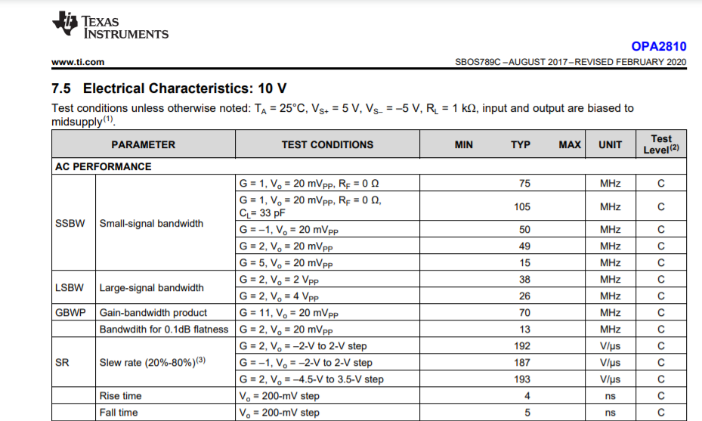
So using the SSBW of 49Mhz and the 2Vpp 38MHz MLSBW, the implied LSBW would be 60MHz. Using this equation for mapping to implied SR, extracts an estimate of 213V/usec.
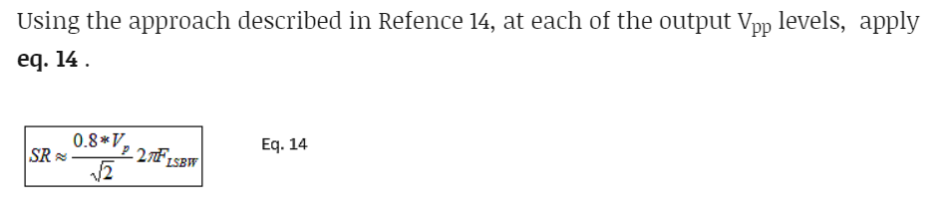
Now repeat this with the 4Vpp 26MHz MLSBW number. Implied LSBW extracted is 30.7MHz, and then using Eq14 above that estimates 217V/usec – I would say this is working extremely well. And incidentally that app note Xavier Ramus did where we are getting the added 0.8 factor is here,
https://www.ti.com/lit/an/sboa126/sboa126.pdf

So, my extraction from the spec lines is about 217V/usec SR.
We can go on and try to run slew limited time waveforms are take point dV/dT to see where it goes flat – this is much more useful from bench data, but the sim model should give some information. And actually just running a large step and picking a couple of points off the ramp was easy here.
Doing this a simply as possible, just run the gain of 1 reference design with +/-10V input – yes, this output waveform shows 214V/usec SR. That would appear to be the number and the more detailed SR extraction from measured LSBW matches up very nicely with the model SR.
