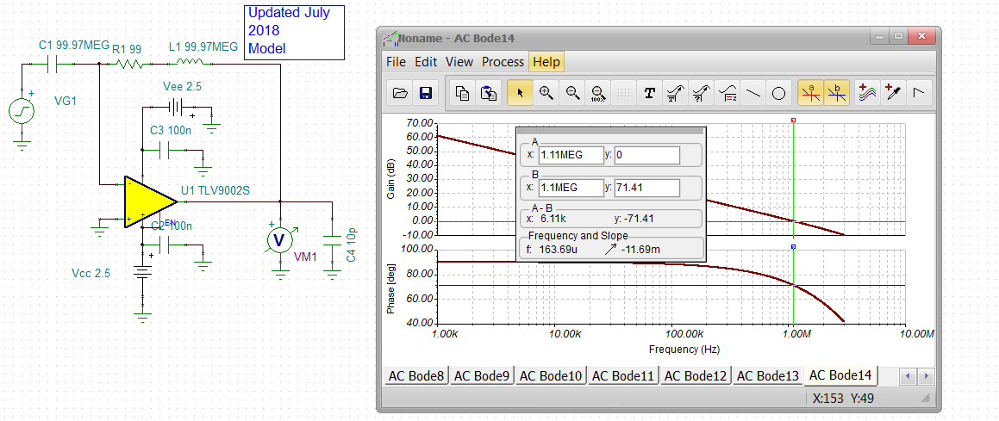

Figure 9. Aol simulation looks pretty close, phase margin at Aol =0dB is 71deg here in sim, Figure 9 looks closer to 80deg. The polarity of VM1 is reporting not phase shift, but phase margin – just like Fig.9.

