Final THS4551 stage phase margin tests with different models,
Michael Steffes 1/1/2021
There has been an evolution of the TINA model for the THS4551. The original one at release, I really focused on Aol and Zol fit to get accurate warnings of low phase margin in the ubiquitous filtering and load C driving apps,
Here is the current last stage circuit using the initial release model, predicting an oscillation with that -1.37deg phase margin, the approach used here is in this article,
https://www.planetanalog.com/stability-issues-and-resolutions-for-high-speed-fully-differential-amplifiers-fdas-insight-8/#
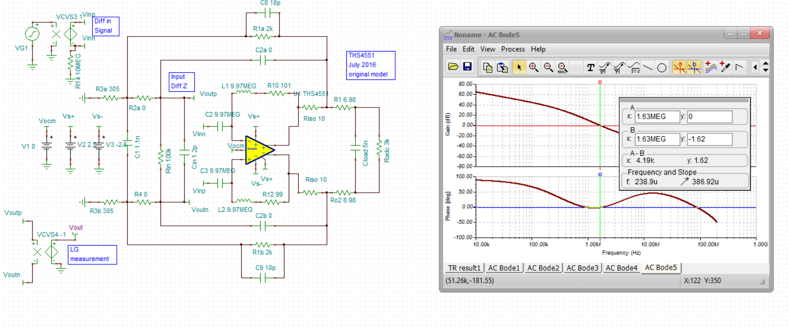
The model updates vary just a little bit from this with all of them showing instability.

Here is a 2019 update to the GWL template, I believe they softened the Zol resonance in this one, might not be as accurate for phase margin, but this is predicting unstable,

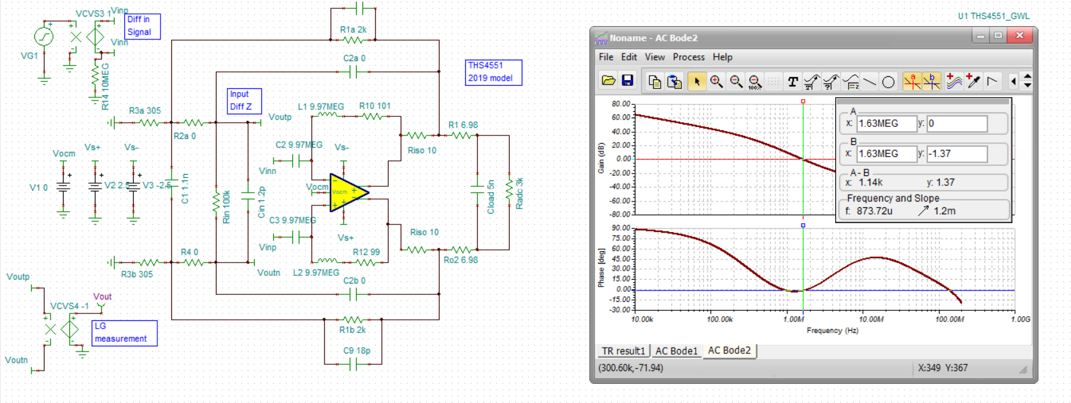
And then here is the most recent Feb. 2020 model update, about the same as the 2019 model,
