High gain cascaded stages 1MHz carrier, 150kHz data,
1st low power stage with OPA838 gain of 50 AC coupled, 50ohm input
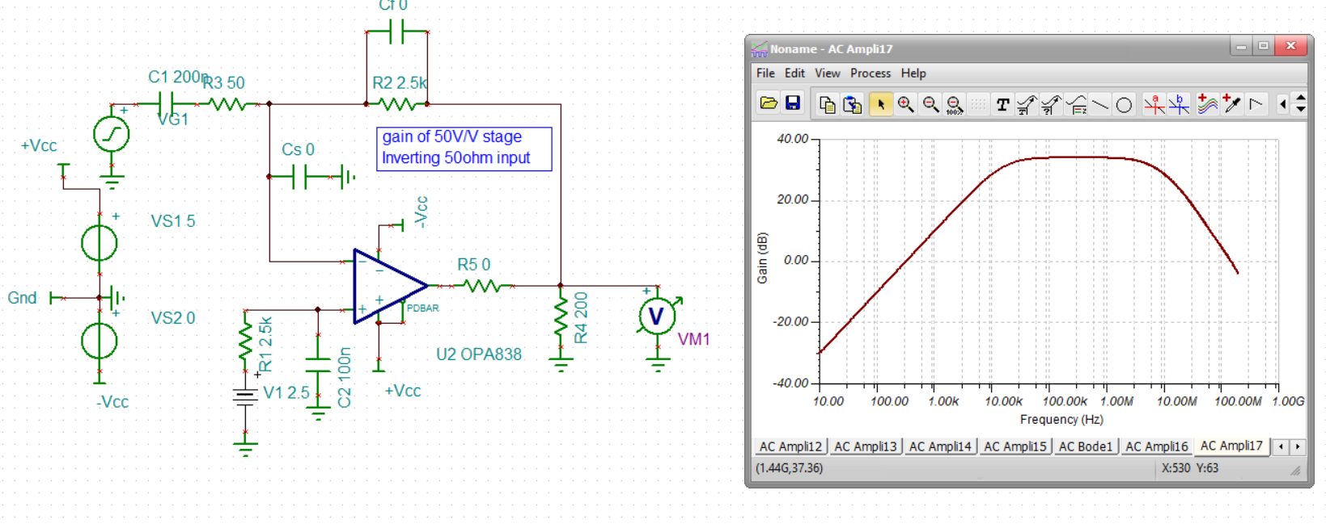
Now let’s add some bandlimiting in the feedback C, will need that cap to ground on the inverting input to keep stable,
Set feedback pole at 5Mhz, 12pF – to shape noise gain up to 8, set Cs to 90pF
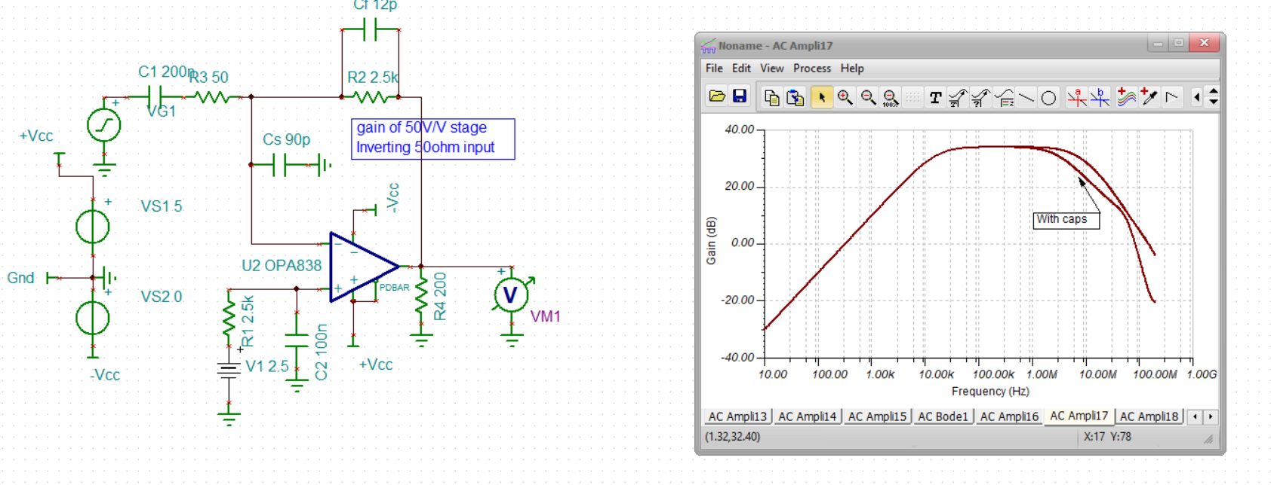
Now let’s look at the broadband output spot noise, looking for sharp spikes indicating resonance out of band, no resonance, looks ok if not particularly low,
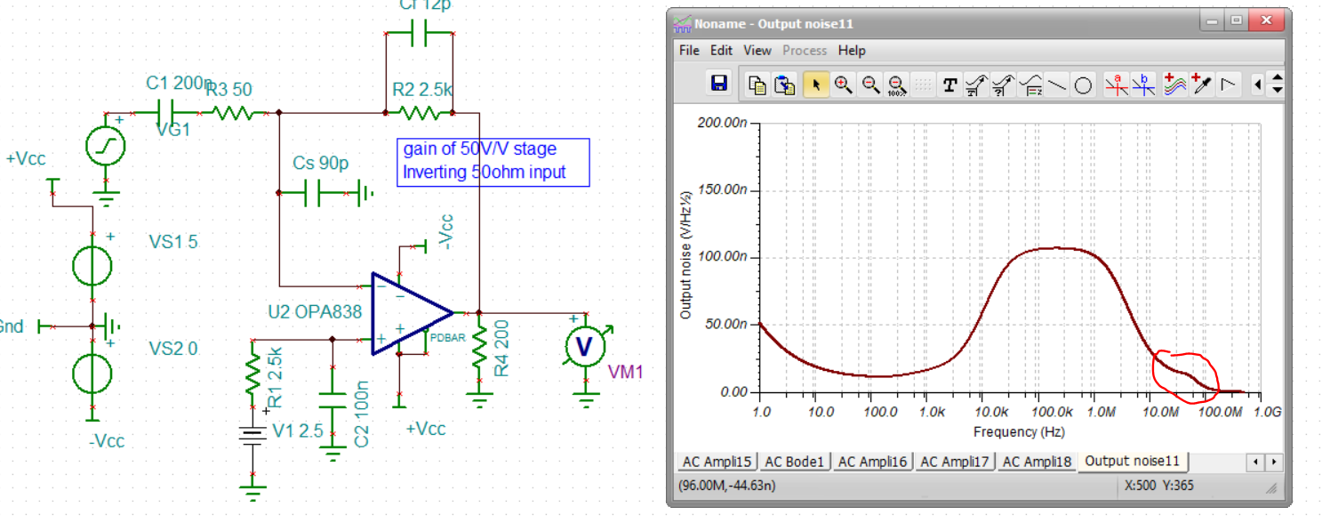
Input referred, and here I do not have the antennae source Z. This is ok, I do have other circuits that are more active input match that can be much lower than this if need be,
Input referred spot noise,
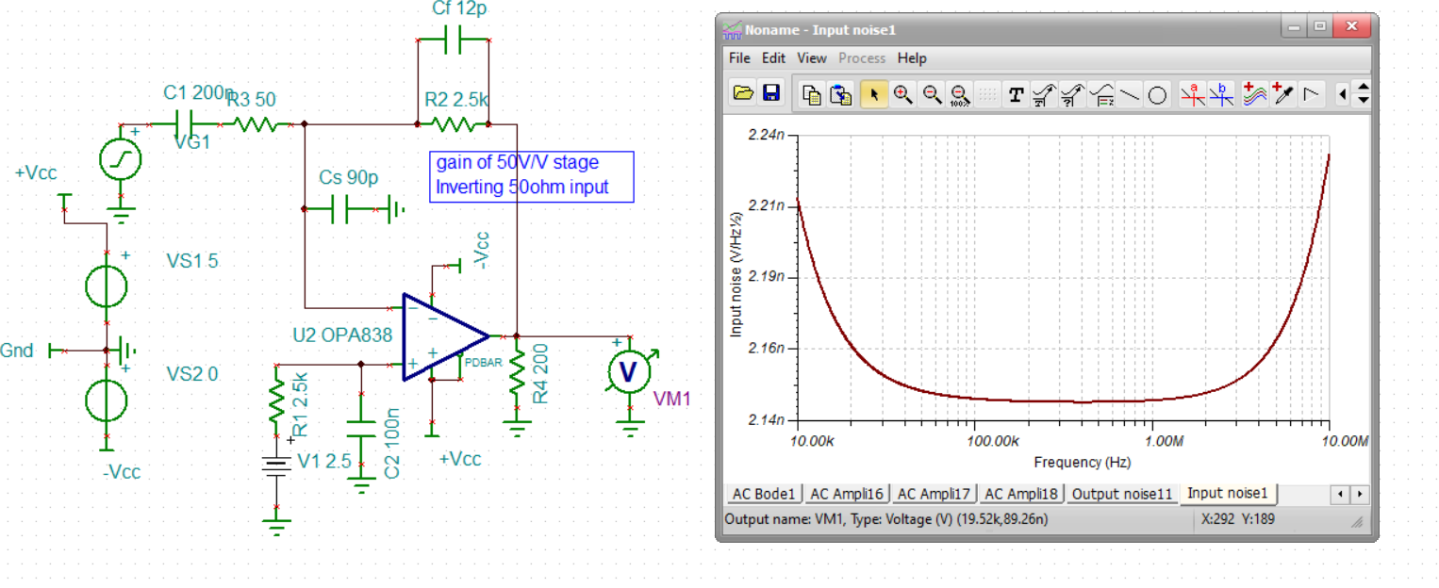
Ok, so this is a gain of 50V/V to get up to 5500 total, need a 2nd stage of 110V/V try the OPA684 improved CFA – don’t need super low noise there nor DC precision if AC coupled channel, This is non-inverting so the OPA838 does not have to drive that 22ohm input R, I have it set to 200ohm load + 2.5V bias path on the V+ input here,
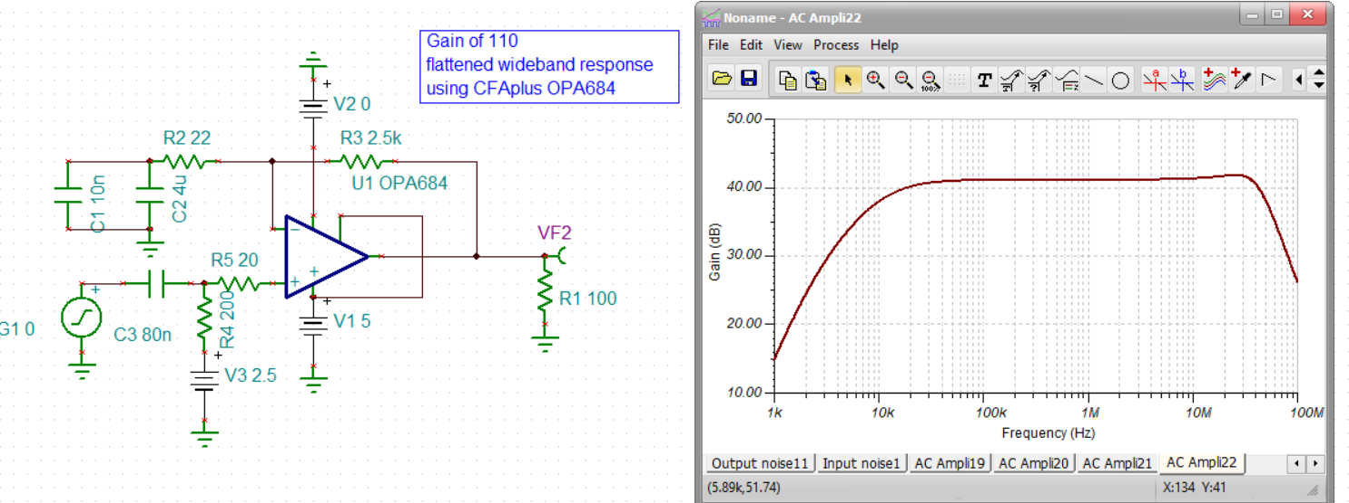
Now paste this on the output of the OPA838 input stage, had a lot of trouble finding an operating point – had to change to a trapezoidal integration and Davis KLU matrix solver, not sure that is available in V9. This 74.6dB gain is 5400V/V.
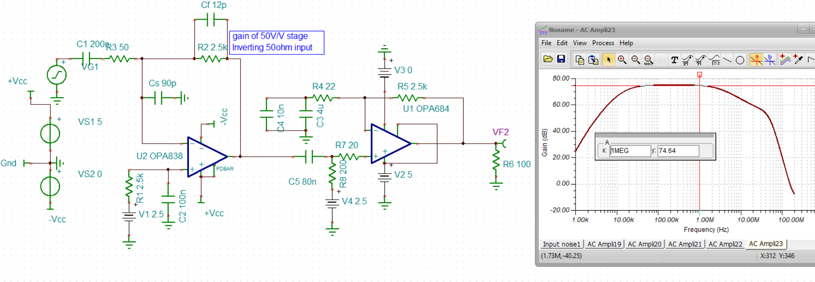
Re-running the input referred noise, should not have changed much over the OPA838 by itself, yup, the same.
