Circuit:

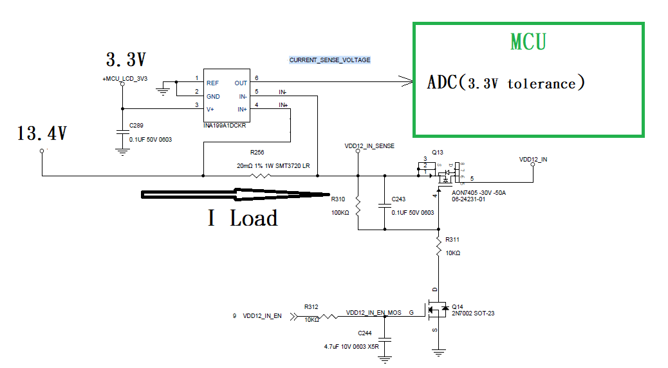

**Test1**: Pin6 output waveform of test dynamic load between 0.5A and 1.8A

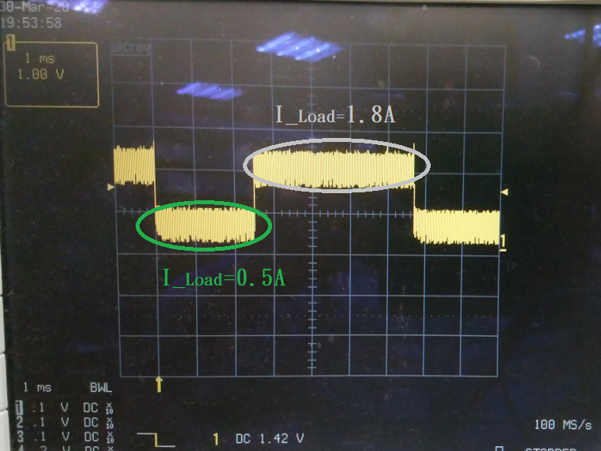

**Test2**: Pin6 output waveform of test Light load on 0.5A.

