Is it OK to connect address pins [A1:A0] to SDA/SCL with multiple slave devices on the same bus ?

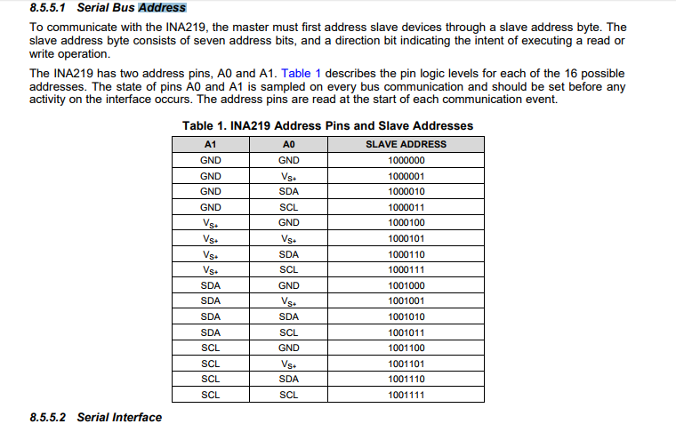

Example:
