**Phase 1: Use INA220 EVM tool get Calibration Value**

1. Enter Rshunt value : **0.0005**
2. Enter Max expected Current : **27**
3. Enter Current LSB : **1.3m**
4. Get Calibration Value : **F627**

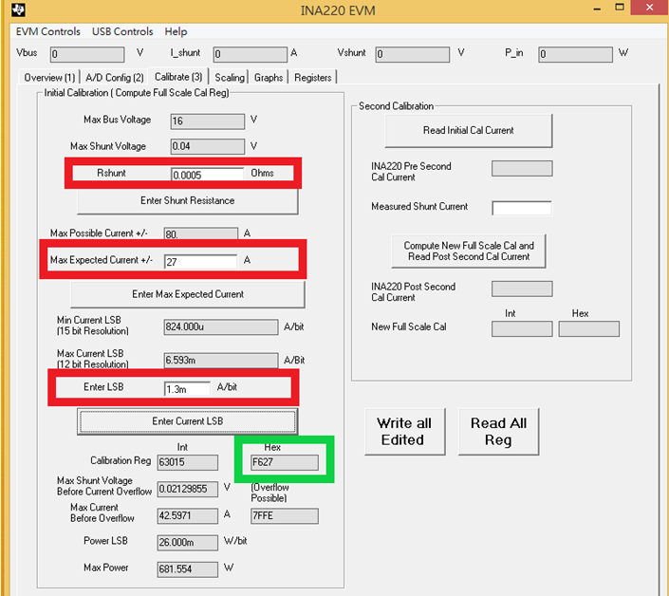

**Phase 2: write back the related parameters(eg.** Calibration Value**) to ina2xx.c linux driver (TBC- to be confirm with TI vendor)**

1. Configuration Register(add 0x00)

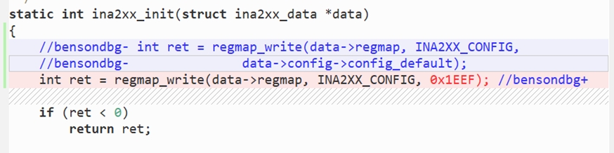

1. Calibration(add 0x05)

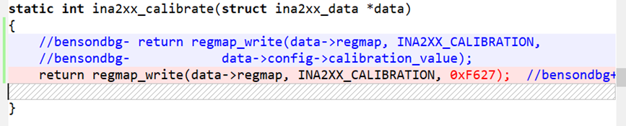

1. **current_lsb/power_lsb ????**

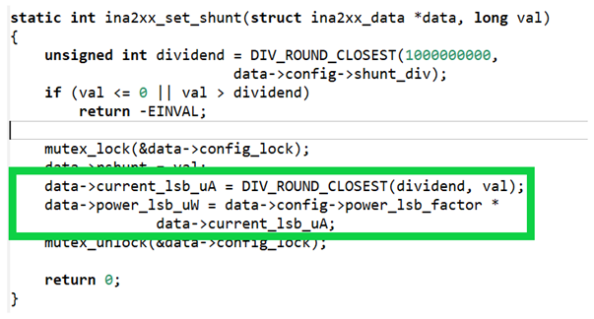

Note.

1. Attachment file are linus driver modified

by before :ina2xx.c_org

after :ina2xx.c

1. Known issue : power val datatype overflow