Investigation of Current Amplifier Output voltage Nonlinearity

Schematic
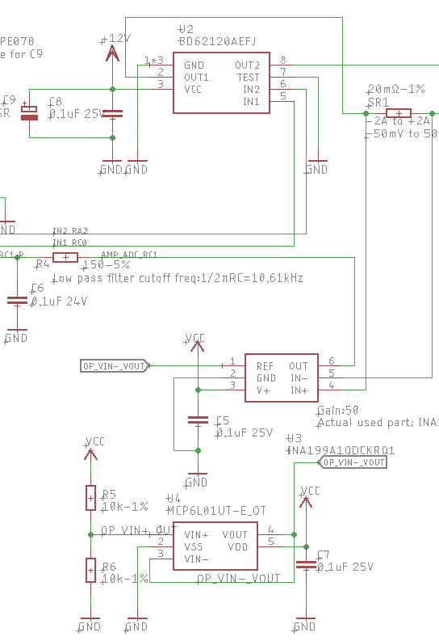
Block Diagram
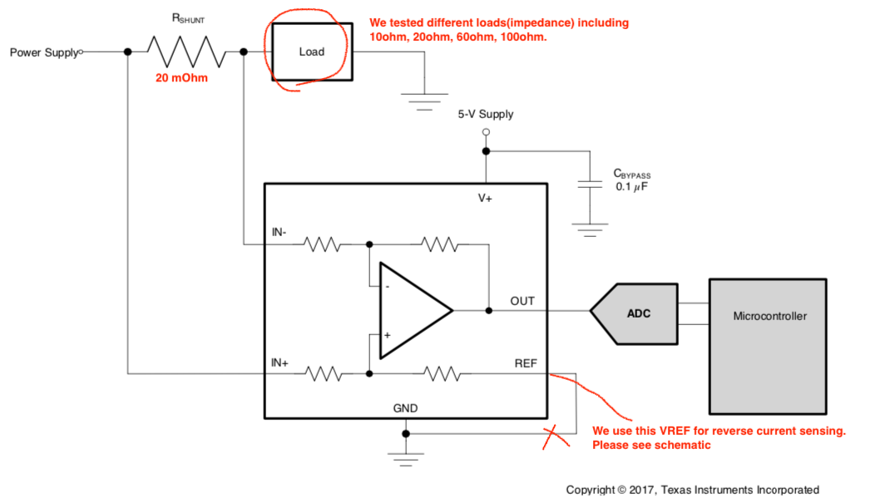

Ch1,Red:Current Clamp(bandwidth:20kHz),1mV/10mA
Ch2,Yellow:voltage of Shunt Resistor(20mΩ) 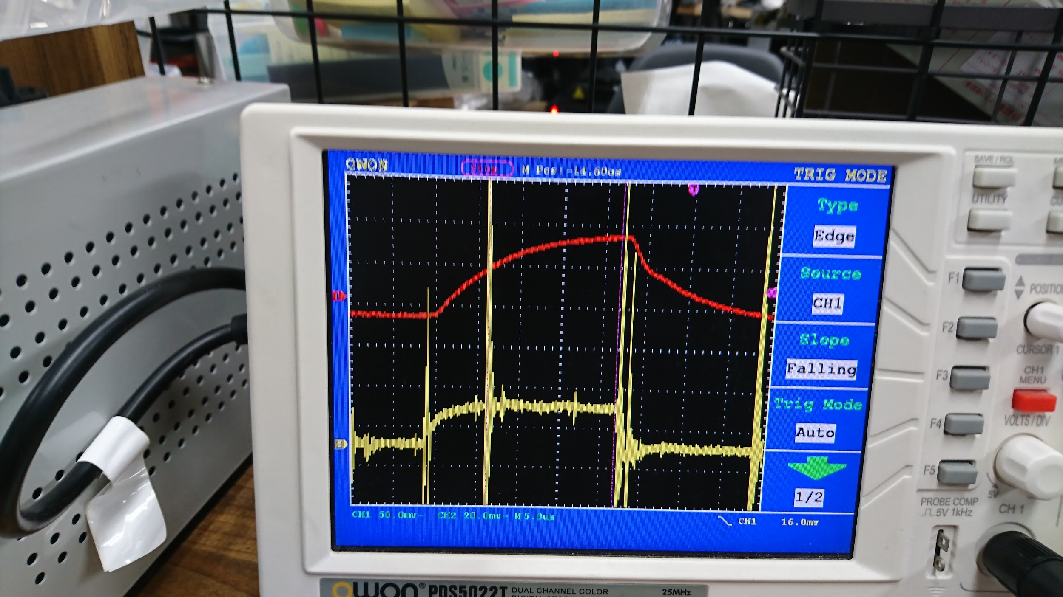

Load impedance is 10Ω
Ch1,Red:Current Clamp(bandwidth:20kHz),1mV/10mA
Ch2,Yellow:Current Amp(bandwidth:80kHz),1mV/1mA
Time Scale: 25uS/div

When in normal current sensing direction, captured current amp output voltage
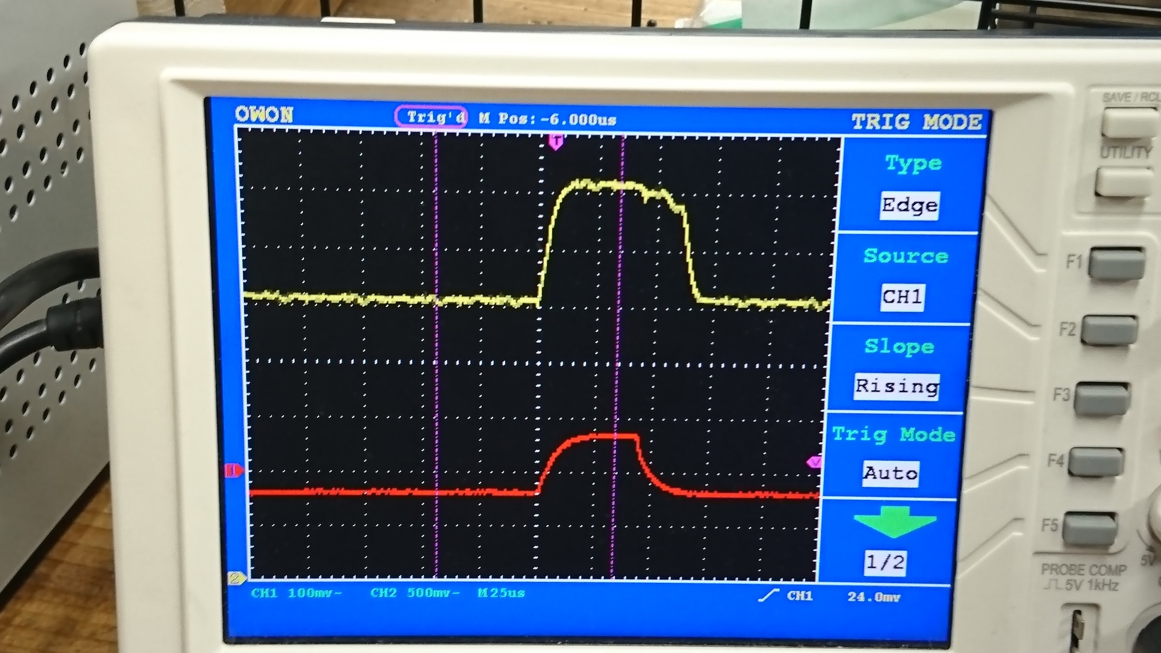
When in reverse current sensing direction, captured current amp output voltage
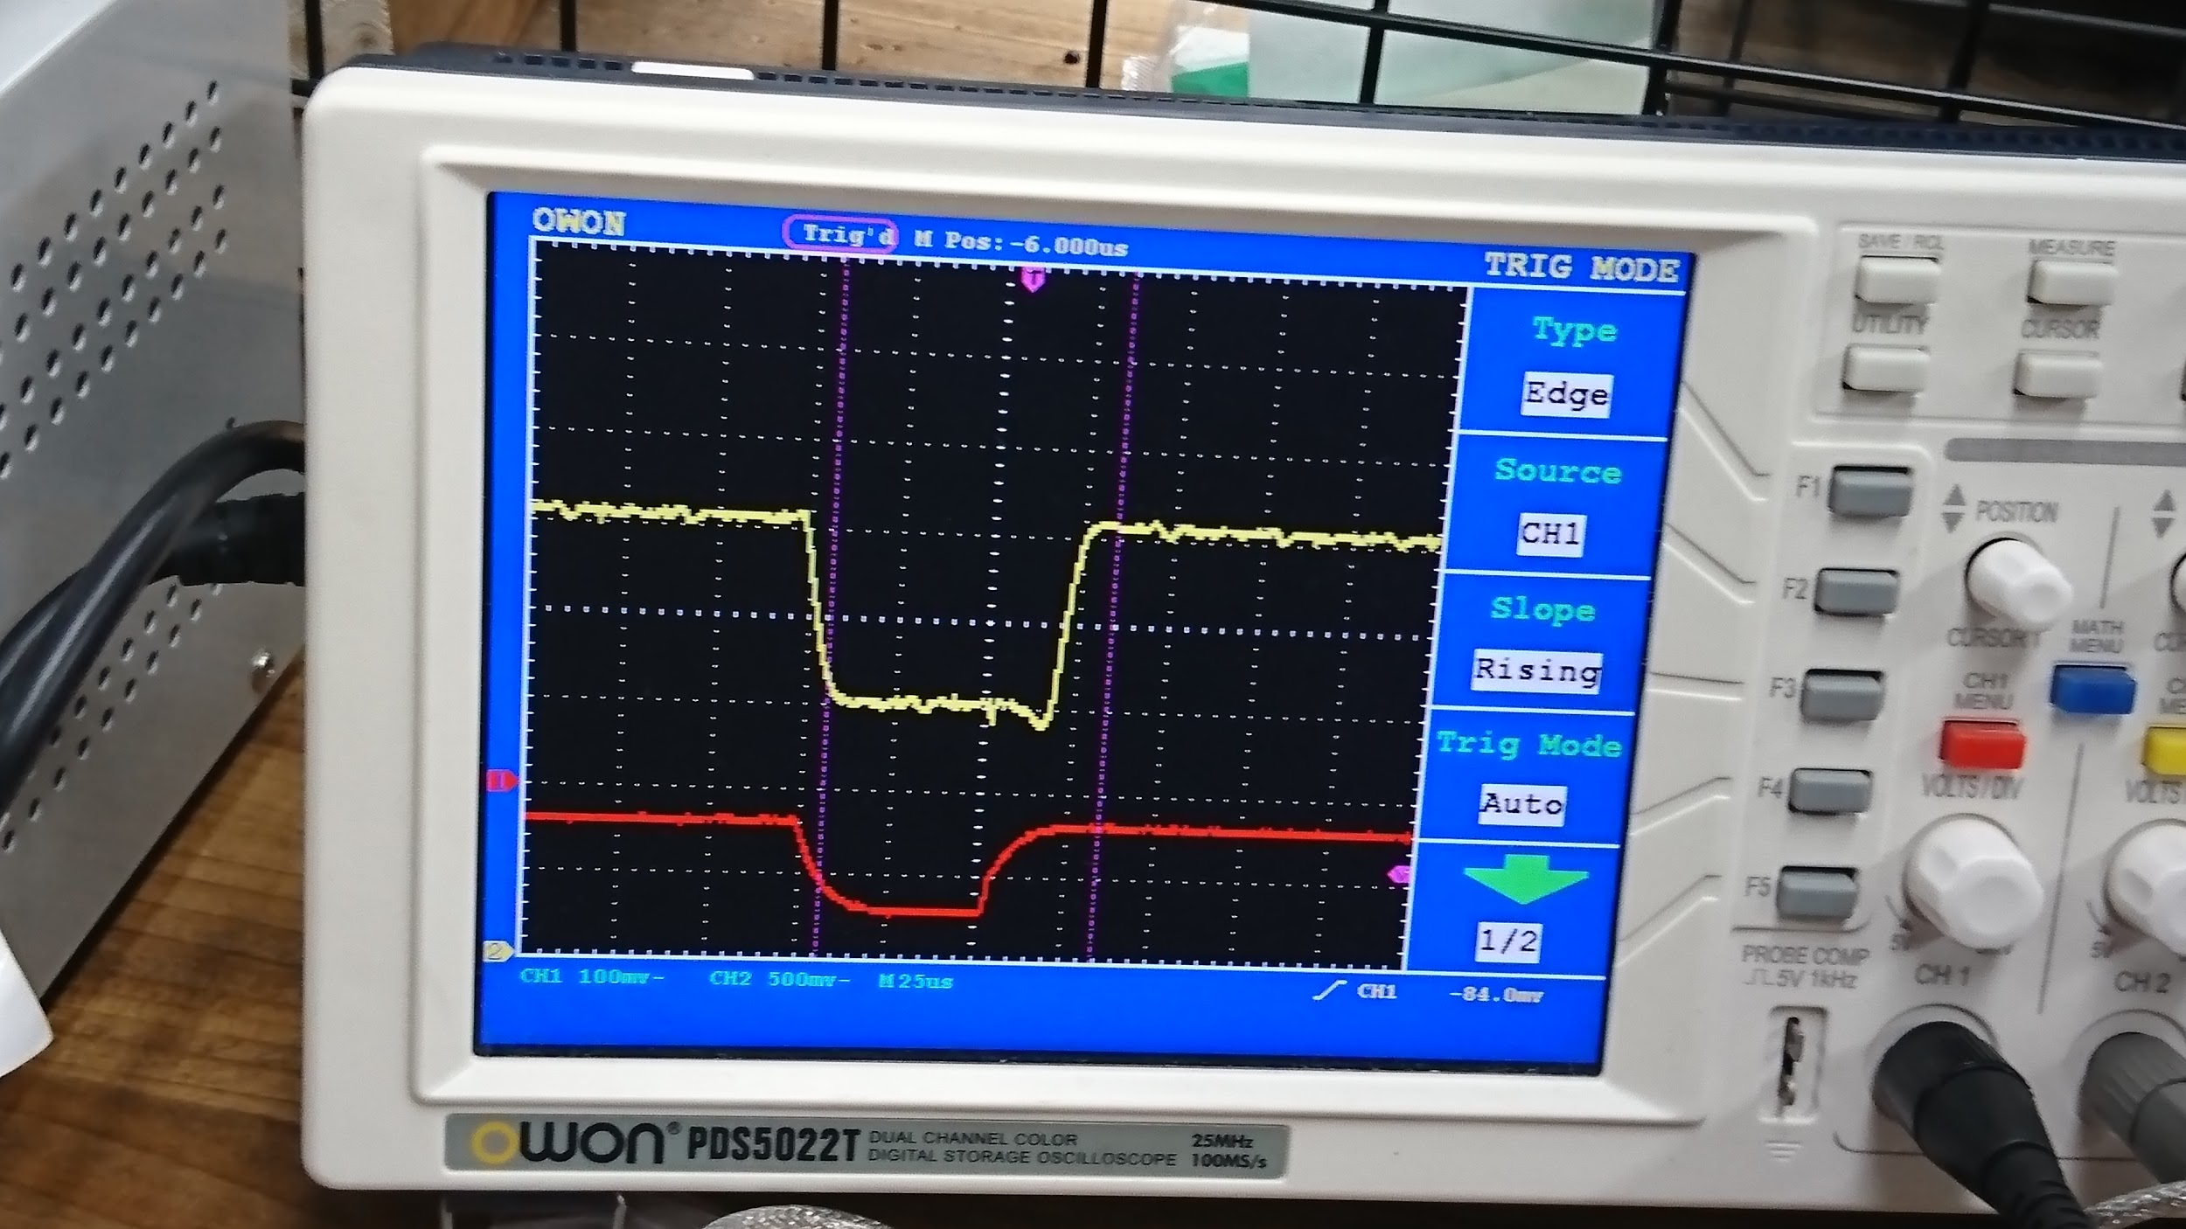
There’s a timing delay on falling edge comparing to Current Amplifier output voltage and Current Clamp measured waveform. It is roughly 15~20us.

Motor PWM vs Current Clamp Waveform
Current clamp measured current value when changing motor PWM duty (From -40% to +40%)
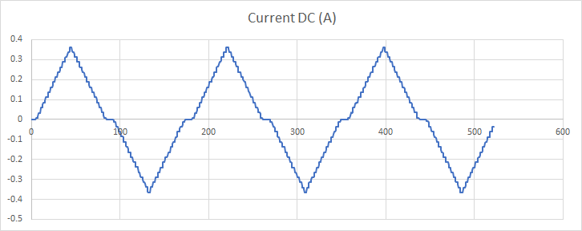
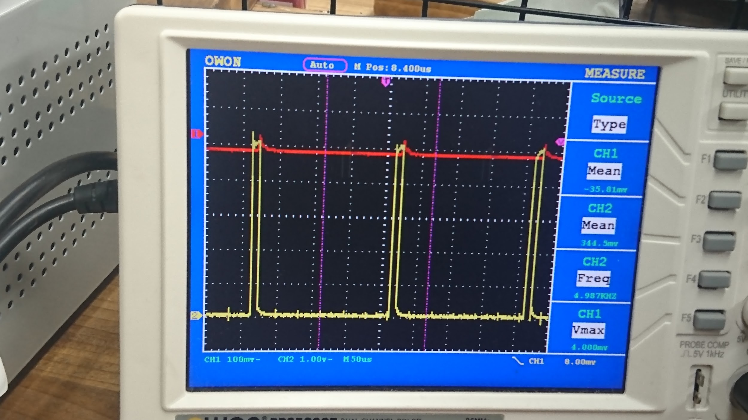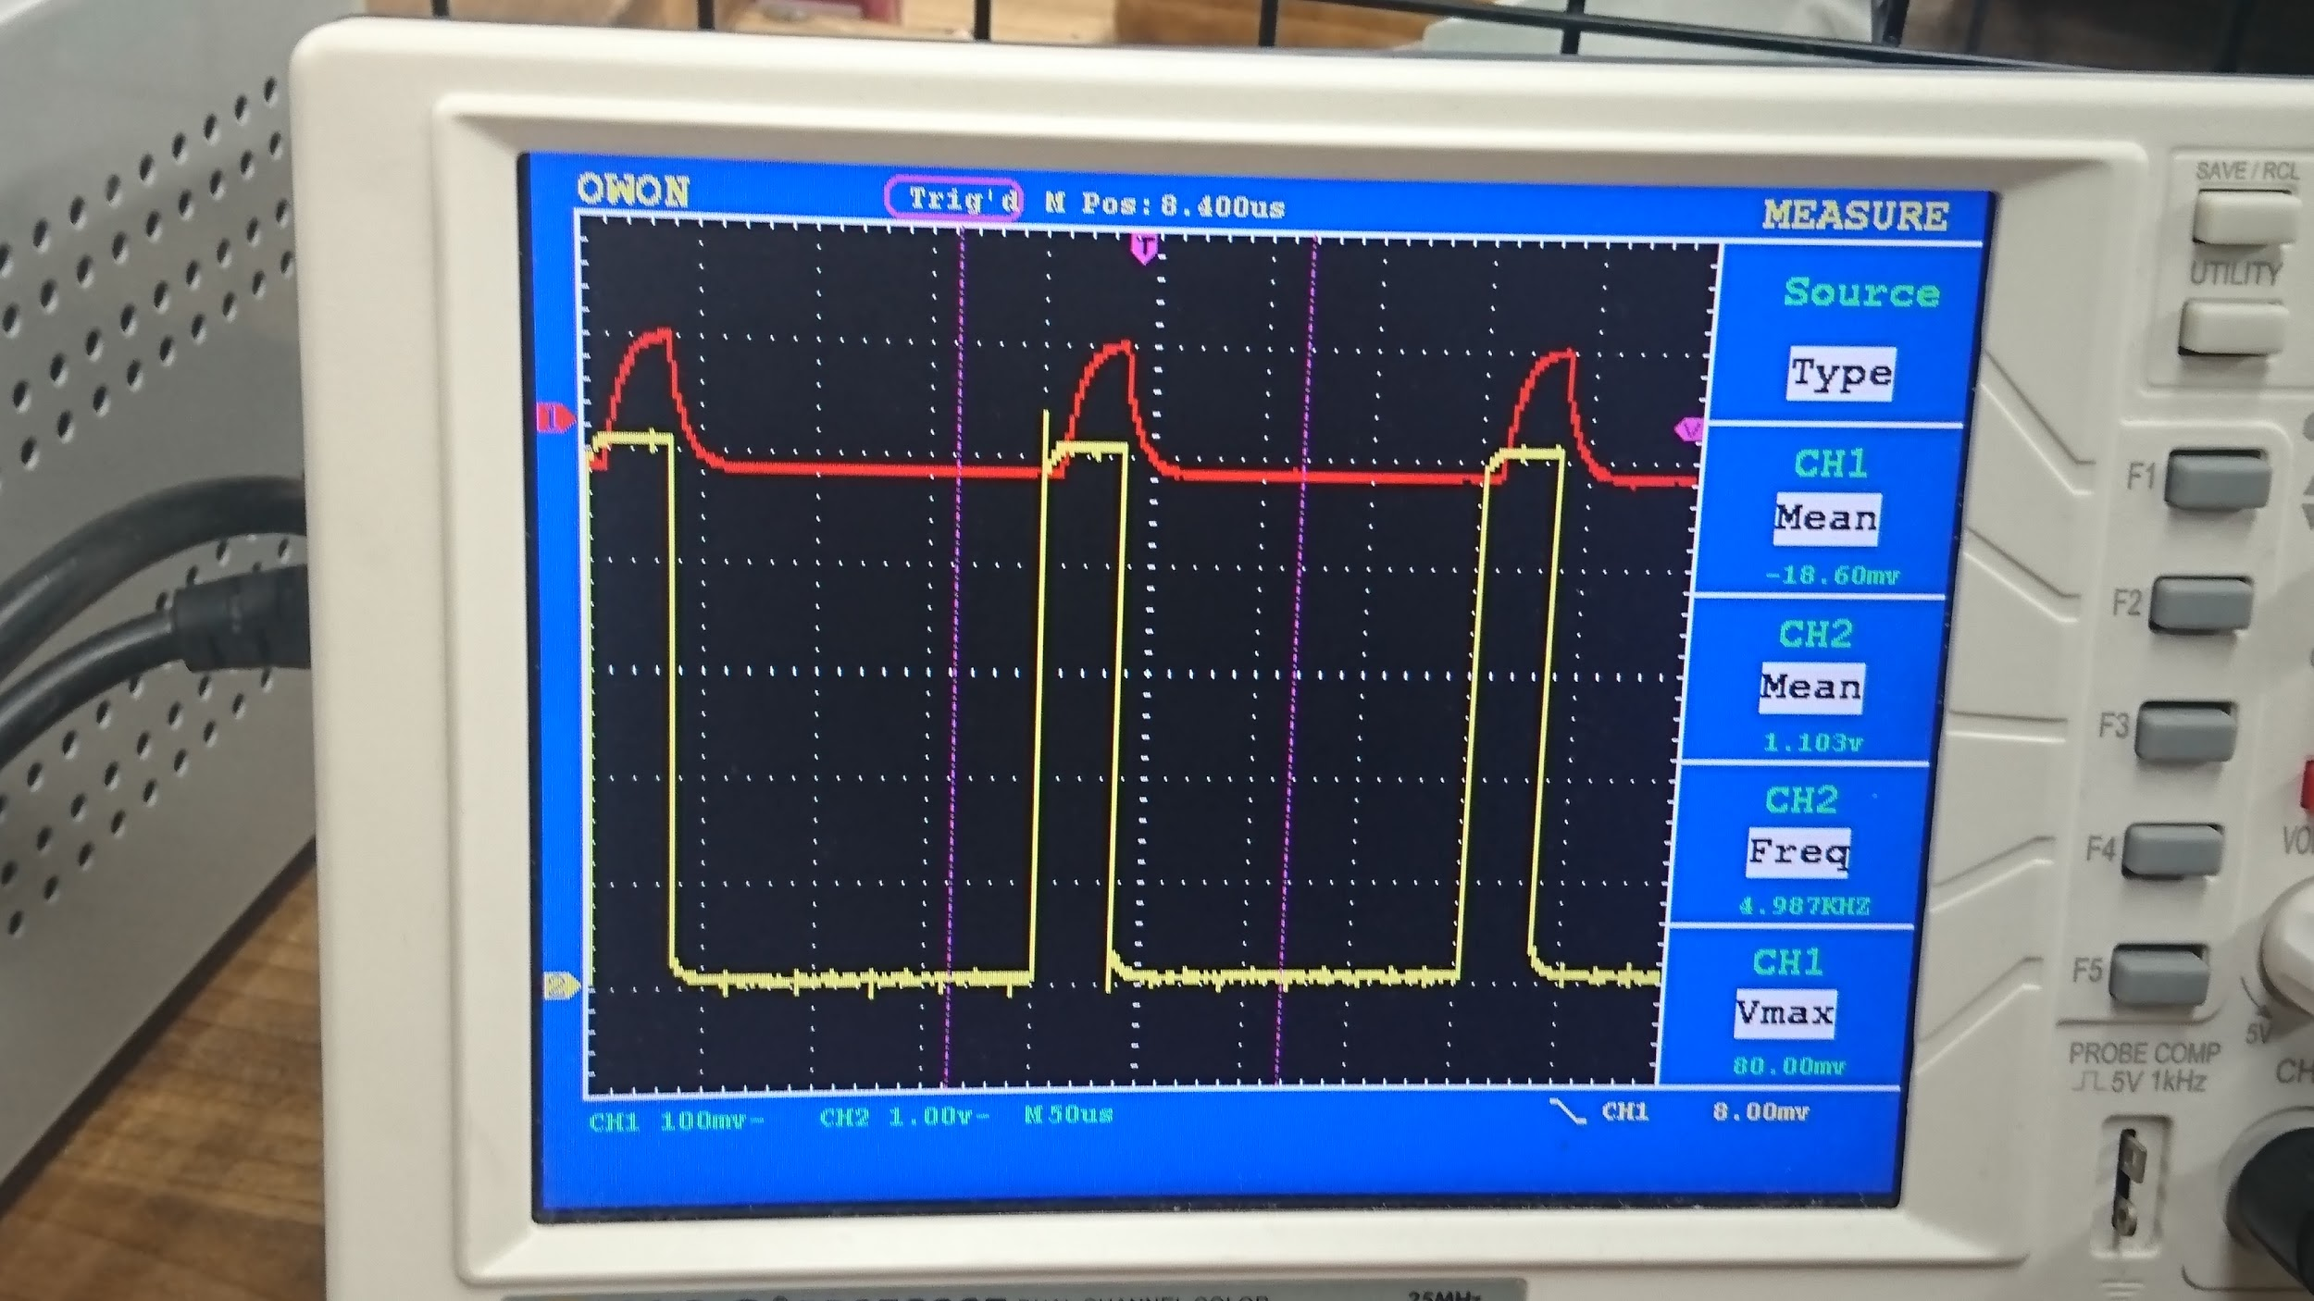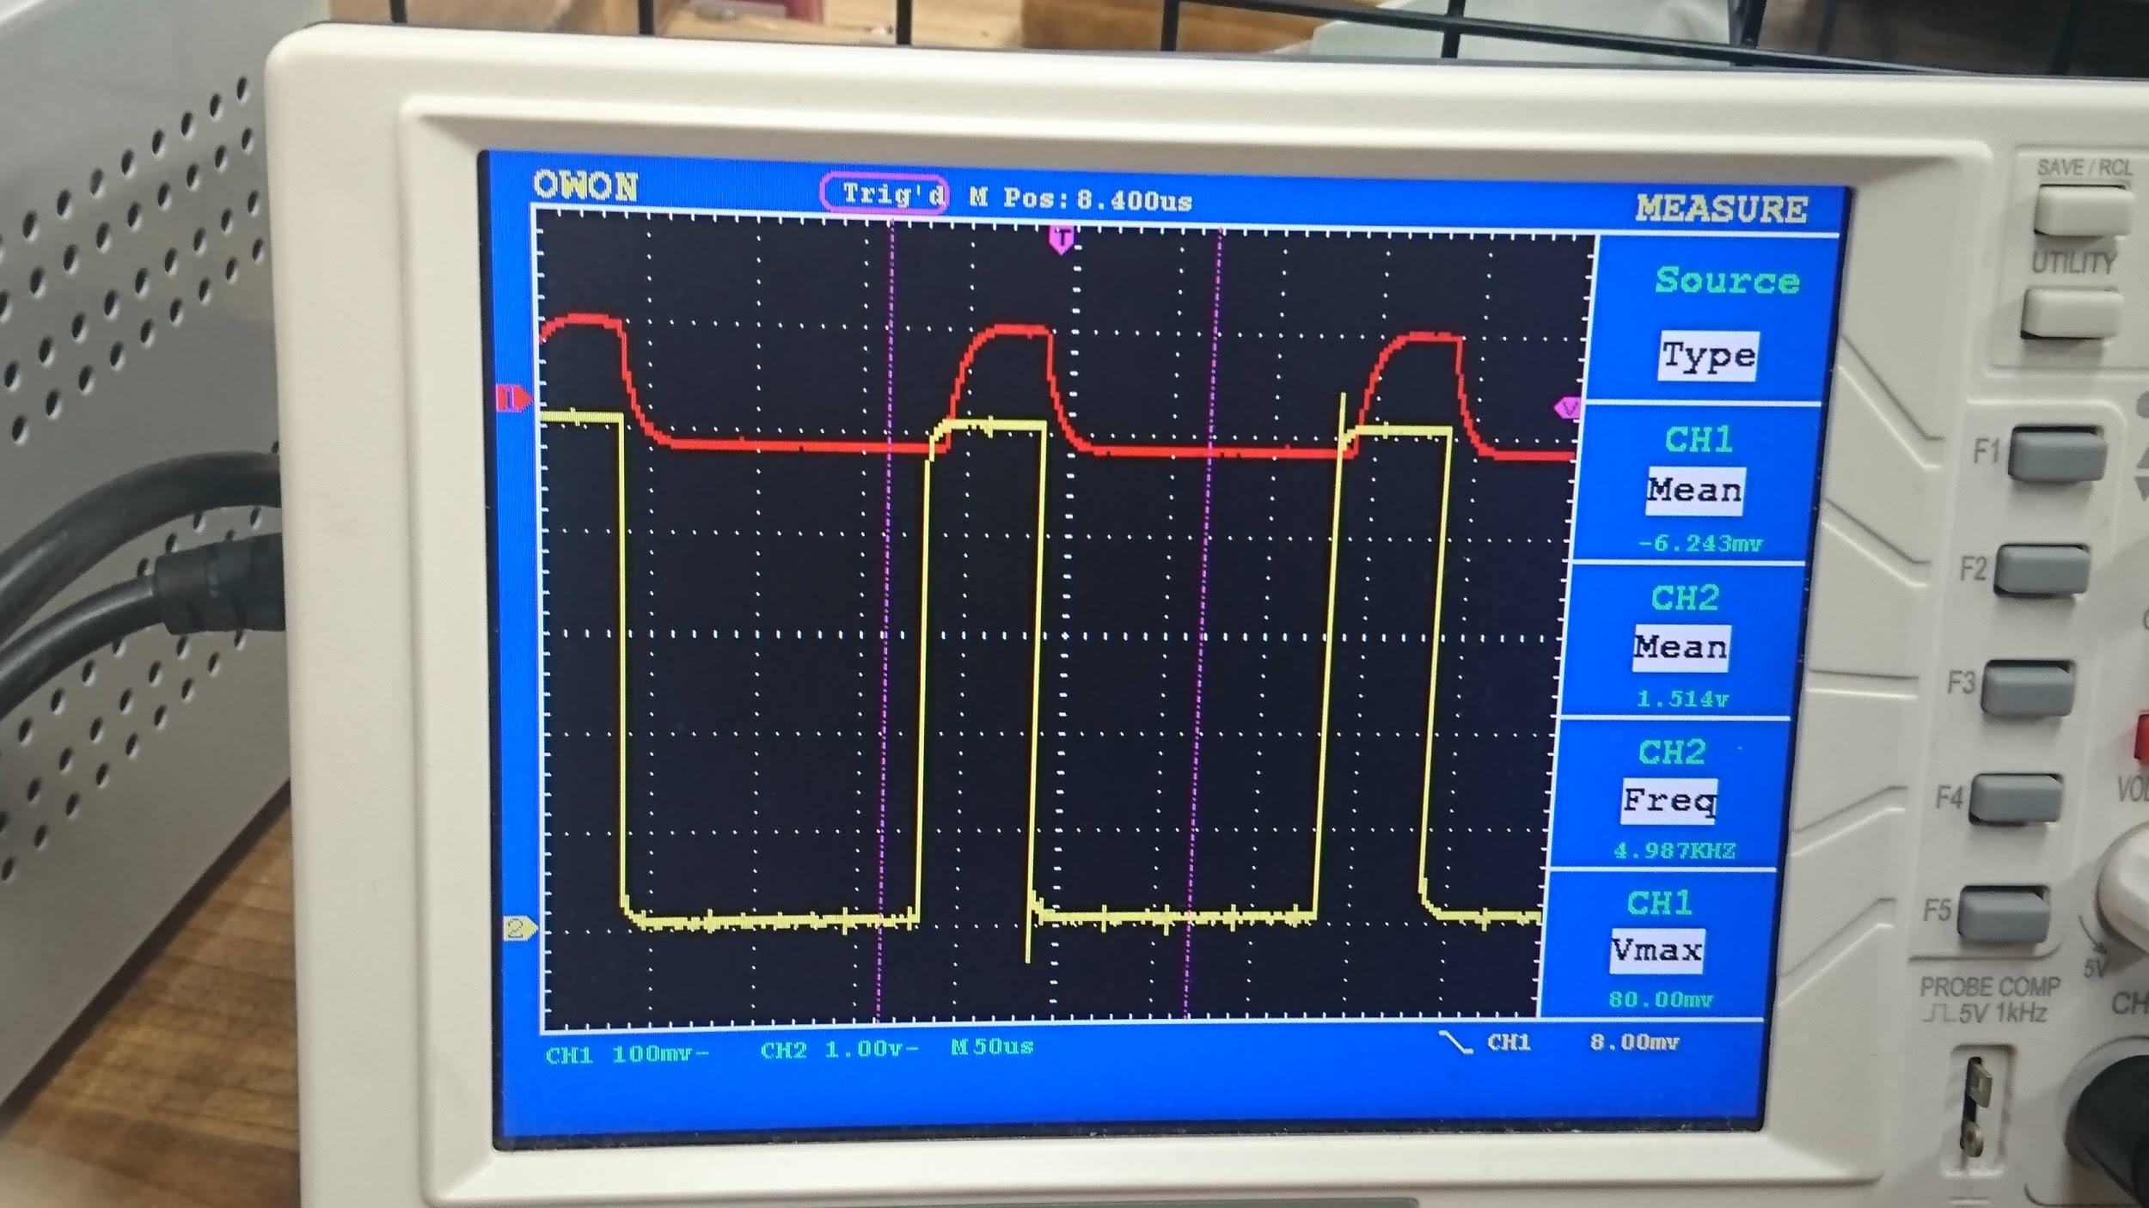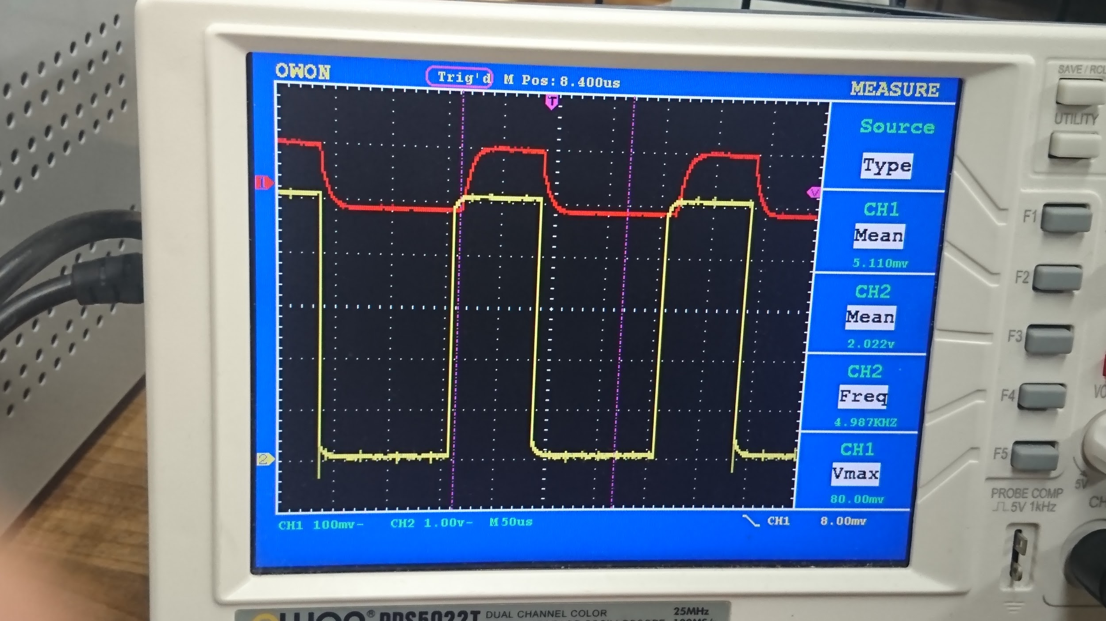

Current Amplifier output voltage when changing PWM duty (From -40% to +40%)

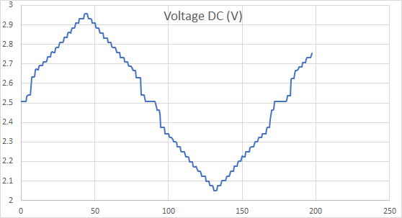
We’re seeing this nonlinearity from 2.55V ~ 2.65V. It’s a weird voltage gap and we hope to understand the reason behind it. Otherwise it is hard for us to implement the firmware algorithm on reading ADC at microcontroller side.

Motor PWM vs Current Amp Output Voltage
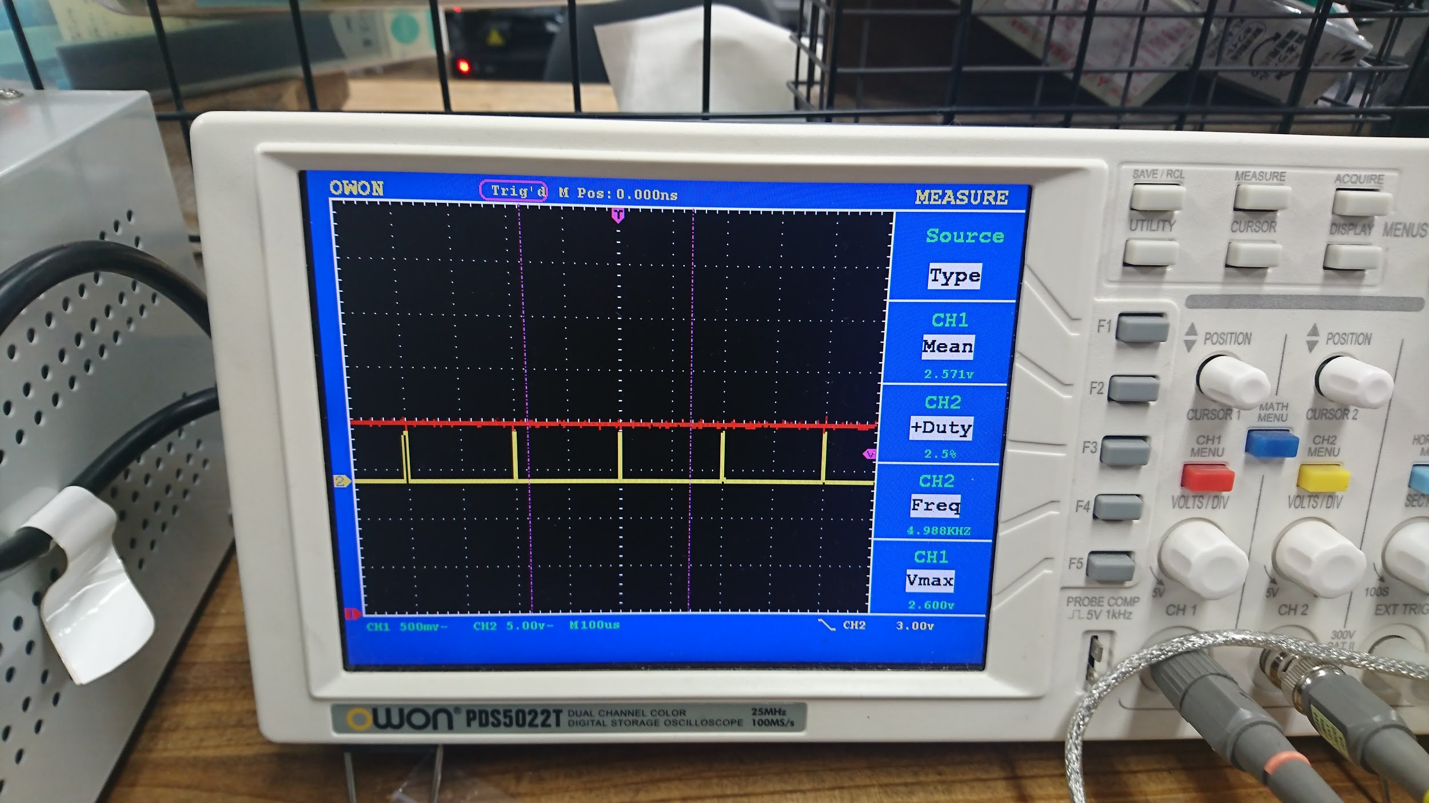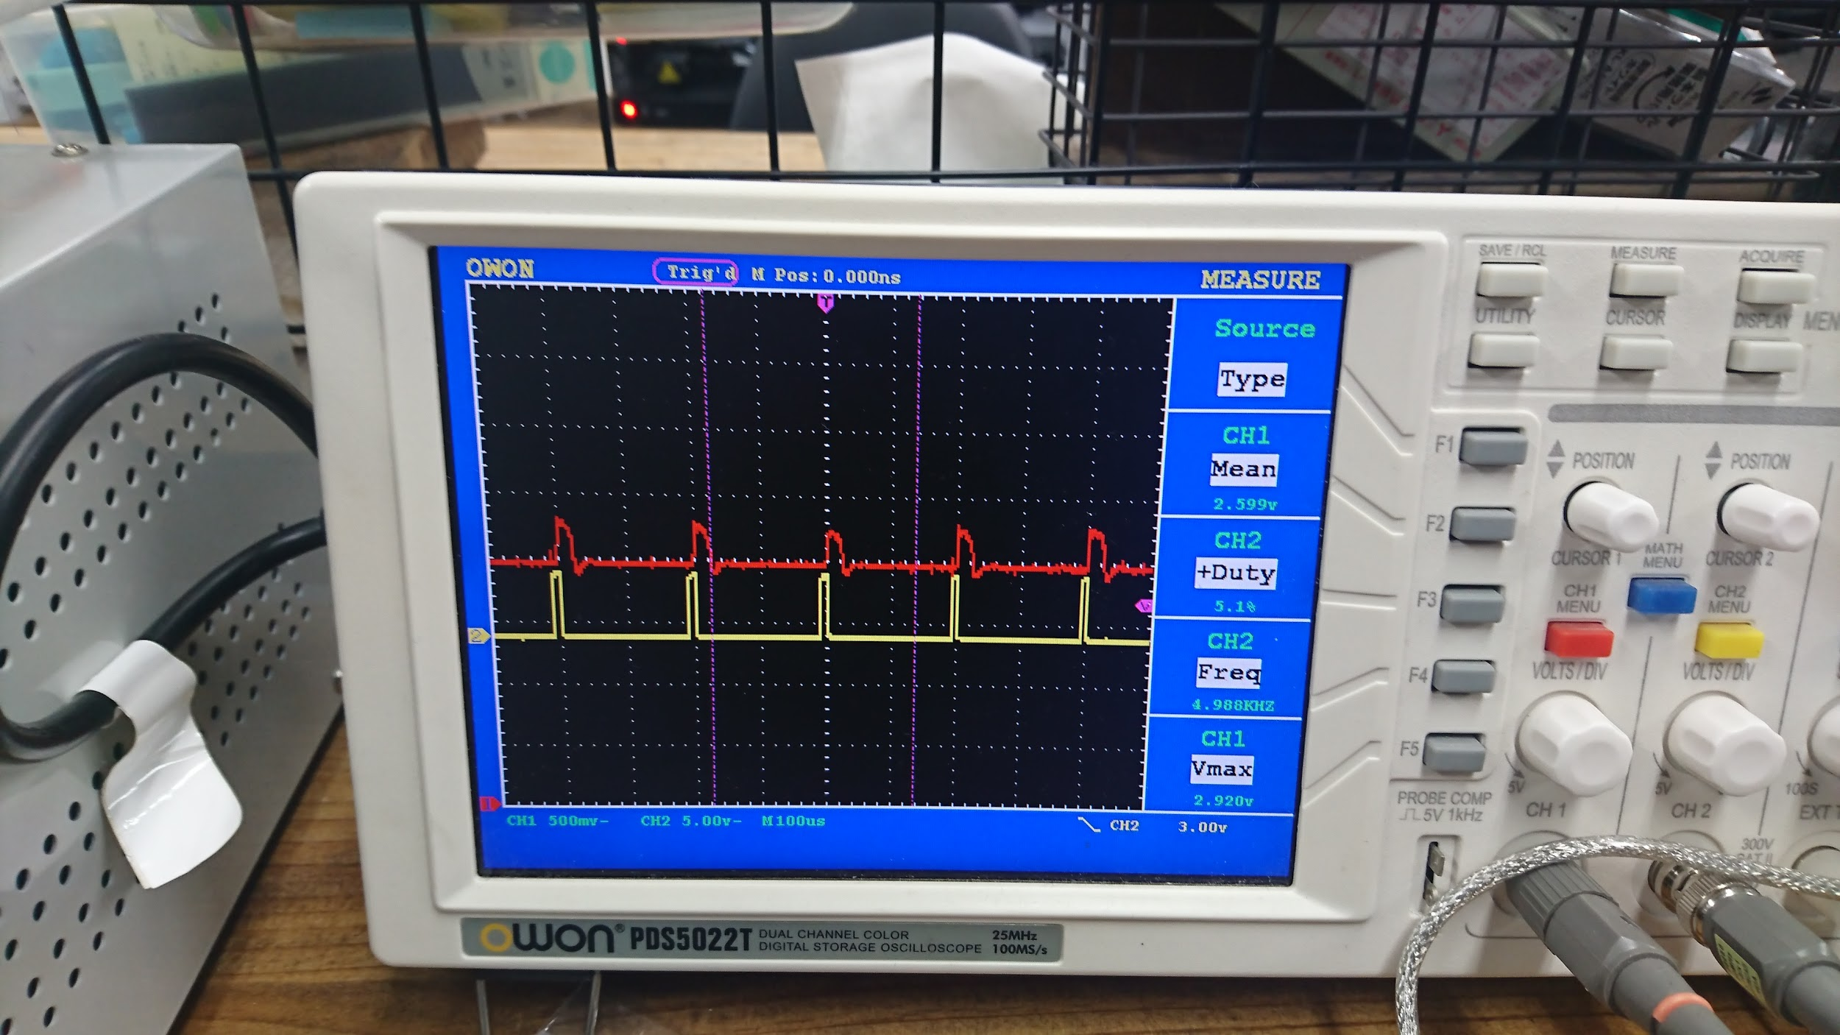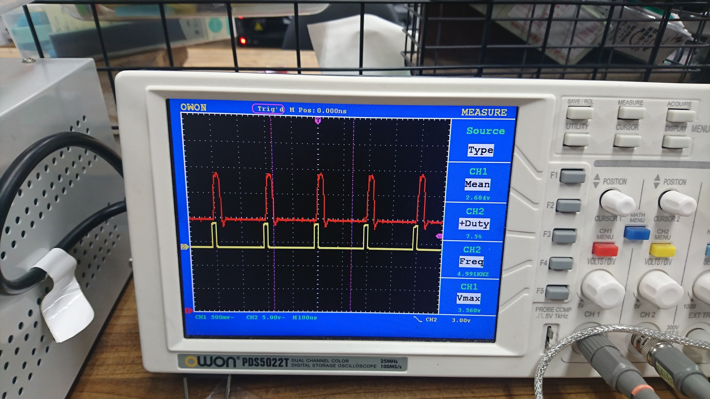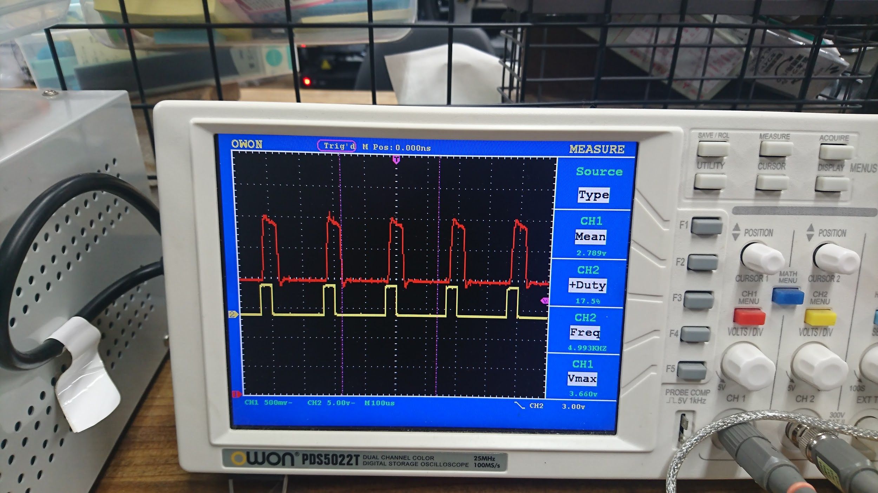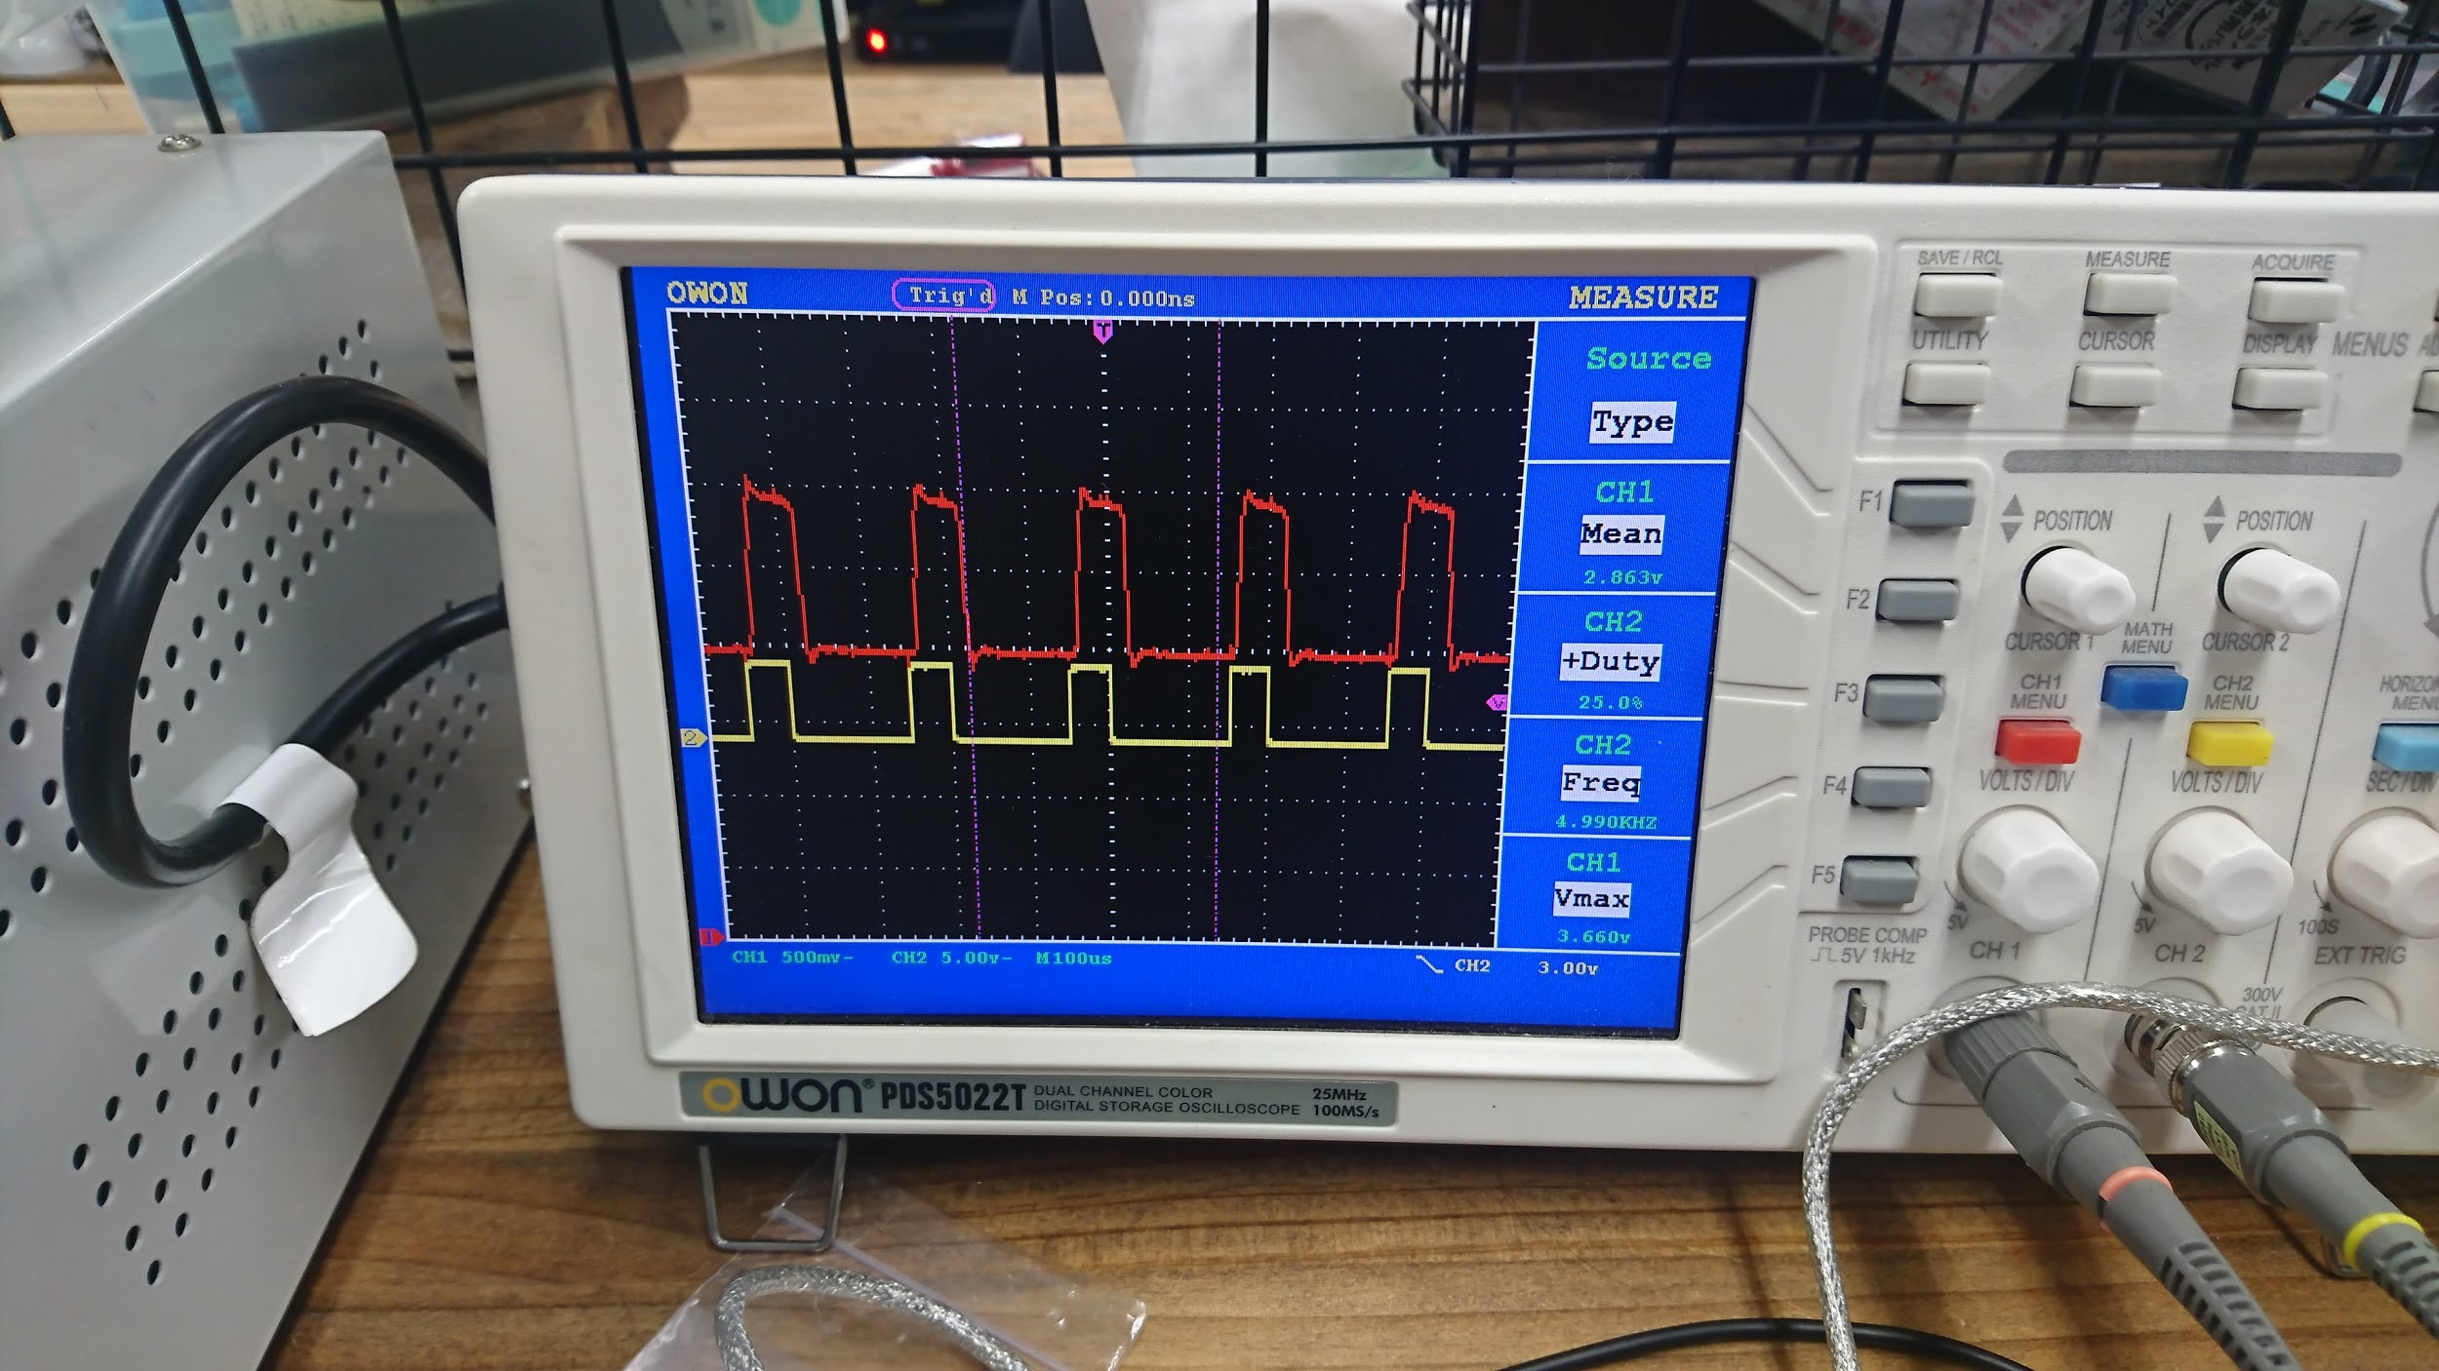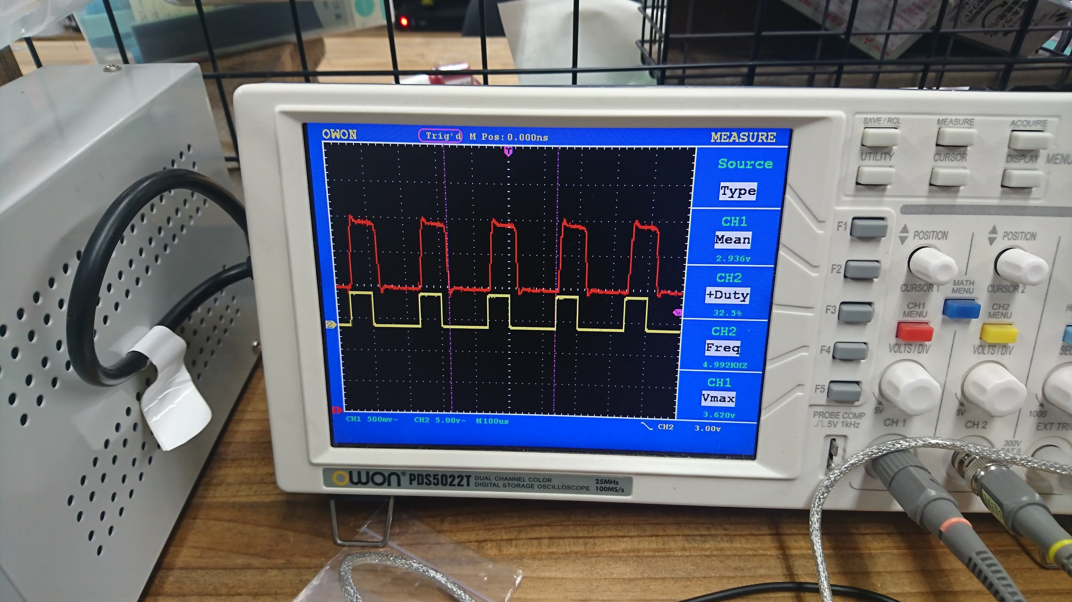
Load impedance is 20Ω
Ch1,Red:Current Clamp(bandwidth:20kHz),1mV/10mA
Ch2,Yellow:Current Amp(bandwidth:80kHz),1mV/1mA
Time Scale: 25uS/div

When it operated in normal current sensing direction, captured current amp output voltage :
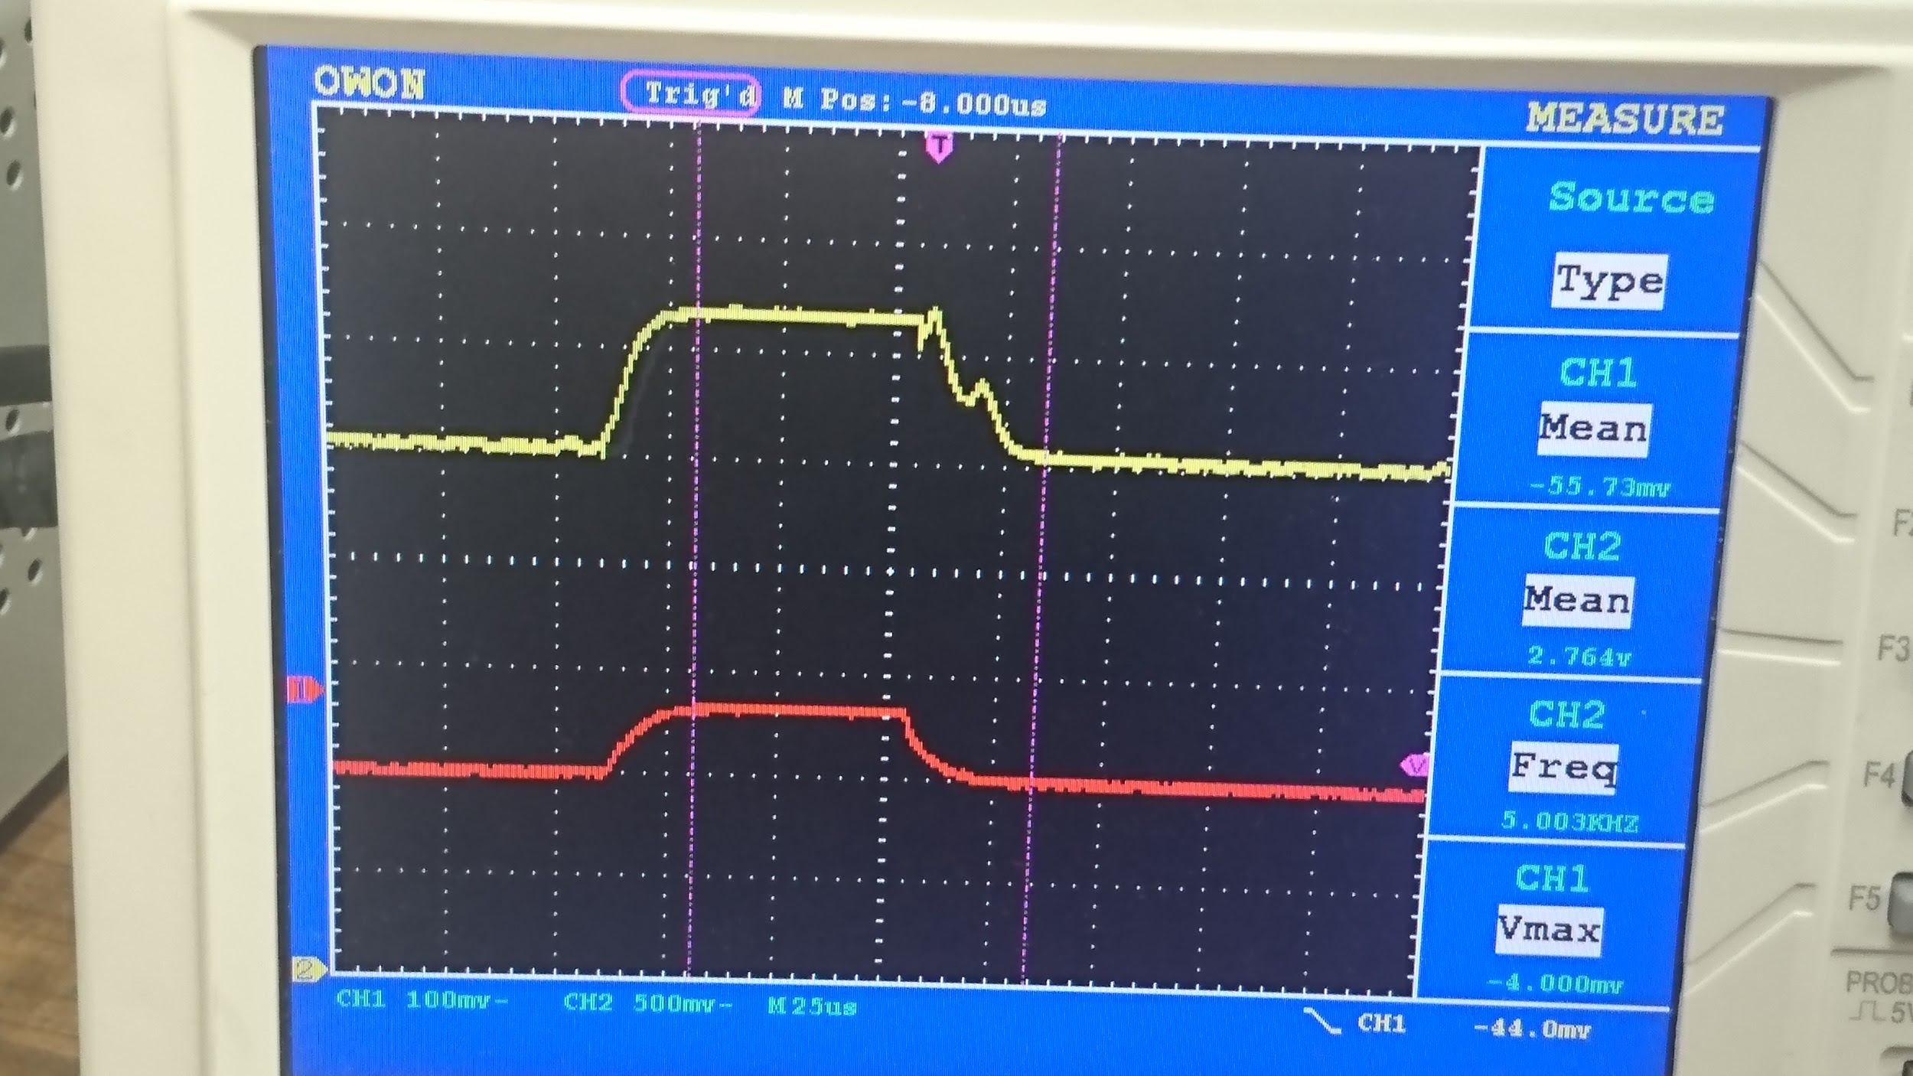
When it operated in reverse current sensing direction, captured current amp output voltage :
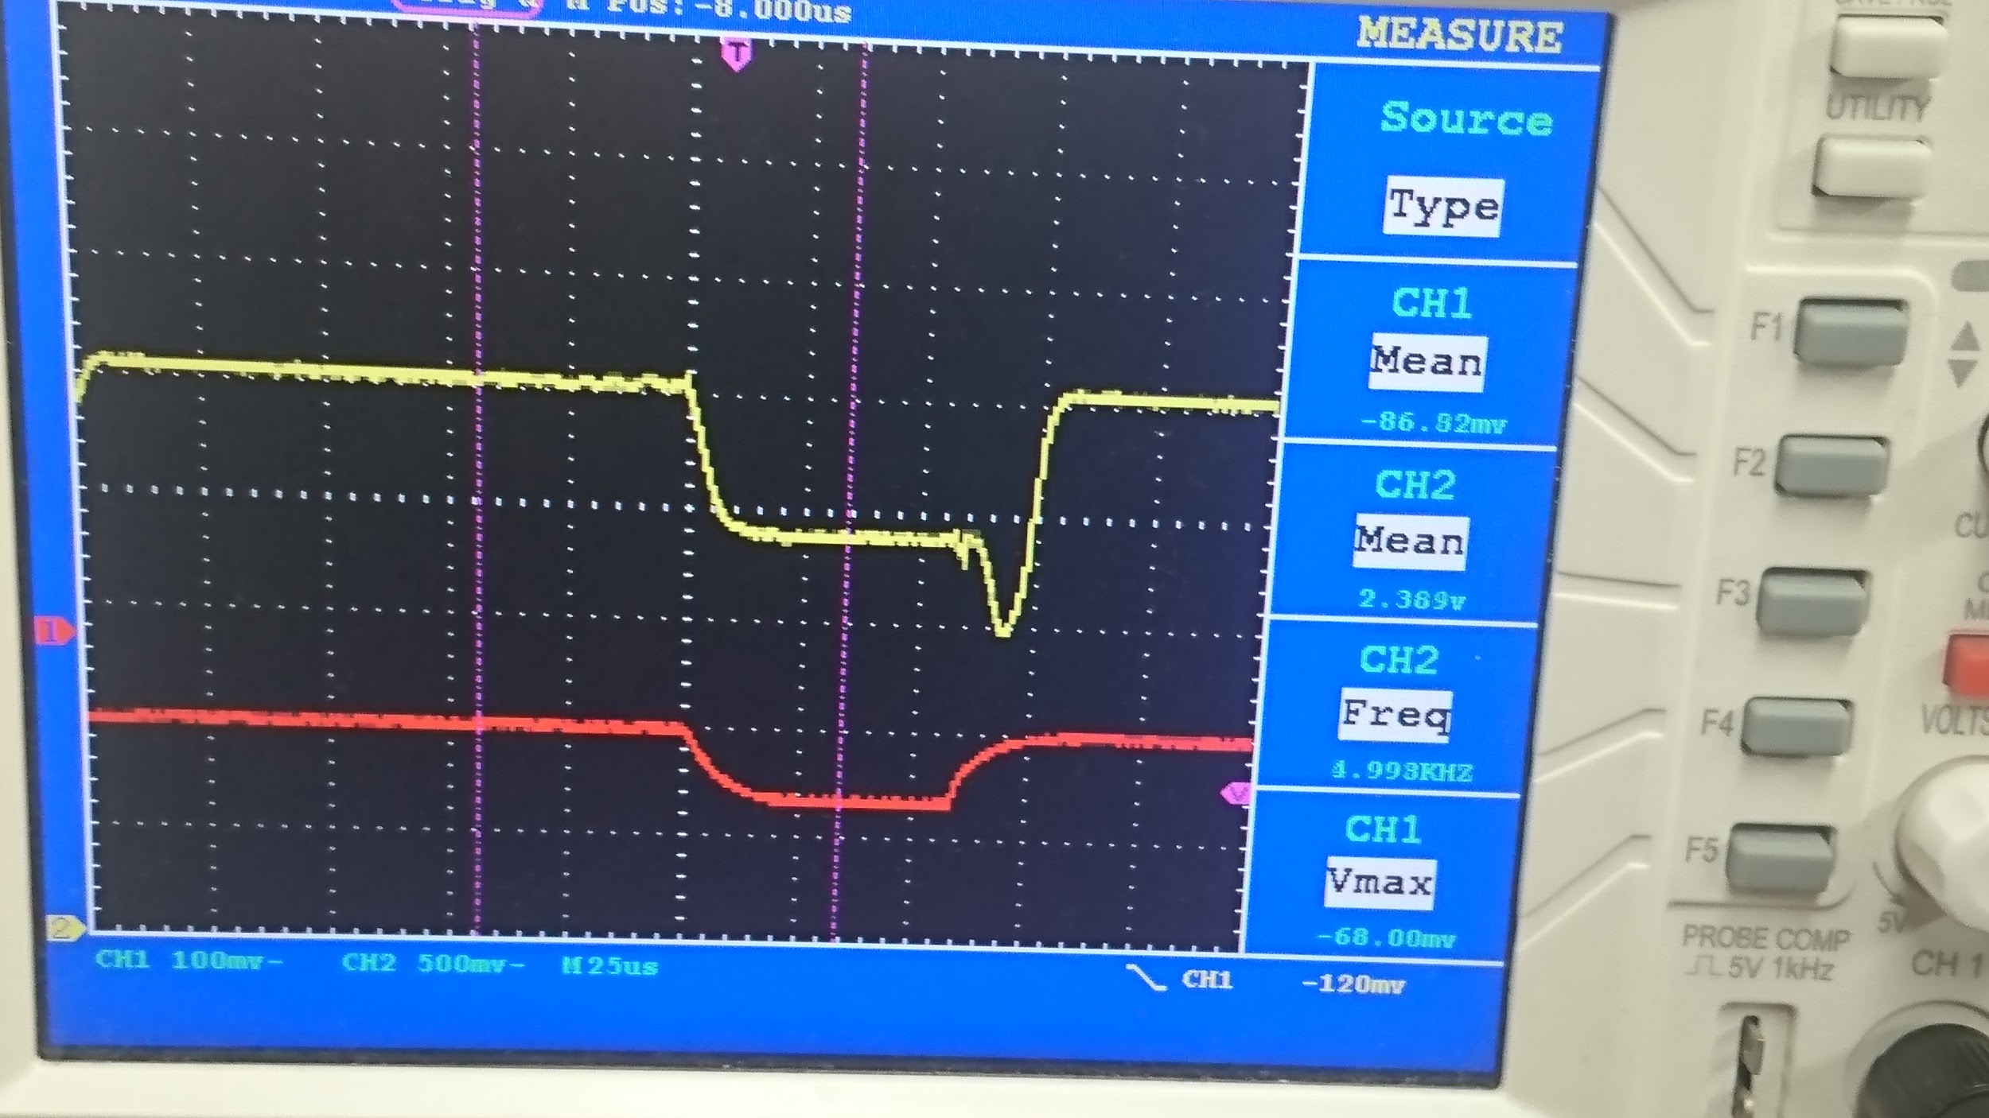
There’s a timing delay on falling edge comparing to Current Amplifier output voltage and Current Clamp measured waveform. It is roughly ~15us.

Load impedance is 60Ω

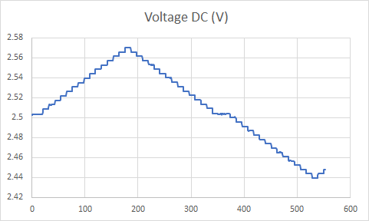
Ch1,Red:Current Clamp(bandwidth:20kHz),1mV/10mA
Ch2,Yellow:Current Amp(bandwidth:80kHz),1mV/1mA
Time Scale: 25uS/div

When in normal current sensing direction, captured current amp output voltage :
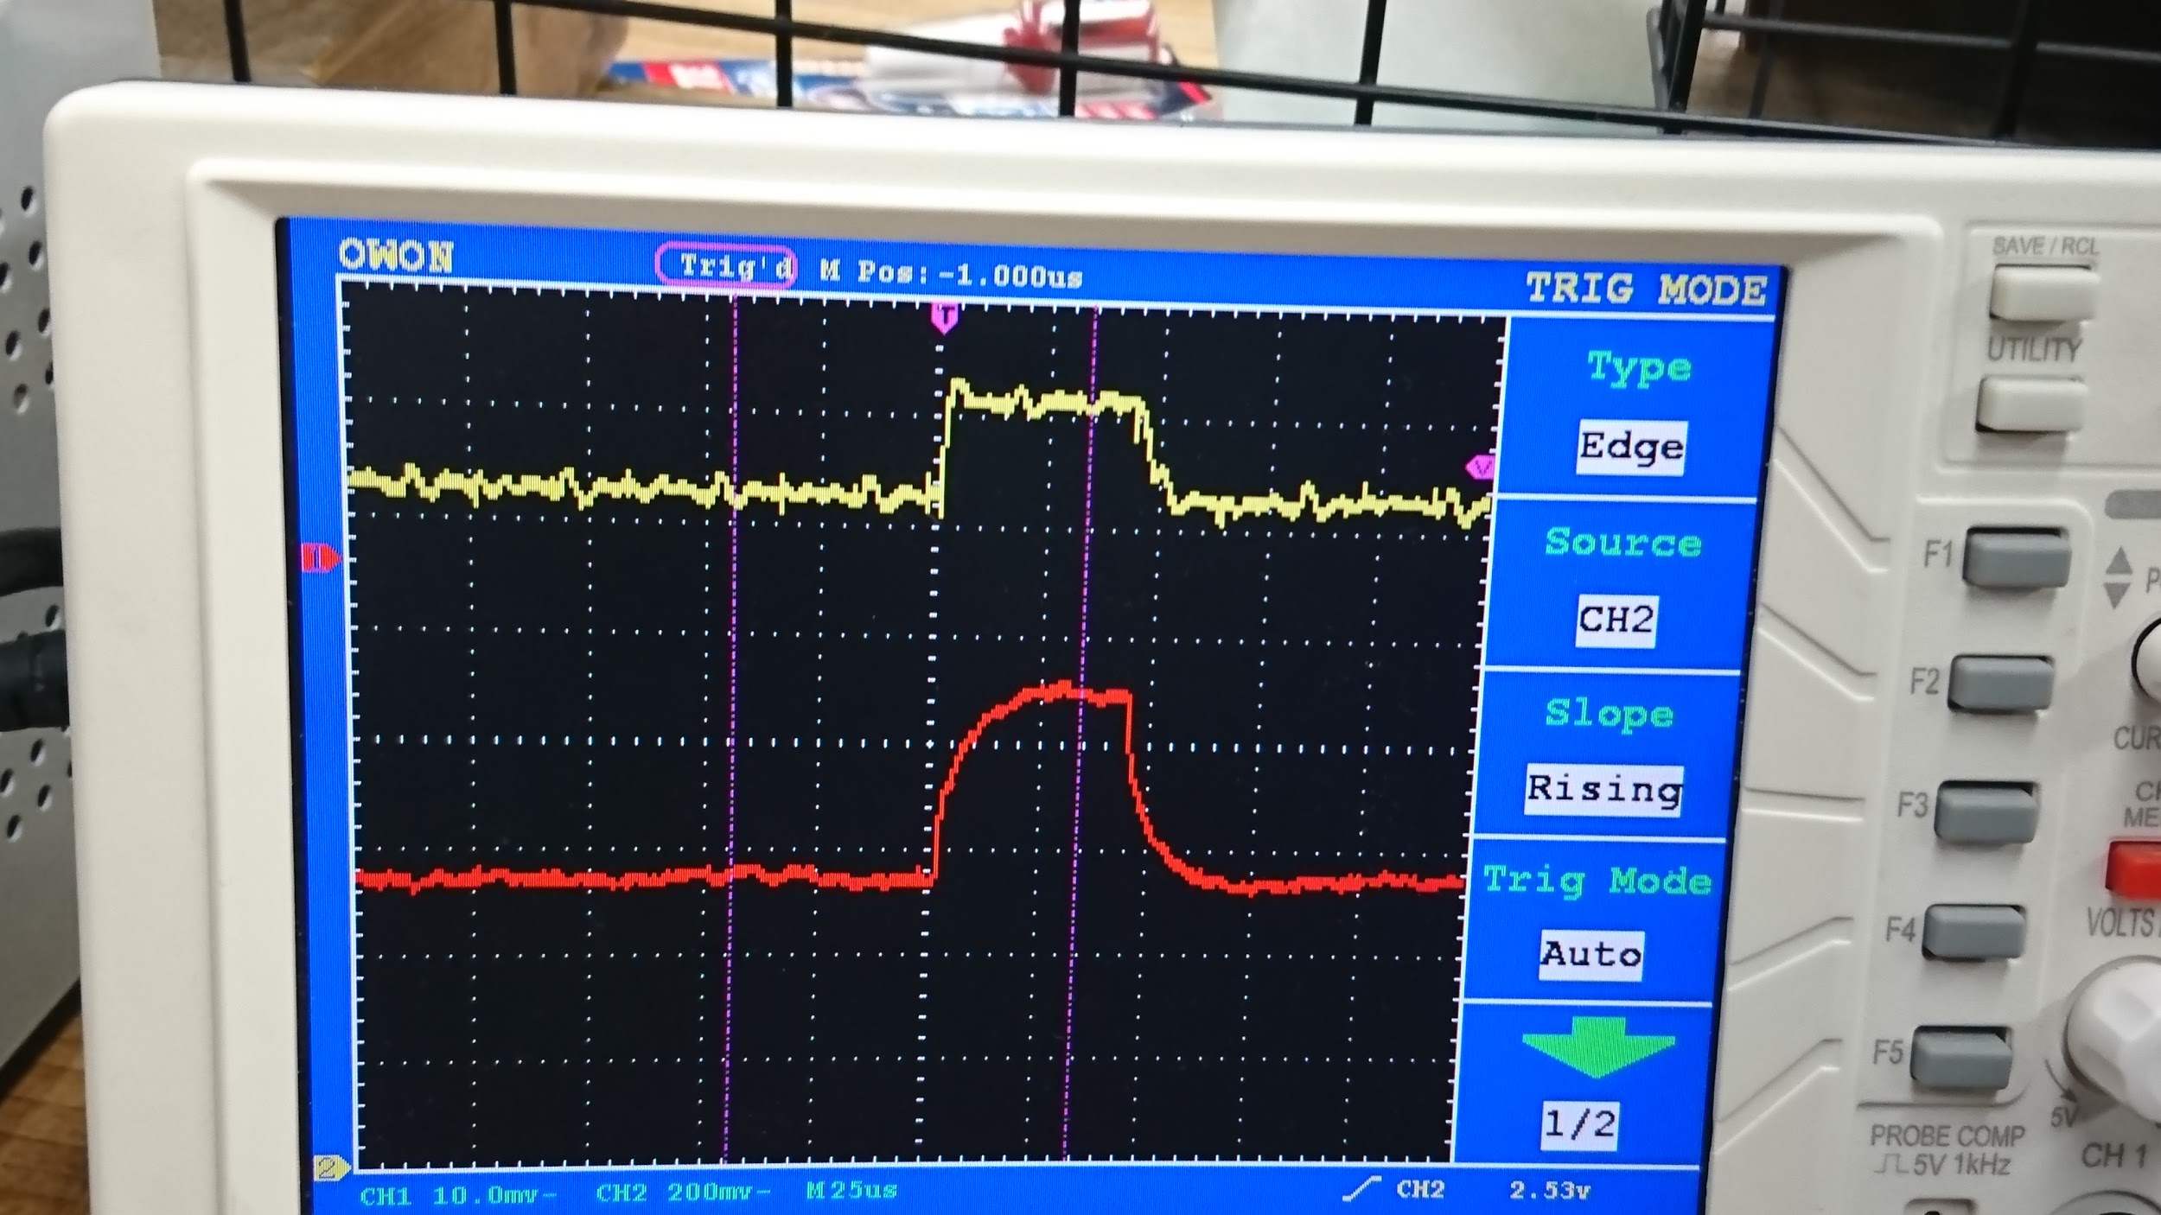

There’s no timing delay on the falling edge comparing to Current Amplifier output voltage and Current Clamp measured waveform.

Load is 100Ω
Ch1,Red:Current Clamp(bandwidth:20kHz),1mV/10mA
Ch2,Yellow:Current Amp(bandwidth:80kHz),1mV/1mA
Time Scale: 25uS/div

When in normal current sensing direction, captured current amp output voltage :
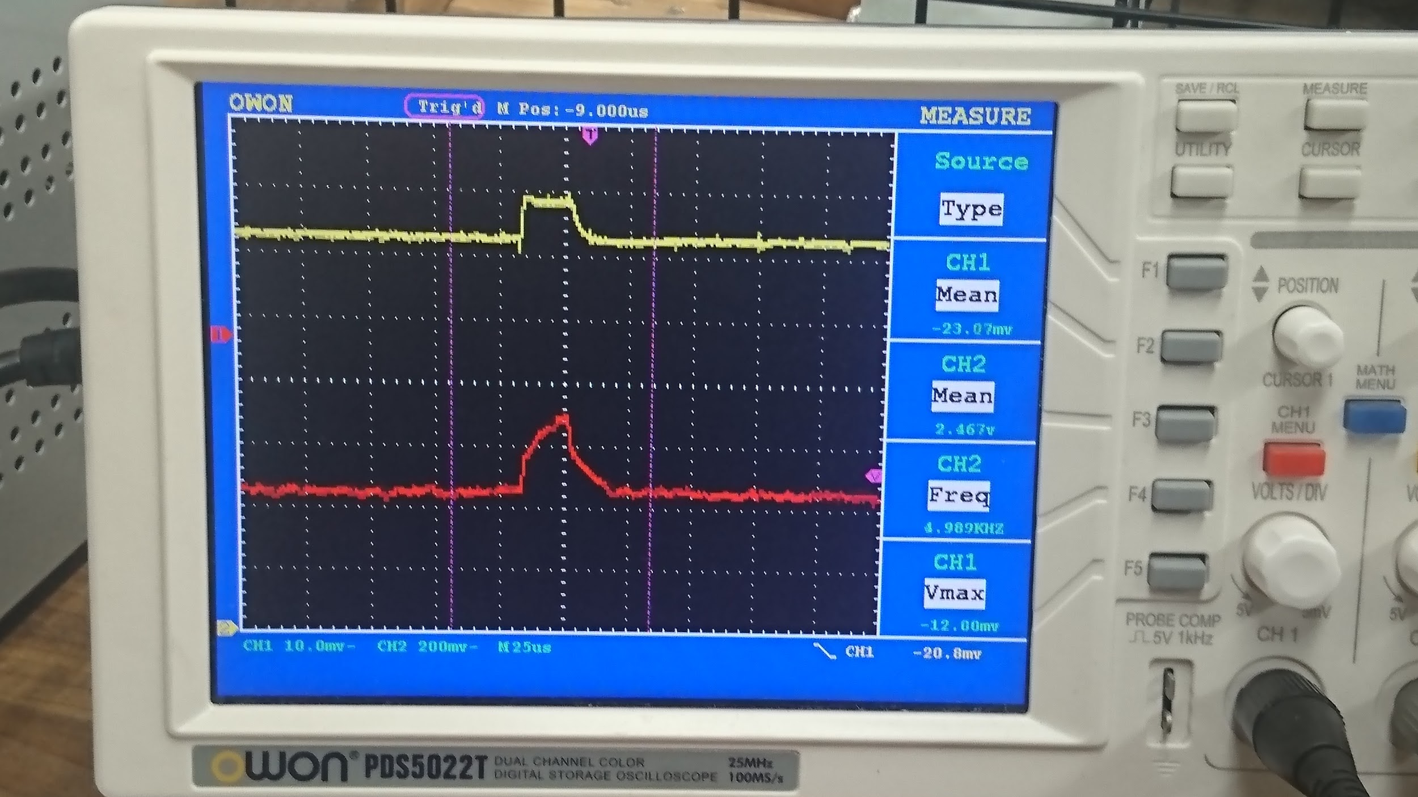
When in reverse current sensing direction, captured current amp output voltage :
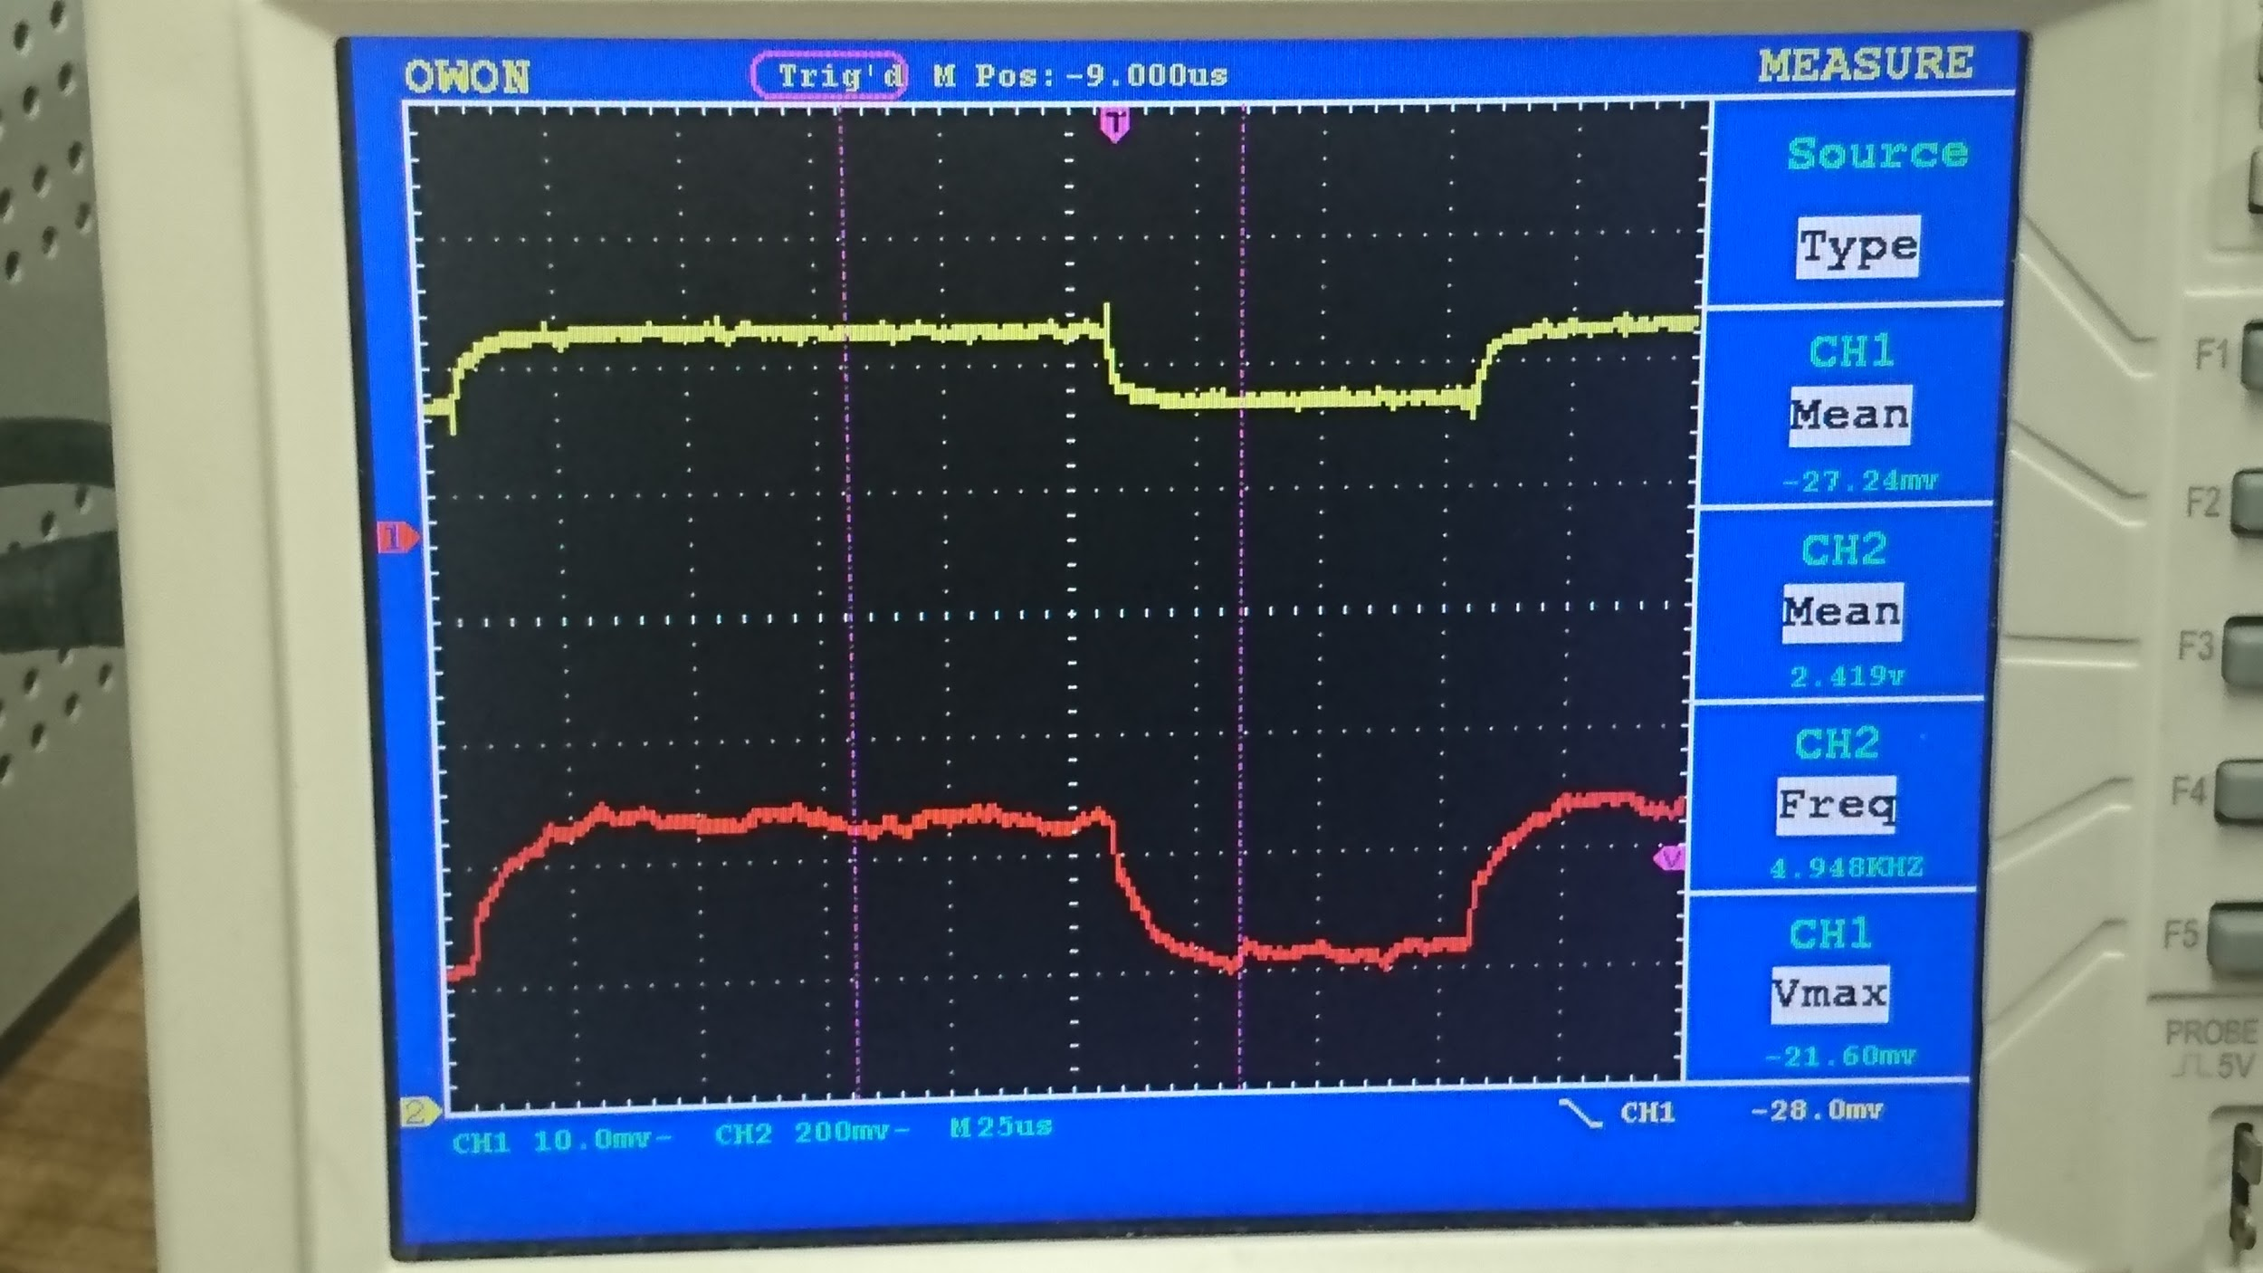

No timing delay whatsoever comparing on 2 channel waveforms.

