Issue Description:

Customer used LM124 to build differential amplifier circuit and reported the output is higher than expected. Customer used single power source, and test as below:

（1）           Vcm=1.8V，Vid=130mV，Au=4， Vout=603mV；

（2）           Vcm=67mV，Vid=134mV，Au=4， Vout=546mV；

Even the (1) with larger error, but while decreased Vid to 0, the Vout still with >500mV and seems related to Vcm.

Built the simulation with TINA as figure 1,

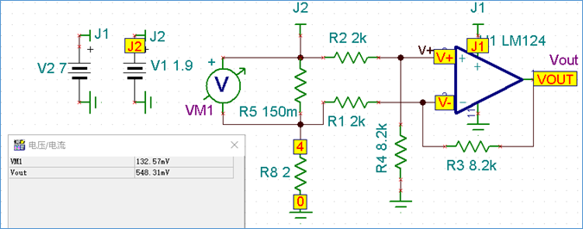

Figure 1: simulated model

With TINA simulation, while the Vcm = 2V, Vid = 0v, Vout is about 76mV; but the real VOUT with the schematic is about 600mV. While place R8 in top of R5 in schematic, the output error would be decreased to <10mV, seems the Vcm impacted the output.

Support Needs:

1. Give comments that under Figure 1 simulated model, reasons for that the bigger difference between the simulation and real schematic.
2. Provide the open loop Gain and phase margin figure for LM124 which datasheet doesn’t include;