Issue description
Customer reported an issue in LM2904DGKR during assembling FCT: the LM2904DGKR output voltage is abnormal.
Test Waveforms
- In Customer products, put the normal and abnormal device in same place, the normal(shown as left figure of row 1) shown correct; but the abnormal(shown as right figure of row 1) shown different output;
- Only with the device, powered up by Positive 5V, IN- short to OUT, IN+ with 3V@1Khz signal, the normal device((shown as left figure of row 2) and abnormal device(shown as right figure of row 2) shown the same test result;
- Only with the device, powered up by the positive 5V, IN- and OUT connected by 20Kohm resister, the abnormal device shown different(shown as right figure of row 3);
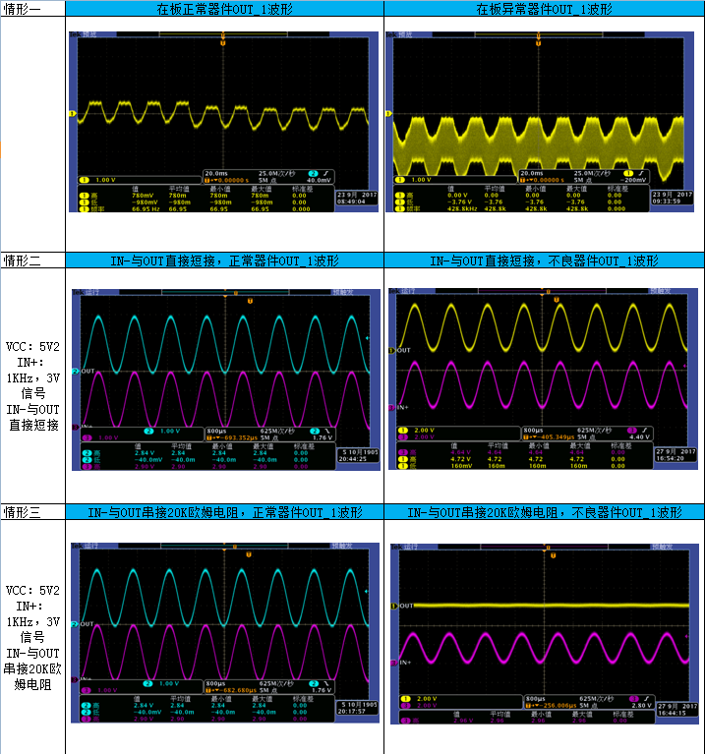
Schematic
Note: C402/C511/C510 NC;
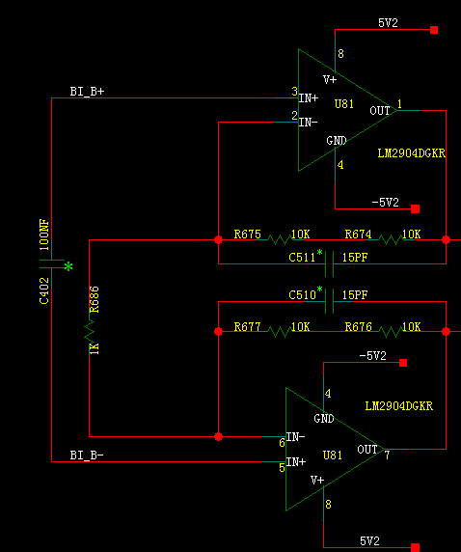
I-V Curve
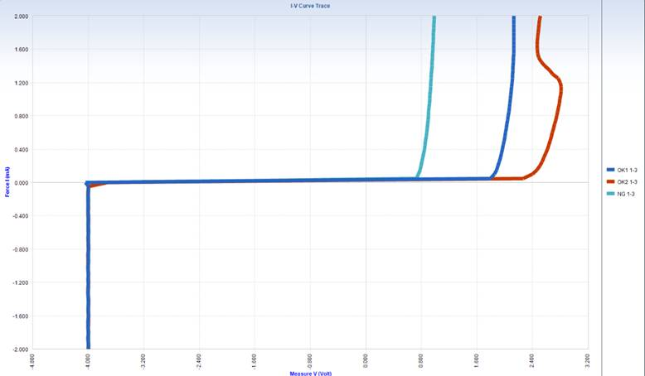
Support Need
- Comments on the schematic design;
- Comments on the I-V curve;

