LMH6702 TINA model validation
Michael Steffes, 3/13/2015 (updated 4/7/2015) and again 3/17/2016
Looking at the Zol curve first. Important here to not load the output as that appears to get into the Zol DC gain. My earlier work had 100ohm output load and that was messing up the correlations. It is a good model to reflect the load into the Zol curve.
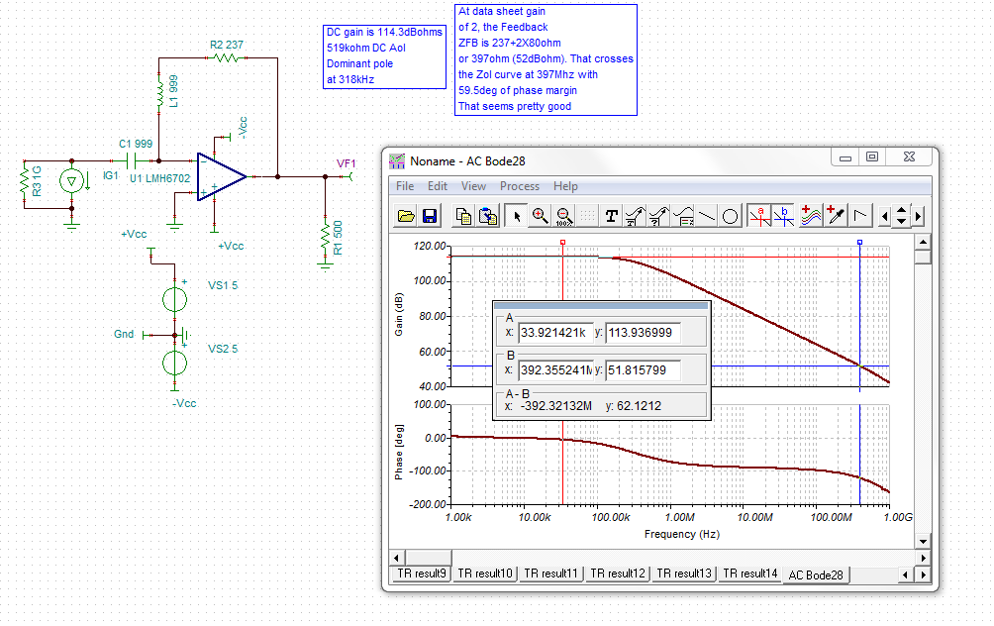
The data sheet shows something very similar. It has 111dBohm DC Zol and about 350kHz dominant pole. The next thing to check is the gain of 2 loop gain xover – and then the phase margin at that point to link back into the closed loop Av=2V/V response curve. The 114.3dBohms DC Zol is 519kohm DC open loop gain. The inverting input Ri is 80ohm in the model, so the Zol crossover for this 237+2*80ohm feedback Zfb (52dBohms) is at about 400MHz with 60deg of phase margin. Seems reasonable and matches the PDS closed loop curve approx..
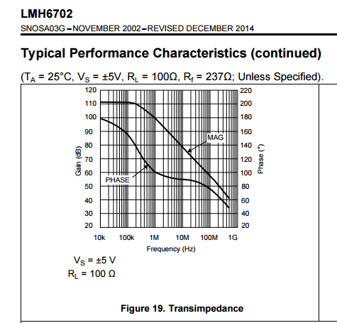

Here the simulated inverting input R, seems pretty high actually, the total quiescent on the LMH6702 is 12.5mA.
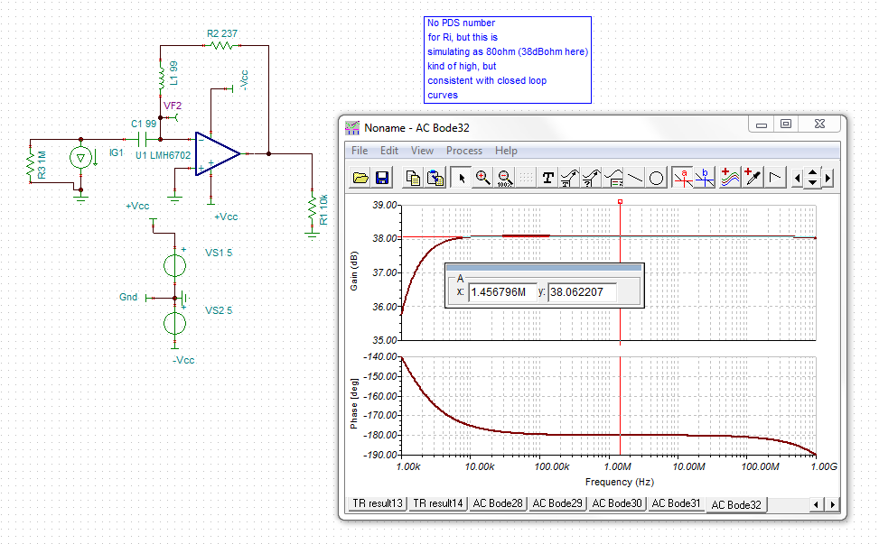

Now doing the gain of 2 sim. The resulting closed loop response from the above analysis should give about 1.6*397Mhz = 864Mhz F-3dB. Since the phase margin is 60deg, should be a slightly peaked response. The gain of 2 sim with Rf = 237 is a bit lower, but I have noticed that loading the output reduces the DC Zol and the profile – good model in that respect. (the output load here is 1k||474)
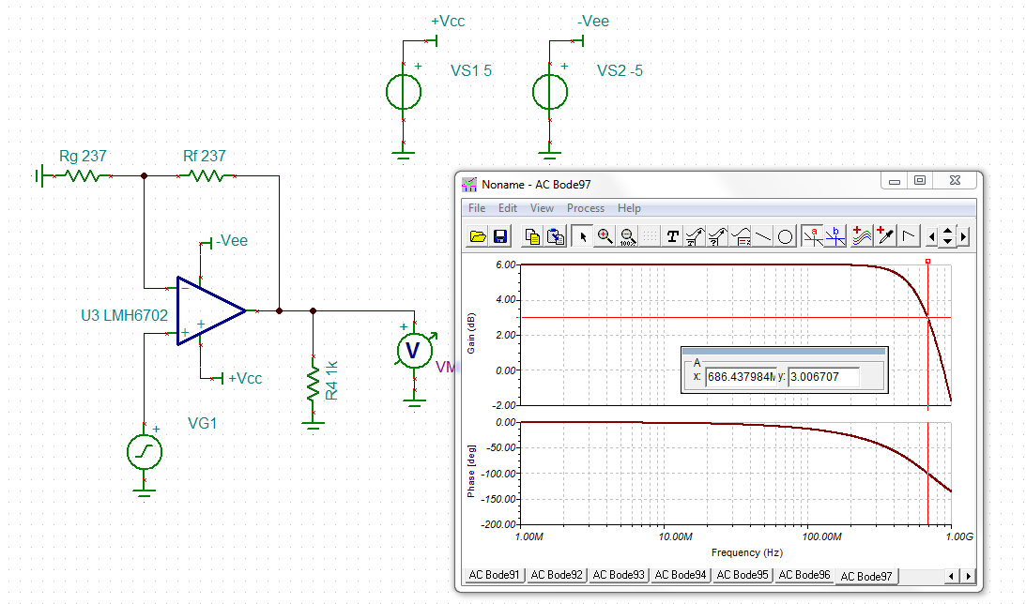
The actual data sheet about 700Mhz BW but this is large signal. Pretty good model match.
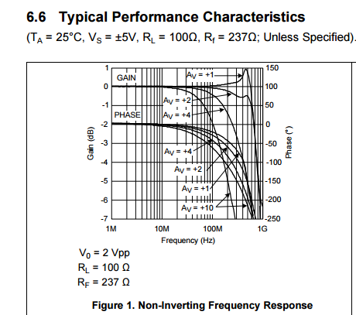

There are not many BW vs gain plots and no effort to adjust Rf for optimum Zfb, but just regenerating the one shown above at gains of 4 and 10 with fixed Rf=237ohm gives this set of curves. Here the F-3dB vs gain is simulating as – this is adding a 100ohm load which seems to reduce the BW through the Zol curve change
Gain of 2 580Mhz (PDS plot is about 700Mhz)
Gain of 4 350Mhz (PDS plot is about 320Mhz)
Gain of 10 150Mhz (PDS plot is about 150Mhz)
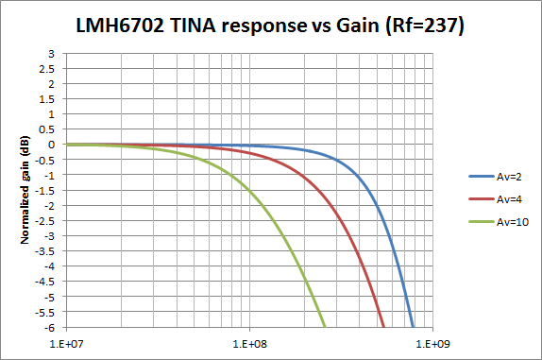
So actually the TINA model is tracking the device plots pretty closely, that would suggest the Ri physically is close to that 80ohms in the model. Very high, but matches the apparent data.
We can test that by trying to adjust Rf vs gain to get the same response shape. Try a gain of 2, 2.5, 3
Av=2, Rf = 237
Av =2.5, Rf = 197
Av=3, Rf = 157
This works exactly like it should so the model with Ri = 80ohm and a Zfb opt = 397 is very accurate. There should have been some discussion of this in the PDS, but at least the model is accurate in this respect.
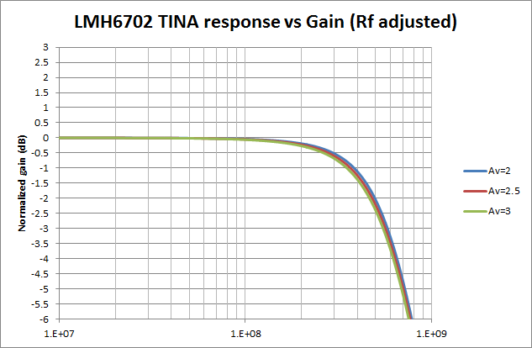

Now let’s check the non-inverting input C, this extracts out as 1.6pF
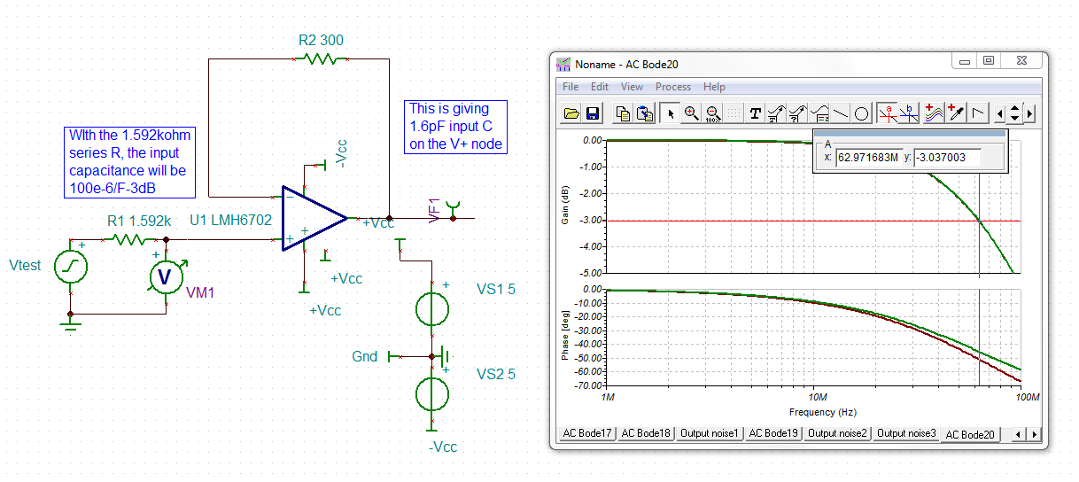

The data sheet reports 1.6pF so this is modeled right, that 1.4Mohm in parallel with that seem very high (physically) but not a big issue.
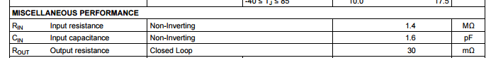
We can also use that circuit to check the buffer gain and the Loop Gain for this simple circuit.
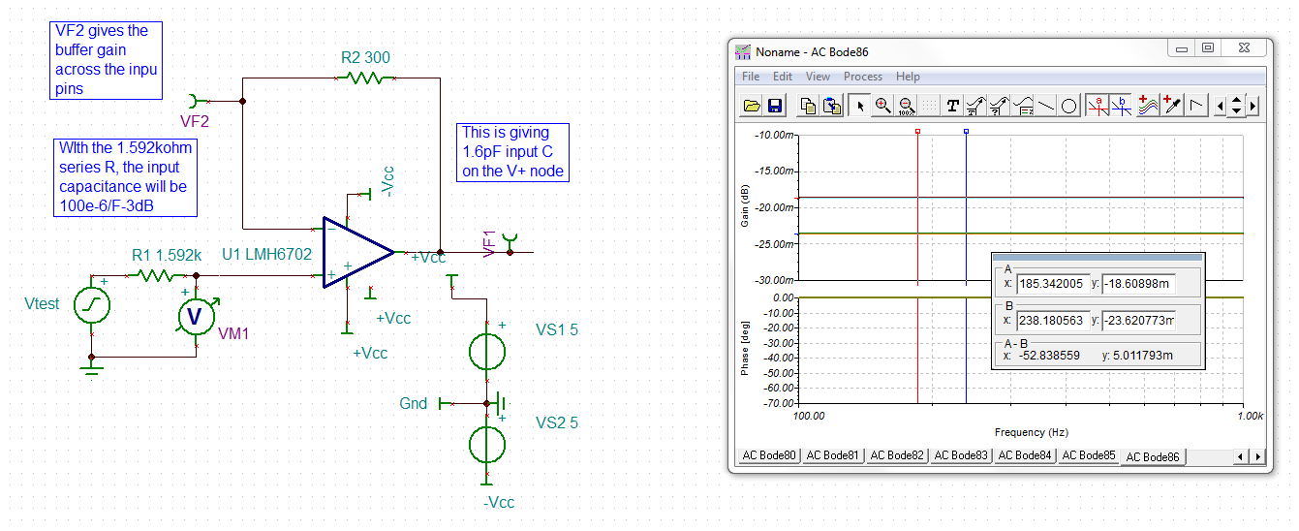
The upper curve is the buffer output showing a -.018509dB gain. From there to the output is just the LG/LG+1 loss

Buffer gain = 0.9978 (a bit closer to one than the 48dB CMRR would predict .996V/V)
With the 80ohm inverting input Z + Rf = 300ohm the loop gain is 519kohm/(300+80) = 1366. So the LG/(LG+1) should be 0.9992683V/V. That is a dB gain loss from V- node of -.006357dB. Going from VF2 to the output above gives us -.00501dB gain loss – pretty close agreement on this.

Now lets check the output impedance. The 0dB (1ohm) output impedance is at 21Mhz.
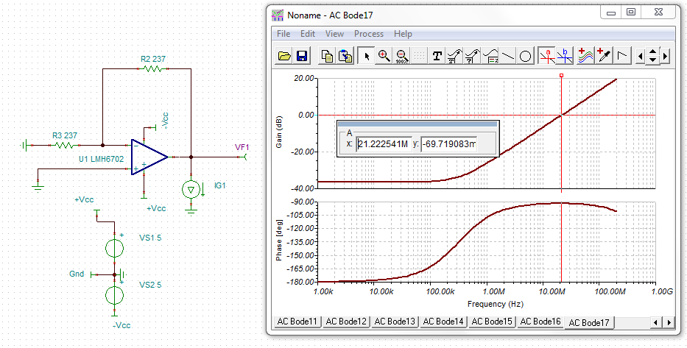
The data sheet shows this – It also is passing though 0dBohms at about 20Mhz. The low frequency value is about -30dBohms, simulating about the same. The LG at 21Mhz in the TINA model is about 18.7 That implies the inside the loop Ro is 19.7 ohms at this 1ohm closed loop Zo output frequency – very reasonable and looks accurate. We can directly measure the open loop output impedance with this circuit. That 25.8dBohms open loop Ro is 19.5ohms. Very good match to closed loop estimate.
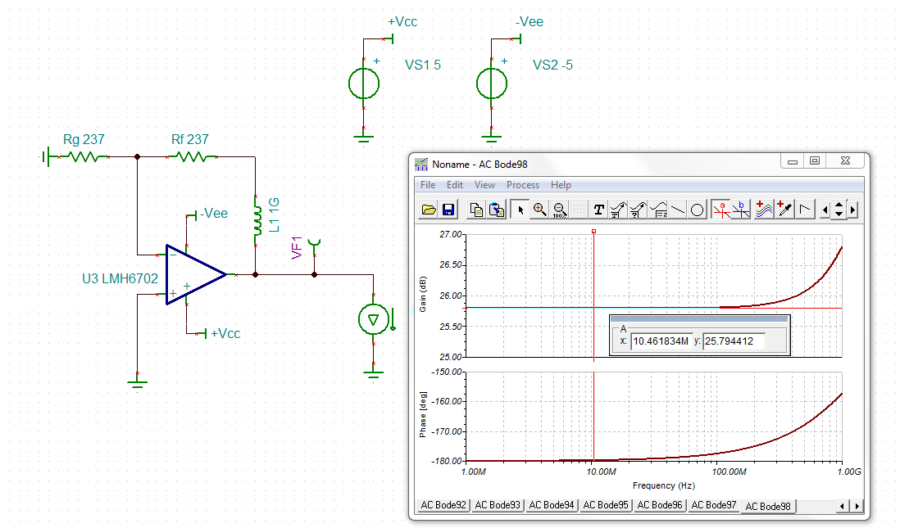
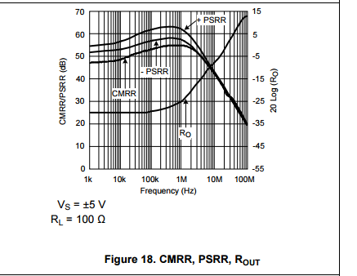

Now let’s extract the input noise terms. Here is the 3 condition set up used.
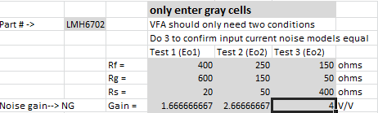
Here is the extracted noise models
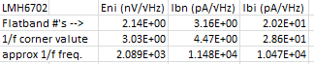
Here are the TINA model input noise terms plotted over F

The Ibi looks very close, 20pA flatband modeled and the corner is at 10kHz in the model vs about 20kHz in the PDS
The Eni looks very close, 2nV flatband modeled with a corner at 2kHz, measured shows 2nV with a 6kHz corner
The Ibn is very close, 3pA flatband modeled with a corner at 11.5kHz corner, measured shows 3pA with a 30kHz corner
These are all very close match to the PDS.
