LMP7704-SP 2021 new model testing,

Reference design, I will not be using the 20pF load,

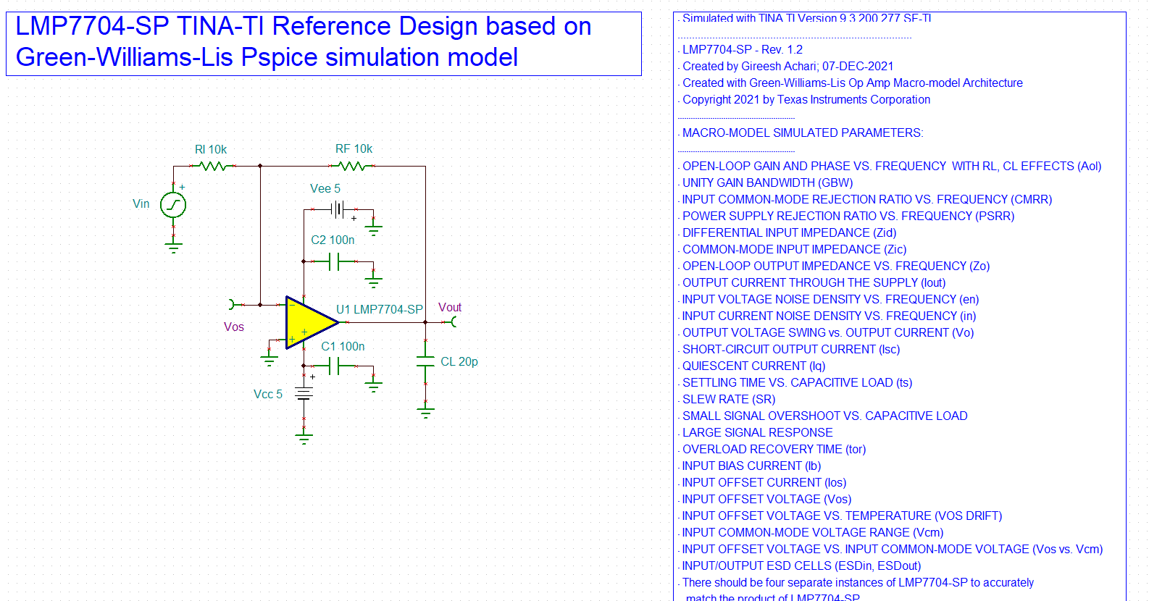

1st set up for Aol test with 10kohm load, going to the 40dB Aol point, this is 2.5MHz true GBP. Very good phase margin, so that 2.5MHz unity gain in the datasheet is going to be close.

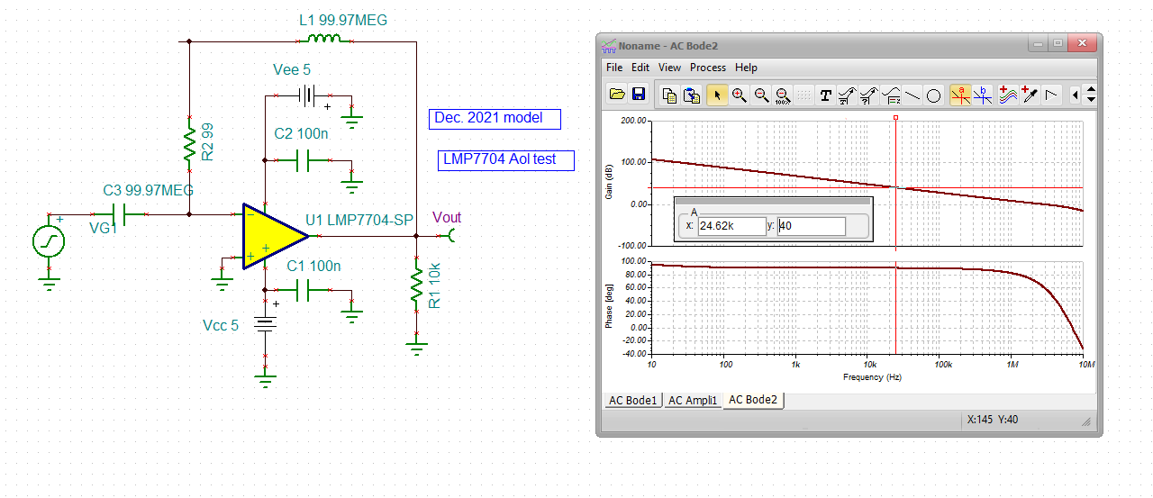

Quickly add back that 20pF load, used sometimes to extend bandwidth by reducing phase margin, about the same GBP, but the phase at unity gain is down to 60deg now, that will extend the unity gain closed loop by about 1.6X over that 2.77MHz unity gain Aol xover.

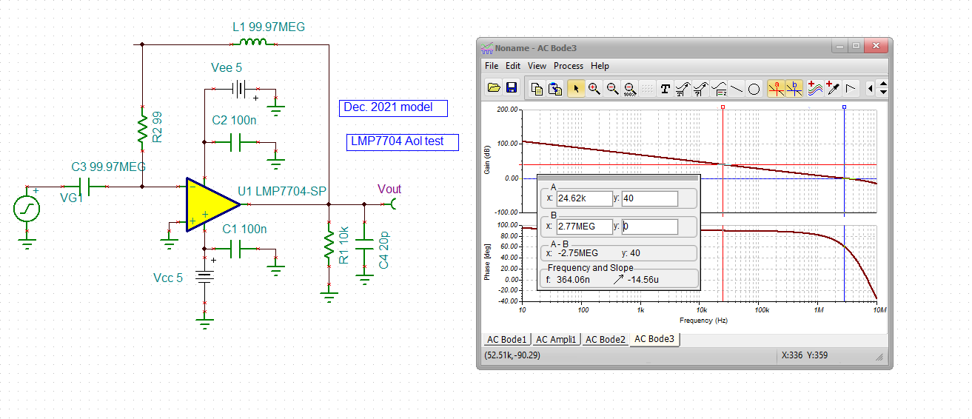

Unity gain sim with 20pF load, maybe they are using that load C to tune for max flat BW? Should have been about 1.6\*2.8MHz or 4.5MHz, actually quite a lot more, 6.1MHz.

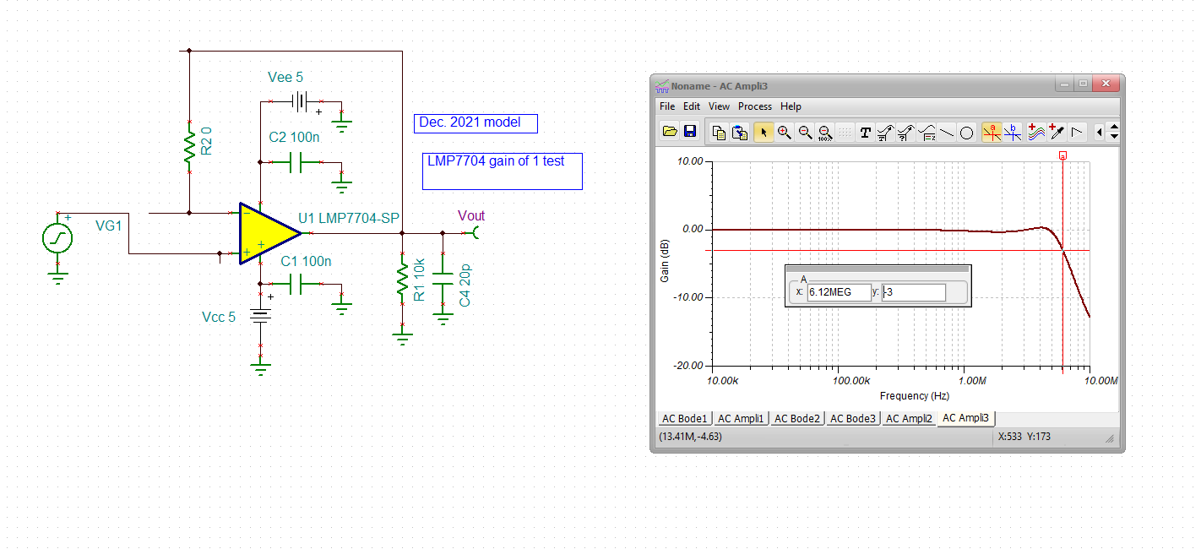

Ok, next, the open loop Zol test, there is something there, doesn’t look right, very low at DC, 10ohms midband, little bit of resonance higher up but very mild for a RRO part,

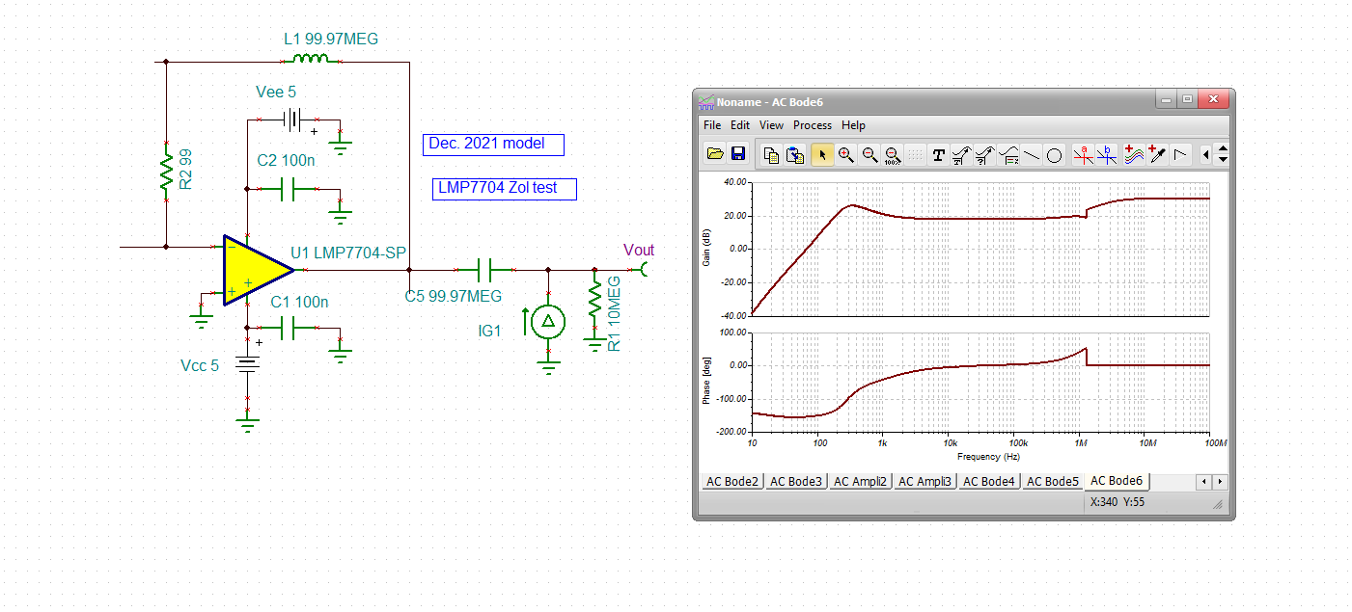

Now test the input C, quite high on this part via datasheet discussion – not in specs.

From this article,

<https://www.planetanalog.com/input-impedance-extraction-and-application-for-high-speed-amplifiers-insight-9/>

Total input C, the simple Ccm test was peaking with 15.92kohm source? This is 28pF total Ccm + Cdiff

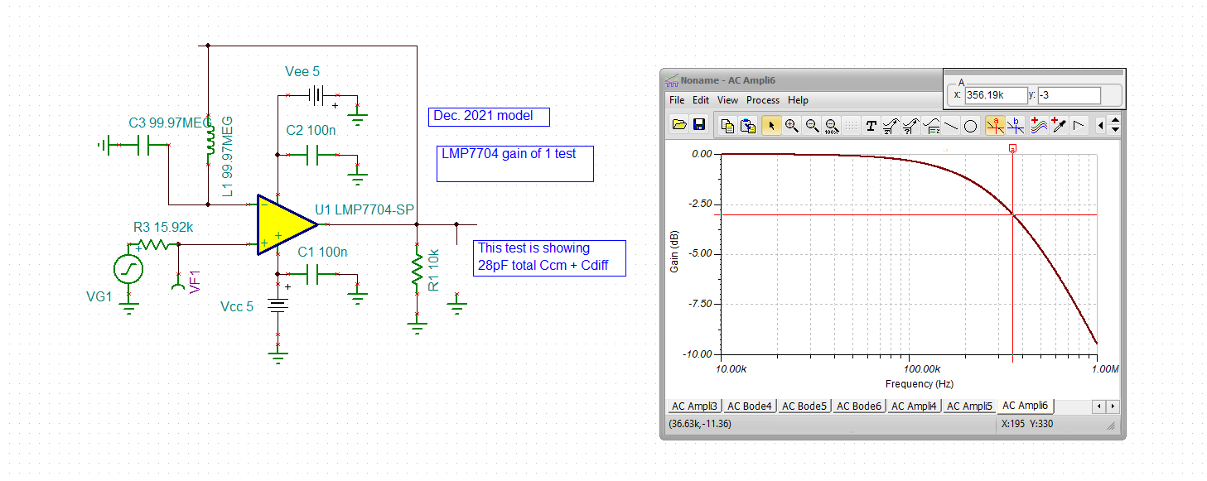

Try reducing the source R in the Ccm extract. Not understanding this, oh well, For Zt designs, it is the 28pF we need for the Ccm + Cdiff. Close to the datasheet 25pF on page 16.

